Supplemental Information for

Molten flux growth of single crystals of quasi-1D hexagonal chalcogenide BaTiS₃

Authors: Huandong Chen¹, Shantanu Singh¹, Hongyan Mei², Guodong Ren³, Boyang Zhao¹, Mythili Surendran^{1,4}, Yan-Ting Wang¹, Rohan Mishra^{5,3}, Mikhail A. Kats^{2,6}, Jayakanth Ravichandran^{1,4,7*}

¹Mork Family Department of Chemical Engineering and Materials Science, University of Southern California, Los Angeles CA, USA
²Department of Electrical and Computer Engineering, University of Wisconsin-Madison, Madison WI, USA
³Institute of Materials Science & Engineering, Washington University in St. Louis, St. Louis MO, USA
⁴Core Center for Excellence in Nano Imaging, University of Southern California, Los Angeles CA, USA
⁵Department of Mechanical Engineering and Materials Science, Washington University in St. Louis, St. Louis MO, USA
⁶Department of Materials Science and Engineering, University of Wisconsin-Madison, Madison WI, USA
⁷Ming Hsieh Department of Electrical and Computer Engineering, University of Southern California, Los Angeles CA, USA

*Email: j.ravichandran@usc.edu

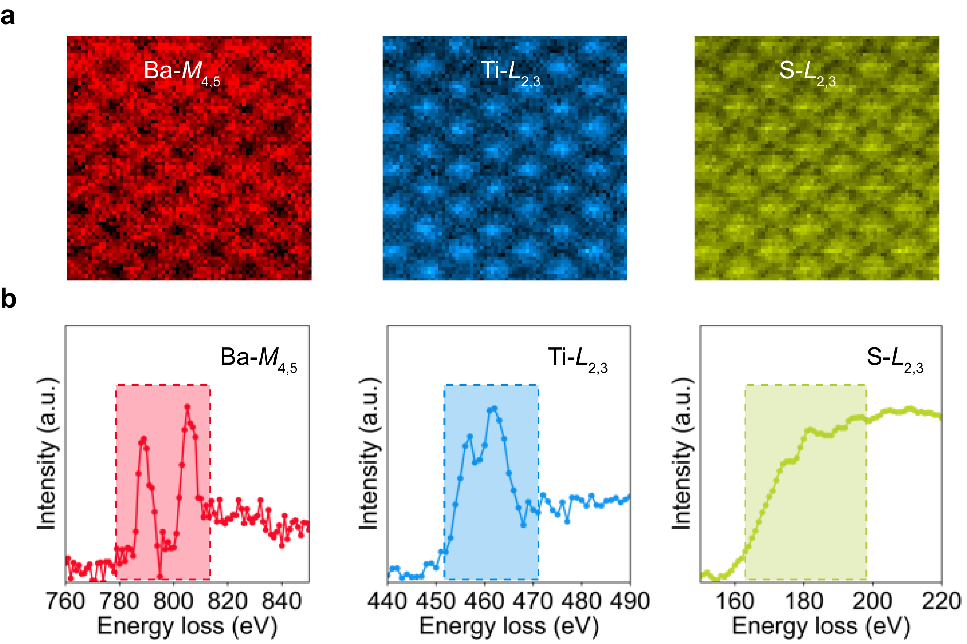
Figure S1. (a) Elemental edge maps using Ba-M, Ti-L, and S-L edges extracted from an EELS image. (b) The EEL spectra of the corresponding elements used to make the elemental maps in (a). The energy range used for signal integration have been highlighted with shaded boxes.

Figure S2. Optical images of quartz ampoules prepared for (a) KI flux growth, and (b) BaCl₂-BaI₂ flux growth. Additional alumina crucible was used as inner container for BaCl₂-BaI₂ flux to minimize its corrosion to quartz ampule.

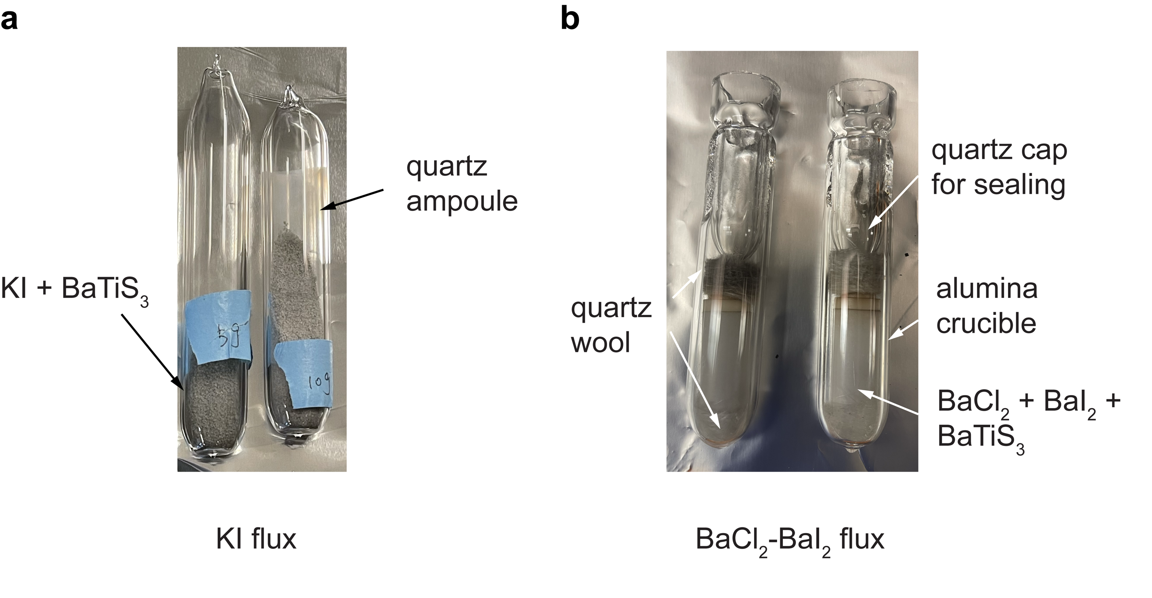

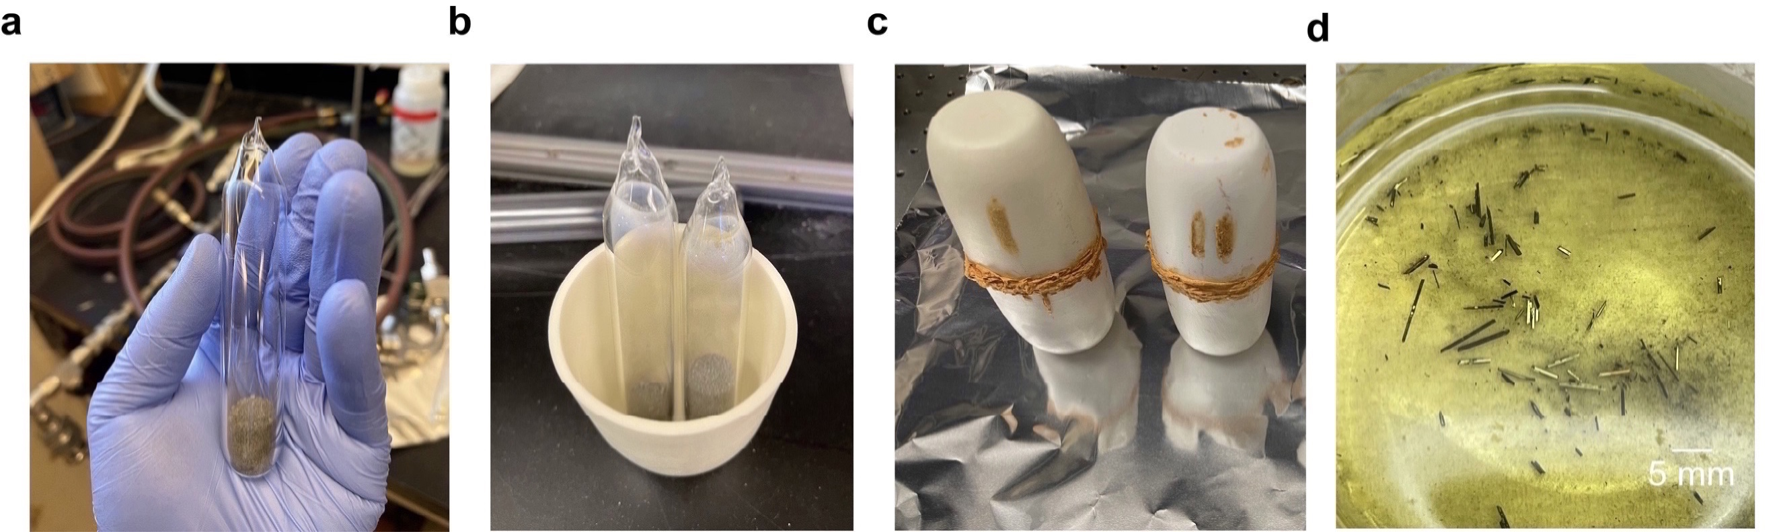
Figure S3. Optical images of several different steps of BaTiS₃ crystal synthesis using KI flux: (a) after sealing KI flux, pre-synthesized BaTiS₃ powder and excess sulfur in a quartz ampule, (b) after loading samples in an alumina crucible, (c) after sealing alumina crucibles using high temperature cement, this step protects the furnace from any potential leaking, and (d) removing excess KI flux in a crystallizing dish using DI water.

Figure S4. (a) Precession maps of a conventional CVT-grown BaTiS₃ crystal along hk2 projection for three different phases. The data was adapted from the Reference¹. (b) Reciprocal precession images of a BaCl₂-BaI₂ flux-grown BaTiS₃ crystal along the same projection, taken at 300 K, 220 K, and 100 K, respectively during the warming cycle.

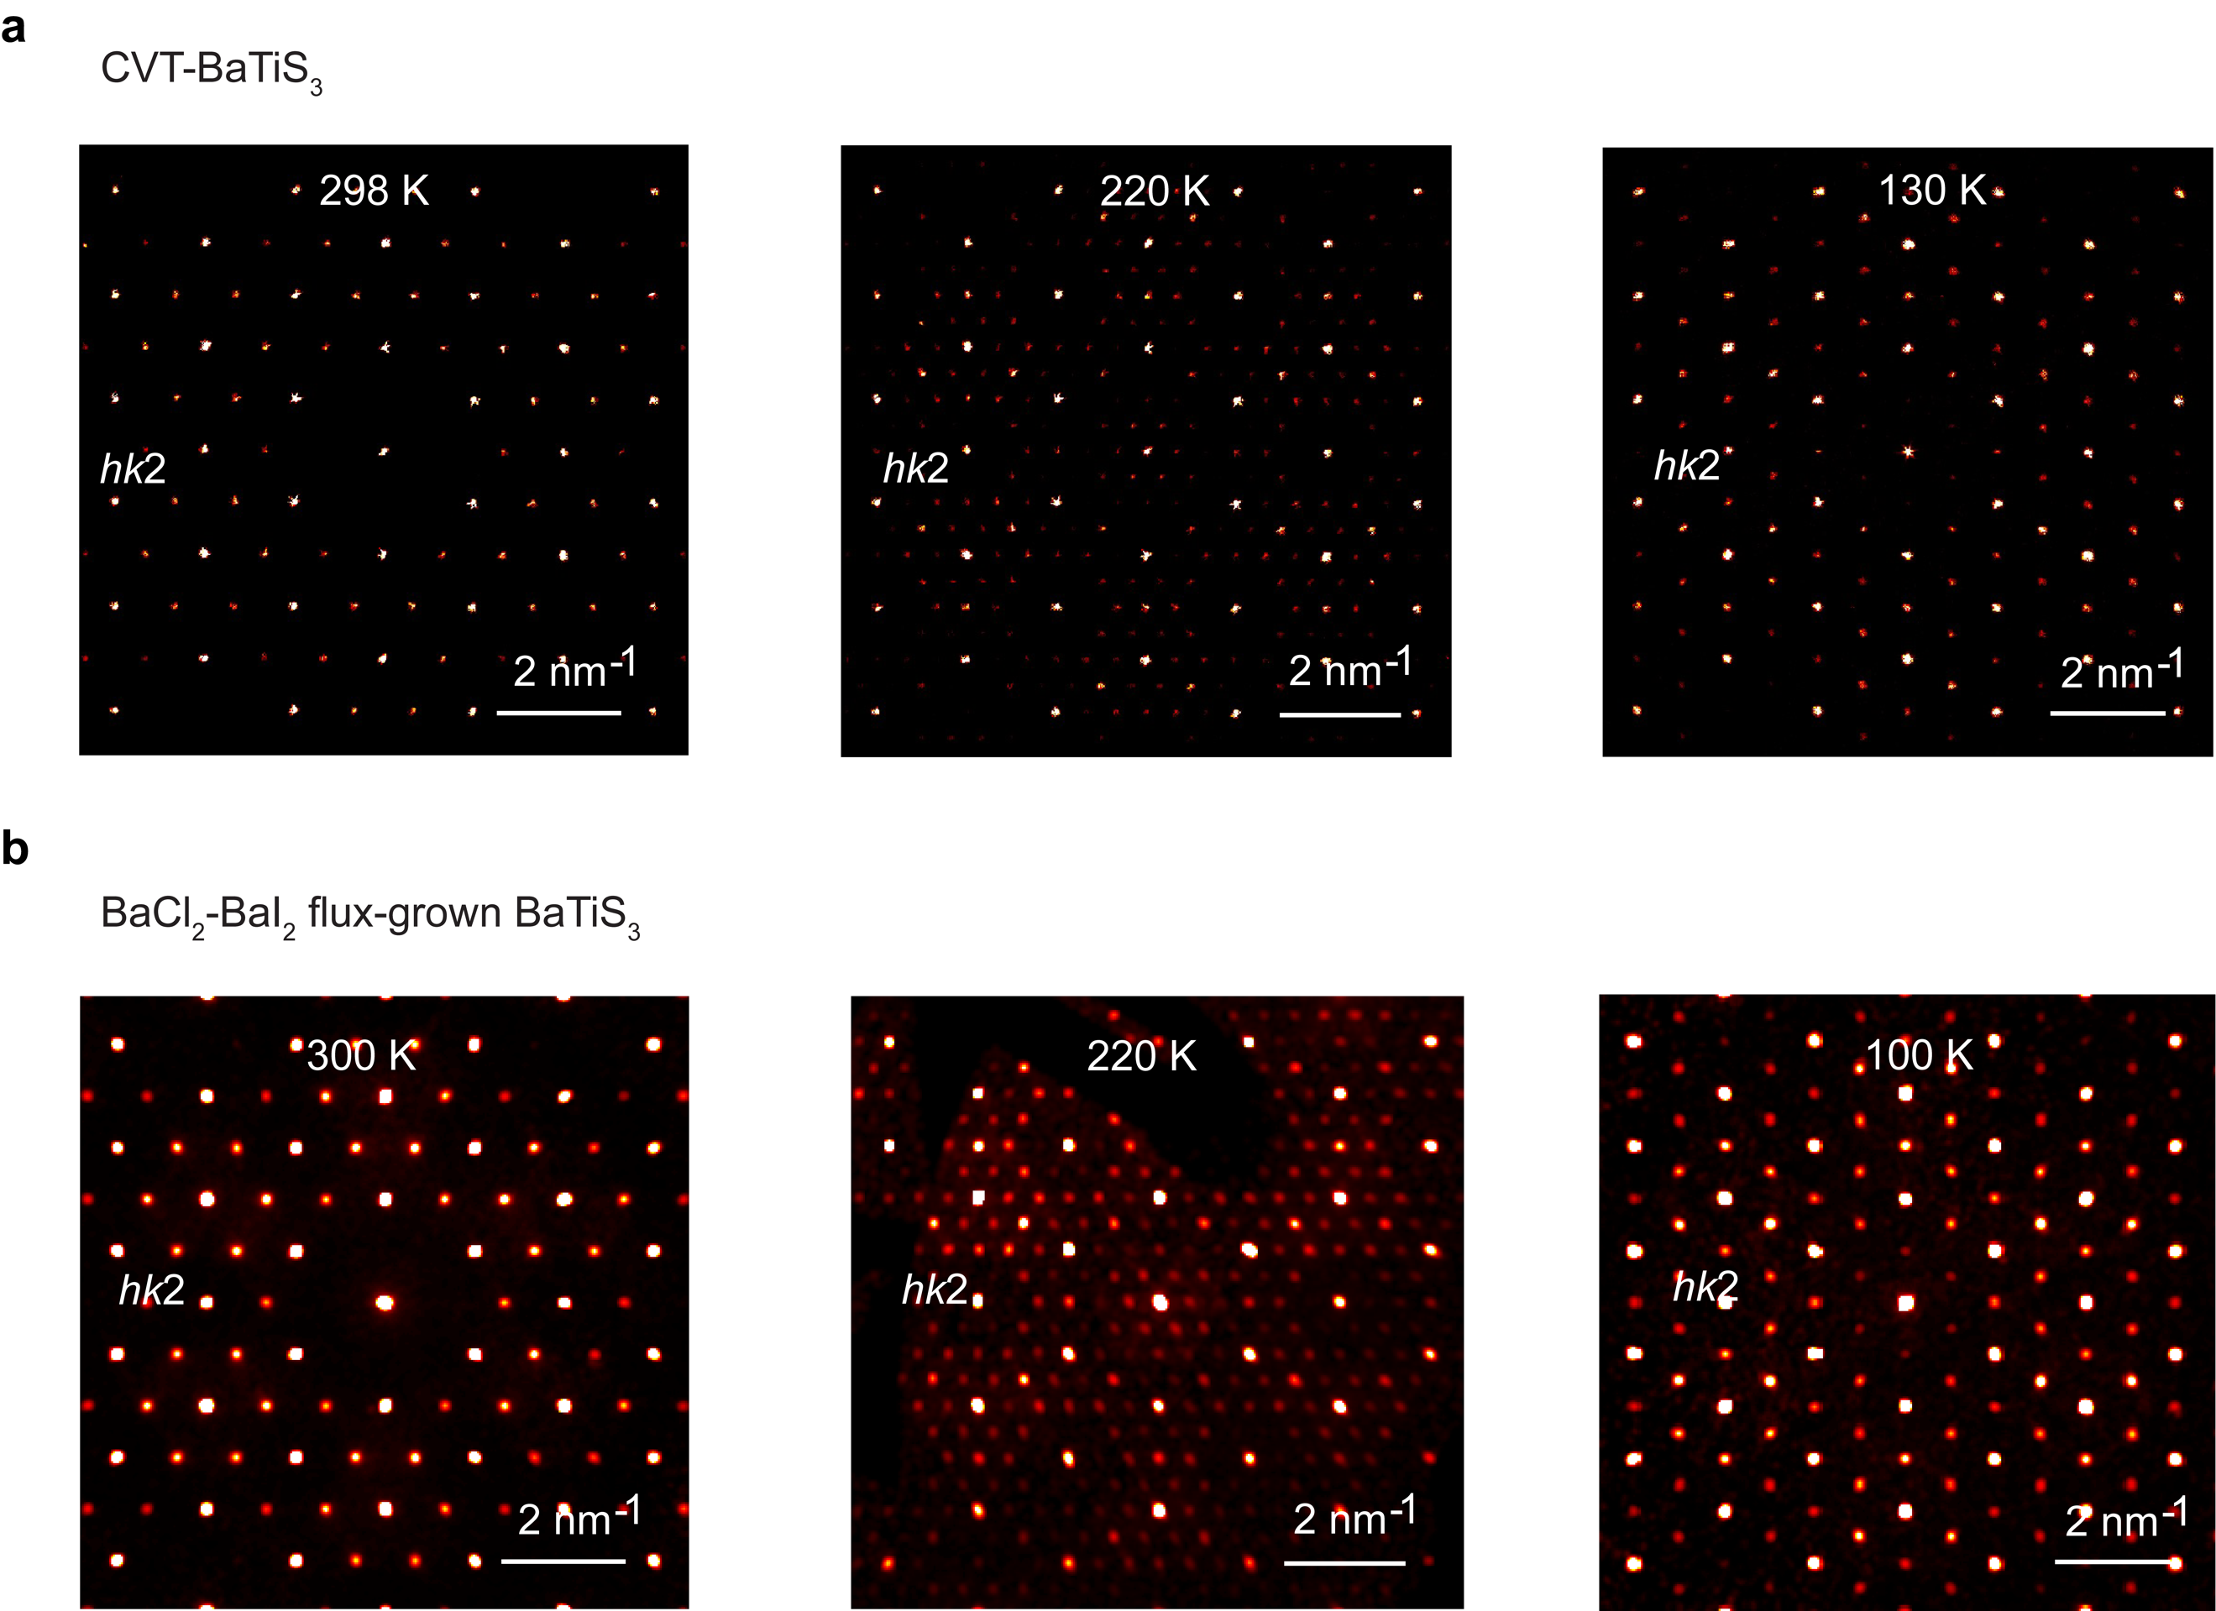
Table S1. Evolution of flux-grown BaTiS₃ unit cell sizes at different temperatures

Flux-BaTiS₃ | 300 K | 240 K | 100 K
a, b, c (Å) | 11.71, 11.71, 5.84 | 23.38, 23.38, 5.85 | 13.46, 13.46, 5.83
α, β, γ (°) | 90, 90, 120 | 90, 90, 120 | 90, 90, 120
space group | P6₃cm | P3c1 | P2₁

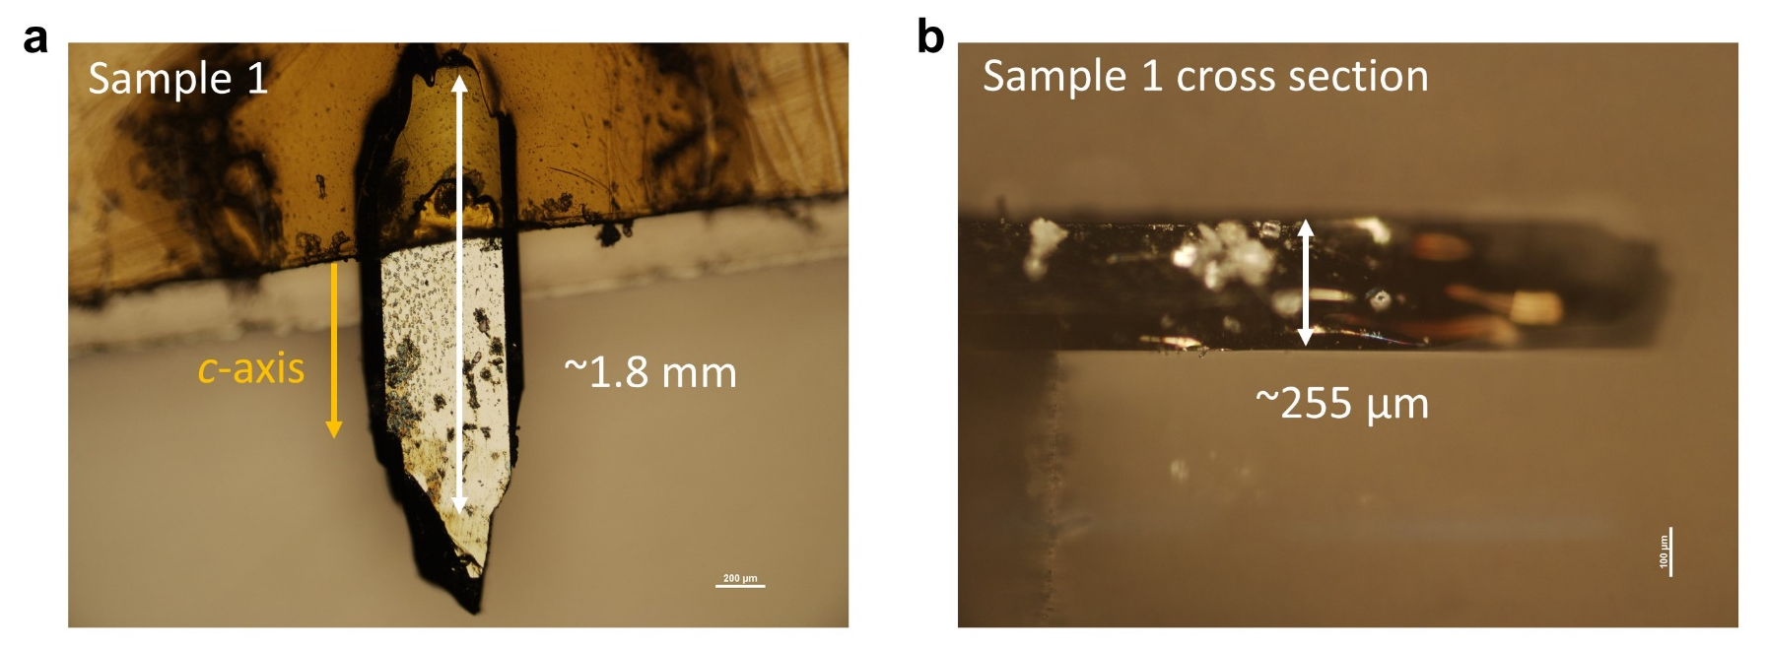
Figure S5. (a) optical images of a KI flux grown BaTiS₃ crystal plate, with dimension along the c-axis larger than 1.8 mm. (b) cross-section image of a KI flux grown BaTiS₃ crystal plate, showing the thickness of ~255 µm.

Figure S6. Raw ellipsometry data ($Ψ$ (a-c) and $Δ$ (d-f) of $A_{ne}$, Mueller matrix elements (g-i)) for KI flux grown BaTiS₃ at $θ_{i}=55°$ with the crystal c-axis perpendicular, parallel, and at an off-axis angle $\sim 48°$ to the plane of incidence, showing good consistence between the experimental data (green lines) and model fit data (red lines).
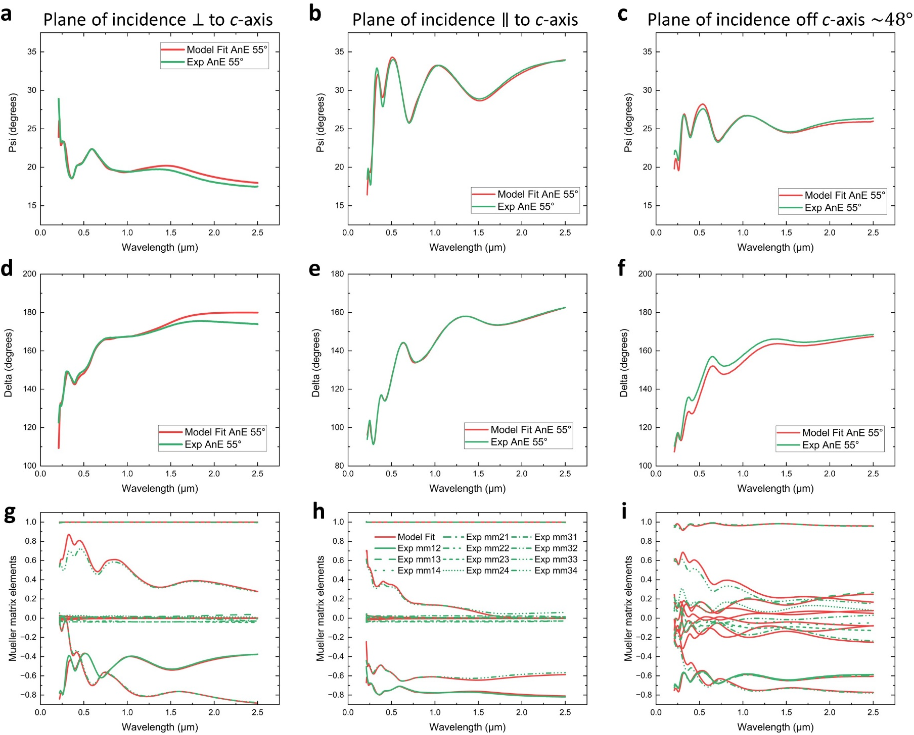

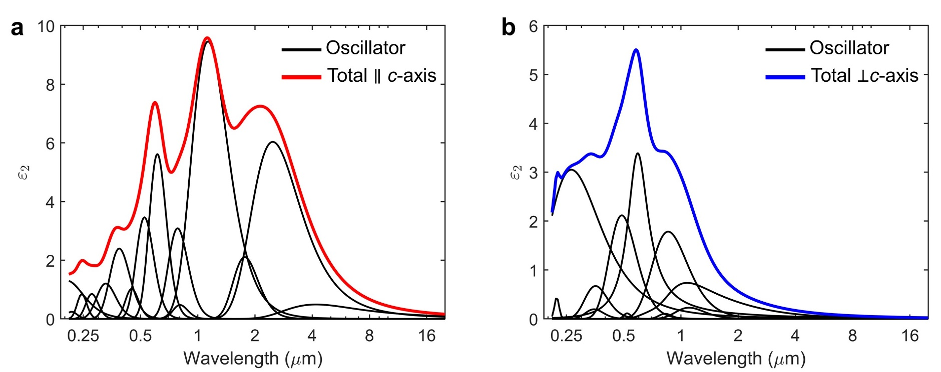
Figure S7. The $ε_{2}$ values calculated from the final optical oscillator model used to fit to the ellipsometry data of KI flux grown BaTiS₃. The optical oscillator model is built on Kramers-Kronig consistent oscillators.

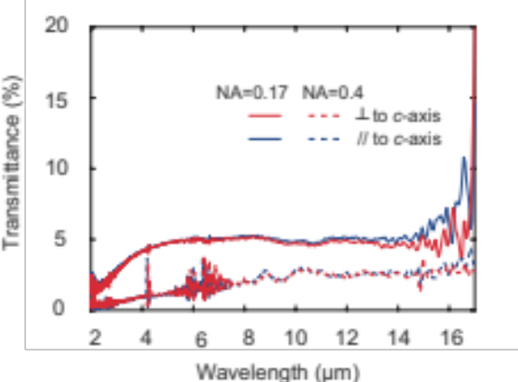
Figure S8. Infrared transmission spectra of a thick KI flux-grown BaTiS₃ crystal with incident light polarized at 0˚ and 90˚, with respective to the c-axis. No substantial difference was observed between different polarizations and the absolute values of transmittances are low. Two different objective lenses (15×, NA = 0.4, Casegrain reflective objective; 5×, NA = 0.17, Ge IR refractive objective) have been used for the measurements. The corresponding reflectance spectra with NA = 0.4 is shown in Figure 3a.
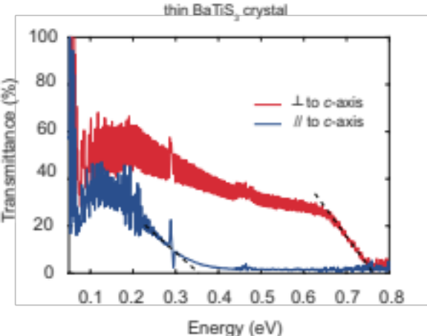
Figure S9. Infrared transmission spectra of a relatively thin KI flux-grown BaTiS₃ crystal (~ 40 µm thick) with incident light polarized perpendicular and parallel to the c-axis. Two absorption edges at ~ 0.35 eV and ~ 0.77 eV are clearly revealed. Energy scale was used for the ease of analysis.

Supplementary Note 1. Extraction of the Anisotropic Complex Refractive Index
Generalized spectroscopic ellipsometry (VASE + focusing optics, J.A. Woollam Co.) and polarized reflection/transmission infrared spectroscopy (Bruker VERTEX 70 + Hyperion 2000 with MCT IR detector) were employed to extract the complex refractive index tensor of KI flux grown BaTiS₃ from 210 nm to 17 µm. The BaTiS₃ crystal was suspended over air with no substrate during the measurement, as shown in Figure S5.
Four ellipsometry measurements were made under Mueller Matrix Mode with three different crystal orientations: with the crystal c-axis perpendicular to the plane of incidence; parallel to the plane of incidence; and at off-axis angles (~48°) and the three measurements were made with an angle of incidence of 55° from the surface normal.
Figure S6 shows the fitting between the raw measured ellipsometry data (in green) and the corresponding model data (in red) for the three measurements of KI flux grown BaTiS₃, consisting of the generalized ellipsometry data types $A_{ne}$ and Mueller matrix elements $mm_{12}, …,mm_{34}$. $A_{ne}$ is the ratio between the two Fresnel coefficients $r_{pp}$ and $r_{ss}$. Mueller matrix elements describe how the sample transforms the Stokes vector of the incident light. The $m_{11}$ element represents the total intensity of the reflection or transmission of the sample and the VASE ellipsometer records other Mueller matrix elements normalized to $m_{11}$, so the quantities range between -1 and +1².
$$A_{ne}=ρ=\frac{r_{pp}}{r_{ss}}=\tan\left(Ψ_{A_{ne}}\right)e^{iΔ_{A_{ne}}}$$
$S=\left[\begin{matrix}I \\ Q \\ U \\ V\end{matrix}\right]=M\left[\begin{matrix}I^{in} \\ Q^{in} \\ U^{in} \\ V^{in}\end{matrix}\right]$, $M=\left[\begin{matrix}m_{11} & m_{12} & m_{13} & m_{14} \\ m_{21} & m_{22} & m_{23} & m_{24} \\ m_{31} & m_{32} & m_{33} & m_{34} \\ m_{41} & m_{42} & m_{43} & m_{44}\end{matrix}\right]=m_{11}\left[\begin{matrix}1 & m_{12}' & m_{13}' & m_{14}' \\ m_{21}' & m_{22}' & m_{23}' & m_{24}' \\ m_{31}' & m_{32}' & m_{33}' & m_{34}' \\ m_{41}' & m_{42}' & m_{43}' & m_{44}'\end{matrix}\right]$
All three datasets were fitted simultaneously using a single optical model with uniaxial birefringence. Here, optical properties perpendicular and parallel to the c-axis contain independent oscillators. By integrating the polarization-resolved reflectance of KI flux grown BaTiS₃ into the ellipsometry data, the optical model could be extended up to the detection limit of our FTIR (17 μm). Thus, three ellipsometry measurements and two reflectance measurements could all be fit simultaneously to a single anisotropic optical model to yield a full set of refractive indices spanning 210 nm through 17 μm. As shown in Figure S6, the measured data match well with the model fitted data.
The total oscillator model for each direction is the sum of individual Kramers-Kronig-consistent oscillators as shown in Figure S7. Table S2 lists the oscillators used in the anisotropic optical model for both the ordinary and extraordinary directions.

Table S2. Oscillators and the fitted parameters of KI flux grown BaTiS₃.
Oscillator | Parameters (eV)
Gaussian  $$\begin{aligned}ε_{Gaus}=ε_{1}+iε_{2}\end{aligned}$$  $$ε_{2}=A_{n}e^{{-\left(\frac{E-E_{n}}{σ}\right)}^{2}}-A_{n}{e^{-\left(\frac{E+E_{n}}{σ}\right)}}^{2}$$  $$ε_{1} =\frac{2}{π}P\int_{0}^{∞}{\frac{ξε_{2}(ξ)}{ξ^{2}-E^{2}}dξ}$$  Where $σ=\frac{Br_{n}}{2\sqrt{\ln\left(2\right)}}$, the $1/2\sqrt{In(2)}$ factor defines $Br_{n}=FWHM$. P is the Cauchy Principal Value. | Ordinary  A₁ = 0.22881  A₂ = 1.7844  A₃ = 0.10508  A₄ = 0.11355  A₅ = 2.117  A₆ = 0.67282  A₇ = 0.19641  A₈ = 3.0509  A₉ = 0.44297  Extraordinary  A₁ = 0.49005  A₂ = 6.0344  A₃ = 2.1032  A₄ = 9.455  A₅ = 0.47327  A₆ = 3.0859  A₇ = 5.616  A₈ = 3.4602  A₉ = 1.0241  A₁₀ = 2.3982  A₁₁ = 1.2056  A₁₂ = 0.85088  A₁₃ = 0.84736  A₁₄ = 0.24468  A₁₅ = 1.3047 | Ordinary  E₁ = 1.1236  E₂ = 1.4476  E₃ = 1.5034  E₄ = 2.3794  E₅ = 2.5385  E₆ = 3.4884  E₇ = 3.5532  E₈ = 4.6747  E₉ = 5.5807  Extraordinary  E₁ = 0.29574  E₂ = 0.5  E₃ = 0.70144  E₄ = 1.0952  E₅ = 1.5367  E₆ = 1.5826  E₇ = 2.2017  E₈ = 2.3637  E₉ = 2.7584  E₁₀ = 3.2084  E₁₁ = 3.7787  E₁₂ = 4.4721  E₁₃ = 5.0477  E₁₄ = 5.7131  E₁₅ = 6.0456 | Ordinary  Br₁ = 0.4612  Br₂ = 0.73465  Br₃ = 0.27766  Br₄ = 0.23803  Br₅ = 0.97834  Br₆ = 1.1235  Br₇ = 0.91346  Br₈ = 3.3703  Br₉ = 0.36085  Extraordinary  Br₁ = 0.31132  Br₂ = 0.3465  Br₃ = 0.24885  Br₄ = 0.56054  Br₅ = 0.32465  Br₆ = 0.445  Br₇ = 0.49401  Br₈ = 0.5914  Br₉ = 0.5183  Br₁₀ = 0.91344  Br₁₁ = 1.0342  Br₁₂ = 0.79528  Br₁₃ = 0.69215  Br₁₄ = 0.86262  Br₁₅ = 2.6429
Lorentz  $$ε_{L}=ε_{1}+iε_{2}$$  $$ε_{2}= \frac{A_{n}Br_{n}E_{n}}{E_{n}^{2}-E^{2}-iBr_{n}E}$$  $$ε_{1} =\frac{2}{π}P\int_{0}^{∞}{\frac{ξε_{2}(ξ)}{ξ^{2}-E^{2}}dξ}$$  Where P is the Cauchy Principal Value. | Ordinary  A₁ = 3.3693 E₁ = 2.1165 Br₁ = 0.64235
Parametric Semiconductor  Psemi-(M0, M1, M2, M3 & Tri)  See WVASE manual by J.A. Woollam Co.² | Ordinary (Psemi-Tri)
 | A₁ = 1.7299 | Ec₁ = 1.233 | B₁ = 0.18861
 | WL₁ = 1.0042 WR₁ = 1.0207
 | AL₁ = 0.86247 AR₁ = 0.1880
Reference
1 Chen, H. et al. Charge density wave order and electronic phase transitions in a dilute d-band semiconductor. Adv. Mater., 2303283 (2023).
2 Woollam, J. Guide to Using WVASE: Spectroscopic Ellipsometry Data Acquisition and Analysis Software: Lincoln. NE, USA: JA Woollam Company, Incorporated (2012).

