Supporting information

Torsional Performance and Failure Analysis of FFF Carbon Fiber–Reinforced PLA: An Experimental Study
Muhammad Haseem Umer,^{a,b} Muhammad Bilal Khan^{c*}, Muhammad Qasim Zafar^{d}, Ghulam Hussain^{d}, Muhammad Hassan Razzaq^{e,f,g*}

*Correspondence Author: Muhammad Hassan Razzaq (razzaq@mci.sdu.dk)
Muhammad Bilal Khan (muhammadbilalkhan@zju.edu.cn)

ªFaculty of Mechanical Engineering, Ghulam Ishaq Khan Institute of Engineering Sciences and Technology, Topi, Swabi, 23640, KP, Pakistan.
^{b}Department of Mechanical and Aerospace Engineering, Air University, Islamabad, 44000, Pakistan.
^{c}Mechanical Engineering Department, College of Engineering, University of Bahrain, Isa Town, 32038, Bahrain.
^{d}Department of Civil Engineering, Zhejiang University, Hangzhou, 310058, China
^{e}Department of Mechanical Engineering, Institute for Graduate School of Natural and Applied Sciences, Gazi University, Ankara 06570, Türkiye.
^{f}Additive Manufacturing Technologies Application and Research Center - EKTAM, Gazi University, 06980, Kahramankazan, Ankara, TÜRKIYE.
^{g}Smart Materials, NanoSYD, Mads Clausen Institute, University of Southern Denmark, Alsion 2, 6400, Sønderborg, Denmark

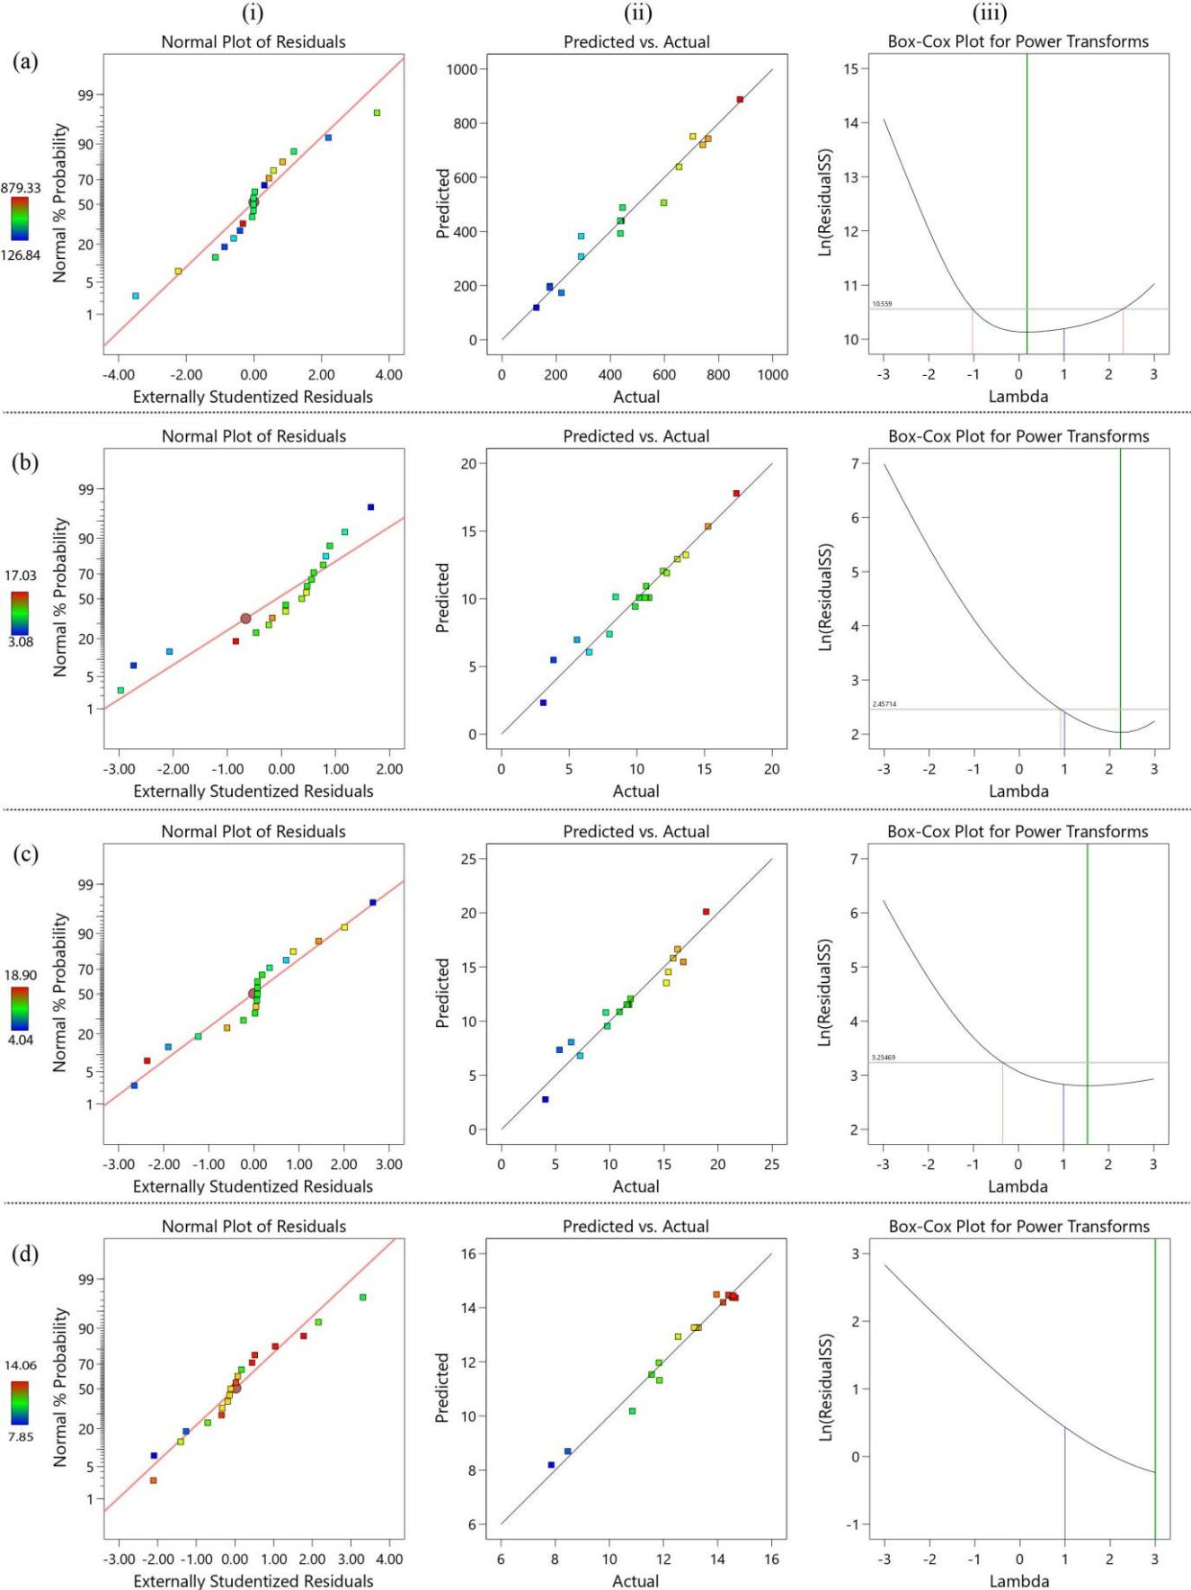Figure S1: Fit measuring criteria: (a) Shear modulus; (b) Yield strength; (c) Ultimate shear strength; (d) Failure strain; [(i) Normal distribution plot; (ii) Actual and predicted plot; and (iii) Box-cox plot.

Table S1: Shear properties from torsion testing of samples.

Sample | Shear Modulus  (MPa) | Yield Stress  (MPa) | Ultimate Shear Stress  (MPa) | Failure Strain  (%)
1 | 176.29 | 3.83 | 5.35 | 14.58
2 | 653.58 | 9.87 | 10.89 | 14.56
3 | 597.68 | 13.60 | 15.40 | 11.85
4 | 292.39 | 8.42 | 9.63 | 12.53
5 | 176.29 | 6.47 | 7.26 | 14.40
6 | 438.59 | 10.72 | 11.63 | 13.21
7 | 440.74 | 10.89 | 11.77 | 13.29
8 | 436.44 | 10.59 | 11.56 | 13.13
9 | 741.73 | 15.25 | 16.26 | 11.56
10 | 438.59 | 10.68 | 11.63 | 13.20
11 | 219.29 | 7.969 | 9.76 | 11.83
12 | 445.04 | 12.99 | 16.78 | 10.84
13 | 126.84 | 3.08 | 4.04 | 14.66
14 | 879.33 | 17.35 | 18.90 | 7.85
15 | 438.59 | 10.16 | 11.63 | 13.18
16 | 705.18 | 10.68 | 11.90 | 14.51
17 | 761.08 | 12.20 | 15.22 | 14.20
18 | 292.39 | 11.92 | 15.85 | 8.46
19 | 437.51 | 5.573 | 6.432 | 13.96

