Supplementary Information

Mastering Binder Jet 3D Printing of 316L Stainless Steel: A Descriptive Model Approach to Particle Size and Deposition Thickness
A. Simchi^{1,2*}, B. Barthel¹, S.B. Hein¹, L. Reineke¹, D. Hosseini²
¹Fraunhofer Institute for Manufacturing Technology and Advanced Materials (IFAM), 28359 Bremen, Germany
²Department of Materials Science and Engineering, Sharif University of Technology, 14588 Tehran, Iran
*Corresponding author: abdolreza.simchi@ifam.fraunhofer.de (A. Simchi)

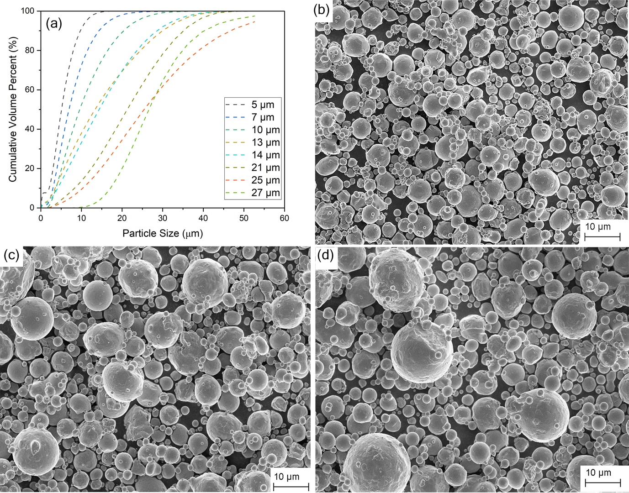
Fig. S1. (a) Particle size distribution of 316 SS powders. Representative SEM images of selected powders showing the spherical morphology of the particles: (b) 10 µm; (c) 16 µm; (d) 22 µm.

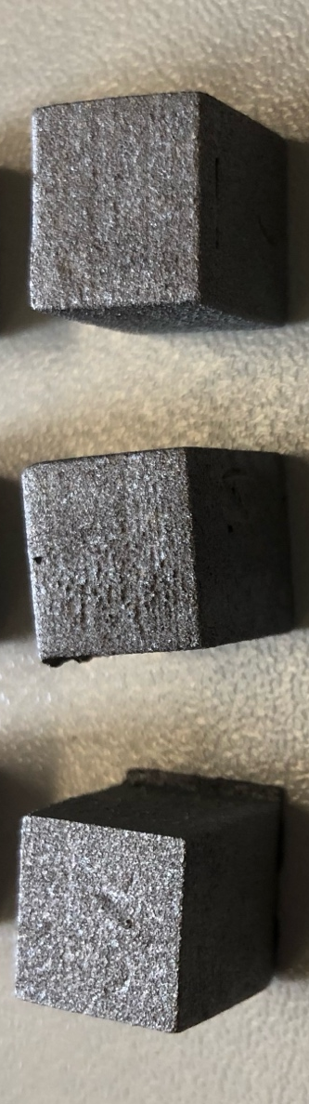

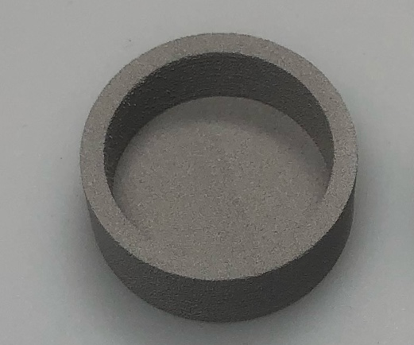

Fig. S2. Representative images of printed (a) cuboidal parts (1 cm³) and (b) cups (Outer diameter: 35 mm)

Table S1. Parameters used for binder jet additive manufacturing of 316L powders

Parameter | Value
Droplet/line spacing, µm | X= 50.8; Y=51
Print head traverse velocity, mm.s⁻¹ | 150
Print passes per X jet spacing | 5
Droplet volume, pL | 26
Droplet frequency, Hz | 2900
Roller transverse speed, mm.min⁻¹ | 5
Roller rotational speed, U.min⁻¹ | 500
Roller diameter, mm | 12
Binder saturation, % | 65
Foundation layer | 10
Bottom bleed reduction, % | 50
Z-Retraction, mm | 0.1
Bed temperature, °C | 40

