Supplementary Information

Automated RAFT Polymerization using Batch, Increment, and
Continuous Addition Modes to Enhance Properties of Fluorescent Polymers
Sophia Beilharz,¹ Juan Manuel Urueña,² Zachary Nett,² Morgan Bates,² Logan Hughes,² Konpal Raheja,¹ Metin Karayilan^{1,}*
¹ Department of Chemistry, Case Western Reserve University, Cleveland, OH, USA
² NSF BioPACIFIC MIP, University of California, Santa Barbara, Santa Barbara, California, USA
* metin.karayilan@case.edu
Table of Contents
A. Materials and Equipment 2
B. Synthesis 3
1. Control: RAFT Polymerization OEGA with BA in Batch and Increment Methods in Toluene 3
2. RAFT Polymerization OEGA with FluA 4
2.1. Batch and Increment Methods in Toluene 4
2.2. Batch and Increment Methods in THF 5
2.3. Batch and Increment Methods in DMF 6
2.4. Continuous Flow Method in THF 7
2.5. Continuous Flow Method in DMF 8
C. Characterization 11
1. Nuclear Magnetic Resonance (NMR) Analysis 11
1.1. P(OEGA-co-BA) Copolymer 11
2.1. P(OEGA-co-FluA) Copolymer 12
Batch System in PhMe 13
Incremental Addition in PhMe 13
Batch System in THF 14
Incremental Addition in THF 14
Batch System in DMF 15
Incremental Addition in DMF 23
Continuous Flow Addition - 0.3 mL/hour 29
Continuous Flow Addition - 0.4 mL/hour 34
Continuous Flow Addition - 0.5 mL/hour 39
Continuous Flow Addition - 1.0 mL/hour 44
2. Gel Permeation Chromatography (GPC) 46
3. UV/Vis Spectroscopy 50
4. Fluorescence Spectroscopy 53

A. Materials and Equipment
Materials. Fluorescein o-acrylate (FluA, Sigma-Aldrich, 95%) and 4-cyano-4-(((dodecylthio)carbonothioyl)thio)pentanoic acid (CTA, TCI, 97%) were used as received. Oligo(ethylene glycol) methyl ether acrylate (OEGA, M_{n} = 480 g/mol, Sigma-Aldrich) and benzyl acrylate (BA, TCI, 97%) were purified by passing through neutral alumina. 2,2'-azobis(2-methylpropionitrile) (AIBN, Sigma-Aldrich, 98%) was purified by recrystallizing from methanol. Solvents included toluene (Fisher Scientific, ACS grade), tetrahydrofuan (THF, Fisher Scientific, ACS grade), and N,N-dimethylformamide (DMF, Fisher Scientific, ACS grade).
Equipment. Reaction aliquots were analyzed by ¹H nuclear magnetic resonance (NMR, 400 MHz Bruker AVANCE III HD and 500 MHz Bruker AscendTM), gel permeation chromatography (GPC, TOSOH EcoSEC HLC-8320 GPC equipped with a TSK SuperMultiporeHZ-M column and fitted with a refractive index detector) with THF as the mobile phase (0.35 mL/min at 40 °C), UV-Vis spectroscopy (Agilent Cary 60), and fluorescence spectroscopy (Horiba FluoroMax). The BioPACIFIC MIP Chemspeed Swing XL is an automated benchtop-scale chemistry platform was used for automated polymerization reactions.
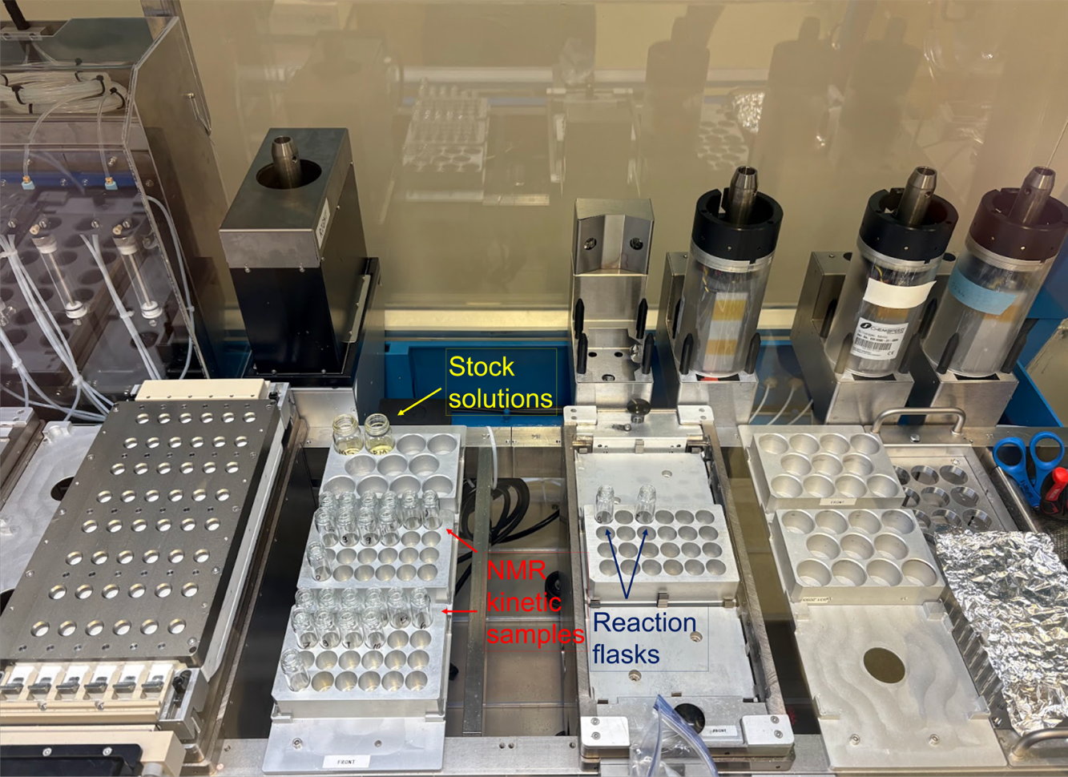

Figure S1. Digital image of the BioPACIFIC MIP Chemspeed Swing XL automated chemistry platform. The system enables benchtop-scale automated workflows for materials discovery, reaction screening, process optimization, and time-resolved studies. Featuring a modular robotic setup with mountable tool heads, the platform facilitates precise reagent handling across photochemical, high-pressure, and temperature-controlled reactors (-40 to 180 °C, up to 100 bar), with reactions conducted in disposable vial formats to ensure reproducibility and flexibility under inert conditions. Chemspeed automated platform configured with 20 mL scintillation vials for stock solutions (top left), 1-dram vials for time-resolved NMR sampling (bottom left), and dedicated reaction vials for batch and incremental polymerizations (right).

B. Synthesis

1. Control: RAFT Polymerization OEGA with BA in Batch and Increment Methods in Toluene

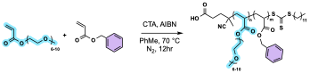
Scheme S1. Synthetic scheme of RAFT polymerization of OEGA and BA in toluene
Purified OEGA (2.73 g, 5.7 mmol), CTA (12.0 mg, 0.03 mmol), AIBN (5.0 mg, 0.03 mmol), and 5 mL of toluene were added into a 20 mL scintillation vial, sealed with a rubber septum and copper wire, and sonicated until dissolved. This is the starting polymer mixture (SPM). BA (48.66mg, 0.30 mmol) and 5 mL of toluene were added into a separate 20 mL scintillation vial, sealed with a rubber septum and copper wire, and sonicated until dissolved. This is the comonomer solution (CS). Both stock solutions were deoxygenated by purging and sparging with N₂ for 10 min. After sparging, the stock solutions, along with forty-eight 7 mL scintillation vials for ¹H NMR aliquots and two 7 mL scintillation vials as reaction vessels, were placed into the Chemspeed system via the antechamber. Once in the antechamber, the antechamber was put under vacuum and then exposed to N₂ gas, this cycle repeated five times to ensure the antechamber was purged of air and under an N₂ environment. Then, everything in the antechamber was transferred into the Chemspeed glove box and placed in their corresponding zones with the rubber septa removed from the stock solutions. The Chemspeed system was programmed to transfer 2.5 mL of SPM into both batch and increment reaction vessels. Following this, 2.5 mL of CS was transferred to the batch reaction vessel. An initial ¹H NMR aliquot was taken from both reaction vessels. For the increment reaction, 250 µL of comonomer stock were added once every 30 minutes for 3.5 hours, starting at time t=0.5 hr and ending at t=4.0 hr. ¹H NMR aliquots of 50 µL were taken automatically by the Chemspeed system from each reaction vessel every 30 minutes. This occurred right before the addition of CS for the increment reaction. The batch and increment reactions ran simultaneously for 12 hr at 70 °C (the Chemspeed heating plate is set to 81°C to achieve this temperature), being shaken during this time to simulate a stirring motion. After the reaction was complete, a final ¹H NMR aliquot was taken from both reaction vessels, the reaction vessels along with the ¹H NMR aliquots and stock solution vials were capped and removed from the Chemspeed system for further analysis.

2. RAFT Polymerization OEGA with FluA

2.1. Batch and Increment Methods in Toluene
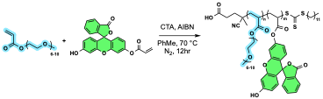
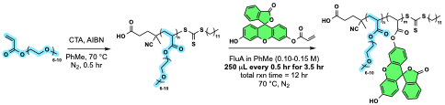
Scheme S2. Synthetic schemes of RAFT polymerization of OEGA and FluA in toluene via batch system (top) and incremental addition (bottom)
Purified OEGA (2.73 g, 5.7 mmol), CTA (11.7 mg, 0.03 mmol), AIBN (4.8 mg, 0.03 mmol), and 5 mL of toluene were added into a 20 mL scintillation vial, sealed with a rubber septum and copper wire, and sonicated until dissolved. This is the SPM. FluA (116.0mg, 0.30 mmol) and 5 mL of toluene were added into a separate 20 mL scintillation vial, sealed with a rubber septum and copper wire, and sonicated until dissolved. This is the CS. Both stock solutions were deoxygenated by purging and sparging with N₂ for 10 min. After sparging, the stock solutions, along with forty-eight 7 mL scintillation vials for ¹H NMR aliquots and two 7 mL scintillation vials as reaction vessels, were placed into the Chemspeed system via the antechamber. Similarly, once in the antechamber, the antechamber was put under vacuum and then exposed to N₂ gas, this cycle was repeated five times to ensure the antechamber was purged of air and under an N₂ environment. Then, everything in the antechamber was transferred into the Chemspeed glove box and placed in their corresponding zones with the rubber septa removed from the stock solutions. The Chemspeed system was programmed to transfer 2.5 mL of SPM into both batch and increment reaction vessels. Following this, 2.5 mL of CS was transferred to the batch reaction vessel. An initial ¹H NMR aliquot was taken from both reaction vessels. For the increment reaction, 250 µL of comonomer stock were added once every 30 minutes for 3.5 hours, starting at time t=0.5 hr and ending at t=4.0 hr. ¹H NMR aliquots of 50 µL were taken automatically by the Chemspeed system from each reaction vessel every 30 minutes. This occurred right before the addition of CS for the increment reaction. The batch and increment reactions ran simultaneously for 12 hr at 70 °C (the Chemspeed heating plate is set to 81°C to achieve this temperature), being shaken during this time to simulate a stirring motion. After the reaction was complete, a final ¹H NMR aliquot was taken from both reaction vessels, the reaction vessels along with the ¹H NMR aliquots and stock solution vials were capped and removed from the Chemspeed system. It should be noted that FluA is not completely soluble in toluene and believed that during the reaction, phase separation occurred, changing the concentration of CS and thus changing the amount of FluA added to both the batch and increment reaction vessels.

2.2. Batch and Increment Methods in THF
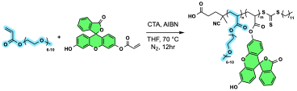
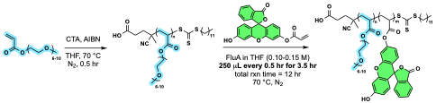
Scheme S3. Synthetic schemes of RAFT polymerization of OEGA and FluA in THF via batch system (top) and incremental addition (bottom)
Because FluA was not completely soluble in toluene, the solvent used to make the stock solutions was switched to THF as FluA has proven to be highly soluble in THF. Purified OEGA (2.73 g, 5.7 mmol), CTA (11.5 mg, 0.03 mmol), AIBN (6.0 mg, 0.04 mmol), and 5 mL of THF were added into a 20 mL scintillation vial, sealed with a rubber septum and copper wire, and sonicated until dissolved. This is the SPM. FluA (114.9mg, 0.30 mmol) and 5 mL of THF were added into a separate 20 mL scintillation vial, sealed with a rubber septum and copper wire, and sonicated until dissolved. This is the CS. Both stock solutions were deoxygenated by purging and sparging with N₂ for 10 min. After sparging, the stock solutions, along with forty-eight 7 mL scintillation vials for ¹H NMR aliquots and two 7 mL scintillation vials as reaction vessels, were placed into the Chemspeed system via the antechamber. Once in the antechamber, the antechamber was put under vacuum and then exposed to N₂ gas, this cycle repeated five times to ensure the antechamber was purged of air and under an N₂ environment. Then, everything in the antechamber was transferred into the Chemspeed glove box and placed in their corresponding zones with the rubber septa removed from the stock solutions. The Chemspeed system was programmed to transfer 2.5 mL of SPM into both batch and increment reaction vessels. Following this, 2.5 mL of CS was transferred to the batch reaction vessel. An initial ¹H NMR aliquot was taken from both reaction vessels. For the increment reaction, 250 µL of comonomer stock were added once every 30 minutes for 3.5 hours, starting at time t=0.5 hr and ending at t=4.0 hr. ¹H NMR aliquots of 50 µL were taken automatically by the Chemspeed system from each reaction vessel every 30 minutes. This occurred right before the addition of CS for the increment reaction. The batch and increment reactions ran simultaneously for 12 hr at 70 °C (the Chemspeed heating plate is set to 81 °C to achieve this temperature), being shaken during this time to simulate a stirring motion. After the reaction was complete, a final ¹H NMR aliquot was taken from both reaction vessels, the reaction vessels along with the ¹H NMR aliquots and stock solution vials were capped and removed from the Chemspeed system. It is important to note that THF has a relatively low boiling point (THF bp = 66 °C) and we observed that solvent evaporated from both stock solutions during the reaction, as well as from the reaction vessels, changing the concentration of the stock solutions and the reaction mixtures, and thus changing the amount of FluA added to both the batch and increment reaction vessels. Additionally, evaporation of THF from the stock solution and reaction mixture hindered the transfer of the stock solution to the reaction vessel and the removal of samples for NMR analysis.

2.3. Batch and Increment Methods in DMF
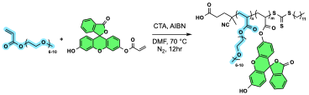
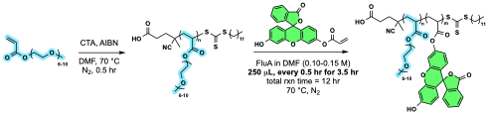
Scheme S4. Synthetic schemes of RAFT polymerization of OEGA and FluA in DMF via batch system (top) and incremental addition (bottom)
Due to THF evaporation during the reaction, the solvent for stock solution preparation was switched to DMF, which has a higher boiling point (153 °C), offers improved stability under reaction conditions, and provides good solubility for FluA. As DMF is harder to remove by evaporation under reduced pressure after the reaction, less solvent was used in the preparation of stock solutions and thus amounts of stock solutions added to reaction vessels were adjusted accordingly to compensate for the change in concentration. Purified OEGA (2.73 g, 5.7 mmol), CTA (12.5 mg, 0.03 mmol), AIBN (4.5 mg, 0.03 mmol), and 2 mL of DMF were added into a 20 mL scintillation vial, sealed with a rubber septum and copper wire, and sonicated until dissolved. This is the SPM. FluA (115.4 mg, 0.30 mmol) and 2.5 mL of DMF were added into a separate 20 mL scintillation vial, sealed with a rubber septum and copper wire, and sonicated until dissolved. This is the CS. Both stock solutions were deoxygenated by purging and sparging with N₂ for 10 min. After sparging, the stock solutions, along with forty-eight 7 mL scintillation vials for ¹H NMR aliquots and two 7 mL scintillation vials as reaction vessels, were placed into the Chemspeed system via the antechamber. Once in the antechamber, the antechamber was put under vacuum and then exposed to N₂ gas, this cycle repeated five times to ensure the antechamber was purged of air and under an N₂ environment. Then, everything in the antechamber was transferred into the Chemspeed glove box and placed in their corresponding zones with the rubber septa removed from the stock solutions. The Chemspeed system was programmed to transfer 1.0 mL of SPM into both batch and increment reaction vessels. Following this, 1.0 mL of CS was transferred to the batch reaction vessel. An initial ¹H NMR aliquot was taken from both reaction vessels. For the increment reaction, 125 µL of comonomer stock were added once every 30 minutes for 3.5 hours, starting at time t=0.5 hr and ending at t=4.0 hr. ¹H NMR aliquots of 50 µL were taken automatically by the Chemspeed system from each reaction vessel every 30 minutes. This occurred right before the addition of CS for the increment reaction. The batch and increment reactions ran simultaneously for 12 hr at 70 °C (the Chemspeed heating plate is set to 81 °C to achieve this temperature), being shaken during this time to simulate a stirring motion. After the reaction was complete, a final ¹H NMR aliquot was taken from both reaction vessels, the reaction vessels along with the ¹H NMR aliquots and stock solution vials were capped and removed from the Chemspeed system.

2.4. Continuous Flow Method in THF
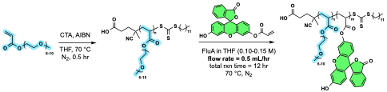

Scheme S5. Synthetic scheme of RAFT polymerization of OEGA and FluA in THF via continuous flow
Purified OEGA (1.36 g, 2.84 mmol), CTA (6.8 mg, 0.017 mmol), AIBN (3.0 mg, 0.018 mmol), and 2.5 mL of THF were added into a 20 mL scintillation vial, sealed with a rubber septum and copper wire, and sonicated until dissolved. This is the SPM. FluA (57.2 mg, 0.15 mmol) and 2.5 mL of THF were added into a separate 20 mL scintillation vial, sealed with a rubber septum and copper wire, and sonicated until dissolved. This is the CS. Both stock solutions were deoxygenated by purging and sparging with N₂ for 10 min. After sparging, the stock solutions, along with six 7 mL scintillation vials for ¹H NMR aliquots and one 7 mL scintillation vial that are acting as a reaction vessel, were placed into the Chemspeed system via the antechamber. Once in the antechamber, the antechamber was put under vacuum and then exposed to N₂ gas, this cycle repeated five times to ensure the antechamber was purged of air and under an N₂ environment. Then, everything in the antechamber was transferred into the Chemspeed glove box and placed in their corresponding zones with the rubber septa removed from the stock solutions. The Chemspeed system was programmed to transfer 3.0 mL of SPM into the reaction vessel. An initial ¹H NMR aliquot was taken from both reaction vessels. The CS was added to the reaction vessel at a rate of at 0.5 mL/hr for 2 hours starting at time t=0.5 hr and ending at t=2.5 hr. The addition of CS was supposed to occur for 4 hours for a total of 2.0 mL CS transferred, but the Chemspeed was initially paused to take first ¹H NMR aliquot, and unaware to the users at the time, Chemspeed cannot be paused mid-task. Thus, the programming was never resumed after the addition of the first 1.0 mL. The syringe used to transfer the CS is a 1.0 mL syringe and thus two syringefuls are needed to complete the flow. Therefore, the transfer is not completely continuous as the needle must reload after the addition of the first mL of CS, hence the two separate tasks and why the second mL was not added when the first task was paused. The reaction ran for 12 hr at 70 °C (the Chemspeed heating plate is set to 81°C to achieve this temperature), being shaken during this time to simulate a stirring motion. ¹H NMR aliquots were taken manually every hour for the first five hours of the reaction. When doing this, the shaking must be paused momentarily to take the aliquot and then is started again after the aliquot has been taken. After the reaction was complete, a final ¹H NMR aliquot was taken from the reaction vessel, the reaction vessel along with the ¹H NMR aliquots and stock solution vials were capped and removed from the Chemspeed system.

2.5. Continuous Flow Method in DMF
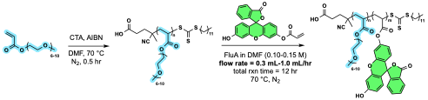
Scheme S6. Synthetic scheme of RAFT polymerization of OEGA and FluA in DMF via continuous flow
Flow rate: 0.3mL/hr. Due to THF evaporation during the reaction, the solvent for stock solution preparation was switched to DMF, which has a higher boiling point (153 °C), offers improved stability under reaction conditions, and provides good solubility for FluA. As DMF is harder to remove, less solvent was used in the preparation of stock solutions and thus amounts of stock solutions added to reaction vessels were adjusted accordingly to compensate for the change in concentration. Purified OEGA (1.36 g, 2.84 mmol), CTA (5.7 mg, 0.014 mmol), AIBN (2.9 mg, 0.017 mmol), and 1.25 mL of DMF were added into a 20 mL scintillation vial, sealed with a rubber septum and copper wire, and sonicated until dissolved. This is the SPM. FluA (57.2 mg, 0.15 mmol) and 1.25 mL of DMF were added into a separate 20 mL scintillation vial, sealed with a rubber septum and copper wire, and sonicated until dissolved. This is the CS. Both stock solutions were deoxygenated by purging and sparging with N₂ for 10 min. After sparging, the stock solutions, along with six 7 mL scintillation vials for ¹H NMR aliquots and one 7 mL scintillation vial that are acting as reaction vessels, were placed into the Chemspeed system via the antechamber. Once in the antechamber, the antechamber was put under vacuum and then exposed to N₂ gas, this cycle repeated five times to ensure the antechamber was purged of air and under an N₂ environment. Then, everything in the antechamber was transferred into the Chemspeed glove box and placed in their corresponding zones with the rubber septa removed from the stock solutions. The Chemspeed system was programmed to transfer 1.5 mL of SPM into the reaction vessel. An initial ¹H NMR aliquot was taken from both reaction vessels. The CS was added to the reaction vessel at a rate of at 0.3 mL/hr for 3.3 hr starting at time t=0 hr and ending at t=3.3 hr. The addition of CS was supposed to begin at 0.5 hr, but the Chemspeed was miscoded, and addition began after the first 5 seconds. Thus, FluA was added from the beginning and there was no initial OEGA block as intended. This coding error, unaware to users at the time, was fixed for subsequent continuous flow reactions. The reaction ran for 22 hours at 70 °C (the Chemspeed heating plate is set to 81 °C to achieve this temperature), being shaken during this time to simulate a stirring motion. ¹H NMR aliquots were taken manually every hour for the first five hours of the reaction. When doing this, the shaking must be paused momentarily to take the aliquot and then is started again after the aliquot has been taken. After the reaction was complete, a final ¹H NMR aliquot was taken from the reaction vessel, the reaction vessel along with the ¹H NMR aliquots and stock solution vials were capped and removed from the Chemspeed system. It should be noted that the reaction was intended to run for 12 hours. However, the programming got stuck in a loop and was unable to stop after 12 hours had surpassed. Again, this coding error, unaware to users at the time, was fixed for subsequent continuous flow reactions.

Flow rate: 0.4mL/hr. The continuous flow reaction in DMF was repeated at a faster addition rate. It should be noted that an addition of 0.3mL/hr is the slowest rate of addition the Chemspeed system is capable of and thus any change in addition rate would be an increase in addition rate. Purified OEGA (1.36 g, 2.84 mmol), CTA (6.7 mg, 0.017 mmol), AIBN (2.2 mg, 0.013 mmol), and 1.25 mL of DMF were added into a 20 mL scintillation vial, sealed with a rubber septum and copper wire, and sonicated until dissolved. This is the SPM. FluA (59.0 mg, 0.15 mmol) and 1.25mL of DMF were added into a separate 20 mL scintillation vial, sealed with a rubber septum and copper wire, and sonicated until dissolved. This is the CS. Both stock solutions were deoxygenated by purging and sparging with N₂ for 10 min. After sparging, the stock solutions, along with six 7 mL scintillation vials for ¹H NMR aliquots and one 7 mL scintillation vial that are acting as reaction vessels, were placed into the Chemspeed system via the antechamber. Once in the antechamber, the antechamber was put under vacuum and then exposed to N₂ gas, this cycle repeated five times to ensure the antechamber was purged of air and under an N₂ environment. Then, everything in the antechamber was transferred into the Chemspeed glove box and placed in their corresponding zones with the rubber septa removed from the stock solutions. The Chemspeed system was programmed to transfer 1.5 mL of SPM into the reaction vessel. An initial ¹H NMR aliquot was taken from both reaction vessels. The CS was added to the reaction vessel at a rate of at 0.4 mL/hr for 2.5 hours starting at time t=0.5 hr and ending at t=3.0 hr. The reaction ran for 12 hours at 70 °C (the Chemspeed heating plate is set to 81 °C to achieve this temperature), being shaken during this time to simulate a stirring motion. ¹H NMR aliquots were taken manually every hour for the first five hours of the reaction. When doing this, the shaking must be paused momentarily to take the aliquot and then is started again after the aliquot has been taken. After the reaction was complete, a final ¹H NMR aliquot was taken from the reaction vessel, the reaction vessel along with the ¹H NMR aliquots and stock solution vials were capped and removed from the Chemspeed system.

Flow rate: 0.5mL/hr. The continuous flow reaction in DMF was repeated at an even faster addition rate. Purified OEGA (1.36 g, 2.84 mmol), CTA (6.8 mg, 0.017 mmol), AIBN (3.4 mg, 0.02 mmol), and 1.25 mL of DMF were added into a 20 mL scintillation vial, sealed with a rubber septum and copper wire, and sonicated until dissolved. This is the SPM. FluA (57.0 mg, 0.15 mmol) and 1.25 mL of DMF were added into a separate 20 mL scintillation vial, sealed with a rubber septum and copper wire, and sonicated until dissolved. This is the CS. Both stock solutions were deoxygenated by purging and sparging with N₂ for 10 min. After sparging, the stock solutions, along with six 7 mL scintillation vials for ¹H NMR aliquots and one 7 mL scintillation vial that are acting as reaction vessels, were placed into the Chemspeed system via the antechamber. Once in the antechamber, the antechamber was put under vacuum and then exposed to N₂ gas, this cycle repeated five times to ensure the antechamber was purged of air and under an N₂ environment. Then, everything in the antechamber was transferred into the Chemspeed glove box and placed in their corresponding zones with the rubber septa removed from the stock solutions. The Chemspeed system was programmed to transfer 1.5 mL of SPM into the reaction vessel. An initial ¹H NMR aliquot was taken from both reaction vessels. The CS was added to the reaction vessel at a rate of at 0.5 mL/hr for 2 hours starting at time t=0.5 hr and ending at t=2.5 hr. The reaction ran for 12 hours at 70 °C (the Chemspeed heating plate is set to 81 °C to achieve this temperature), being shaken during this time to simulate a stirring motion. ¹H NMR aliquots were taken manually every hour for the first five hours of the reaction. When doing this, the shaking must be paused momentarily to take the aliquot and then is started again after the aliquot has been taken. After the reaction was complete, a final ¹H NMR aliquot was taken from the reaction vessel, the reaction vessel along with the ¹H NMR aliquots and stock solution vials were capped and removed from the Chemspeed system.

Flow rate: 1.0mL/hr. The continuous flow reaction at a rate of 0.5 mL/hr was scaled up by a factor of two. Thus, the rate of addition was changed to 1.0 mL/hr to account for this. Purified OEGA (2.73 g, 5.7 mmol), CTA (11.8 mg, 0.03 mmol), AIBN (6.3 mg, 0.04 mmol), and 2.5 mL of DMF were added into a 20 mL scintillation vial, sealed with a rubber septum and copper wire, and sonicated until dissolved. This is the SPM. FluA (117.2 mg, 0.20 mmol) and 2.5 mL of DMF were added into a separate 20 mL scintillation vial, sealed with a rubber septum and copper wire, and sonicated until dissolved. This is the CS. Both stock solutions were deoxygenated by purging and sparging with N₂ for 10 min. After sparging, the stock solutions and one 7 mL scintillation vial that is acting as reaction vessels, were placed into the Chemspeed system via the antechamber. Once in the antechamber, the antechamber was put under vacuum and then exposed to N₂ gas, this cycle repeated five times to ensure the antechamber was purged of air and under an N₂ environment. Then, everything in the antechamber was transferred into the Chemspeed glove box and placed in their corresponding zones with the rubber septa removed from the stock solutions. The reaction vessel was capped to test Chemspeed’s ability to perform under closed environments. The Chemspeed system was programmed to transfer 3.0 mL of SPM into the reaction vessel. An initial ¹H NMR aliquot was taken from both reaction vessels. The CS was added to the reaction vessel at a rate of at 1.0 mL/hr for 2 hours starting at time t=0.5 hr and ending at t=2.5 hr. The reaction ran for 12 hours at 70 °C (the Chemspeed heating plate is set to 81 °C to achieve this temperature), being shaken during this time to simulate a stirring motion. Because of the cap, it was too difficult to take ¹H NMR aliquots manually every hour. Additionally, when capped, the shaking cannot occur as the cap must be stationary to not break the injection needle. Thus, the reaction was completed without any shaking. After the reaction was complete, a final ¹H NMR aliquot was taken from the reaction vessel, and the reaction vessel along and stock solution vials were capped and removed from the Chemspeed system.

Purification. The p(OEGA-co-FluA) polymers synthesized in DMF (this includes via batch, increment, and continuous flow at 0.3 mL/hr, 0.4 mL/hr, 0.5 mL/hr, and 1 mL/hr) were purified as followed. The obtained copolymers were washed with hexanes and redissolved in MeOH three times to ensure the complete removal of DMF. It should be noted that the copolymer synthesized via continuous flow at 1.0 mL/hr experienced some cloudiness when redissolved. It is believed this is due to some unreacted FluA that remained. Our previous work has shown the difficulty of removing unreacted FluA, as traditional methods, such as precipitation in a poor solvent which is used here, is impractical and insufficient due to similar solubility profiles of FluA and p(OEGA-co-FluA) in various organic solvents, dialysis has challenges related to scalability and the prolonged duration required for the process, and silica column chromatography results in a significant portion of the fluorescent polymer remained trapped at the top of the column. It is possible this is because of the scale of the reaction and that the Chemspeed system is better suited for smaller scale reactions. After purification, a final ¹H NMR was taken of each sample to confirm purification. The p(OEGA-co-FluA) polymers synthesized in PhMe (this includes via batch and increment) were purified similariy, washing with hexanes and redissolving in THF three times to ensure the complete removal of PhMe. The remaining p(OEGA-co-FluA) polymers (this includes batch and increment synthesized in both PhMe and THF) were not purified as the solvents were deemed not optimal in synthesis via Chemspeed.

Table S1. The final compositions of P(OEGA-co-FluA) polymers synthesized via different Chemspeed techniques with a FluA feed ratio of 10 mol%.
Method | OEGA (mol%) |  | FluA (mol%)
Batch |  | 91.6 | 8.4
Increment |  | 84.8 | 15.2
Continuous flow
0.3 mL/hr |  | 94.9 | 5.1
0.4 mL/hr |  | 92.8 | 7.2
0.5 mL/hr |  | 93.8 | 6.2
1.0 mL/hr |  | 95.0 | 5.0

C. Characterization

1. Nuclear Magnetic Resonance (NMR) Analysis

1.1. P(OEGA-co-BA) Copolymer

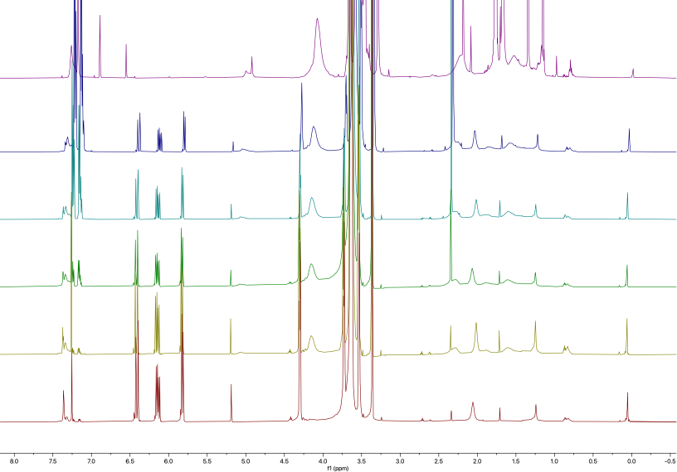

Figure S2. Overlayed ¹H NMR spectra of P(OEGA-co-BA) in CDCl₃ via batch RAFT polymerization in toluene. Aliquots collected every half hour, followed by a final sample taken after purification.
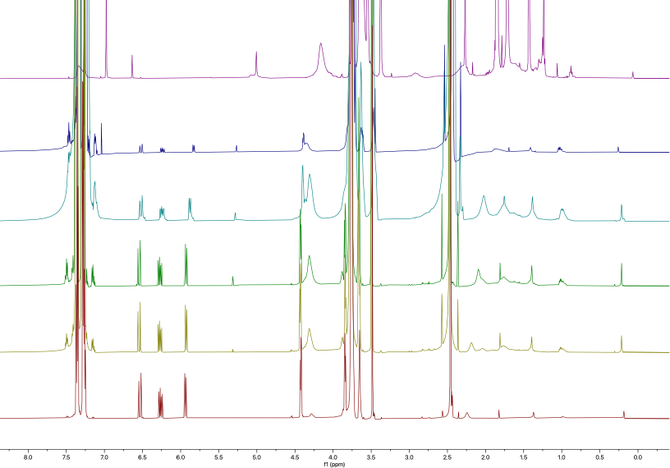

Figure S3. Overlayed ¹H NMR spectra of p(OEGA-co-BA) in CDCl₃ via increment RAFT polymerization in toluene. Aliquots collected every half hour, followed by a final sample taken after purification.

2.1. P(OEGA-co-FluA) Copolymer
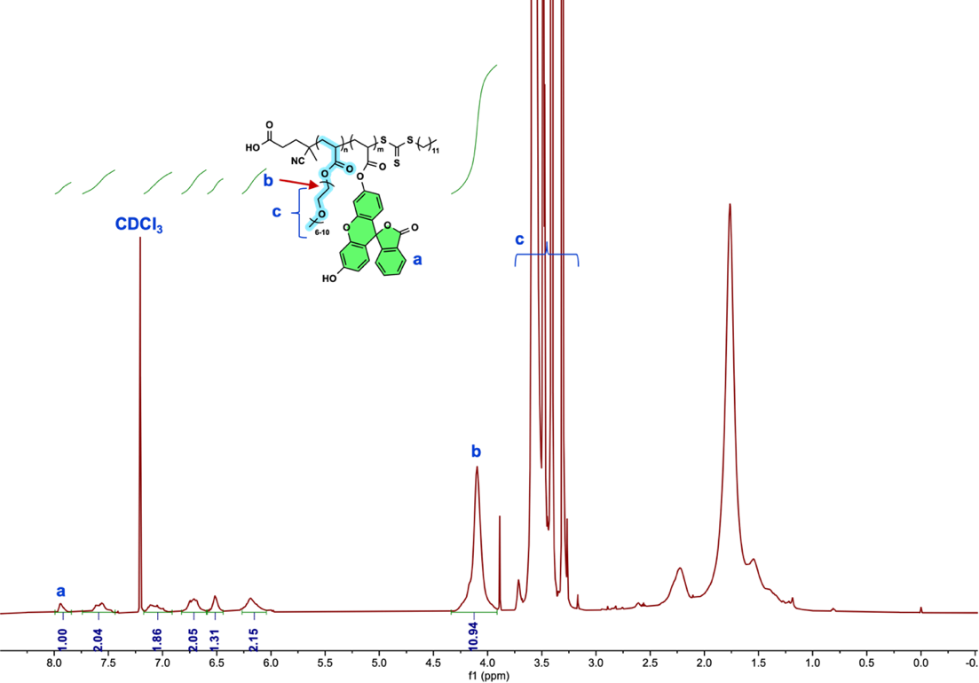

Figure S4. 1H NMR spectrum of P(OEGA-co-FluA) copolymer via RAFT polymerization after purification in CDCl₃.

Batch System in PhMe
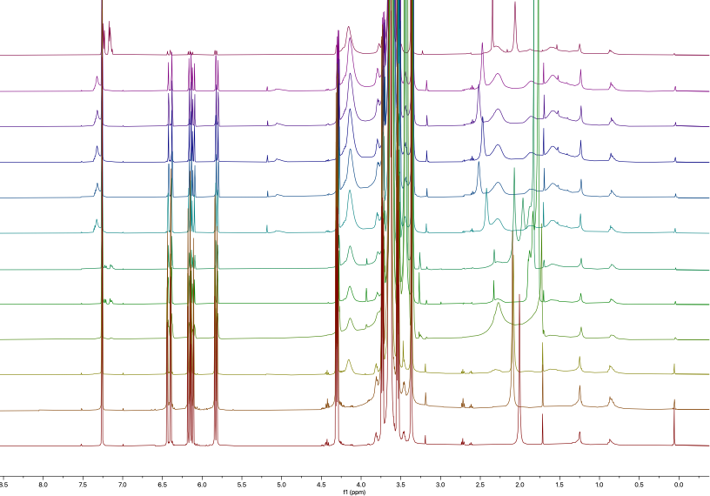

Figure S5. Overlayed ¹H NMR spectra of P(OEGA-co-FluA) in CDCl₃ via batch RAFT polymerization in toluene. Aliquots collected every half hour, followed by a final sample taken after purification.

Incremental Addition in PhMe
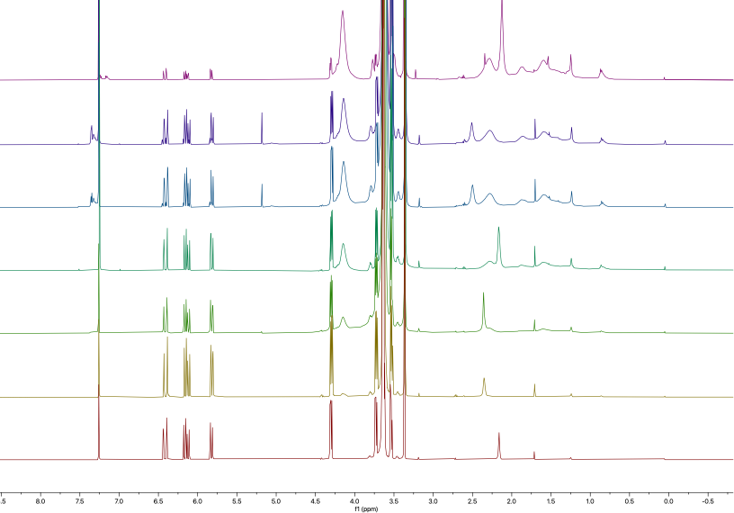

Figure S6. Overlayed ¹H NMR spectra of P(OEGA-co-FluA) in CDCl₃ via increment RAFT polymerization in toluene. Aliquots collected every half hour, followed by a final sample taken after purification.

Batch System in THF
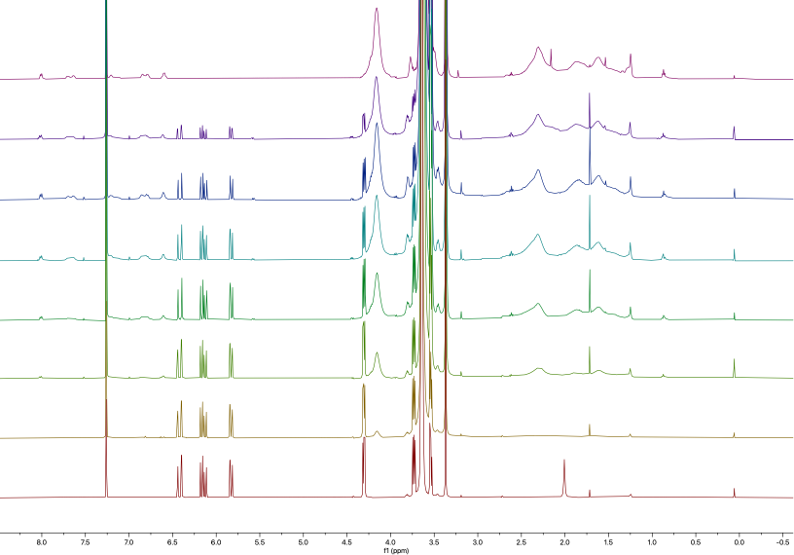

Figure S7. Overlayed ¹H NMR spectra of P(OEGA-co-FluA) in CDCl₃ via batch RAFT polymerization in THF. Aliquots collected every half hour, followed by a final sample taken after purification.

Incremental Addition in THF
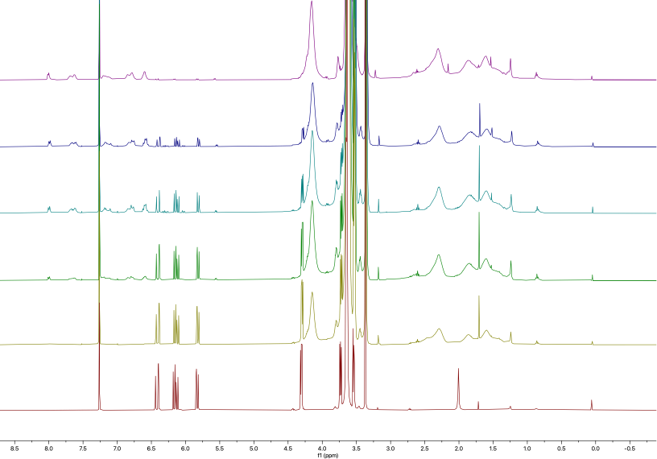

Figure S8. Overlayed ¹H NMR spectra of P(OEGA-co-FluA) in CDCl₃ via increment RAFT polymerization in THF. Aliquots collected every half hour, followed by a final sample taken after purification.

Batch System in DMF
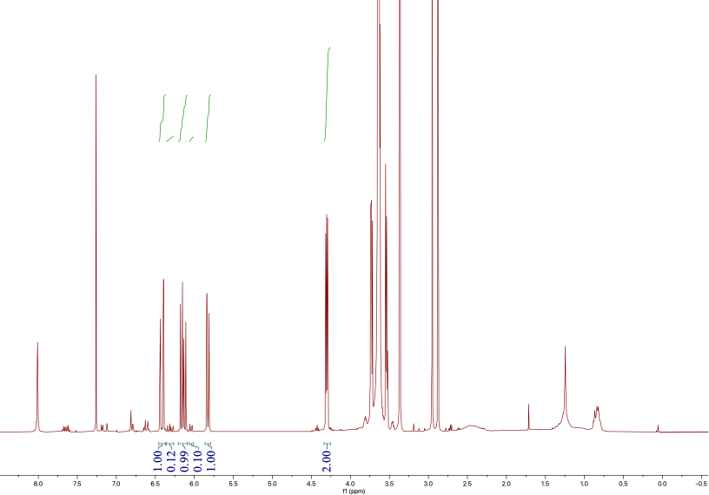
Figure S9. ¹H NMR spectrum of p(OEGA-co-FluA) via batch RAFT polymerization in DMF at time t=0 hr in CDCl₃.
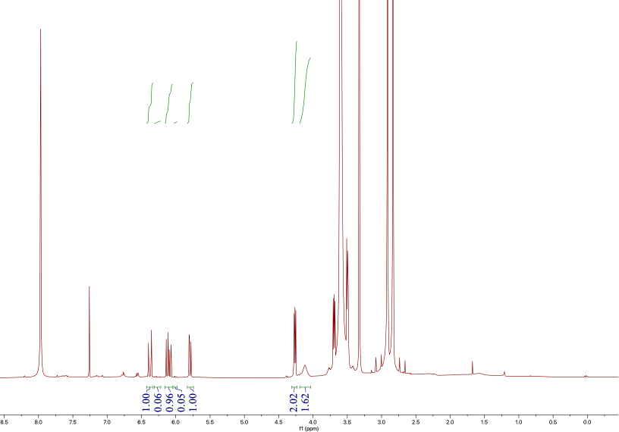
Figure S10. ¹H NMR spectrum of p(OEGA-co-FluA) via batch RAFT polymerization at time t=0.5 hr in CDCl₃.
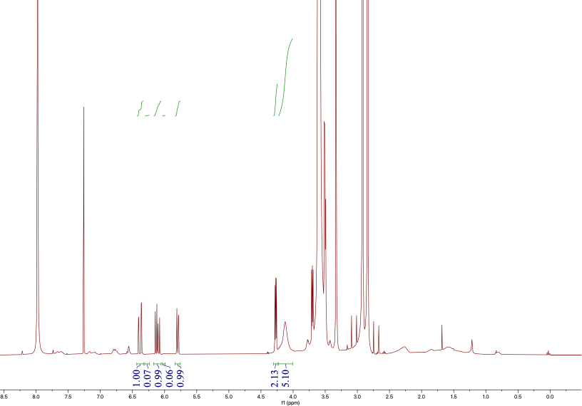
Figure S11. ¹H NMR spectrum of p(OEGA-co-FluA) via batch RAFT polymerization at time t=1 hr in CDCl₃.
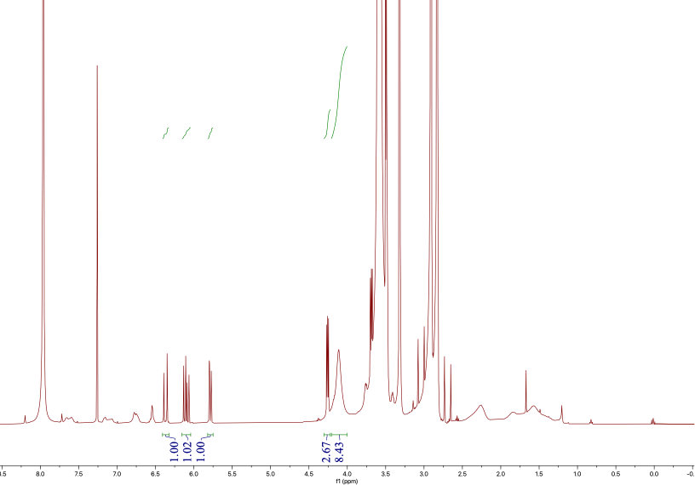
Figure S12. ¹H NMR spectra of p(OEGA-co-FluA) via batch RAFT polymerization at time t=1.5 hr in CDCl₃.
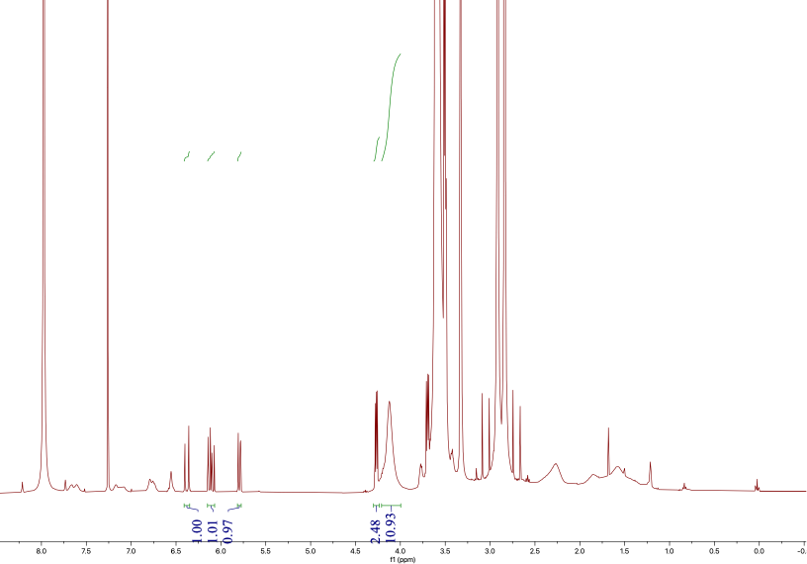
Figure S13. ¹H NMR spectrum of p(OEGA-co-FluA) via batch RAFT polymerization at time t=2 hr in CDCl₃.
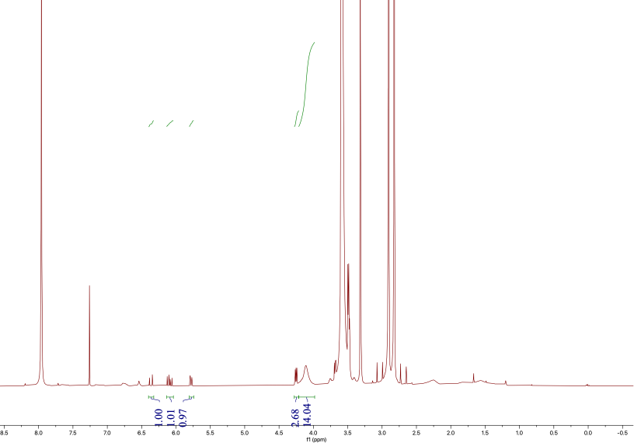
Figure S14. ¹H NMR spectrum of p(OEGA-co-FluA) via batch RAFT polymerization at time t=2.5 hr in CDCl₃.
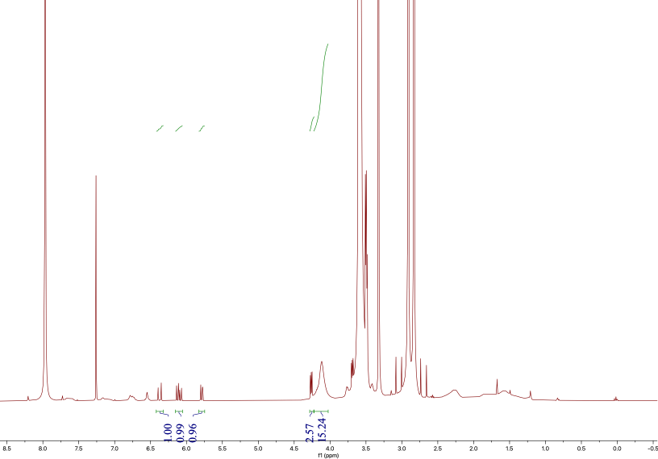
Figure S15. ¹H NMR spectrum of p(OEGA-co-FluA) via batch RAFT polymerization at time t=3 hr in CDCl₃.
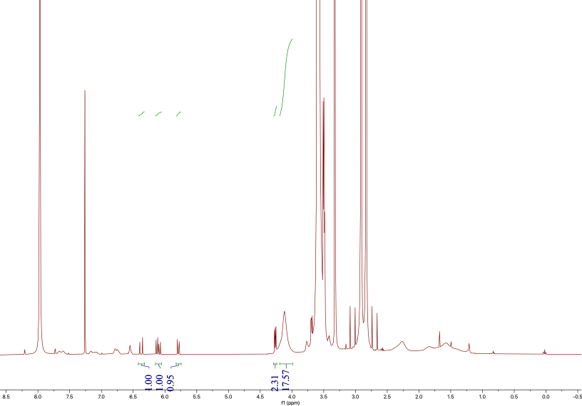
Figure S16. ¹H NMR spectrum of p(OEGA-co-FluA) via batch RAFT polymerization at time t=3.5 hr in CDCl₃.
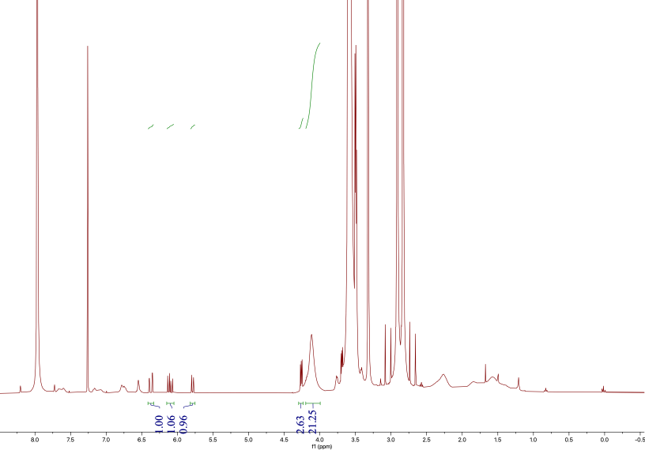
Figure S17. ¹H NMR spectrum of p(OEGA-co-FluA) via batch RAFT polymerization at time t=4 hr in CDCl₃.
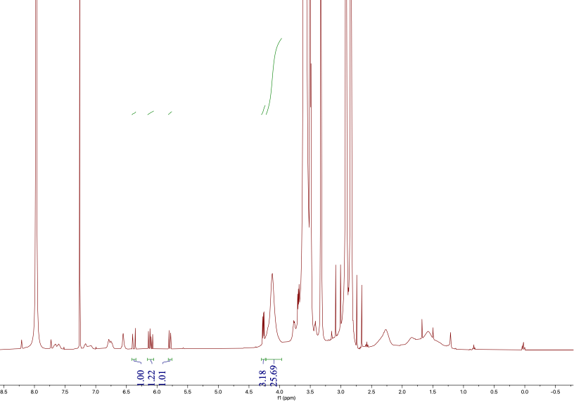
Figure S18. ¹H NMR spectrum of p(OEGA-co-FluA) via batch RAFT polymerization at time t=4.5 hr in CDCl₃.
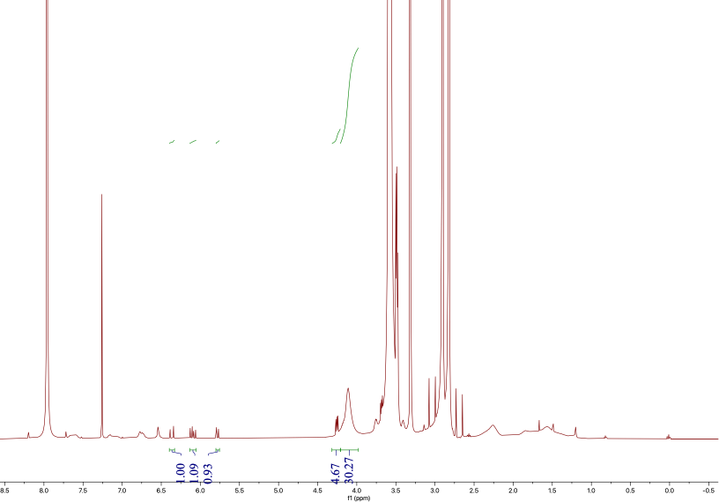
Figure S19. ¹H NMR spectrum of p(OEGA-co-FluA) via batch RAFT polymerization at time t=5 hr in CDCl₃.
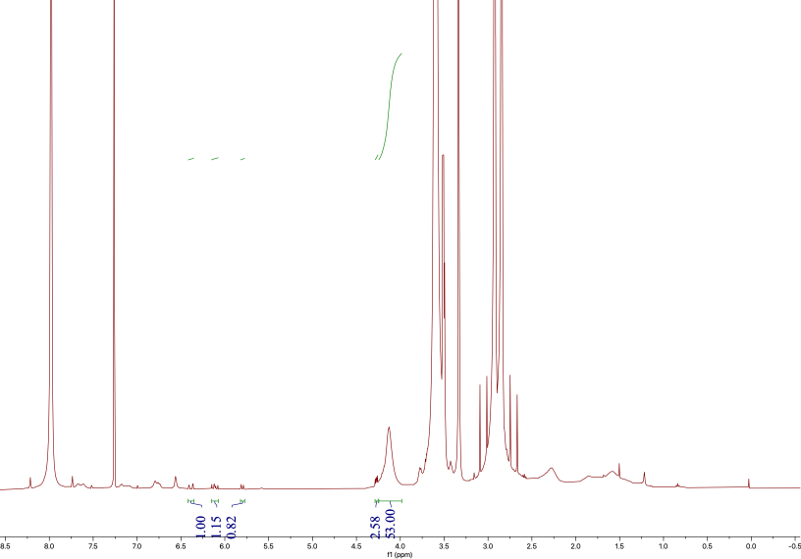
Figure S20. ¹H NMR spectrum of p(OEGA-co-FluA) via batch RAFT polymerization after reaction completion in CDCl₃.
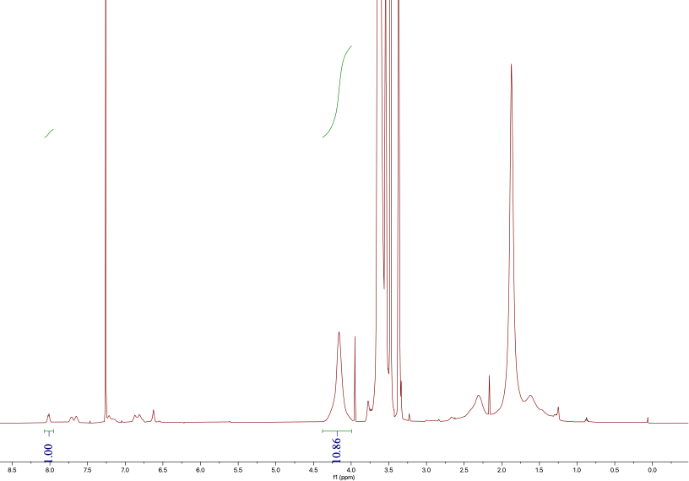

Figure S21. ¹H NMR spectrum of p(OEGA-co-FluA) via batch RAFT polymerization after purification in CDCl₃.
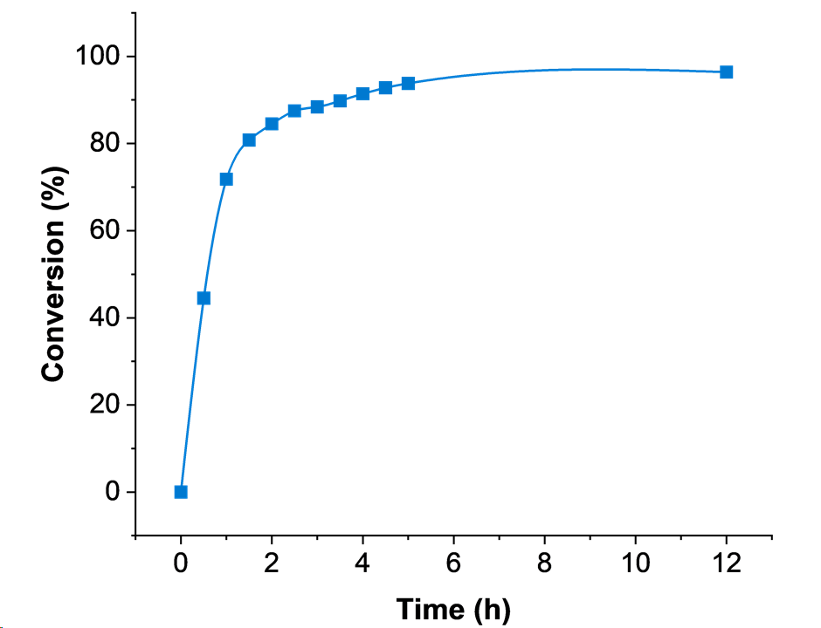
Figure S22. Conversion vs. time plot for batch RAFT polymerization in DMF
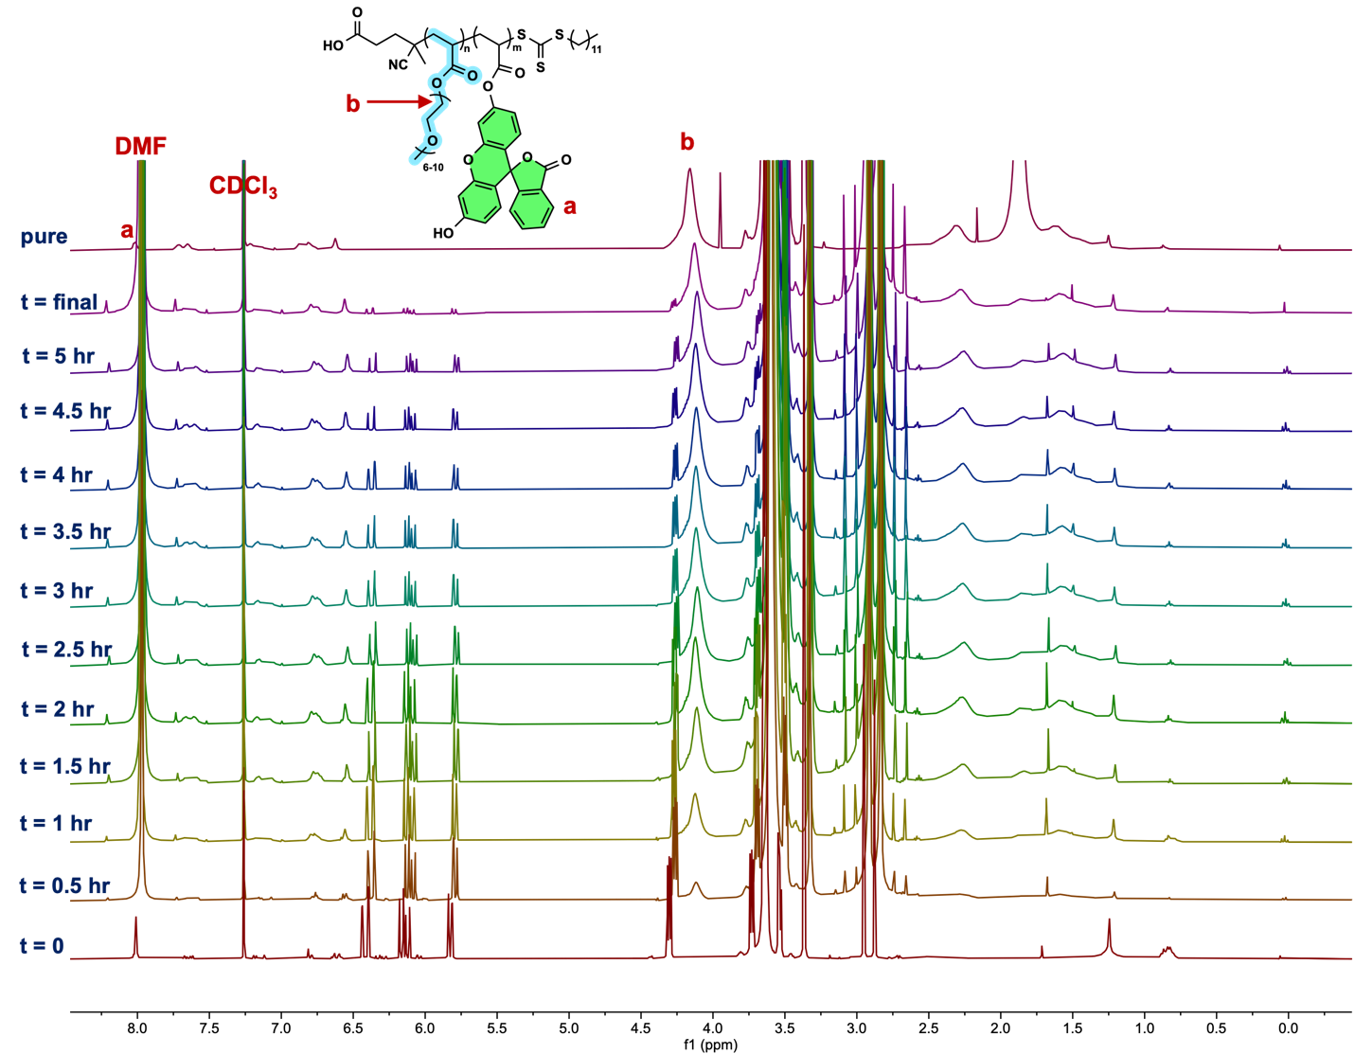

Figure S23. Overlayed ¹H NMR spectra of P(OEGA-co-FluA) via RAFT polymerization in a batch. From bottom to top: aliquots collected every half hour from t = 0 to t = 10 hours, followed by a final kinetic sample post-reaction, and a final sample taken after purification.

Incremental Addition in DMF
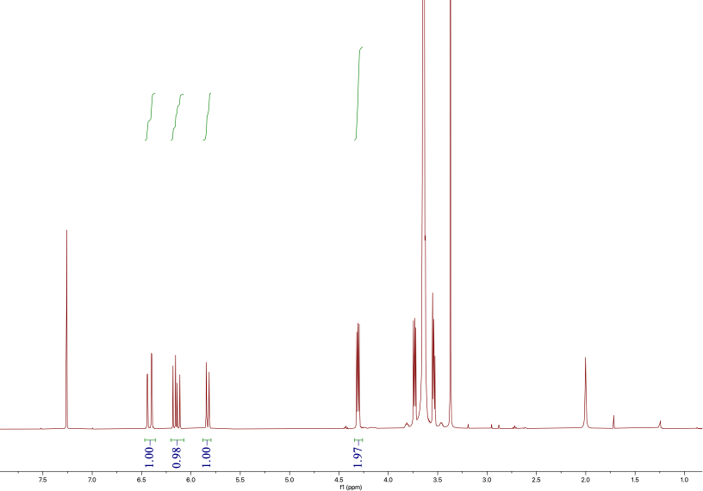
Figure S24. ¹H NMR spectrum of p(OEGA-co-FluA) via increment RAFT polymerization at time t=0 hr in CDCl₃.
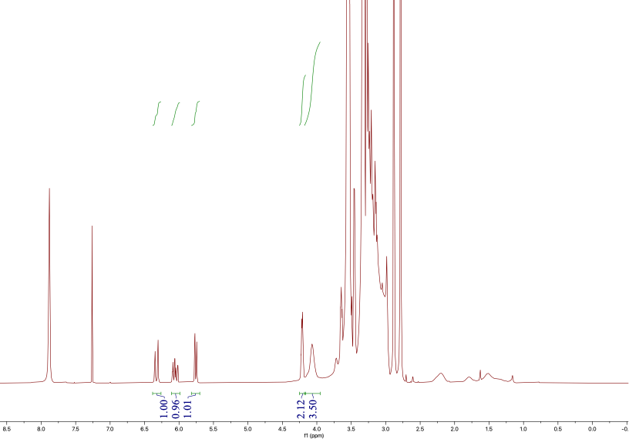
Figure S25. ¹H NMR spectrum of p(OEGA-co-FluA) via increment RAFT polymerization at time t=0.5 hr in CDCl₃.
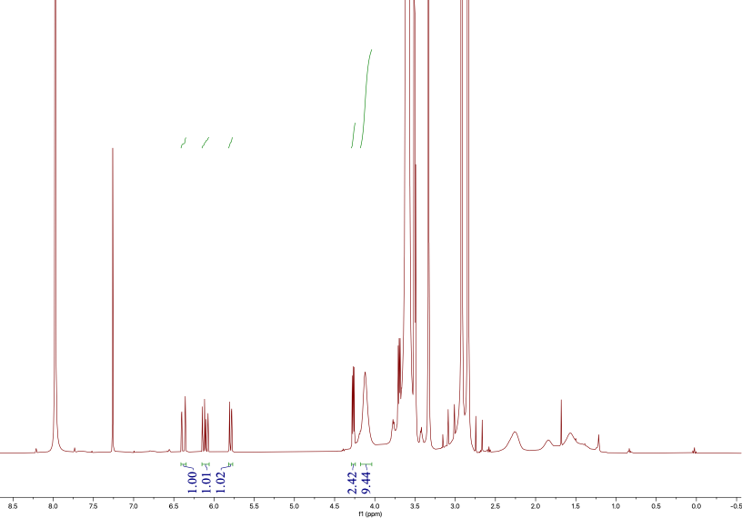
Figure S26. ¹H NMR spectrum of p(OEGA-co-FluA) via increment RAFT polymerization at time t=1 hr in CDCl₃.
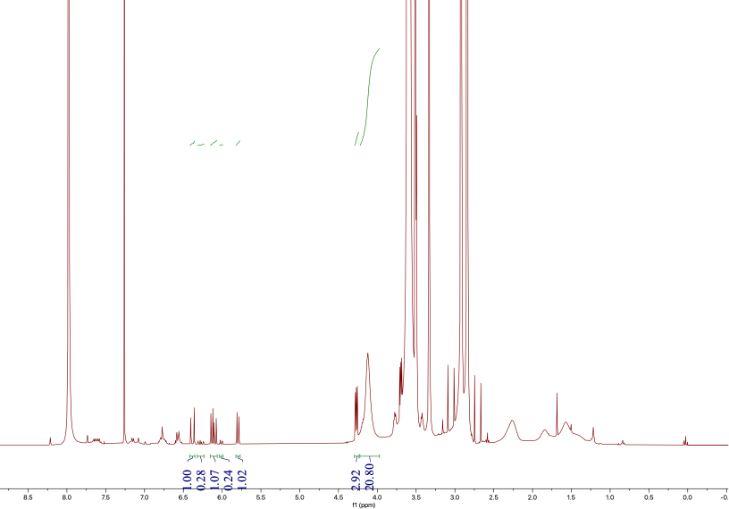
Figure S27. ¹H NMR spectrum of p(OEGA-co-FluA) via increment RAFT polymerization at time t=2 hr in CDCl₃.
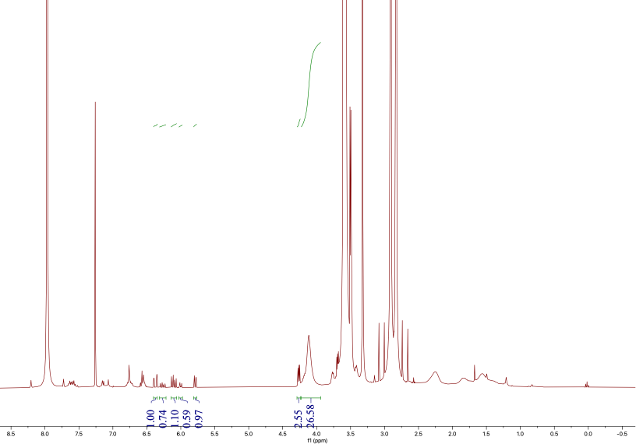
Figure S28. ¹H NMR spectrum of p(OEGA-co-FluA) via increment RAFT polymerization at time t=3 hr in CDCl₃.
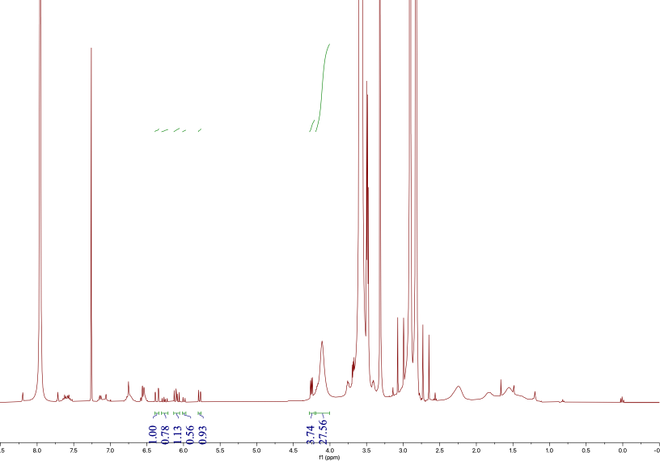
Figure S29. ¹H NMR spectrum of p(OEGA-co-FluA) via increment RAFT polymerization at time t=4 hr in CDCl₃.
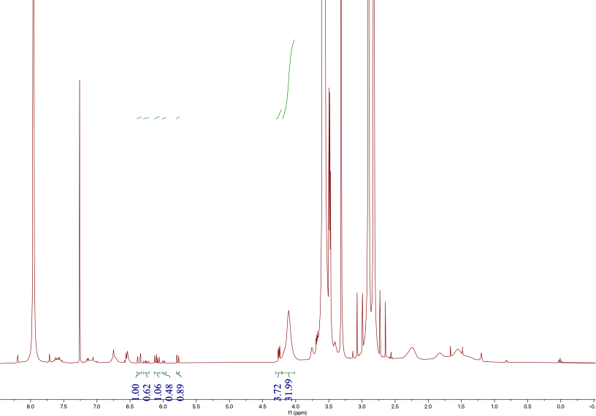
Figure S30. ¹H NMR spectrum of p(OEGA-co-FluA) via increment RAFT polymerization at time t=5 hr in CDCl₃.
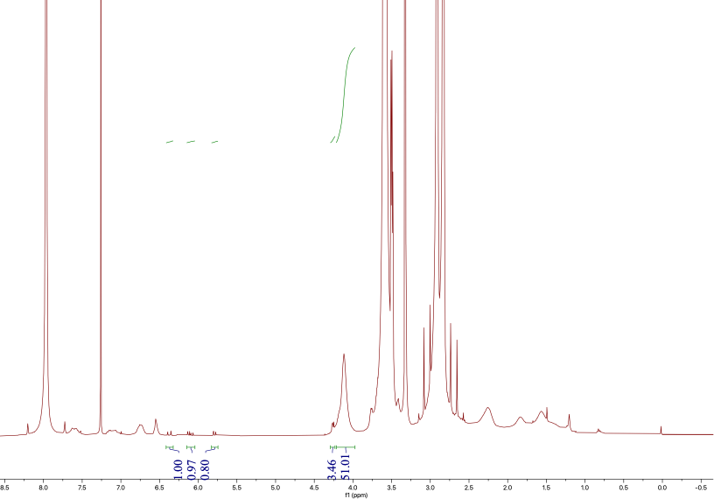
Figure S31. ¹H NMR spectrum of p(OEGA-co-FluA) via increment RAFT polymerization after reaction completion in CDCl₃.
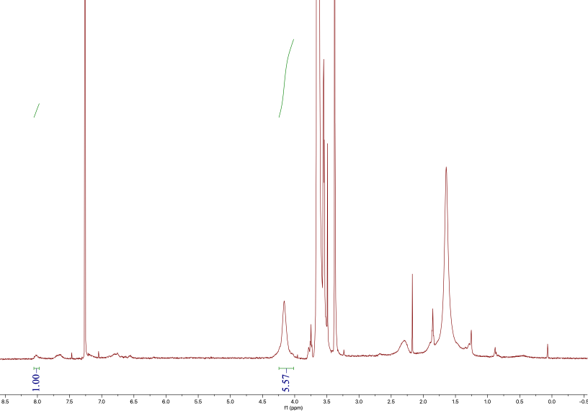

Figure S32. ¹H NMR spectrum of p(OEGA-co-FluA) via increment RAFT polymerization after purification in CDCl₃.
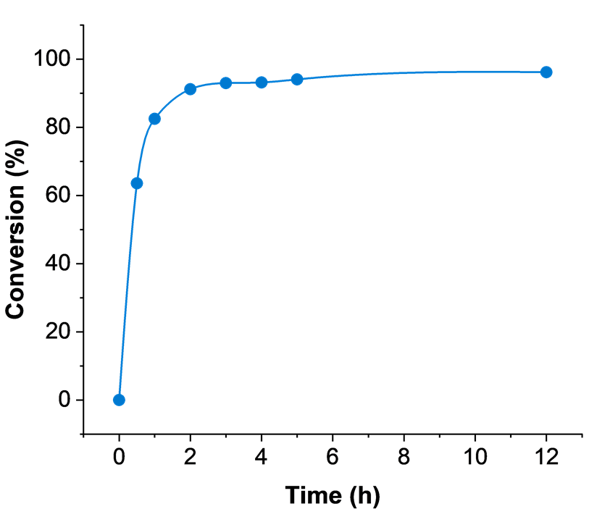
Figure S33. Conversion vs. time plot for incremental RAFT polymerization in DMF
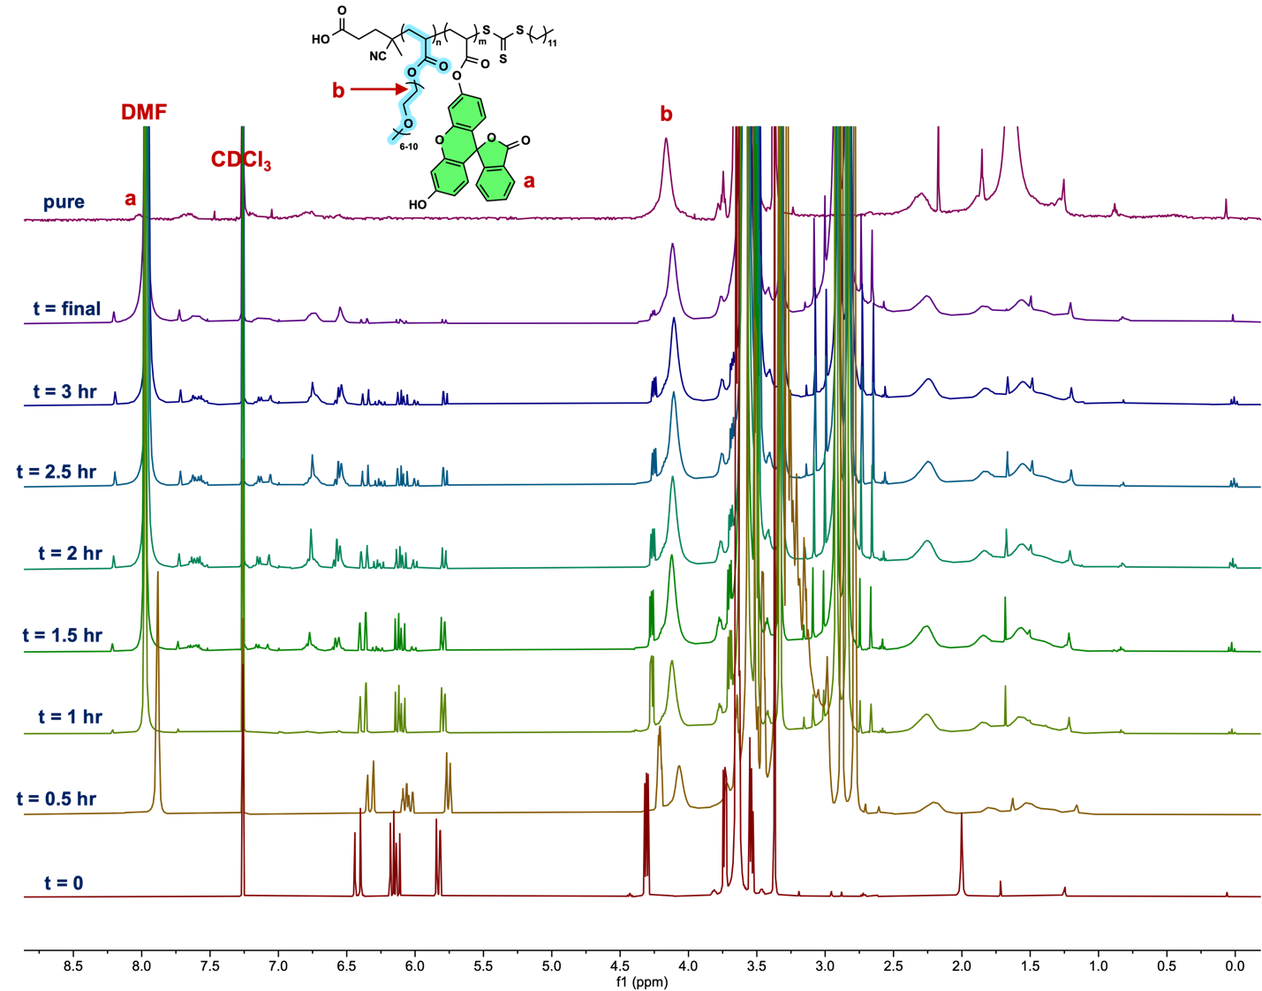

Figure S34. Overlayed ¹H NMR spectra of p(OEGA-co-FluA) via increment RAFT polymerization with kinetic samples, from bottom to top, taken at time from t = 0 to t = 3 hours, and at every following hour to time t=5hr, a final kinetic sample taken after the reaction was completed, and a sample taken after purification in CDCl₃.

Continuous Flow Addition - 0.3 mL/hour
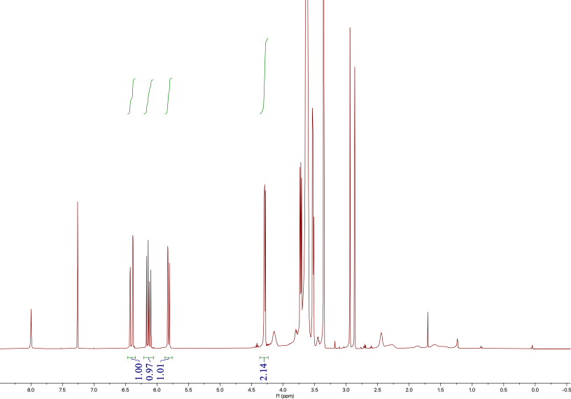
Figure S35. ¹H NMR spectrum of p(OEGA-co-FluA) via continuous flow RAFT polymerization at a rate of 0.3 mL/hr at time t=0 hr in CDCl₃.
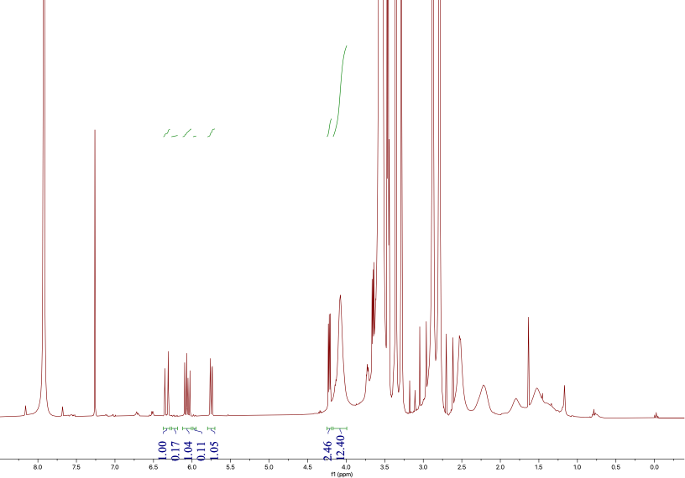
Figure S36. ¹H NMR spectrum of p(OEGA-co-FluA) via continuous flow RAFT polymerization at a rate of 0.3 mL/hr at time t=1 hr in CDCl₃.
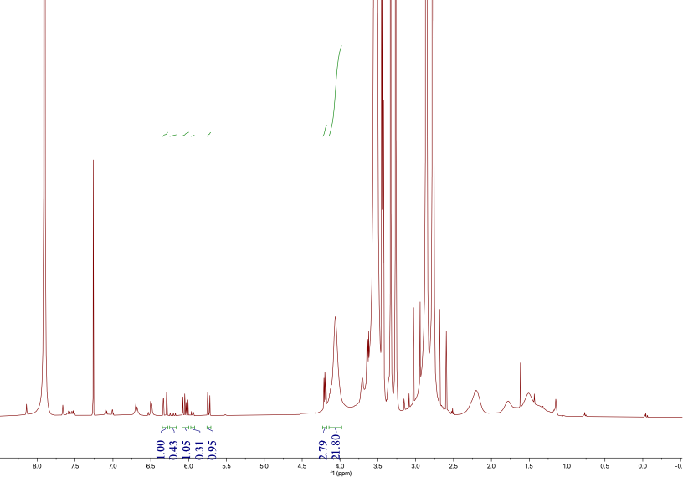
Figure S37. ¹H NMR spectrum of p(OEGA-co-FluA) via continuous flow RAFT polymerization at a rate of 0.3 mL/hr at time t=2 hr in CDCl₃.
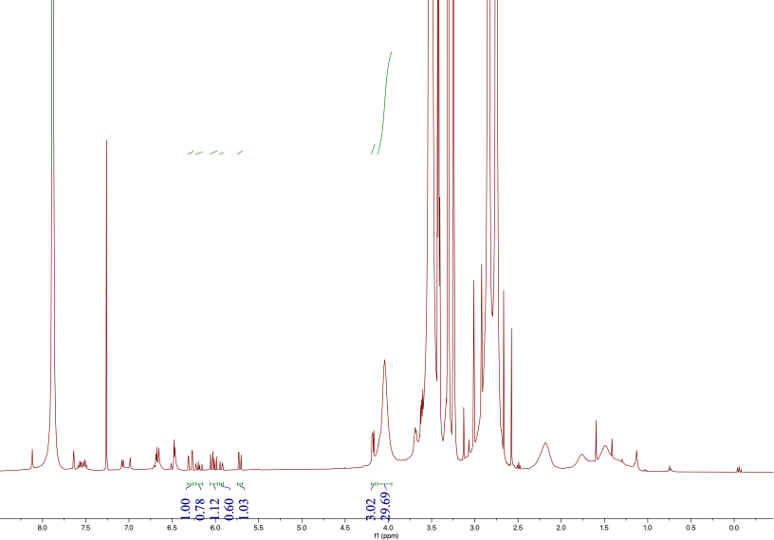
Figure S38. ¹H NMR spectrum of p(OEGA-co-FluA) via continuous flow RAFT polymerization at a rate of 0.3 mL/hr at time t=3 hr in CDCl₃.
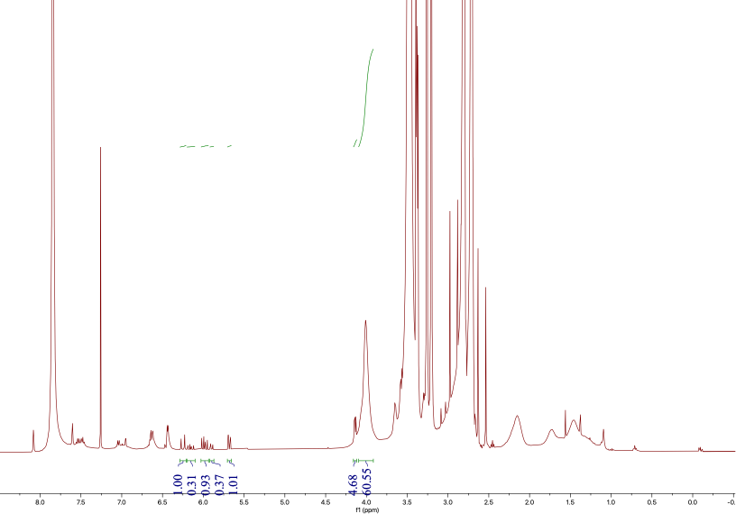
Figure S39. ¹H NMR spectrum of p(OEGA-co-FluA) via continuous flow RAFT polymerization at a rate of 0.3 mL/hr at time t=4 hr in CDCl₃.
Figure S40. ¹H NMR spectrum of p(OEGA-co-FluA) via continuous flow RAFT polymerization at a rate of 0.3 mL/hr at time t=5 hr in CDCl₃.
Figure S41. ¹H NMR spectrum of p(OEGA-co-FluA) via continuous flow RAFT polymerization at a rate of 0.3 mL/hr after reaction completion in CDCl₃.
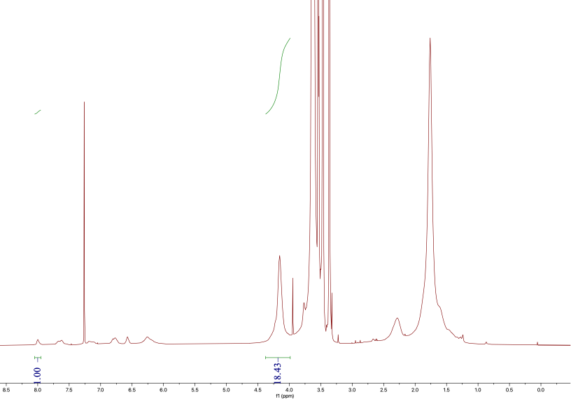
Figure S42. ¹H NMR spectrum of p(OEGA-co-FluA) via continuous flow RAFT polymerization at a rate of 0.3 mL/hr after purification in CDCl₃.
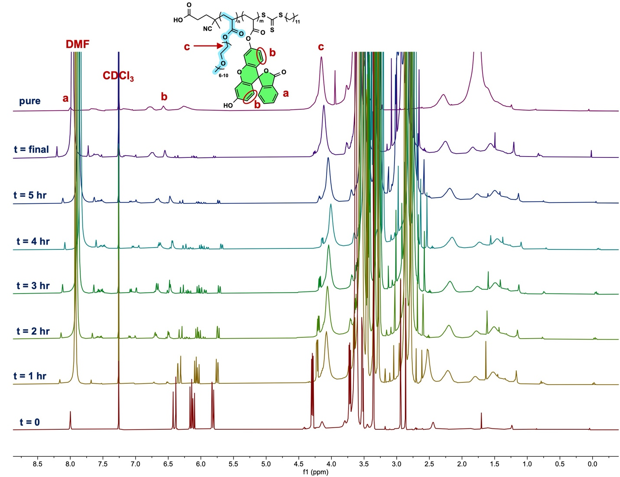

Figure S43.¹H NMR spectra of p(OEGA-co-FluA) polymerized via continuous flow RAFT polymerization at a continuous flow rate of 0.3 mL/hr with kinetic samples, from bottom to top, taken every hour from time t=0 hr to time t=5hr, a final kinetic sample taken after the reaction was completed, and a sample taken after purification in CDCl₃.

Continuous Flow Addition - 0.4 mL/hour
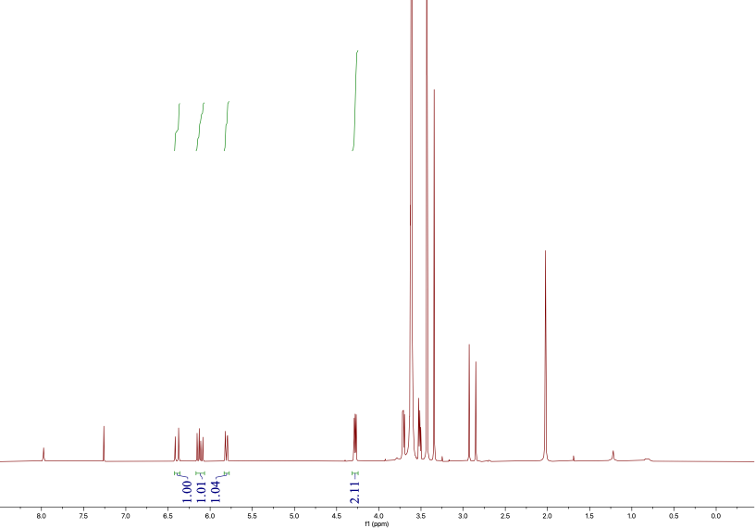
Figure S44. ¹H NMR spectrum of p(OEGA-co-FluA) via continuous flow RAFT polymerization at a rate of 0.4 mL/hr at time t=0 hr in CDCl₃.
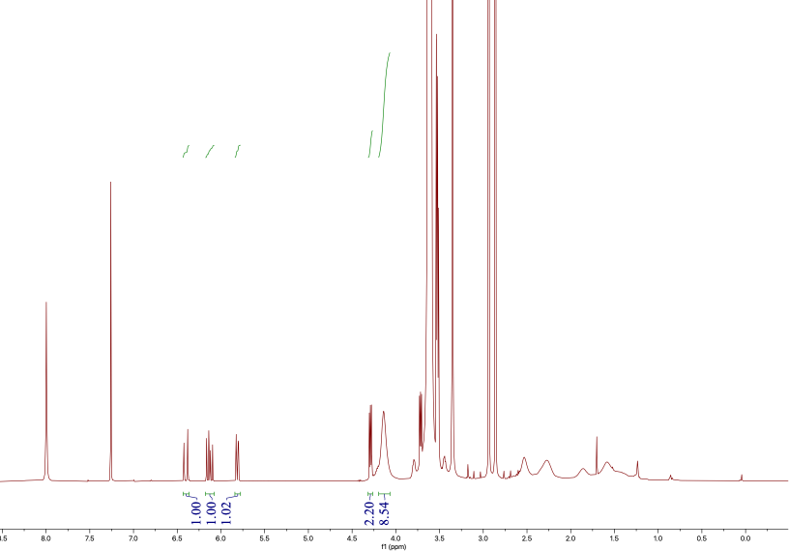
Figure S45. ¹H NMR spectrum of p(OEGA-co-FluA) via continuous flow RAFT polymerization at a rate of 0.4 mL/hr at time t=1 hr in CDCl₃.
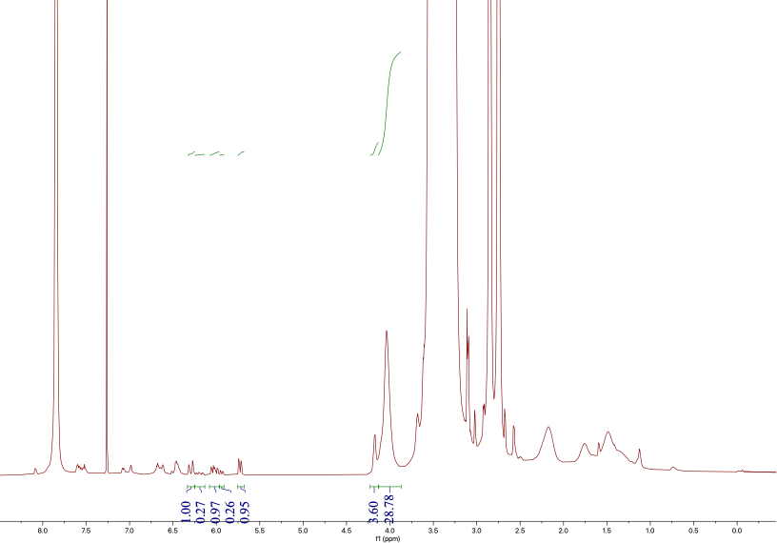
Figure S46. ¹H NMR spectrum of p(OEGA-co-FluA) via continuous flow RAFT polymerization at a rate of 0.4 mL/hr at time t=2 hr in CDCl₃.
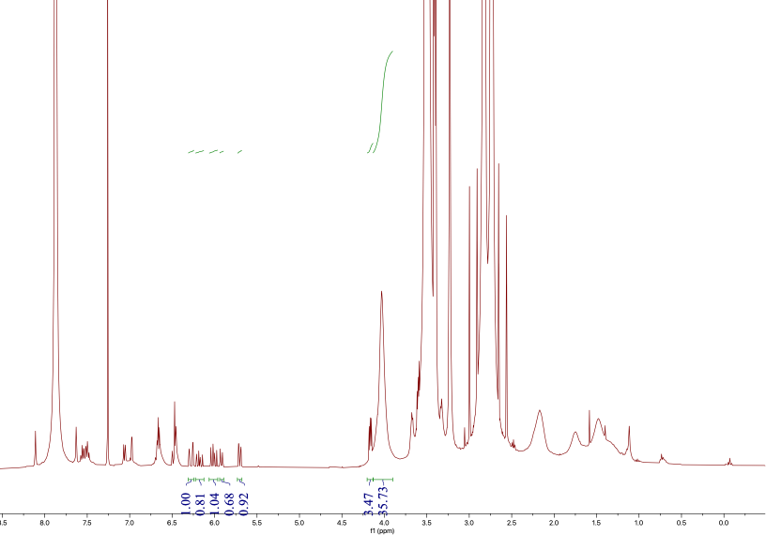
Figure S47. ¹H NMR spectrum of p(OEGA-co-FluA) via continuous flow RAFT polymerization at a rate of 0.4 mL/hr at time t=3 hr in CDCl₃.
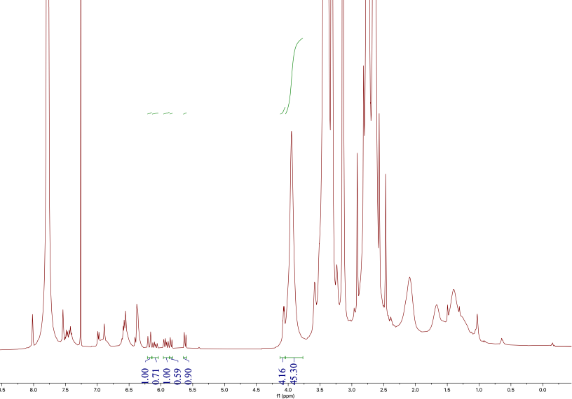
Figure S48. ¹H NMR spectrum of p(OEGA-co-FluA) via continuous flow RAFT polymerization at a rate of 0.4 mL/hr at time t=4 hr in CDCl₃.
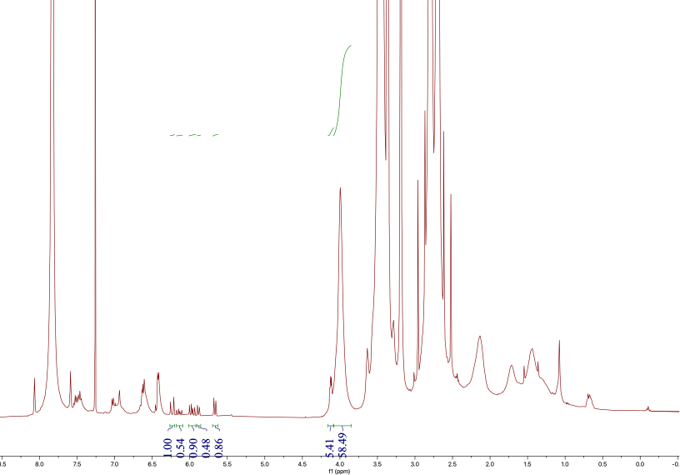
Figure S49. ¹H NMR spectrum of p(OEGA-co-FluA) via continuous flow RAFT polymerization at a rate of 0.4 mL/hr at time t=5 hr in CDCl₃.
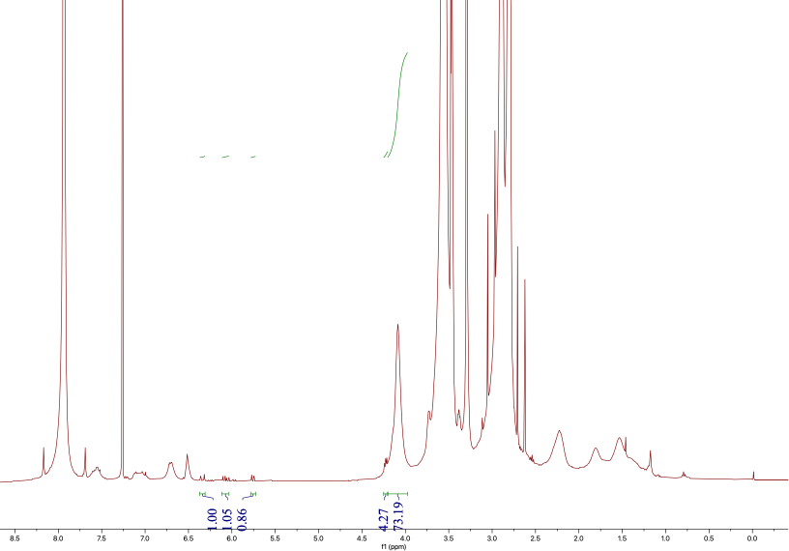
Figure S50. ¹H NMR spectrum of p(OEGA-co-FluA) via continuous flow RAFT polymerization at a rate of 0.4 mL/hr after reaction completion in CDCl₃.
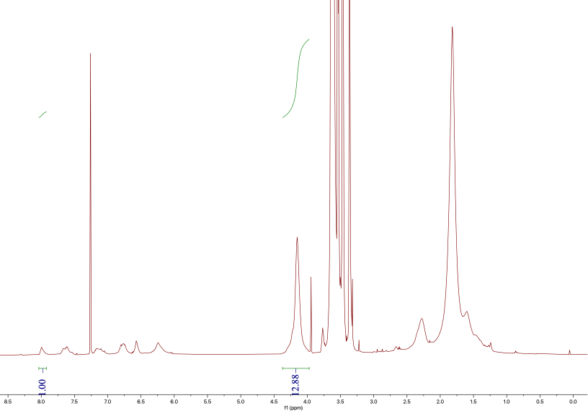
Figure S51. ¹H NMR spectrum of p(OEGA-co-FluA) via continuous flow RAFT polymerization at a rate of 0.4 mL/hr after purification in CDCl₃.
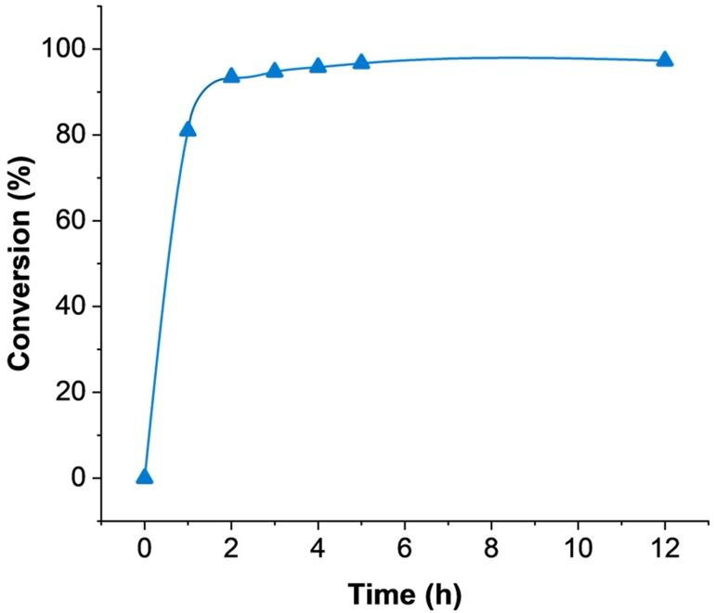

Figure S52. Conversion vs. time plot for continuous addition RAFT polymerization in DMF

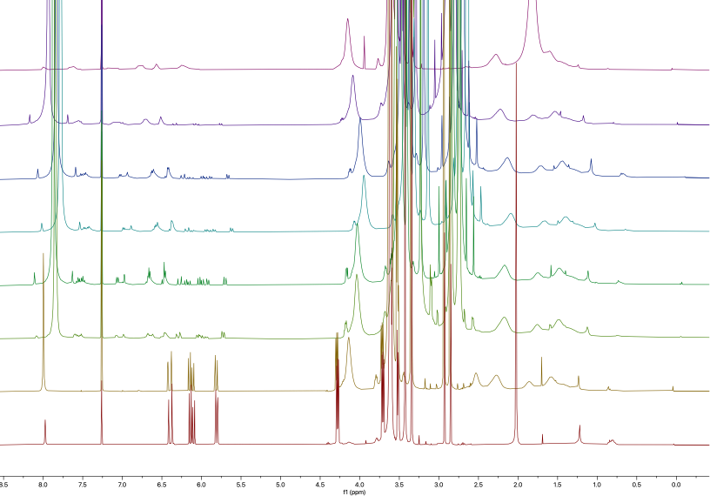

Figure S53. ¹H NMR spectra of p(OEGA-co-FluA) polymerized via continuous flow RAFT polymerization at a continuous flow rate of 0.4 mL/hr with kinetic samples, from bottom to top, taken every hour from time t=0 hr to time t=5hr, a final kinetic sample taken after the reaction was completed, and a sample taken after purification in CDCl₃.

Continuous Flow Addition - 0.5 mL/hour
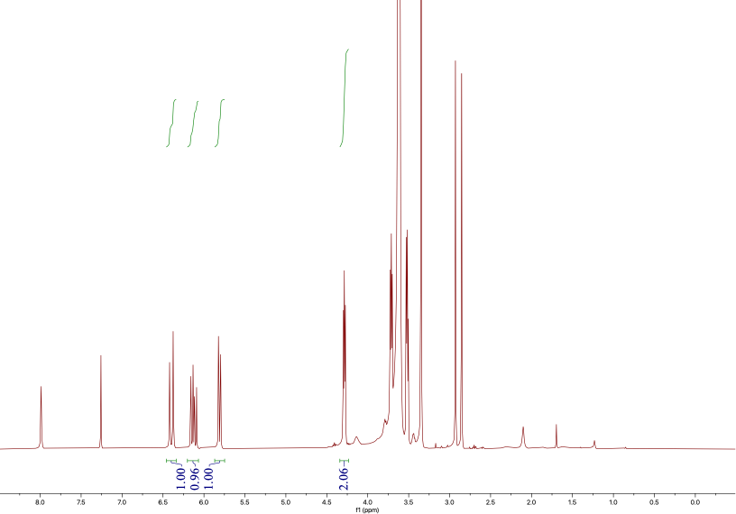
Figure S54. ¹H NMR spectrum of p(OEGA-co-FluA) via continuous flow RAFT polymerization at a rate of 0.5 mL/hr at time t=0 hr in CDCl₃.
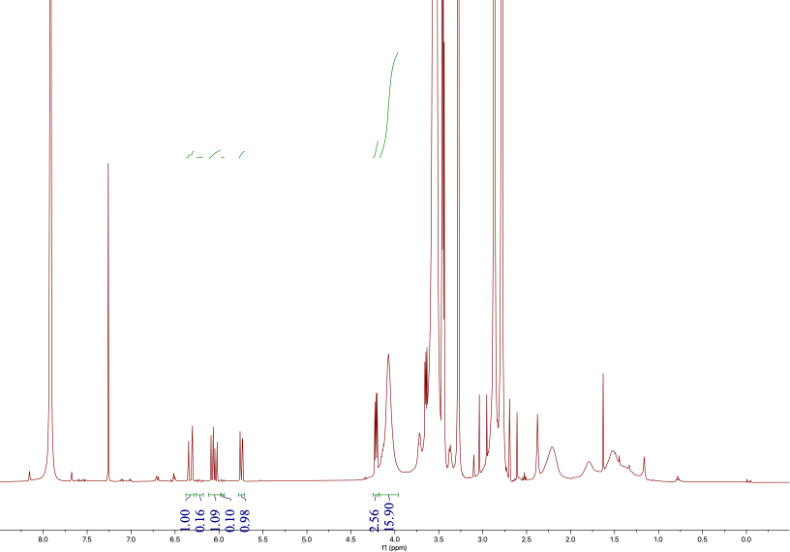
Figure S55. ¹H NMR spectrum of p(OEGA-co-FluA) via continuous flow RAFT polymerization at a rate of 0.5 mL/hr at time t=1 hr in CDCl₃.
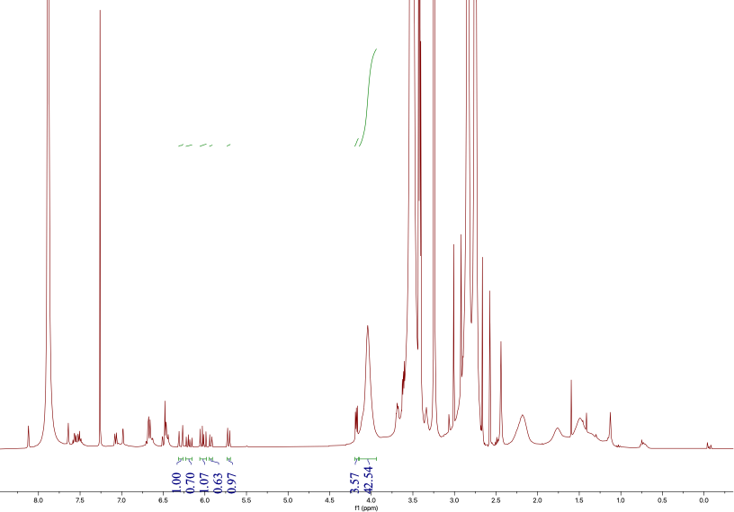
Figure S56. ¹H NMR spectrum of p(OEGA-co-FluA) via continuous flow RAFT polymerization at a rate of 0.5 mL/hr at time t=2 hr in CDCl₃.
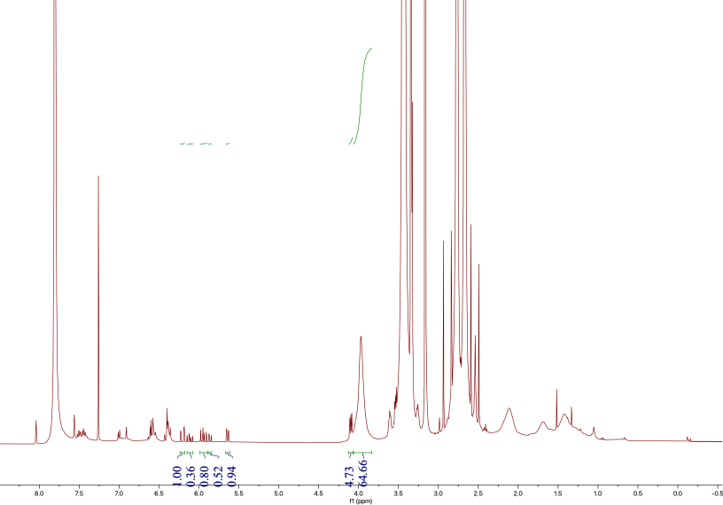
Figure S57. ¹H NMR spectrum of p(OEGA-co-FluA) via continuous flow RAFT polymerization at a rate of 0.5 mL/hr at time t=3 hr in CDCl₃.
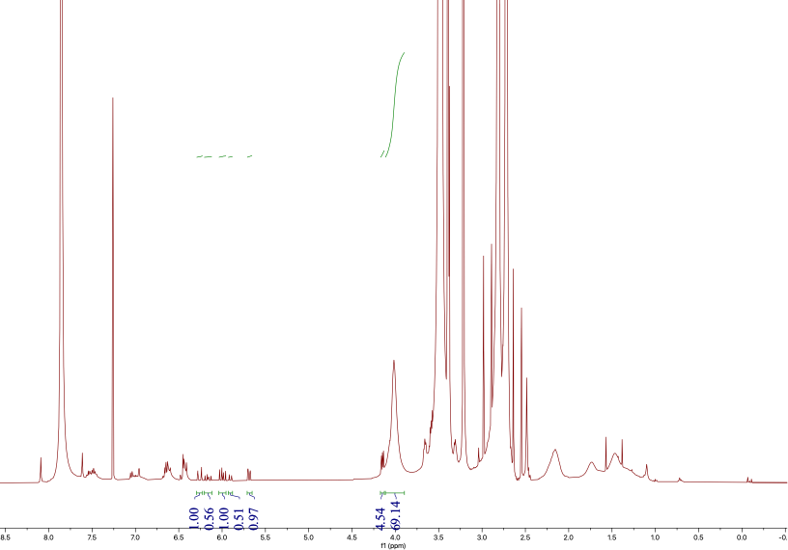
Figure S58. ¹H NMR spectrum of p(OEGA-co-FluA) via continuous flow RAFT polymerization at a rate of 0.5 mL/hr at time t=4 hr.
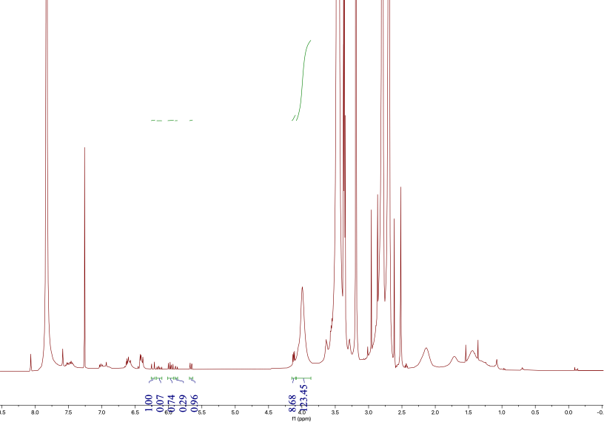
Figure S59. ¹H NMR spectrum of p(OEGA-co-FluA) via continuous flow RAFT polymerization at a rate of 0.5 mL/hr at time t=5 hr in CDCl₃.
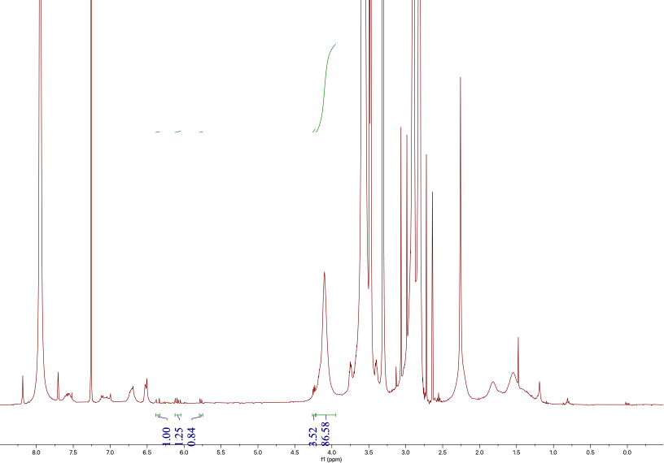
Figure S60. ¹H NMR spectrum of p(OEGA-co-FluA) via continuous flow RAFT polymerization at a rate of 0.5 mL/hr after reaction completion in CDCl₃.
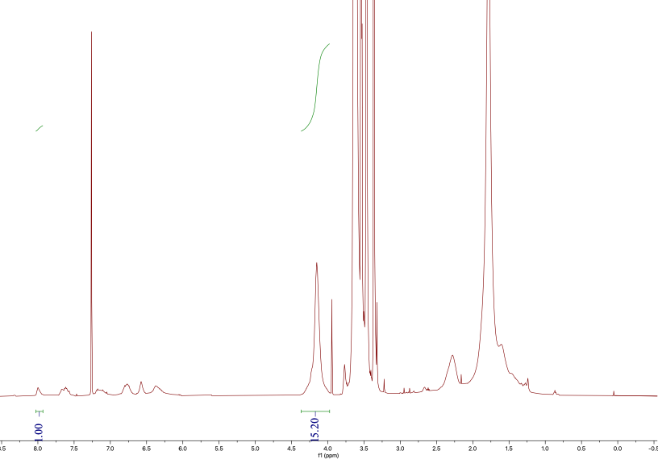
Figure S61. ¹H NMR spectrum of p(OEGA-co-FluA) via continuous flow RAFT polymerization at a rate of 0.5 mL/hr after purification in CDCl₃.
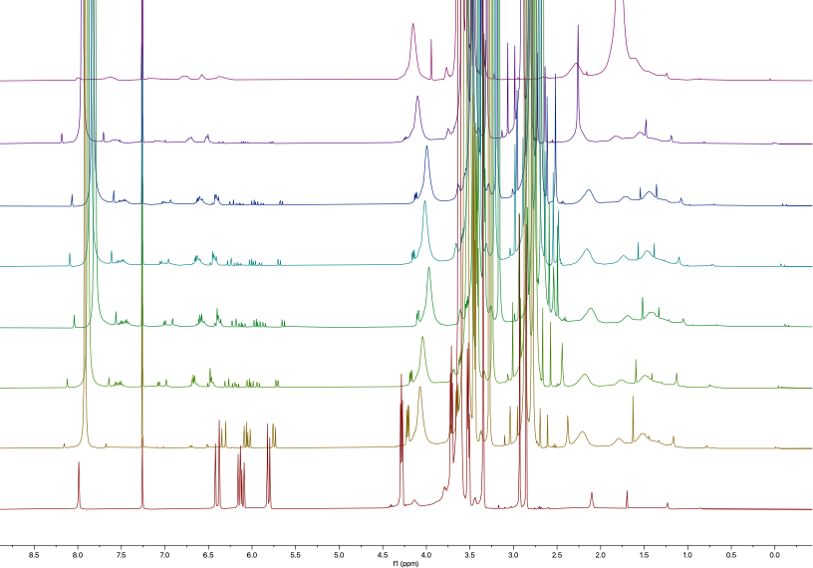

Figure S62. ¹H NMR spectra of p(OEGA-co-FluA) polymerized via continuous flow RAFT polymerization at a continuous flow rate of 0.5 mL/hr with kinetic samples, from bottom to top, taken every hour from time t=0 hr to time t=5hr, a final kinetic sample taken after the reaction was completed, and a sample taken after purification in CDCl₃.

Continuous Flow Addition - 1.0 mL/hour
Figure S63. ¹H NMR spectrum of p(OEGA-co-FluA) via continuous flow RAFT polymerization at a rate of 1.0 mL/hr at time t=0 hr in CDCl₃.
Figure S64. ¹H NMR spectrum of p(OEGA-co-FluA) via continuous flow RAFT polymerization at a rate of 1.0 mL/hr after reaction completion in CDCl₃.
Figure S65. ¹H NMR spectrum of p(OEGA-co-FluA) via continuous flow RAFT polymerization at a rate of 1.0 mL/hr after purification in CDCl₃. Unreacted FluA amount is over 50%.
Figure S66. ¹H NMR spectrum of p(OEGA-co-FluA) via continuous flow RAFT polymerization at a rate of 1.0 mL/hr, from bottom to top, at time t=0 hr, after reaction completion, and after purification in CDCl₃.

2. Gel Permeation Chromatography (GPC)
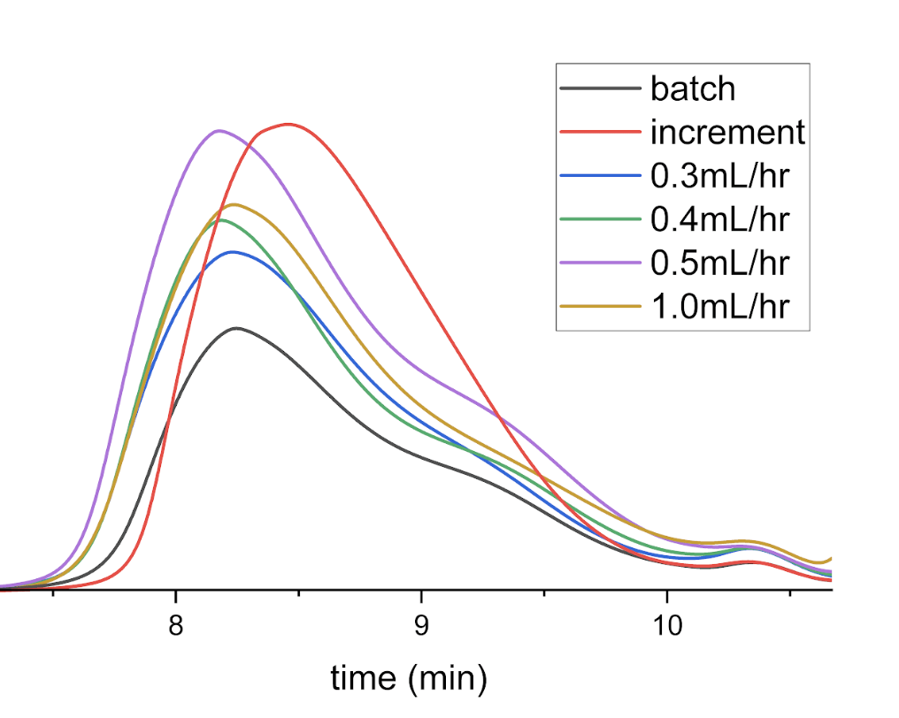
Figure S67. GPC traces of p(OEGA-co-FluA) polymers with different polymerization methods (batch, increment, and continuous flow with varying flow rates) via RAFT polymerization in THF as eluent (Batch: M_{n} = 17,935 g/mol, M_{w} = 31,050 g/mol, PDI = 1.73; Increment: M_{n} = 17,800 g/mol, M_{w} = 27,370 g/mol, PDI = 1.54; 0.3 mL/hr: M_{n} = 20,445 g/mol. M_{w} = 34,520 g/mol, PDI = 1.69; 0.4 mL/hr: M_{n} = 15,440 g/mol, M_{w} = 28,560 g/mol, 1.85; 0.5 mL/hr: M_{n} = 19,870 g/mol, M_{w} = 35,540, PDI = 1.79; 1.0 mL/hr: M_{n} = 18,480 g/mol, M_{w} = 33,520 g/mol, PDI = 1.81).
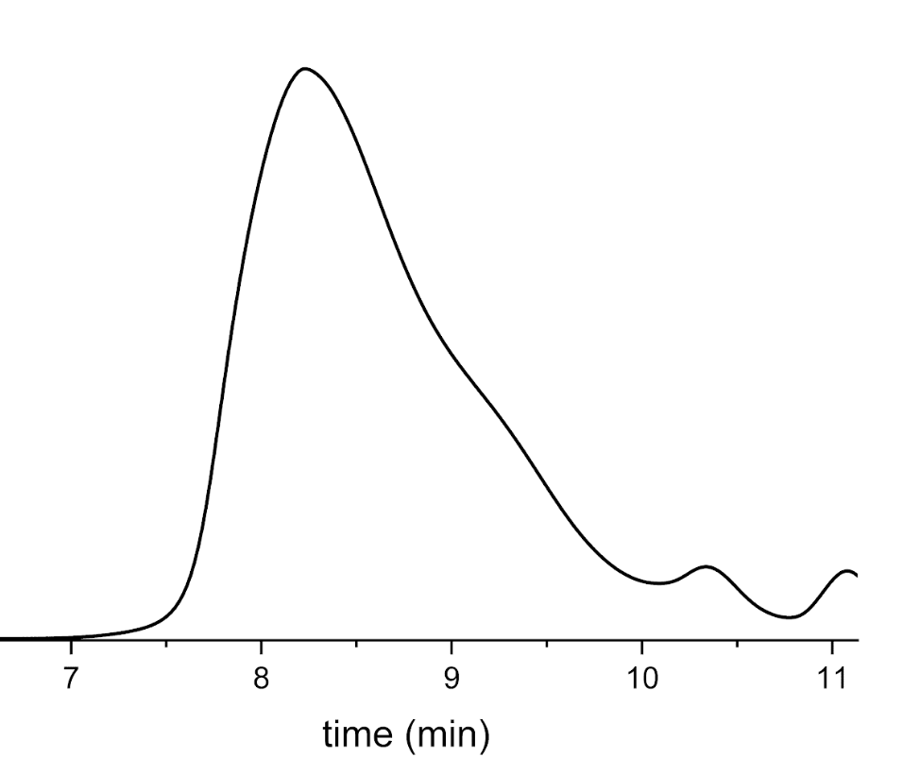
Figure S68. GPC traces of poly(OEGA-co-FluA) polymerized via continuous flow RAFT polymerization at a rate of 0.3 mL/hr in THF as eluent.
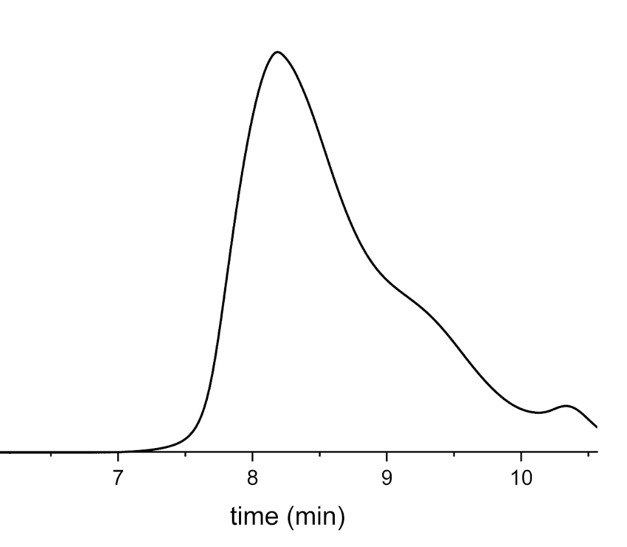
Figure S69. GPC traces of poly(OEGA-co-FluA) polymerized via continuous flow RAFT polymerization at a rate of 0.4 mL/hr in THF as eluent.
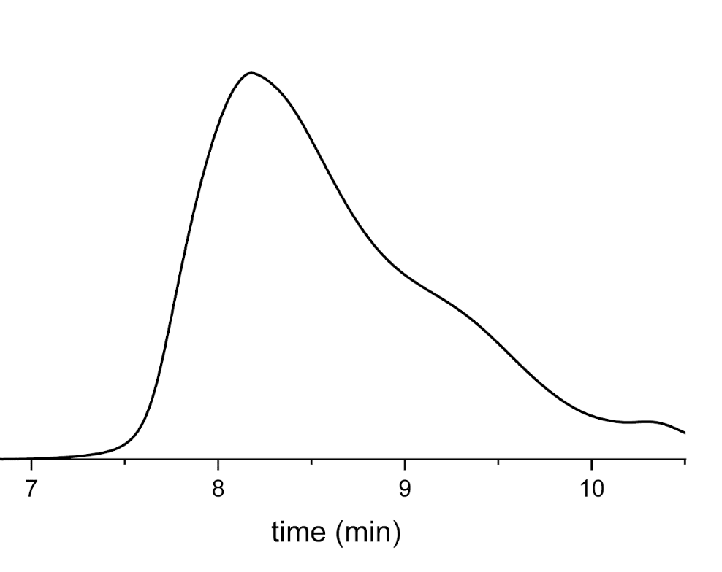
Figure S70. GPC traces of poly(OEGA-co-FluA) polymerized via continuous flow RAFT polymerization at a rate of 0.5 mL/hr in THF as eluent.
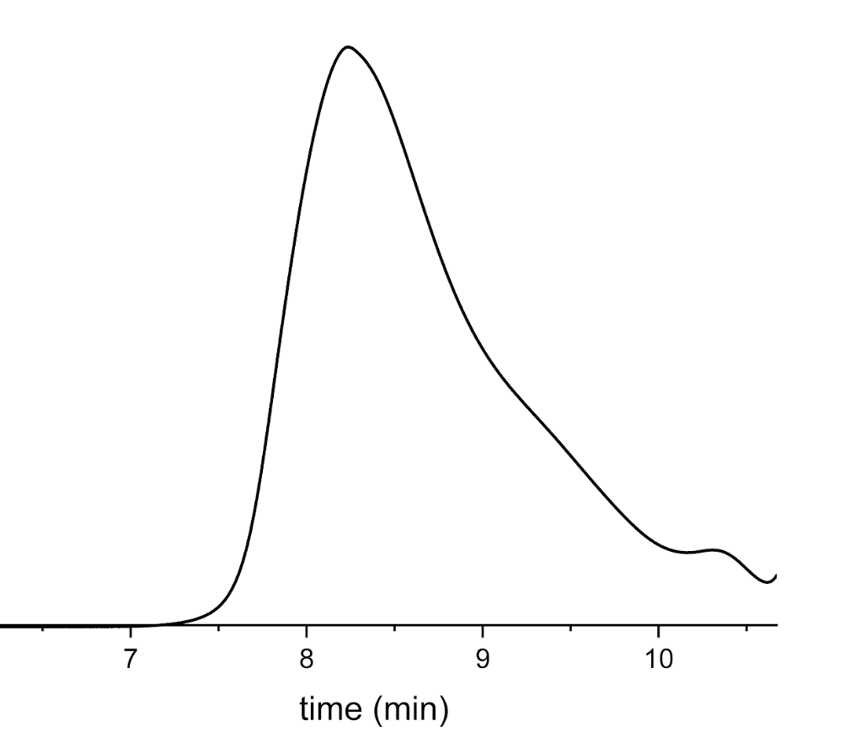
Figure S71. GPC traces of poly(OEGA-co-FluA) polymerized via continuous flow RAFT polymerization at a rate of 1.0 mL/hr in THF as eluent.
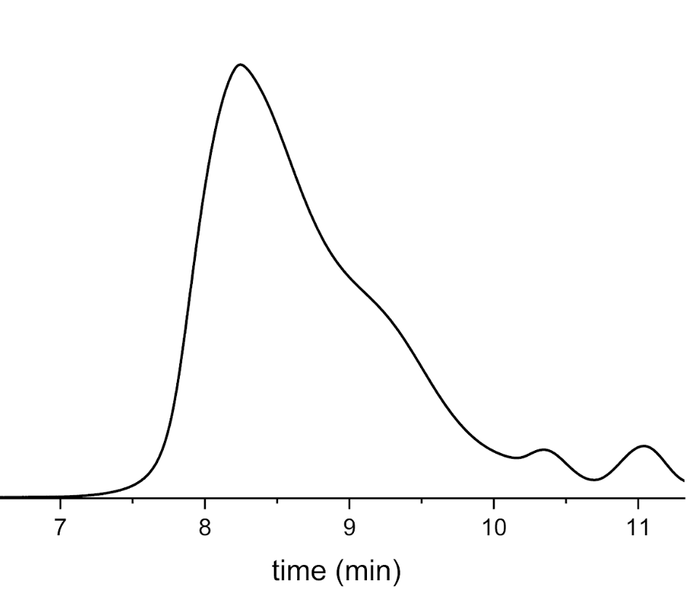
Figure S72. GPC traces of poly(OEGA-co-FluA) polymerized via batch RAFT polymerization in THF as eluent.
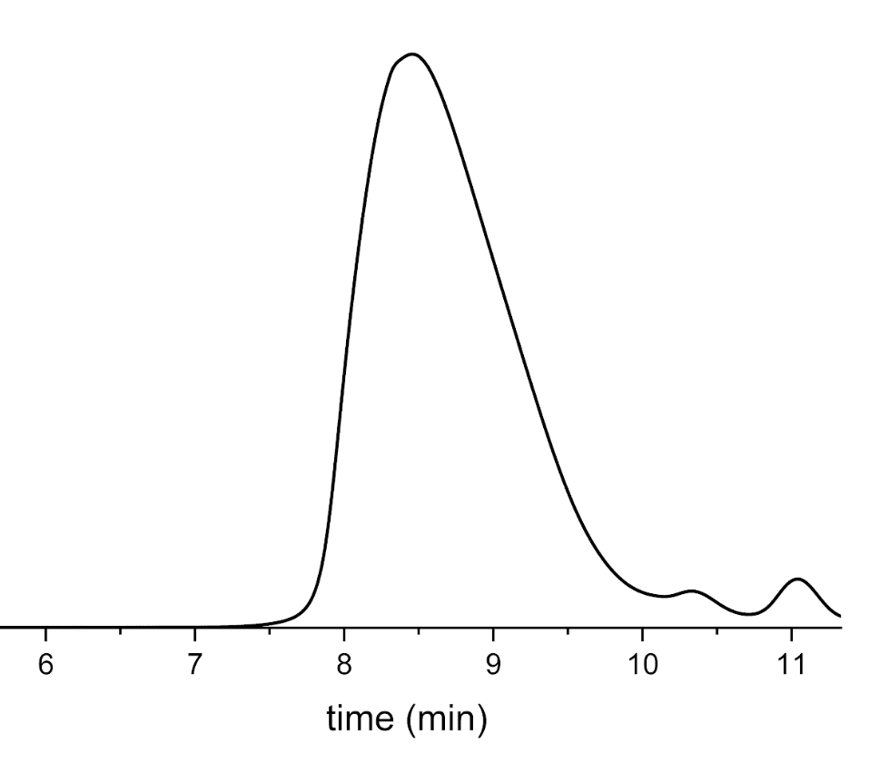
Figure S73. GPC traces of poly(OEGA-co-FluA) polymerized via increment RAFT polymerization in THF as eluent.

3. UV/Vis Spectroscopy
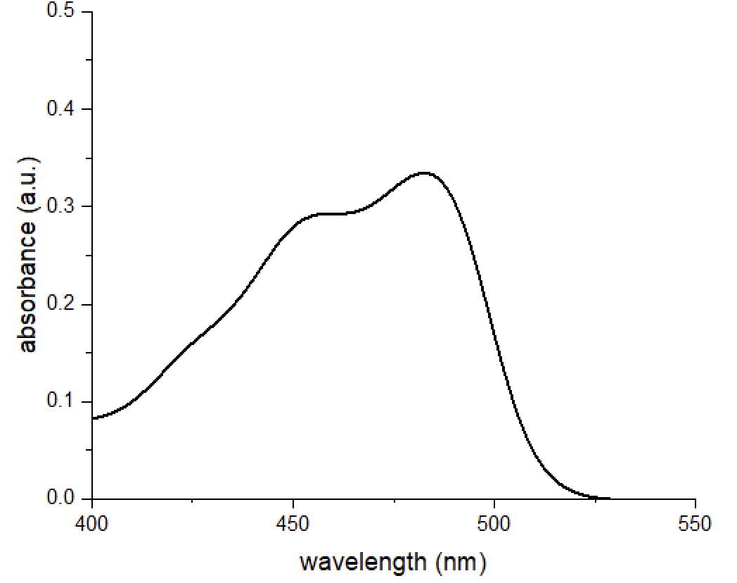
Figure S74. Absorption spectrum of p(OEGA-co-FluA) polymerized via continuous flow RAFT polymerization at a rate of 0.3 mL/hr in DI water at 1 mg/mL after filtering through 0.22 μm cellulose filter.
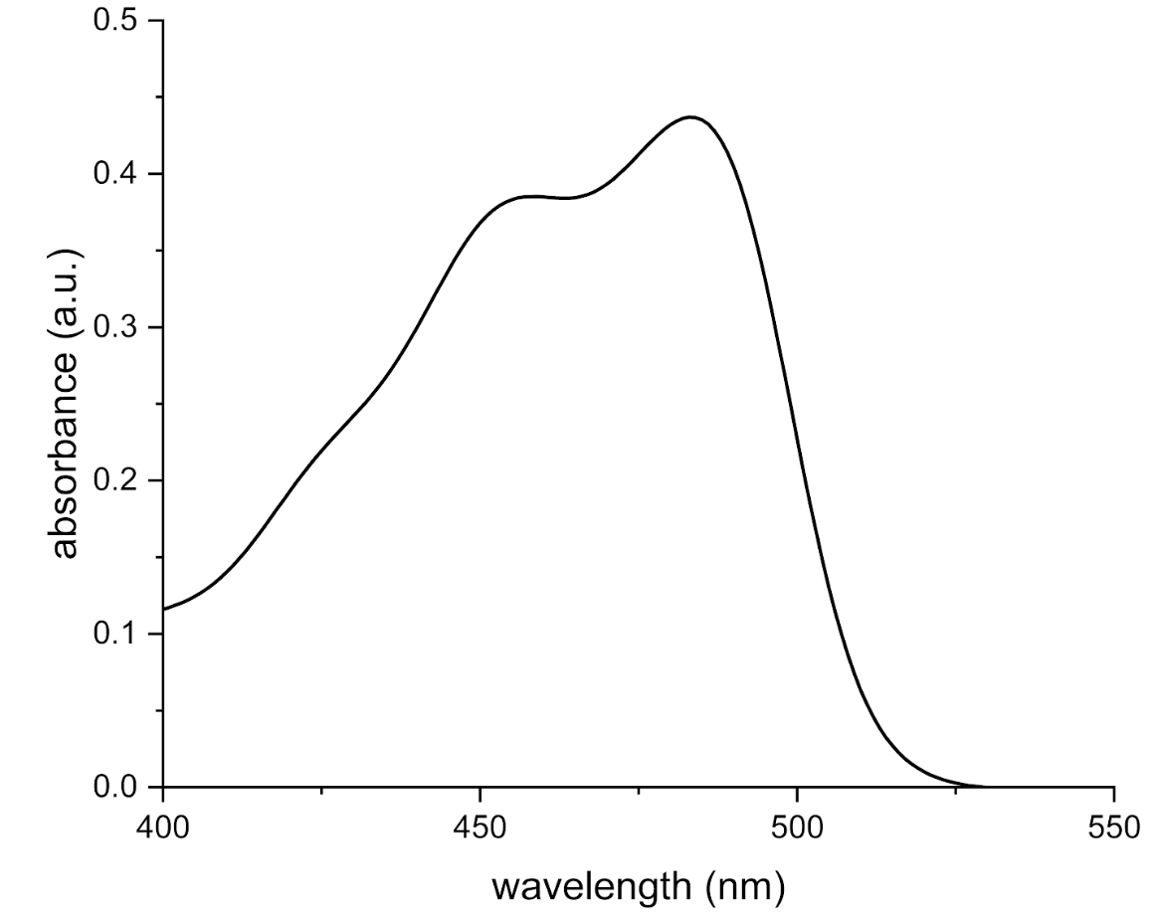
Figure S75. Absorption spectrum of p(OEGA-co-FluA) polymerized via continuous flow RAFT polymerization at a rate of 0.4 mL/hr in DI water at 1 mg/mL after filtering through 0.22 μm cellulose filter.
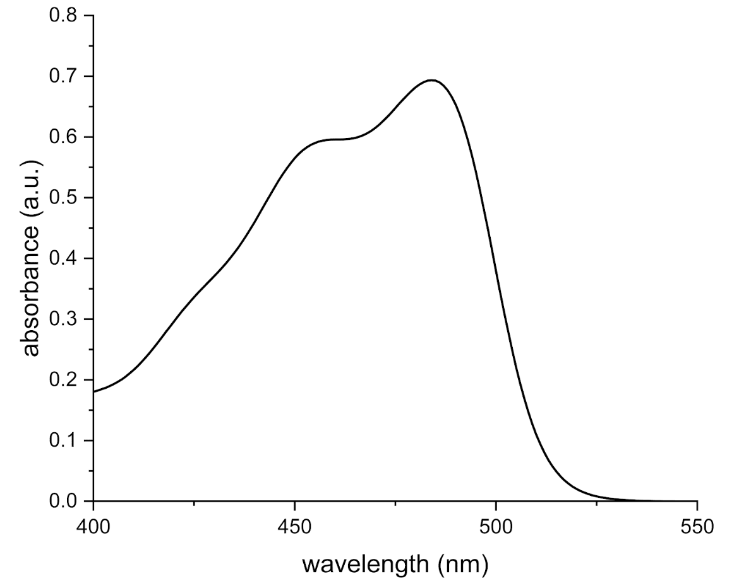
Figure S76. Absorption spectrum of p(OEGA-co-FluA) polymerized via continuous flow RAFT polymerization at a rate of 0.5 mL/hr in DI water at 1 mg/mL after filtering through 0.22 μm cellulose filter.
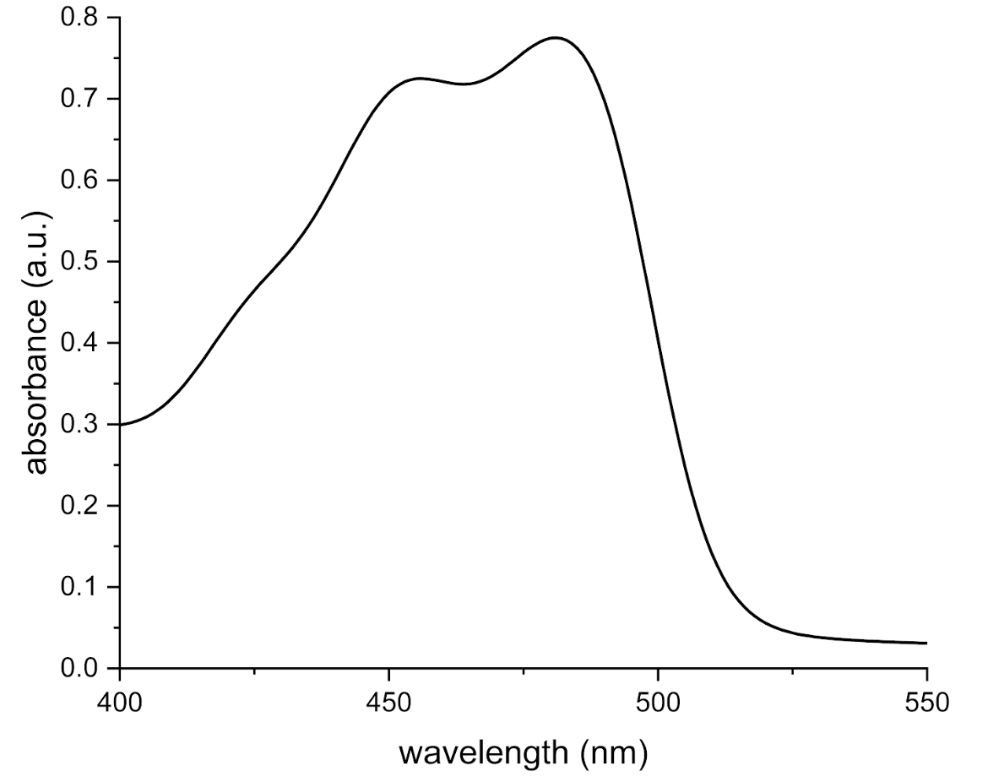
Figure S77. Absorption spectrum of p(OEGA-co-FluA) polymerized via continuous flow RAFT polymerization at a rate of 1.0 mL/hr in DI water at 1 mg/mL after filtering through 0.22 μm cellulose filter.
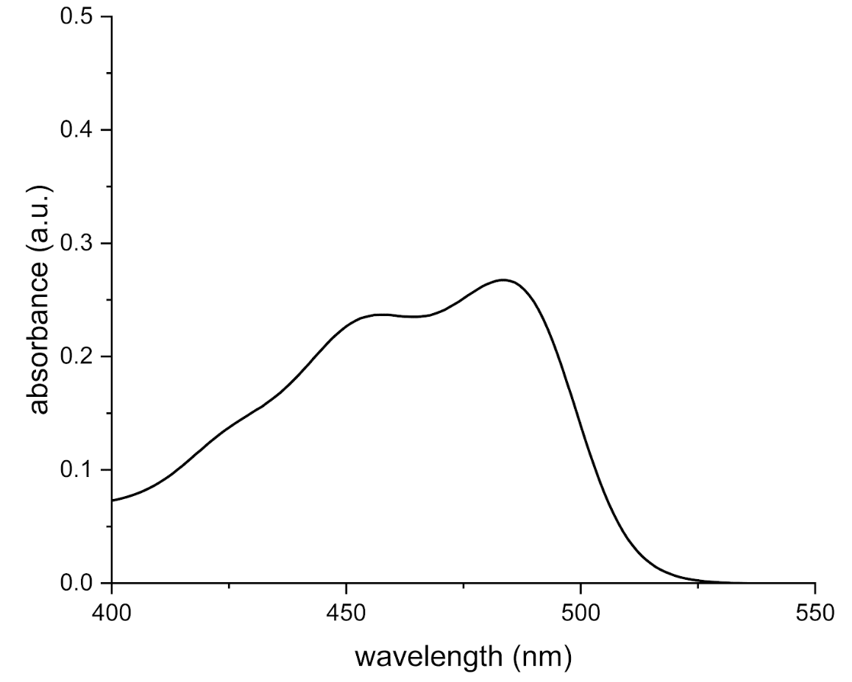
Figure S78. Absorption spectrum of p(OEGA-co-FluA) polymerized via batch RAFT polymerization in DI water at 1 mg/mL after filtering through 0.22 μm cellulose filter.
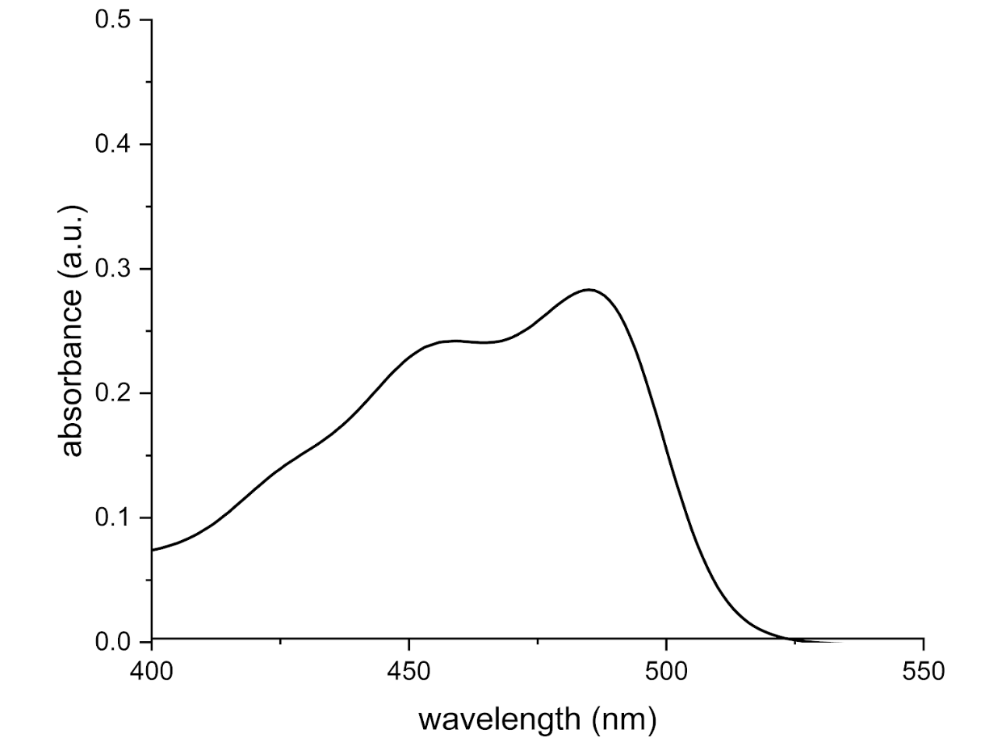
Figure S79. Absorption spectrum of p(OEGA-co-FluA) polymerized via increment RAFT polymerization in DI water at 1 mg/mL after filtering through 0.22 μm cellulose filter.

4. Fluorescence Spectroscopy
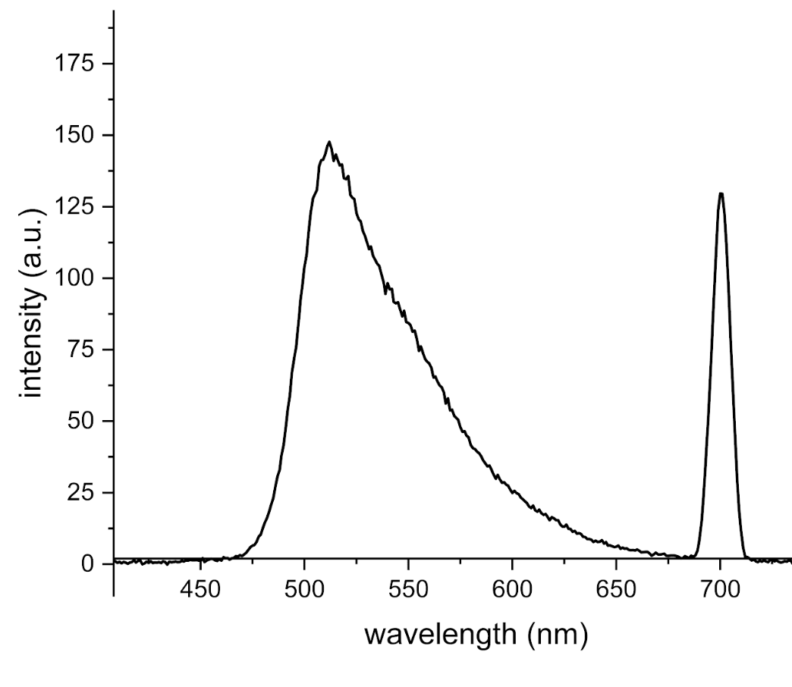
Figure S80. Emission spectrum of p(OEGA-co-FluA) polymerized via continuous flow RAFT polymerization at a rate of 0.3 mL/hr in DI water at 1 mg/mL after filtering through 0.22 μm cellulose filter.
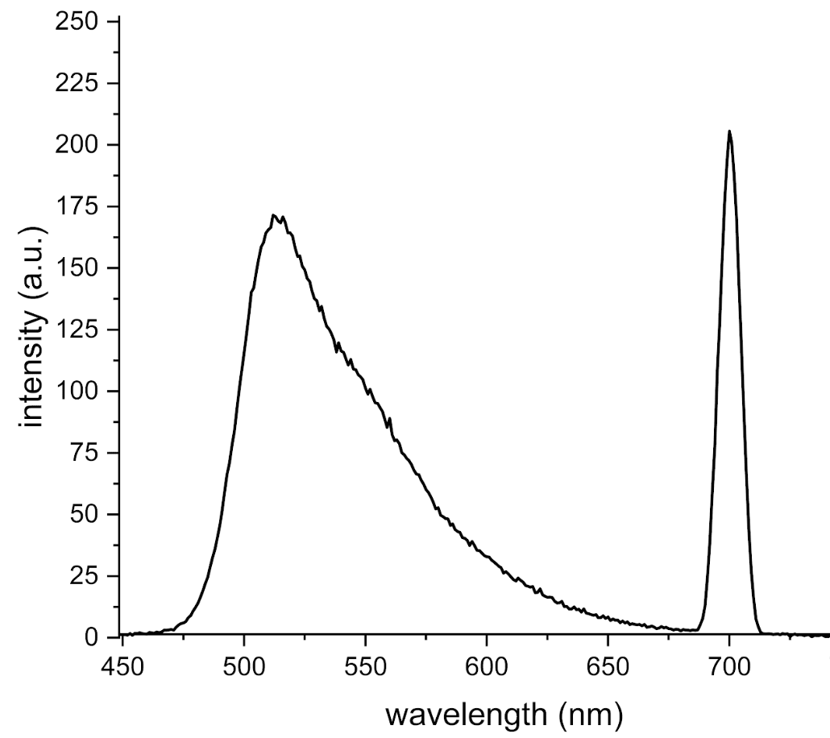
Figure S81. Emission spectrum of p(OEGA-co-FluA) polymerized via continuous flow RAFT polymerization at a rate of 0.4 mL/hr in DI water at 1 mg/mL after filtering through 0.22 μm cellulose filter.
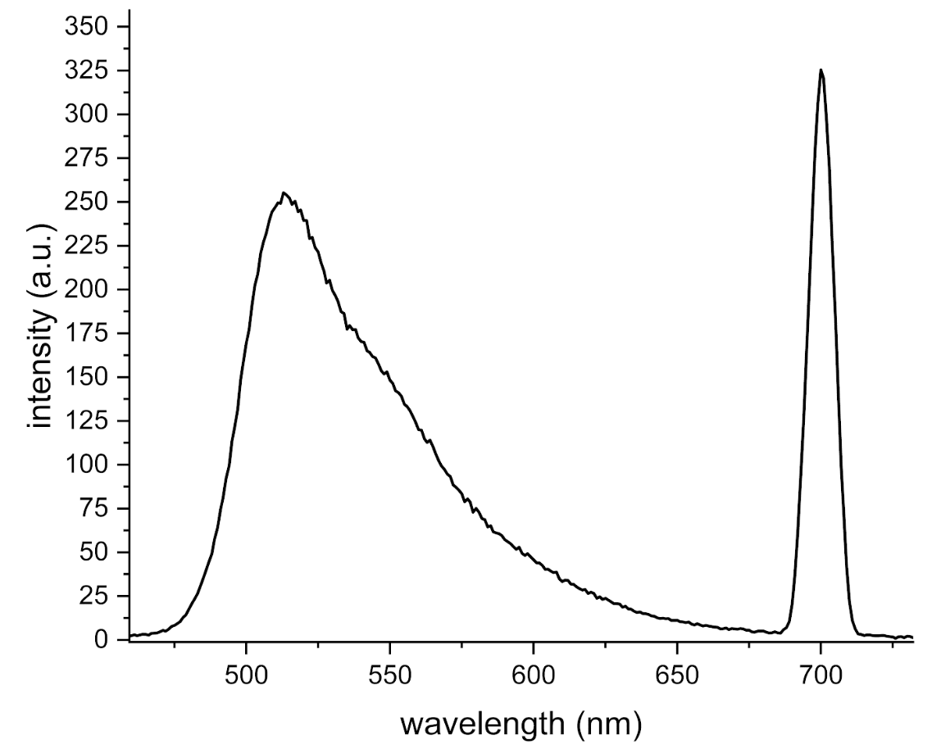
Figure S82. Emission spectrum of p(OEGA-co-FluA) polymerized via continuous flow RAFT polymerization at a rate of 0.5 mL/hr in DI water at 1 mg/mL after filtering through 0.22 μm cellulose filter.
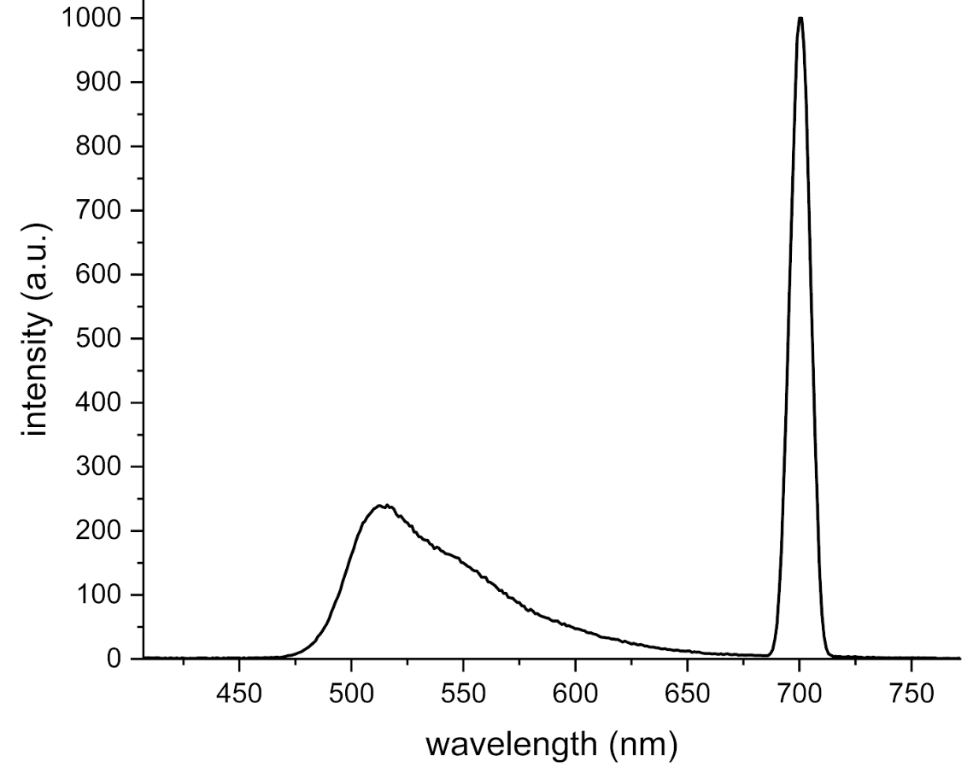
Figure S83. Emission spectrum of p(OEGA-co-FluA) polymerized via continuous flow RAFT polymerization at a rate of 1.0 mL/hr in DI water at 1 mg/mL after filtering through 0.22 μm cellulose filter.

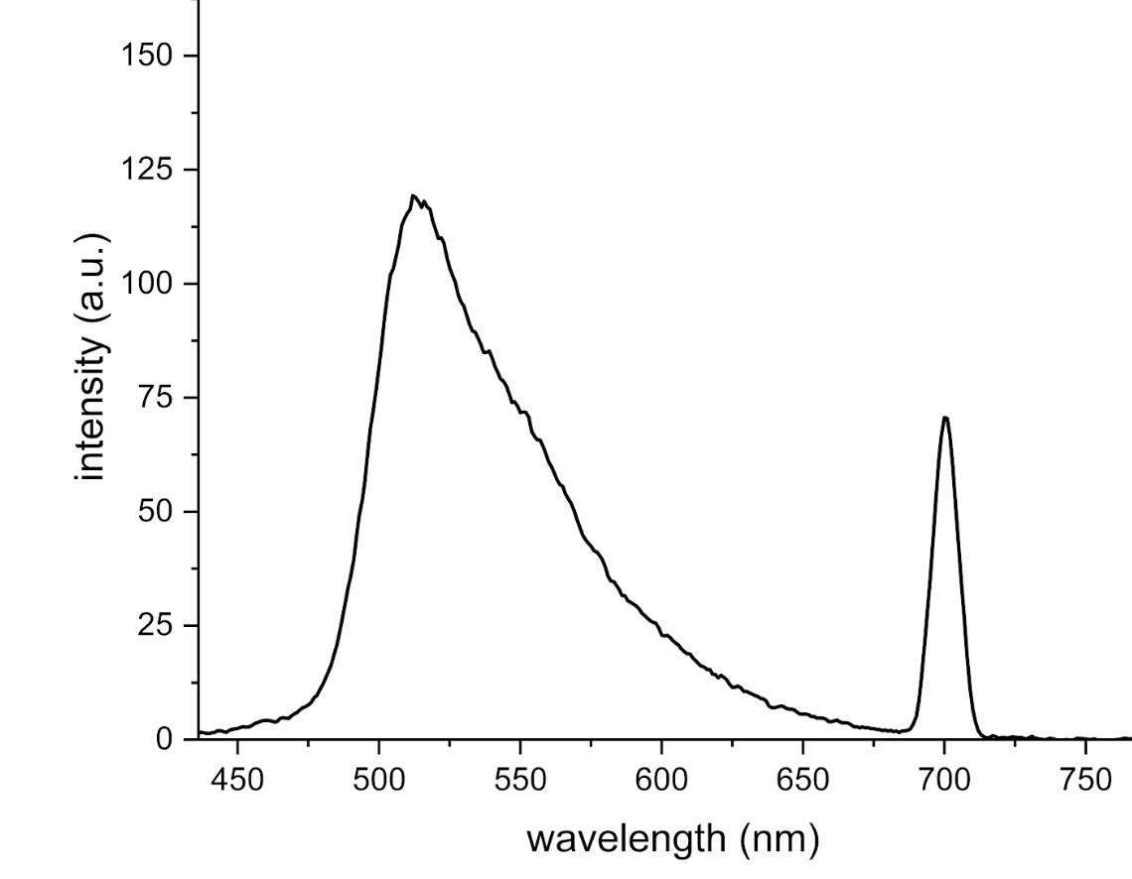
Figure S84. Emission spectrum of p(OEGA-co-FluA) polymerized via batch RAFT polymerization in DI water at 1 mg/mL after filtering through 0.22 μm cellulose filter.
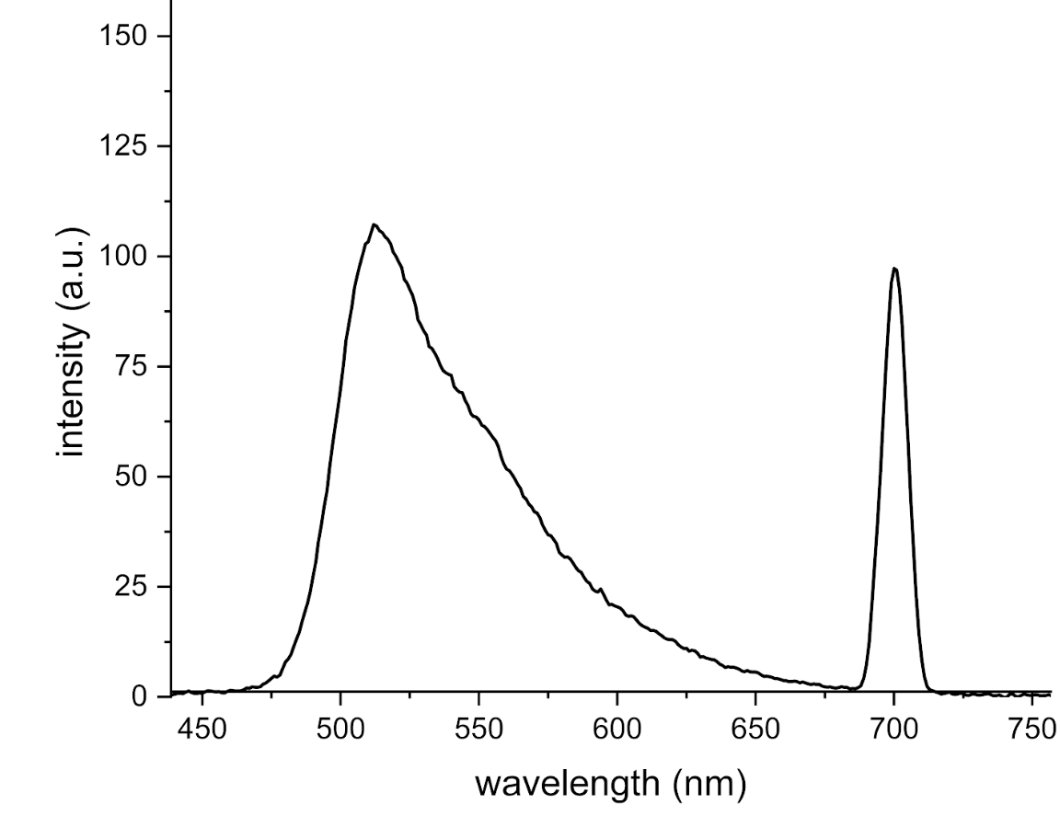
Figure S85. Emission spectrum of p(OEGA-co-FluA) polymerized via increment RAFT polymerization in DI water at 1 mg/mL after filtering through 0.22 μm cellulose filter.

