Supporting Information

Cross-linked zwitterionic copolymer-modified cellulose acetate hollow fiber membranes to reduce protein adsorption

Shuta Otomo¹, Tsukuru Masuda¹, Shuji Nakatsuka², Youichi Matsuo^{1,3}, Madoka Takai^{1,4}*

Affiliation
¹ Department of Bioengineering, School of Engineering, The University of Tokyo 7-3-1 Hongo, Bunkyo-ku, Tokyo 113-8656, Japan, E-mail: takai@bis.t.u-tokyo.ac.jp
² DAICEN MEMBRANE-SYSTEMS Ltd. 1239 Shinzaike, Aboshi-ku, Himeji-shi, Hyogo 671-1283, Japan
³ Gel Coat Biomaterials Inc. 2-3-21 Kouraku, Bunkyo-ku, Tokyo 112-0004, Japan
⁴ Research Center for Water Environment Technology, School of Engineering, The University of Tokyo, 7-3-1 Hongo, Bunkyo-ku, Tokyo 113-8656, Japan

S1. Characterization of the copolymer
1) Analysis of the monomer conversions
The monomer conversions were analyzed by ¹H NMR. An aliquot of the reaction solution after polymerization was added to the solvent for methanol-d₄, and the measurement was proceeded. The monomer conversions of MPC and the sum of MPTSSi and MPTMSi were calculated by the decrease in integral of the peaks derived from a proton bonded to C=C group, which were at 6.13 ppm and 6.09 ppm, respectively. The peaks derived from a proton bonded to C=C group of MPTSSi and MPTMSi were overlapped due to the similarity of the chemical structure. The following Table S1 shows the values of the monomer conversions.

Table S1. Monomer conversion values in the synthesis of the copolymers.
 | Conversion of the monomer unit(s) / %
Polymer | MPC | MPTSSi + MPTMSi
PMMMSi60 | 96.2 | 96.4
PMMMSi80 | 90.0 | 86.0

2) Summary of the characterization of the copolymers
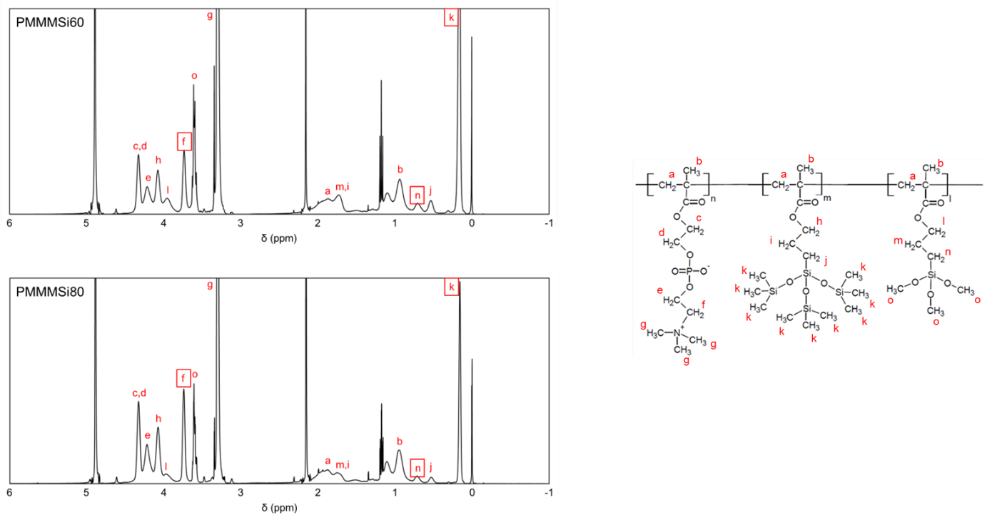
Figure S1. ¹H-NMR spectra of PMMMSi60 and PMMMSi80.

Table S2. Characteristics of synthesized PMMMSi60 and PMMMSi80.
Polymer | Monomer ratio (mol%) ª |  | Average molecular weight ^{b}
Polymer | MPC / MPTSSi / MPTMSi
Polymer | In feed | In copolymer | M_{n} | M_{w} | M_{w} / M_{n}
PMMMSi60 | 60 / 20 / 20 | 62 / 24 / 14 | 3.1 × 10⁴ | 1.4 × 10⁵ | 4.4
PMMMSi80 | 80 / 10 / 10 | 82 / 9 / 9 | 5.5 × 10⁴ | 1.6 × 10⁵ | 2.9
ª Determined via ¹H-NMR. ^{b} Determined via GPC.

S2. Water content of the PMMMSi film coated onto the flat CA
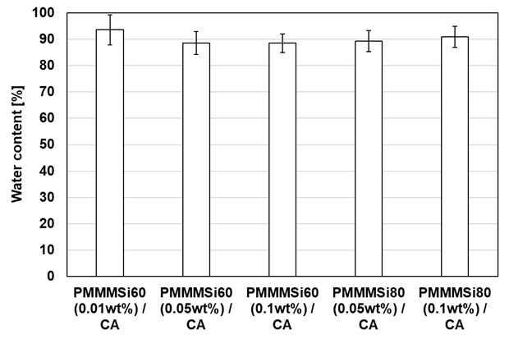

Figure S2. Water content of the PMMMSi film coated onto the flat CA under the aqueous situation measured via spectroscopic ellipsometry.

S3. Quartz crystal microbalance (QCM) measurement for protein adsorption
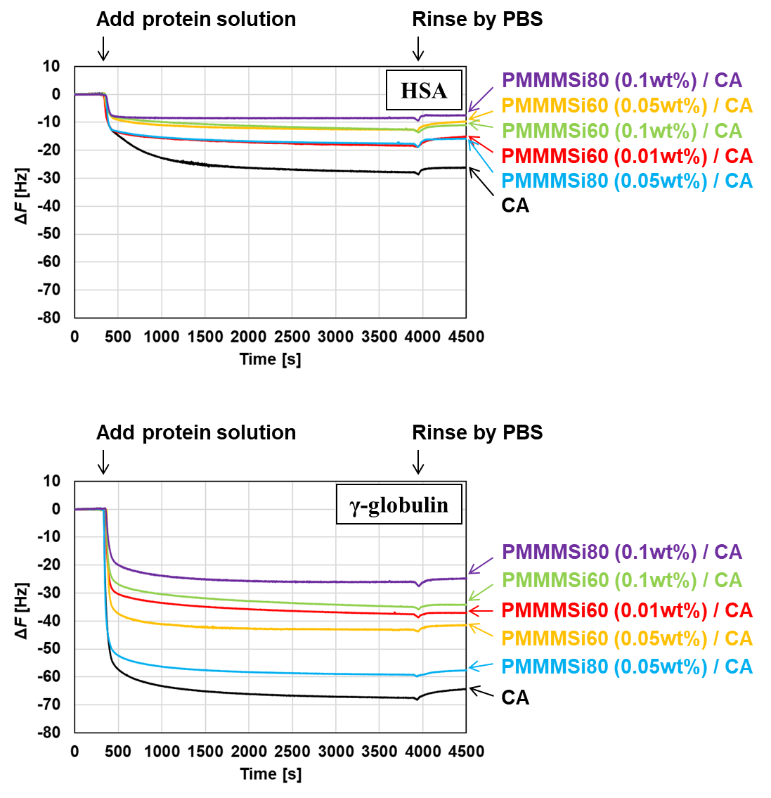

Figure S3. QCM charts of HSA and γ-globulin adsorption on each surface.

S4. Effect of protein adsorption to the hollow fiber membranes under dynamic condition
1) Supplementary Figure corresponding to Figure 4 in the main text
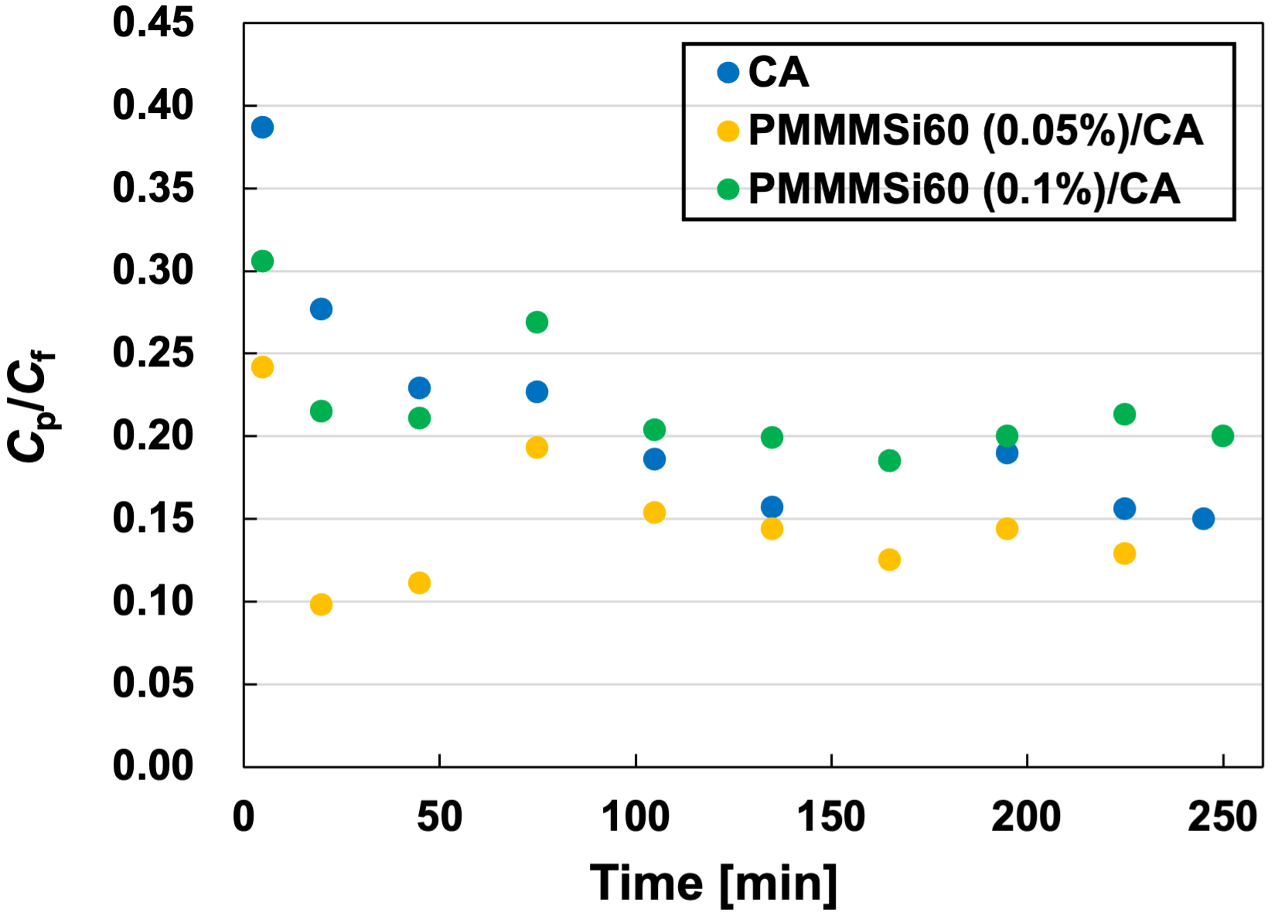
Figure S4. Time-course changes in the C_{p}/C_{f} values when the γ-globulin solution was passed through the CA-HFMs.

2) Supplementary experiment: Dynamic condition in the presence of HAS or γ-globulin
The effect of HSA and γ-globulin adsorption on unmodified and PMMMSi-modified CA hollow fiber membranes was evaluated under dynamic conditions by analyzing the permeate that passed through the membrane surface when a protein solution was flowed inside the hollow fiber membrane. The HSA and γ-globulin solutions (in PBS at concentrations of 4.5 and 1.6 mg/mL, respectively) were independently flowed through the hollow fiber membrane at a rate of 0.3 mL/min and circulated for 160 min. The total volume of each protein solution was 50 mL. The permeate volume from the membrane surface was measured every 20 min to calculate the permeate flux. Furthermore, the protein concentration in the permeate was determined by measuring the absorbance at 280 nm using UV-Vis spectroscopy (SEC2020, BAS Inc., Tokyo, Japan), and the amount of protein in the permeate was calculated.
The HSA and γ-globulin solutions were passed through the CA hollow fiber membranes, and the time-course changes in the permeate flux and the protein content in the permeate are shown in Figure S5. For both proteins, the absolute values of the permeate flux were lower in the PMMMSi60-modified groups compared with the unmodified CA hollow fiber membrane. Such a finding is consistent with the results of the pure water permeability test discussed in the previous section, which was based on the copolymer thickness. However, in terms of time-dependent flux changes, the unmodified sample exhibited a decrease in the permeate flux over time, whereas the PMMMSi60-modified groups maintained a stable flux over the long term. Similarly, the amount of protein in the permeate decreased over time for the unmodified sample but remained relatively constant in the PMMMSi60-modified groups. Such findings indicate that in the unmodified CA hollow fiber membrane, protein adsorption progressed over time, as evidenced by the decrease in both the flux and protein amount in the permeate. In contrast, the PMMMSi60-modified groups maintained both these properties, demonstrating the suppression of protein adsorption under dynamic conditions.
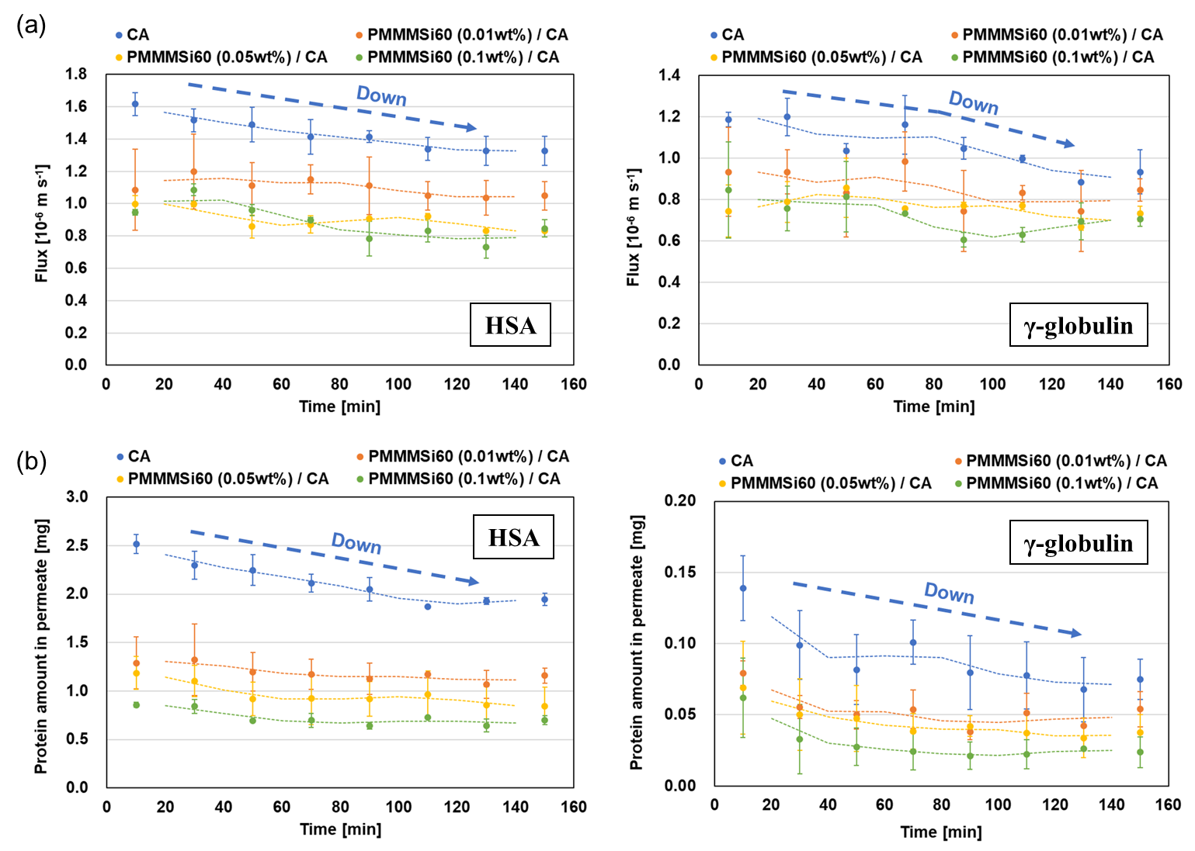
Figure S5. Time-dependent changes of the (a) flux of permeate and (b) amount of protein in the permeate when the HSA and γ-globulin solutions were passed through the CA hollow fiber membranes. The amount of the solution was 50 mL. Moving average lines (dotted lines) were added to further clarify the observed trends.

