Supplementary Material: The Mechanical Response of Micron-Sized Molecular Crystals

Christopher M. Barr, Marcia Cooper, Jeremy Lechman, and Daniel C. Bufford*

Sandia National Laboratories, PO Box 5800, Albuquerque, NM, 87185, USA
* Corresponding author: dcbuffo@sandia.gov

Experiment
Samples were prepared from CL-20 powder (Orbital ATK, Promontory, Utah, USA) with a 2.6 µm mean particle diameter determined by laser light scattering. CL-20 was of high purity and primarily of the ε polymorph. Powder was suspended in isopropanol and sonicated at ambient conditions for 1 minute prior to being dispersed onto a silicon wafer. The wafer was covered as the sample dried in air in a desiccator, and remained desiccated until ready for analysis. Particle compression experiments utilized a Hysitron PI-85 nanoindenter [1] operated in situ inside either a Zeiss Crossbeam 550 SEM or JEOL IT-300HR SEM. The wafer was affixed to an aluminum SEM stub by an ultraviolet-cured adhesive (Bondic®, Laser Bonding Tech, Inc, Aurora, ON, Canada), and electrically grounded using carbon paint (DAG-T-502, Ted Pella, Inc, Redding, CA, USA). The indenter axis was normal to the wafer plane. After being loaded into the SEM, the entire indenter assembly was tilted to an observation angle of 10° from parallel to the wafer plane as shown in the Fig. 1 of the paper. All particles selected for compression experiments were spaced such that neighboring particles neither disrupted indenter contact nor line of sight for viewing. Still micrographs were collected before and after particle compressions, and videos were collected in situ for selected tests. Particle compression experiments utilized a flat-ended conical diamond punch with a nominal 6 µm diameter flat. Load- and displacement-controlled experiments probed the viscoelastic response and fracture behaviors, respectively.

The particles exhibited flat faces and sharp edges characteristic of single crystals. Crystallographic characterization of individual particles was not possible, so the crystal faces and compression directions were unknown. The expected relative abundances of major crystallographic faces in ε-CL-20 have been found to be (in decreasing order) $\left(011\right)$, $\left(110\right)$, $\left(101\right)$, $\left(11\overline{1}\right)$, and $\left(002\right)$ [2]. It is likely that major faces like $\left(011\right)$, $\left(110\right)$, and $\left(101\right)$ were sampled frequently in this work, however, contributions from other faces cannot be ruled out.

Method Validation
Electron beam exposure may alter the mechanical response to varying extents in different materials [3-5], so it was important to first assess the stability of the material to ensure the validity of the in situ testing method. An initial set of compression experiments evaluated beam effects by loading the same particle repeatedly with and without the electron beam in the SEM, as illustrated in Fig. S1. These load-controlled tests consisted of a linear ramp at 10 µN/s to 250 µN, a constant-load hold at 250 µN for 20 s, and subsequent linear unload at 50 µN/s, with data recorded for each segment at 200 Hz. Each segment appears separately in panels (b-d), along with curves fit to either the load-displacement (b and d) or displacement-time behavior (c). Curves were fit by nonlinear least squares using the “curve_fit” function implemented in Version 1.4.1 of SciPy [6]. Data in Fig. S1(a) have been shifted along the displacement (horizontal) axis such that the point at which contact was made (defined here by the load rising 0.5 µN above the noise floor) corresponds to the point at which the unloading curve of the previous test returned to 0 µN. This arrangement illustrates the total displacement accumulated over the course of the seven tests. The curves include additional data prior to contact to illustrate the low noise during the indenter approach.
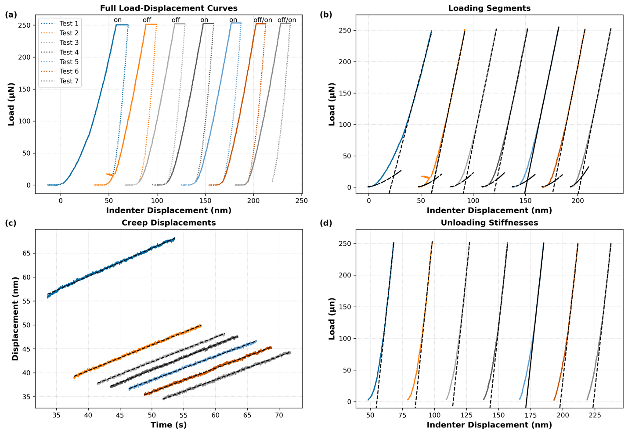

Fig. S1 (a) Load-displacement curves for seven consecutive tests performed in load-control mode on the same particle with the beam on or off as indicated in Table S1. Curves in (a), (b), and (d) are spaced such that the rise point of each curve corresponds to the end of the previous curve. (b) Loading segments from each test with Hertzian fits to the initial portion and linear fits to the latter. (c) Load hold segments from each test with linear fits. (d) Unloading segments with linear fits. In (b-d), solid lines indicate experimental data, and dashed black lines denote fitted curves

The electron beam was on during the first test, and in subsequent tests the beam was either off (Tests 2 and 3), on during the entire test (Tests 4 and 5), or turned on during the constant-load hold (creep) segment (Tests 6 and 7), as documented in Table S1. Stiffness was substantially lower during the first test, as evidenced by the lower slope and greater indenter displacement needed to reach 250 µN. A small kink appeared during this test near 25 nm displacement, and may correspond to yielding or movement of the particle. The particle exhibited smaller differences in loading, creep, and unloading behaviors from the first unloading onward. While the unloading stiffness was ≈ 5% higher in tests with the beam off, the generally consistent mechanical behaviors across multiple tests with the beam on and off suggest that beam effects were minor with the parameters used in these experiments. It should be noted that prolonged, intense, high energy electron beam exposures could alter the particles. Hence, to reduce potential damage, experiments employed minimum beam energies and currents necessary for acceptable imaging (≤ 1.5 kV, ≈ 70 pA), while lower magnifications and beam blanking minimized the accumulated electron dose.

Hertzian theory [7] describes a contact between two non-adhesive elastic bodies by

 | $f=kδ^{3/2}$, | Equation S1

where f is the force, k the stiffness, and δ the displacement. Note that in this generalized form, k incorporates both elastic properties and the shapes of the surfaces in contact. The dashed lines in Fig. S1(b) correspond to fits of Equation S1 to the first 75 data points (about 5 nm displacement) of the loading segment data, but the curves are plotted over about 20 nm to illustrate agreement during the initial contact regime and subsequent deviation. Linear fits in Fig. S1(b) correspond to the final 3000 data points (about 25 nm displacement), but lines are plotted over a greater displacement range to show where the loading curves deviate from linearity. The dashed lines in Fig. S1(c) show linear fits to the displacement-time data from the creep segment. The dashed lines in Fig. S1(d) are linear fits to the first third of the data points from the unloading segment, plotted over a greater displacement range to show where the unloading data diverge from the linearity.

Table S1 Test conditions from the electron beam sensitivity tests and curve fitting parameters from the plots in Fig. S1. Fitted values of k and loading stiffness correspond to Fig. S1(b), accumulated creep displacements to Fig. S1(c), and values of unloading stiffness to Fig. S1(d)
Test  Number | Beam Condition |  |  | k  (µN/nm^{3/2}) | Loading  stiffness  (µN/nm) | Creep Displacement  (nm) | Unloading  Stiffness  (µN/nm)
Test  Number | Load | Hold | Unload
1 | ON | ON | ON | 0.15 | 6.3 | 12.4 | 19.1
2 | OFF | OFF | OFF | 0.20 | 8.1 | 10.6 | 19.9
3 | OFF | OFF | OFF | 0.23 | 8.2 | 10.6 | 19.7
4 | ON | ON | ON | 0.23 | 8.2 | 10.8 | 18.9
5 | ON | ON | ON | 0.20 | 8.1 | 9.8 | 18.6
6 | OFF | OFF/ON | ON | 0.23 | 8.4 | 10.1 | 18.3
7 | OFF | OFF/ON | ON | 0.43 | 8.4 | 9.9 | 18.5

The dashed lines in Fig. S1(b) correspond to fits of Equation S1 to the first 5 nm of the loading segment data, but the curves are plotted over about 20 nm to illustrate brief agreement and subsequent deviation. Linear fits in Fig. S1(b) correspond to the final portion of the loading segment. The initial 5-10 nm of the loading curves agreed with the Hertzian form given in Equation S1 as shown in Fig. S1(b), whereas the linear $(f∝δ$) fits agree with much of the rest of the curves. These differences indicate that the sample began to transition from a Hertzian to a linear load-displacement relationship within the first ≈ 10 nm of displacement following initial contact, and that the transition occurred earlier and more abruptly with each consecutive test. Together these observations suggest the formation of an increasingly flat contact between the particle surface and indenter tip as would be expected from local yielding. It is also apparent that the data are more appropriately interpreted as uniaxial compressions, rather than Hertzian contacts between a convex particle surface and flat punch.

Dashed lines in Fig. S1(c) show linear fits to the displacement-time data from the load hold segment. Displacements accumulated during the creep segment gradually decreased in Tests 1-4 and remained essentially unchanged for Tests 5-7. Fig. S1(c) shows that Tests 1 and possibly 2 were the only ones to exhibit decreasing creep rates during the segment, as is expected for most materials [8]. The observed linearity of the other creep curves may suggest that drift played a role, rather than the material response alone. To investigate the magnitude of potential drift, tests were conducted in which the indenter was held in contact with a particle-free area of the silicon substrate for 20 s at loads of 250 and 750 µN. Creep displacements of 1.3 ± 0.4 nm (mean ± standard deviation) were measured across six separate tests. The comparatively large observed creep displacements of ≈ 10 nm in the particle tests support the creep hypothesis, however, the video and indenter data cannot completely rule out drift under these experimental conditions. The magnitudes of the creep displacements were investigated by subtracting larger and larger constant drift rates until the loading and unloading segments coincided, resulting in an unrealistic T-shaped interface between the loading and creep segments. That is, the creep segment data points were shifted so far that their ends no longer aligned with the loading and curves. The greatest realistic drift correction corresponds to the point just before the decoupling of the ends of the creep segment and loading and unloading segments – in that case, displacement during the creep segments consistently ranged from approximately 1 to 2 nm. A similar treatment of the creep tests performed with the indenter directly on the substrate found that the loading and unloading segments could be brought to nearly coincide with each other without creating unrealistic curve shapes. In those cases, the creep displacements ranged from 0.2 to 0.9 nm.

Linear fits in Fig. S1(d) correspond to the initial portion of the unloading segment, the slope of which defines the unloading stiffness. Unloading stiffness values in Table S1 were ≈ 6 % higher with the beam off and generally decreased from tests 2-7. However, it may be more accurate to state that unloading stiffness remained consistent at 19 ± 0.6 µN/nm (mean ± standard deviation), as it is unclear whether the small differences in unloading stiffness arose from real changes to the sample or from experimental noise. Unloading stiffness values exceeded the loading stiffness values, which is consistent with plastic deformation during loading and the constant hold segment. Finally, the consistent differences between loading and unloading stiffness values in consecutive tests suggests some degree of elastic recovery.

Despite the clear evidence of plastic deformation no clear signs of yielding or fracture appeared over the course of the seven tests, aside from the kink near 25 nm displacement in Test 1. The indenter advanced greater distances with each consecutive test prior to contact with the particle, and the loading segments transitioned more and more quickly to a linear regime following contact with the particle. Inspection of the curves in Fig. S1(a) shows that the ≈ 20 nm of residual deformation (i.e., the distance from the beginning of loading to the end of unloading) exceeded the creep displacements of ≈ 10 nm by a factor of approximately two. Hence, creep alone insufficiently explains the magnitudes of the observed deformations.

References
[1] K. A. Rzepiejewska-Malyska, G. Buerki, J. Michler, R. C. Major, E. Cyrankowski, S. A. S. Asif, et al., In situ mechanical observations during nanoindentation inside a high-resolution scanning electron microscope, J Mater Res. 23(7), 1973-1979, (2008) https://doi.org/10.1557/JMR.2008.0240
[2] J. H. Urbelis and J. A. Swift, Solvent Effects on the Growth Morphology and Phase Purity of CL-20, Cryst Growth Des. 14(4), 1642-1649, (2014) https://doi.org/10.1021/cg401774s
[3] S. Bhowmick, D. Stauffer, R. Major, O. Warren, and S. A. Syed Asif, A Combined Effect of Electron Beam and Stress on Plastic Flow of Amorphous Silica Microparticles, Microsc Microanal. 21(S3), 1015-1016, (2015) https://doi.org/10.1017/S1431927615005875
[4] D. Stauffer, S. Bhowmick, R. Major, O. L. Warren, and S. A. Syed Asif, High Plastic Strain of Silica Microparticles under Electron Beam Irradiation, Microsc Microanal. 20(S3), 1544-1545, (2014) https://doi.org/10.1017/S1431927614009453
[5] M. Mačković, F. Niekiel, L. Wondraczek, E. Bitzek, and E. Spiecker, In situ mechanical quenching of nanoscale silica spheres in the transmission electron microscope, Scripta Mater. 121(70-74, (2016) https://doi.org/10.1016/j.scriptamat.2016.04.019
[6] P. Virtanen, R. Gommers, T. E. Oliphant, M. Haberland, T. Reddy, D. Cournapeau, et al., SciPy 1.0: fundamental algorithms for scientific computing in Python, Nat Methods. 17(3), 261-272, (2020) https://doi.org/10.1038/s41592-019-0686-2
[7] H. Hertz, Ueber die Berührung fester elastischer Körper, J Reine Angew Math. 1882(92), 156-171, (1882) https://doi.org/10.1515/crll.1882.92.156
[8] A. H. Cottrell, The time laws of creep, J Mech Phys Solids. 1(1), 53-63, (1952) https://doi.org/10.1016/0022-5096(52)90006-9

