Supplementary Information
- Changed the title.

- This assumption is also confirmed by data on dynamic light scattering in samples (Figure 3). Small decrease in zeta potential should also be noted (Table 1)

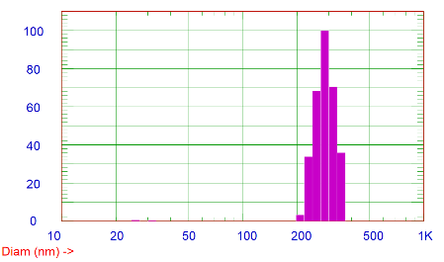
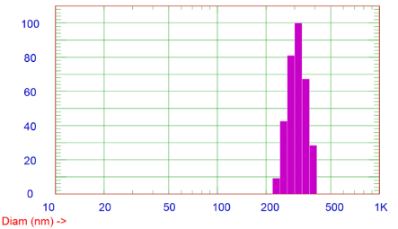
(b)
(a)

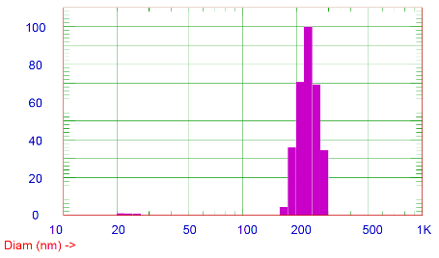
(c)

Figure 1. Size of BaTiO₃-OH nanoparticles modified with (a) 1, (b) 2 and (c) 3 (%v/v) hydrolyzed chitosan

Table 1. Average size and Z potential values of BaTiO₃-OH nanoparticles modified with (a) 1, (b) 2 and (c) 3 (%v/v) hydrolyzed chitosan
Sample | Average size (nm) | Z potential (mV)
BaTiO₃@CH1 | 314.2± 0.1 | 14.34 ± 0.70
BaTiO₃@CH1 | 287.5± 0.1 | 13.66 ± 0.22
BaTiO₃@CH1 | 220.4± 0.1 | 12.36 ± 0.69

- Stability of BaTiO₃-OH nanoparticles modified with 3 (%v/v) hydrolyzed chitosan
Day 1: 04/07/2022
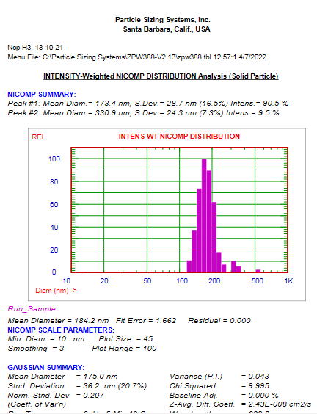

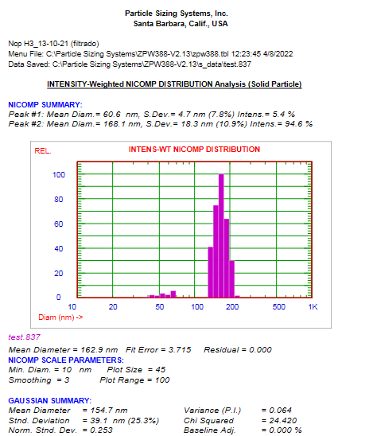
Day 2: 04/08/2022

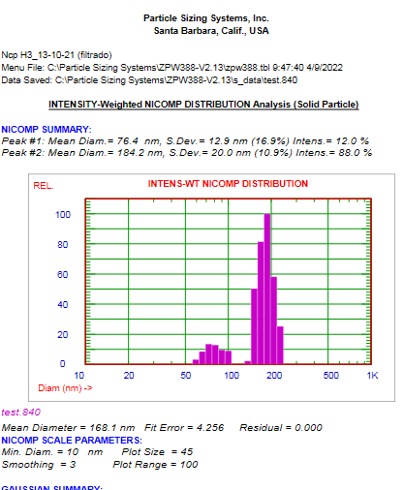
Day 3: 04/09/2022:

Figure 2. Stability of BaTiO₃-OH nanoparticles modified with 3 (%v/v) hydrolyzed chitosan

