Supplementary Information

Investigating the dielectric constant of barium titanate in a
polymer-matrix nanocomposite

Emma Cooper¹, Eduardo De Anda¹, Evan Flitz¹, Halie Kim¹, Nicholas Casañas¹, Lillian Johnson¹, Zoe Kedzierski¹, Jessica Domrzalski², Albert Dato¹, Todd Monson^{2,*}

¹Department of Engineering, Harvey Mudd College, Claremont, CA 91711, USA
²Sandia National Laboratories, Albuquerque, NM 87185, USA
*tmonson@sandia.gov

Section 1 – x-ray diffraction pattern of tBuPA-functionalized BTO
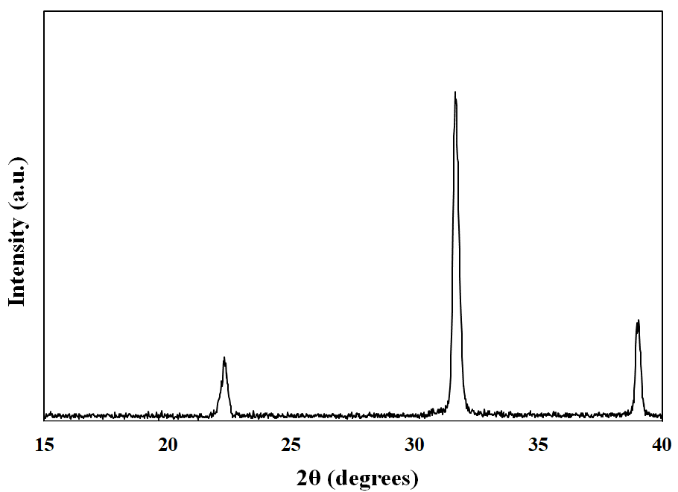
Fig. S1 X-ray diffraction pattern of tBuPA-functionalized BTO nanoparticles with particle diameter of 300 nm. The peaks at 22.2º, 31.5º, and 38.8º indicate the tetragonal crystal structure of the BTO nanoparticles [1-3].

Section 2 – tBuPA calculation

BTO properties
Molecular Weight of Barium Titanate (g/mol) 233.1922 g/mol
Density of Barium Titanate (g/cm^3) 6.02 g/cm³

tBuPA properties
Molecular Weight tBuPA (g/mol) 138.10 g/mol
Surface Area / mol Surfactant (nm^2/mol) 3.029E+22 nm²/mol
Surface Area /mol Surfactant (m^2/mol) 3.029E+04 m²/mol
Surface Area / Molecule (nm^2/molecule) 5.031E-02 nm²/molecule
Surface Area / Molecule (angstrom^2/molecule) 5.031E+00 angs²/molecule

Grinding media properties
Density of Bulk Zirconia 5.68 g/cm³

ABS properties
Density of ABS 1.03 g/cm³

Variables
Diameter of spherical BTO particle d nm
Density of BTO ρ g/cm³
Mass of BTO in the sample M g
Surface Area per mole of tBuPA SAmol, tBuPA nm²/mol

Surface Area of Spherical Nanoparticle,
SABTO (cm²) SA_BTO = 4πr^2 (10^(-14))
Volume of Spherical Nanoparticle, V (cm³) V = 4/3 πr^3 (10^(-21))

Mass of BTO / Nanoparticle, μ (g/nanoparticle) μ = V/ρ

tBuPA Calculation
# BTO Spheres, N N =M/μ
Total surface area of BTO, SATOT (cm2) SA_TOT = N * SA_BTO (10^(-4))
Moles Surfactant Needed, moltBuPa (mol) mol_tBuPA = SA_TOT/SA_(mol,tBuPA)
Mass Surfactant Needed (g) M_tBuPA = mol_tBuPA * molar mass_tBuPA

Section 3 – capacitance measurement method

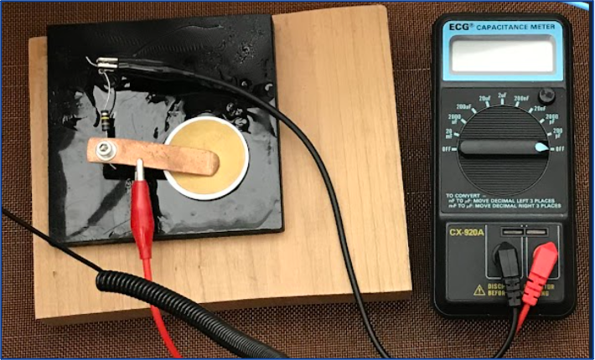
Fig. S2 Capacitance Measurement Setup. Composites were measured in triplicate with 15 seconds between to allow for discharging. The meter was standardized using a disc of pure ABS and the published dielectric constant value of 3.19. Sufficient contact between the charged copper and gold electrodes of composite is crucial. Not pictured is a copper disc underneath the nanocomposite disk.

Equation S1 $ε=\frac{ Capacitance (F) * thickness (m)}{surface area (m^{2})}$

Equation S2 $Dielectric Constant = \frac{ɛ}{ɛ_{0}} ; where ɛ_{0}=8.854*10^{-12}$

Section 4 – TEM images of BTO-ABS nanocomposites

Fig. S3 (a) TEM image of BTO nanoparticles with an average particle diameter of 50 nm incorporated into an ABS matrix. Scale bar is 1 μm. (b) TEM image of BTO nanoparticles with an average particle diameter of 200 nm incorporated into an ABS matrix. Scale bar is 1 μm. (c) TEM image of BTO nanoparticles with an average particle diameter of 500 nm incorporated into an ABS matrix. Scale bar is 1 μm
Section 5 – volumetric internal energy calculation

In finding the composite dielectric constant, we computed the internal energy U of the composite using
$U=\iiint{\frac{1}{2}εε_{0}E^{2}dVol }$ where $ε$ is the dielectric constant of either ABS or BTO at the infinitesimally small volume that is being integrated. For capacitors, $U=\frac{1}{2}CV^{2}$ and solving for C we get $C=\frac{2U}{V^{2}}$. Then using the equation $C=\frac{ε_{c}ε_{0}A}{d}$ we use our previously defined C and solve for $ε_{c}$. Solving for $ε_{c}$ gives us $ε_{c}=\frac{2Ud}{V^{2}ε_{0}A}$.

Section 6 – mean BTO vol% by nanoparticle size

Nanoparticle Size | 50 | 100 | 200 | 300 | 400 | 500
Mean BTO vol% | 31.4 | 35.1 | 33.8 | 34.5 | 37.6 | 37.0
Table S1 Mean BTO vol% for composites of the six nanoparticles sizes.

Section 7 – ANOVA

A two-way additive analysis of variance was performed with the raw data obtained via capacitance measurements and density measurements of the samples generated following the procedure outlined in section 2.1. The BTO nanoparticle size and volume percent of the composite were analyzed for effect on the dielectric constant of the composite. The nanoparticle size factor levels were each of the nanoparticle sizes (50, 100, 200, 300, 500; all in nm). The volume percent BTO was factored by grouping at three levels according to the closest vol.% level. The levels were 30, 35, and 40. These results are present in Table SI.T2.

Factor | F-Value | P-Value
Particle Size | 13.55 | 0.0022
Volume Percent | 0.74 | 0.41
Table S2 Two-way ANOVA test results for nanocomposites.

Using the Bonferroni Correction to maintain a 95% confidence level for the entire test, an individual α level of 0.025 was used as a criterion for null hypothesis evaluation. The null hypothesis is that neither of the factors have an influence on the dielectric constant of the composite. However, as the p-value of nanoparticle size is less than the threshold value of 0.025, nanoparticle size is understood to have an effect. Volume percent results do not reject the null hypothesis.

References

[1] T.M.K. Nayak G, Industrial Engineering & Management 04(03), (2015). https://doi.org/10.4172/2169-0316.1000166
[2] M. Singh, B.C. Yadav, A. Ranjan, M. Kaur, S.K. Gupta, Sensors and Actuators B: Chemical 241, 1170 (2017). https://doi.org/10.1016/j.snb.2016.10.018
[3] R. Tomar, R. Pandey, N.B. Singh, M.K. Gupta, P. Gupta, SN Appl. Sci. 2(2), (2020). https://doi.org/10.1007/s42452-020-2017-8

