Supplementary data

Study of Sargassum as a biosorbent material for the elimination of contaminants dissolved in water
J. Luis Lopez-Miranda¹, Alberto Elizalde-Mata¹, Rodrigo Esparza¹, Miriam Estevez^{*1}
¹ Centro de Física Aplicada y Tecnología Avanzada, Universidad Nacional Autónoma de México, Boulevard Juriquilla 3001, Santiago de Querétaro, Qro., 76230, México.

Corresponding author: miries@fata.unam.mx

S1. Kinetic models
The concentration decrease of phosphate and sulfate in the solution was analyzed to determine the removal process over time. In order to describe the removal kinetics, two mathematical models were applied to the experimental data: the Lagergren pseudo-first-order kinetic model (LPFOM) and the pseudo-second-order kinetic model (PSOM). The adsorption capacity of phosphates and sulfates over time and at the equilibrium, q_{t, e} (mg*g⁻¹), was calculated by Eq. S1:
 | $$q_{t, e}=\frac{\left(C_{i}-C_{e, t}\right)*V}{W}$$ | (Eq. S1)
where C_{i} and C_{e, t} (mg*L⁻¹) are the sulfates or phosphates concentrations at initial, and at over and equilibrium time, respectively, V (L) is the solution volume used, and W (g) is the mass of adsorbent used.
Langmuir and Freundlich's adsorption isothermal models were used to complete the description of the adsorption mechanism involved in the sulfates and phosphates removal. The maximum adsorption capacity (Q_{m}) and the removal efficiency percentage were calculated for each contaminant using the obtained isothermal data.
In addition, the removal efficiency (RE) was calculated for each contaminant concerning each C_{i} using the maximum sorption capacity (Q_{m}) obtained from the isothermal model results. The RE percentage was determined using the equation:
 | $$\%RE=\frac{q_{e}*100}{Q_{m}}$$ | (Eq. S2)
- Lagergren first-order and pseudo-first-order kinetic model (LPFOM): this model suggests that the adsorption occurs through diffusion in the interface, based on the assumption that the adsorption rate is directly proportional to the difference in saturation concentration and the amount of solid uptake with time [1]. The model can be used in the following linear form:

$\log\left(q_{e}-q_{t}\right)=\log\left(q_{e}\right)-\left(\frac{k_{1}}{2.303}\right)*t$ (Eq. S3)

where q_{e} and q_{t} (mg*g⁻¹) are the adsorption capacity at equilibrium and at the time (t), respectively; k₁ is the equilibrium rate constant (min⁻¹).
- Second-order and pseudo-second-order kinetic model (PSOM): this model assumes that the rate-limiting step is mainly chemisorption, however, physisorption could co-occur. The adsorption rate depends on the adsorption capacity, not the adsorbate concentration [1,2]. The pseudo-second-order kinetic model can be expressed as follows:
$\frac{t}{q_{t}}=\frac{1}{\left(k_{2}*q_{e}^{2}\right)}+\frac{t}{q_{e}};$with $h=k_{2}*q_{e}^{2}$ (Eq. S4)

where h is the initial sorption rate (mg*g⁻¹*min⁻¹), q_{e} and q_{t} are the adsorption capacity at equilibrium and at the time (mg*g⁻¹), t is the time (min), and k₂ is the equilibrium rate constant (g*mg⁻¹*min⁻¹).
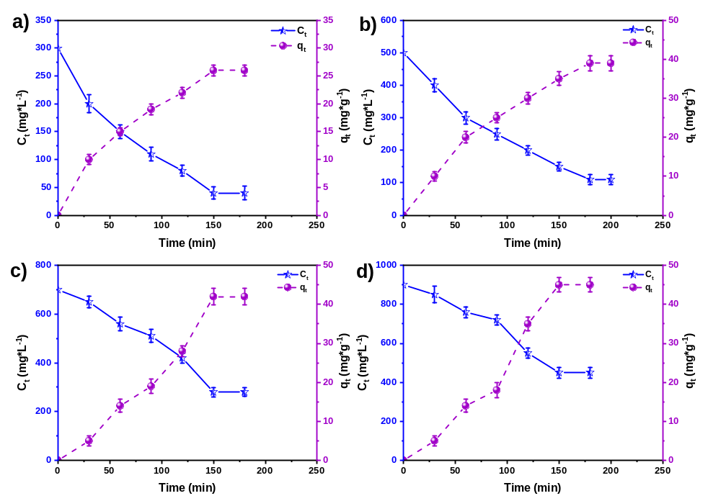
Figure S1. Curves of phosphates removal at different C_{i}s: a).300, b) 500, c) 700, and d) 900 mg*L⁻¹.
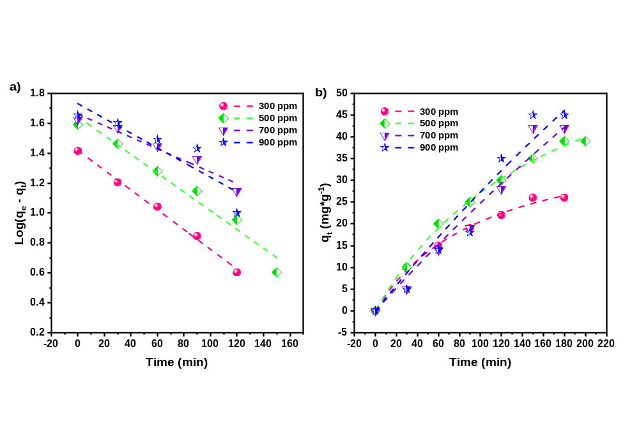
Figure S2. Kinetic model curves of phosphates removal: a) LPFOM, and b) PSOM.
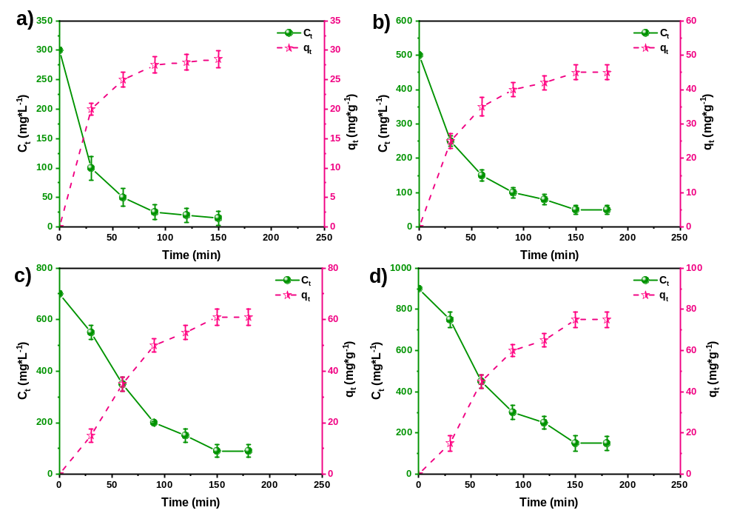
Figure S3. Curves of sulfates removal at different C_{i}s: a).300, b) 500, c) 700, and d) 900 mg*L⁻¹.
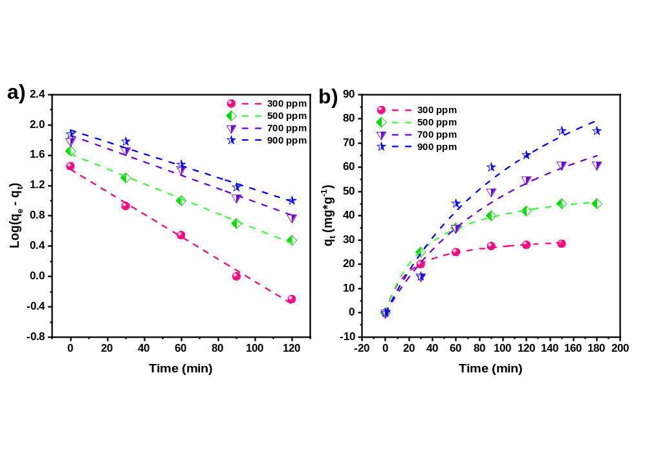
Figure S4. Kinetic model curves of sulfates removal: a) LPFOM, and b) PSOM.

S2 Isothermal models
- Langmuir model: this model assumes that the adsorbent and the adsorbate are in a dynamic equilibrium, the surface is majority homogeneous, the adsorption occurs in a monolayer process, there is no lateral interaction between adsorbed molecules, and the adsorption is reversible. The model is represented in the following equation:
$\frac{1}{q_{e}}=\frac{1}{K_{L*}*Q_{m}{*C}_{e}}+\frac{1}{Q_{m}}$ (Eq. S5)
where Q_{m} (mg*g⁻¹) and C_{e} (mg*L⁻¹) are the maximum adsorption capacity and the concentration at equilibrium, respectively, and K_{L} is the Langmuir constant, which represents the energy of adsorption or the equilibrium constant of adsorbate-absorbent equilibrium (L*mg⁻¹) . The adsorption characteristics of the Langmuir isotherm can be explained in terms of a dimensionless constant R_{L} (separation factor), which is defined as follows:
$R_{L}=\frac{1}{1+{(K}_{L}*C_{e})}$ (Eq S4)
The R_{L} factor indicates if the adsorption process is favored or not. If 0 < R_{L} < 1, adsorption is considered favorable, irreversible for RL=0, unfavorable for R_{L} > 1, and linear adsorption when R_{L}=1.
- Freundlich model: it can describe nonideal, multilayer, reversible adsorption in a heterogeneous surface. The isotherm model assumes that all the adsorption sites have different binding energies and follow an exponential-type function, which is close to the real situation. The empirical equation represents it:
$q_{e}=K_{F}*C_{e}^{1/n}$ (Eq. S6)
where C_{e} is the equilibrium concentration of the adsorbate (mg*L⁻¹). K_{F} and 1/n are the Freundlich constants representing the adsorption capacity and intensity, respectively. The value of 1/n gives characteristic information regarding the adsorption process. When 0<1/n<1, the adsorption is considered favorable, whereas if 1/n > 1 is cooperative or unfavorable (weak interactions) and is irreversible at 1/n = 1 [3,4].
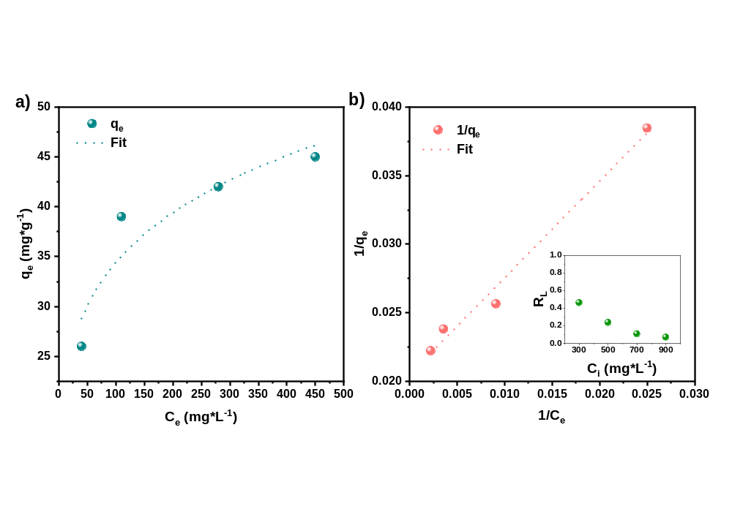
Figure S5. Isothermal model curves of phosphates removal: a) Freundlich, and b) Langmuir.
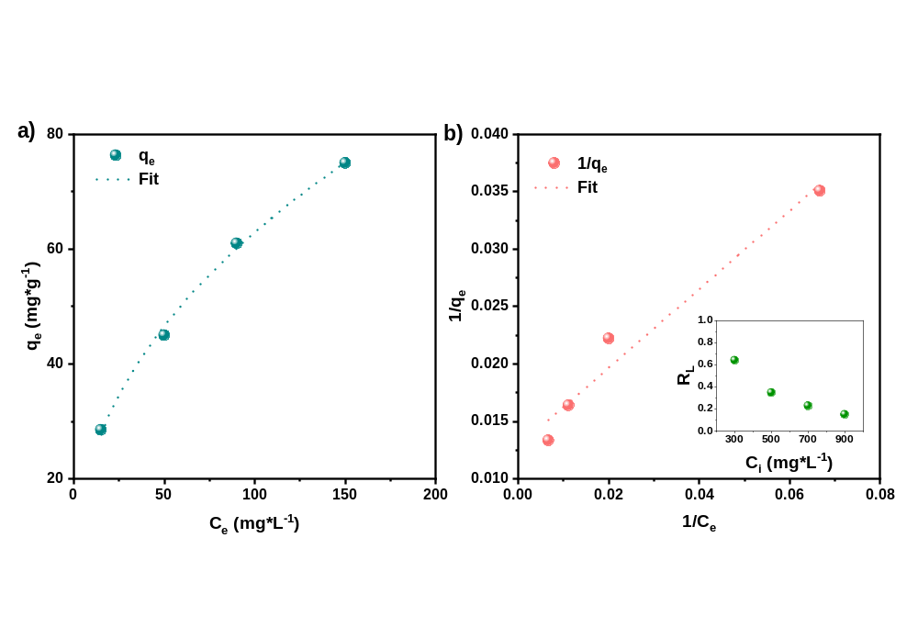
Figure S6. Isothermal model curves of sulfates removal: a) Freundlich, and b) Langmuir.

References
[1] T.R. Sahoo, B. Prelot, Adsorption processes for the removal of contaminants from wastewater: The perspective role of nanomaterials and nanotechnology, Elsevier Inc., 2020. https://doi.org/10.1016/B978-0-12-818489-9.00007-4.
[2] Y. Fei, Y. Li, S. Han, J. Ma, Adsorptive removal of ciprofloxacin by sodium alginate/graphene oxide composite beads from aqueous solution, J. Colloid Interface Sci. 484 (2016) 196–204. https://doi.org/10.1016/j.jcis.2016.08.068.
[3] S. Azizian, S. Eris, Adsorption isotherms and kinetics, Interface Sci. Technol. 33 (2021) 445–509. https://doi.org/10.1016/B978-0-12-818805-7.00011-4.
[4] J. Wang, X. Guo, Adsorption isotherm models: Classification, physical meaning, application and solving method, Chemosphere 258 (2020) 127279. https://doi.org/10.1016/J.CHEMOSPHERE.2020.127279.

