Supplementary information
Scalable Manufacturing of Graphene Oxide Electrodes for Flexible Nucleic Acid Biosensors
Amit K. Barui†,‡,#, Abbey Koneru†,‡,#, Winston Yen-Yu Chen†,‡, Ana Maria Ulloa Gomez†,‡, Ya-Ching Yu†,‡,#, Rahim Rahimi†,‡ and Lia A. Stanciu†,‡,#,*
† School of Materials Engineering, Purdue University, West Lafayette, Indiana 47907, United States
‡ Birck Nanotechnology Center, Purdue University, West Lafayette, Indiana 47907, United States
# Bindley Bioscience Center, Purdue University, West Lafayette, Indiana 47907, United States
*email: lstanciu@purdue.edu

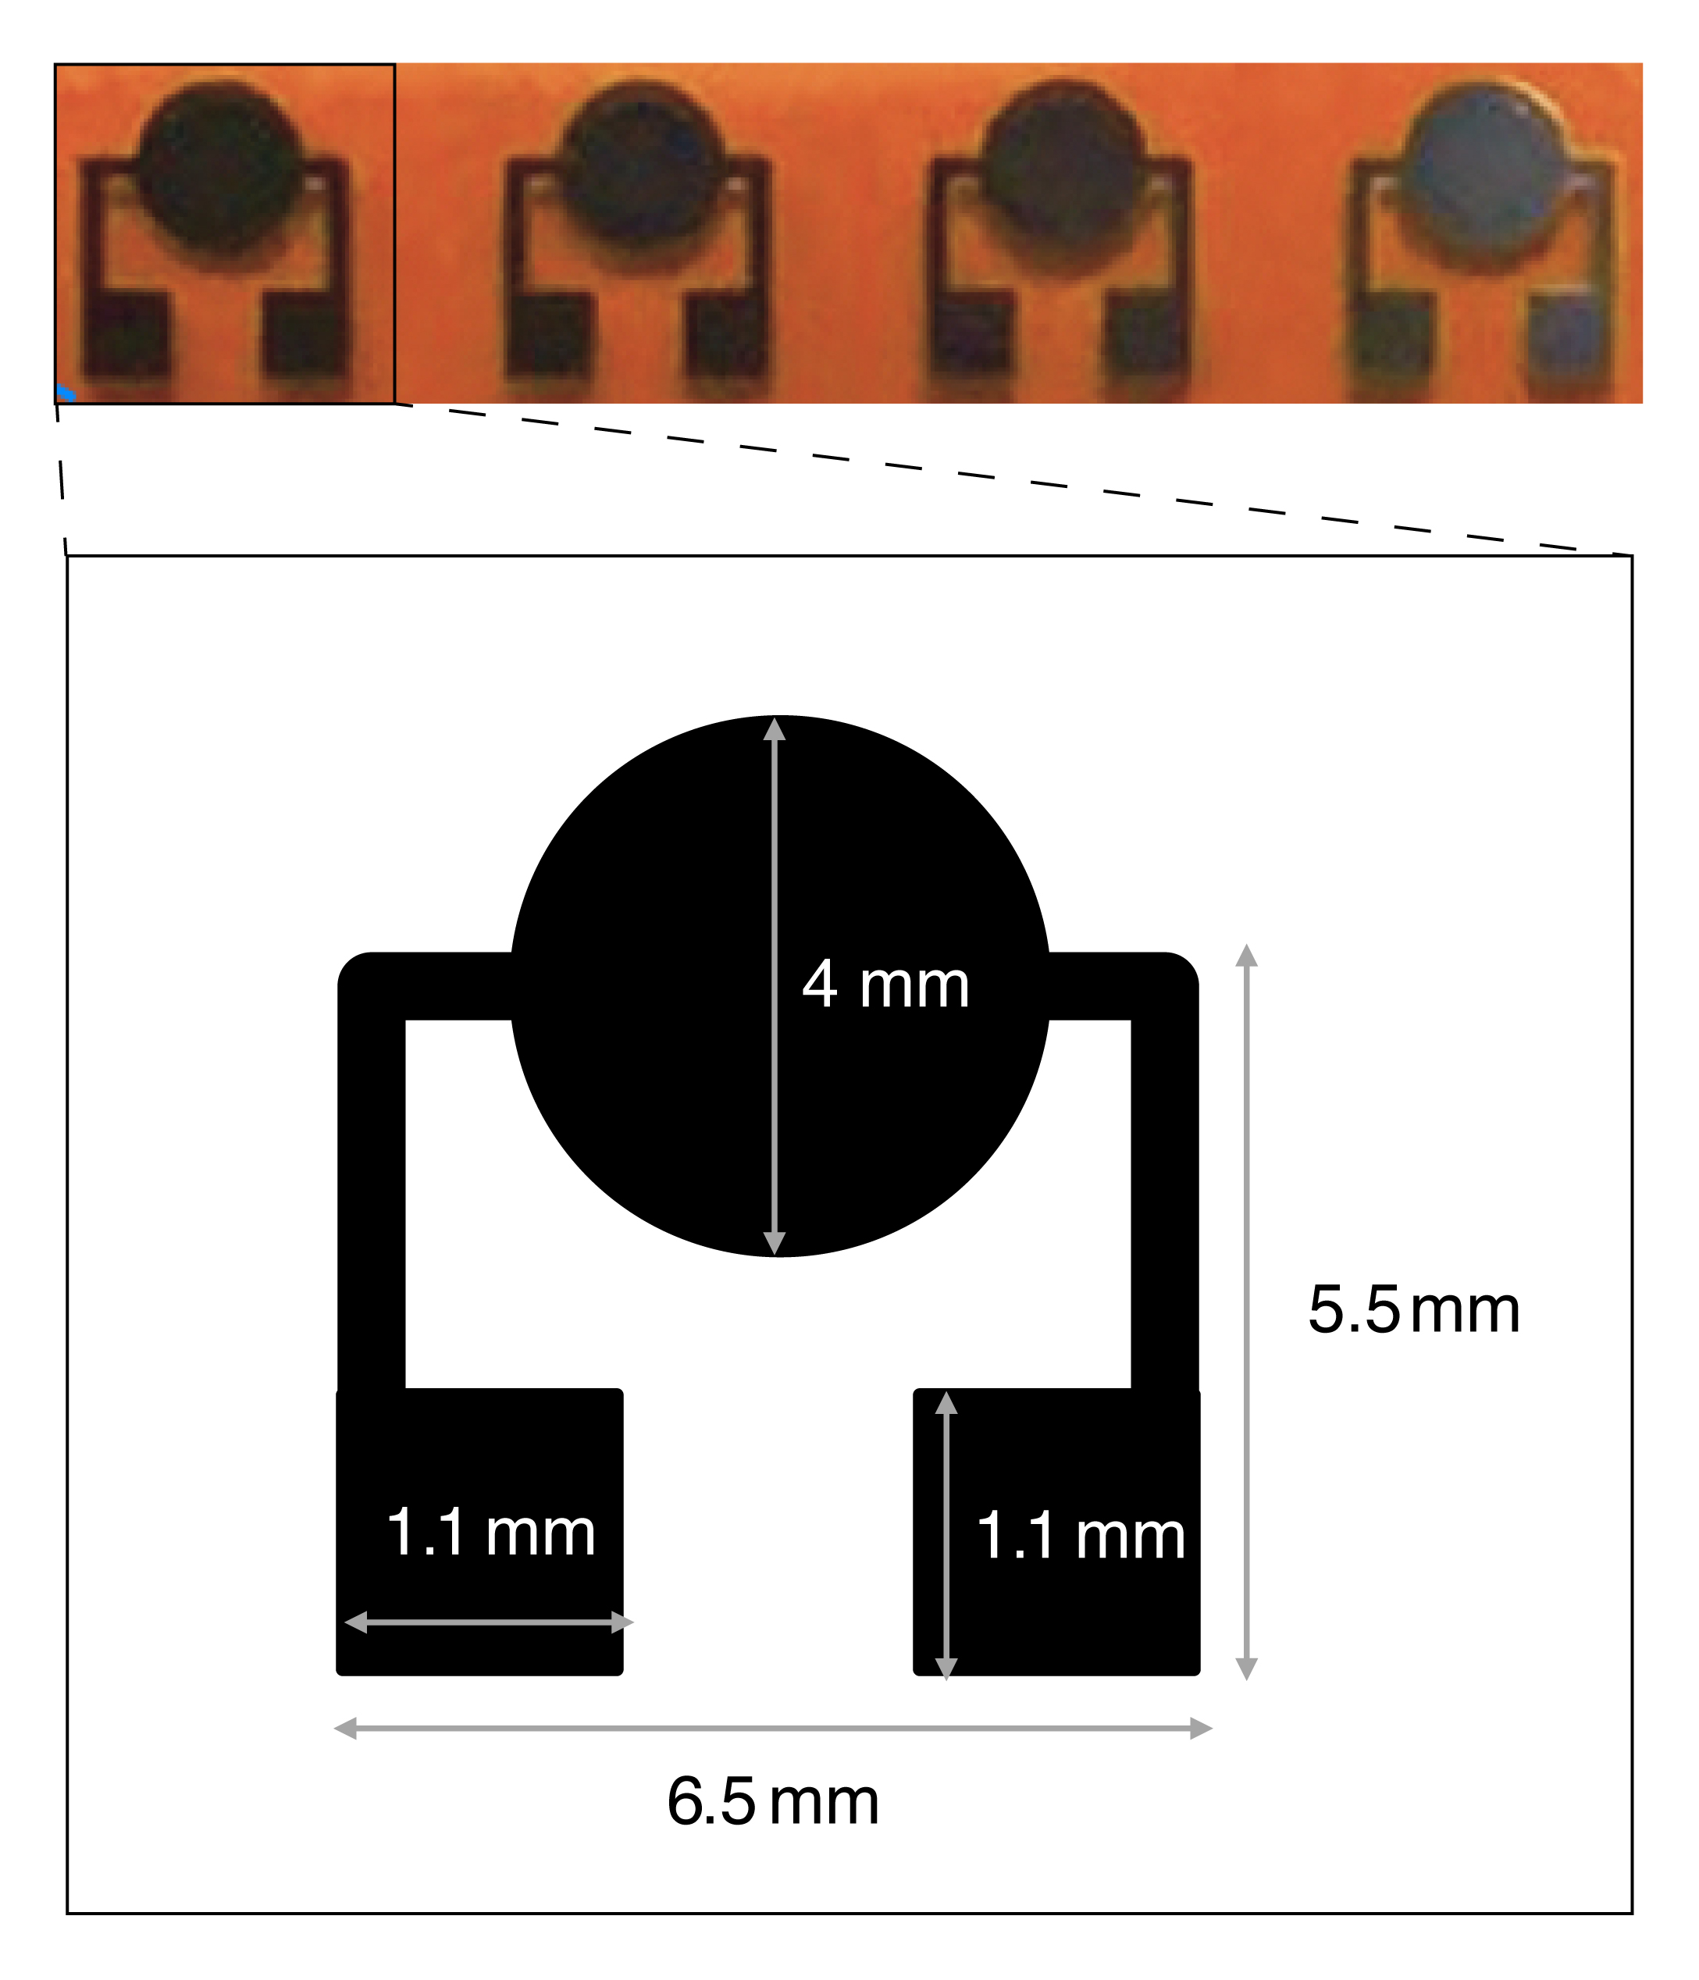
Figure S1. Schematic of the printed sensor array on polyimide.

