Supplementary material

Study of the removal of microplastics in aquatic environments using Sargassum spp. from the Mexican Caribbean
J. L. Lopez-Miranda*¹, Maximiliano Rios-Vargas², Edgar Serafín Mancera¹, I. Velázquez-Hernández¹, M. Estevez¹

¹ Centro de Física Aplicada y Tecnología Avanzada, Universidad Nacional Autónoma de México, Boulevard Juriquilla 3001, Santiago de Querétaro, Qro., 76230, México.
²Universidad Tecnológica de Querétaro, Nanotecnología, Av. Pie de la Cuesta 2501, Nacional 76148 Santiago de Querétaro, Qro, Mexico.

Corresponding author: lopezfim@fata.unam.mx

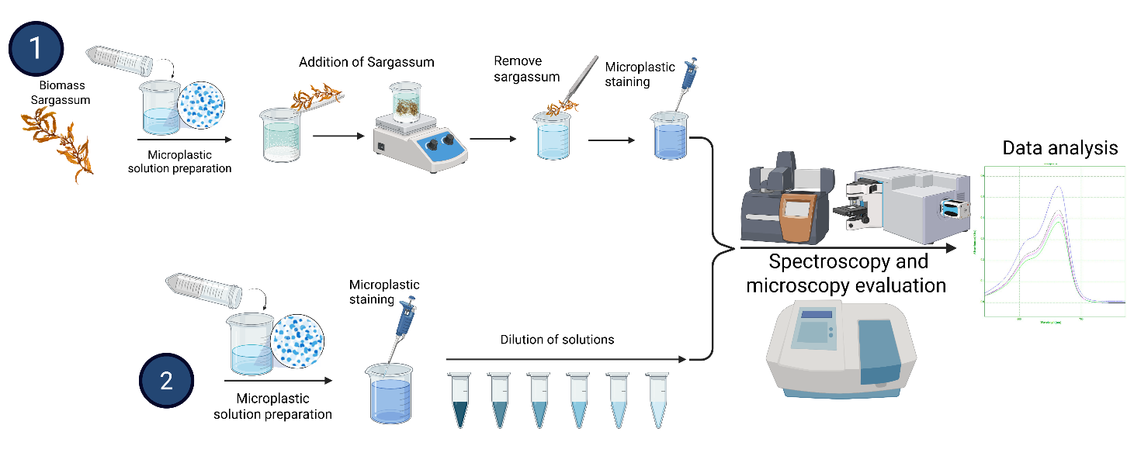
Fig. S1 Methodology section of the microplastic removal process using Sargassum spp.

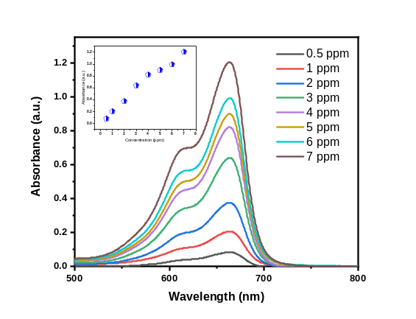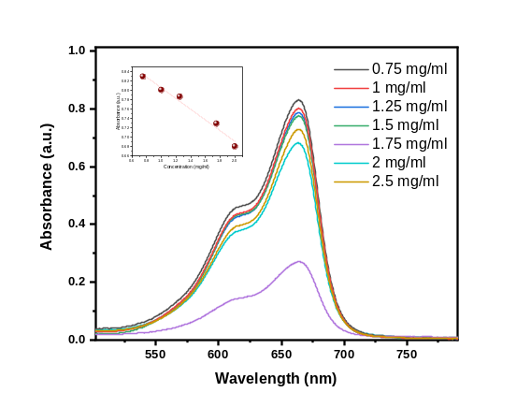
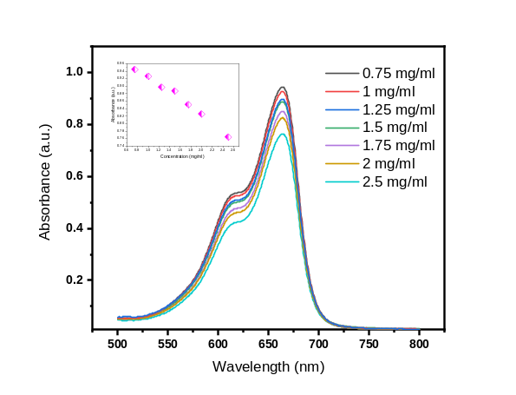
Fig. S2 Calibration curves of methylene blue are shown within the 0.5–7 ppm range. Also shown is the methylene blue response at 5 ppm in the presence of microplastics at concentrations ranging from 0.75 to 2.5 mg/mL.

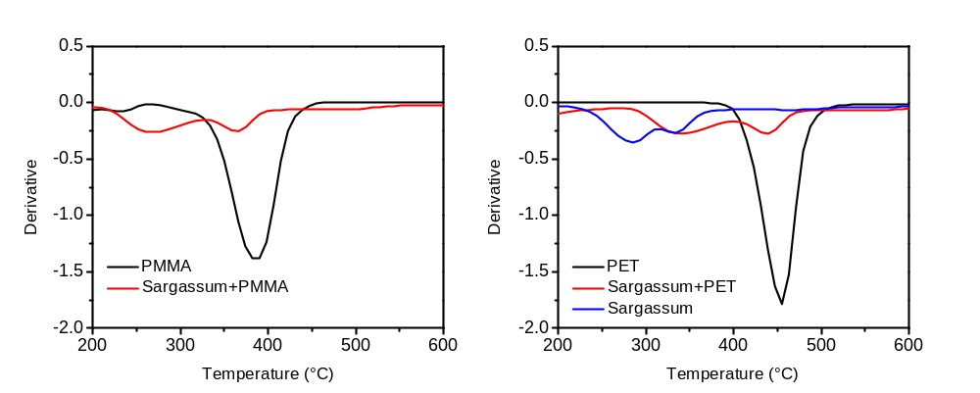
Fig. S3 DTG curves of PMMA and PET, as well as those in the presence of Sargassum spp., show variations in thermal decomposition.

Table S1 This table shows the positions of the Raman shifts (in cm⁻¹) and their corresponding assignments for the primary vibrational modes of polymethyl methacrylate (PMMA, acrylic) and polyethylene terephthalate (PET).
Polymer | Raman Shift (cm⁻¹) | Assignment
Acrylic (PMMA) | 597 | C-C-C skeletal and C-C-O angle deformation
 | 811 | Symmetric C-O-C stretching
 | 984 | C-O stretching and/or CH₃ rocking
 | 1449 | CH₃ and CH₂ bending (deformation)
 | 1727 | C=O (carbonyl) stretching of the ester group
PET | 852 | Benzene ring out-of-plane deformation and CH₂ rocking
 | 994 | C-H bending of the aromatic ring
 | 1093 | C-O stretching of the ester and ethylene glycol
 | 1174 | C-C stretching of the aromatic ring
 | 1285 | C-O stretching of the ester group (aromatic side)
 | 1613 | C=C stretching of the benzene (aromatic) ring
 | 1731 | C=O (carbonyl) stretching of the ester group

Table S2: Physicochemical properties of PMMA and PET polymers.

Property | PMMA (Acrylic) | PET (Polyester)
Structure | Amorphous | Semi-crystalline
Density (g/cm³) | 1.17 – 1.20 | 1.30 – 1.40
Melting Point (°C) | ~ 160 | 250 – 265
Glass Transition (°C) | 105 | 67 – 81
Light Transmission (%) | 92 | 85 – 90
Refractive Index | 1.49 | 1.57 – 1.65
Tensile Strength (MPa) | 48 – 76 | 55 – 80
Elastic Modulus (GPa) | 2.4 – 3.4 | 2.0 – 3.1
Impact Strength | Medium (Brittle) | High (Tough)
Water Absorption (%) | 0.3 | 0.1
UV Resistance | Excellent (Weather resistant) | Moderate (Requires stabilizers)
Chemical Resistance | Good vs. diluted acids; Poor vs. solvents. | Excellent vs. oils, fats, and most solvents.

