Supplementary Information for
Synthesis and characterization of sargassum-based hydrochar for the removal of emerging contaminants in aqueous media
Edgar Serafín Mancera¹, Angel Luis Rodriguez², Maricarmen Gomez-Paredes³, I. Velázquez-Hernández², J. Luis Lopez-Miranda*², Miriam Estevez²

¹ Posgrado en Ciencia e Ingeniería de Materiales, Centro de Física Aplicada y Tecnología Avanzada, Universidad Nacional Autónoma de México, Boulevard Juriquilla 3001, Querétaro, Qro., 76230, México.
² Centro de Física Aplicada y Tecnología Avanzada, Universidad Nacional Autónoma de México, Boulevard Juriquilla 3001, Santiago de Querétaro, Qro., 76230, México.
³ Universidad Tecnológica de Querétaro, Nanotecnología, Av. Pie de la Cuesta 2501, Nacional 76148 Santiago de Querétaro, Qro, México.

Corresponding author: lopezfim@fata.unam.mx

Physicochemical Characterization
Fig. S1 Analysis of Scanning Electron Microscopy (SEM) at different magnifications.

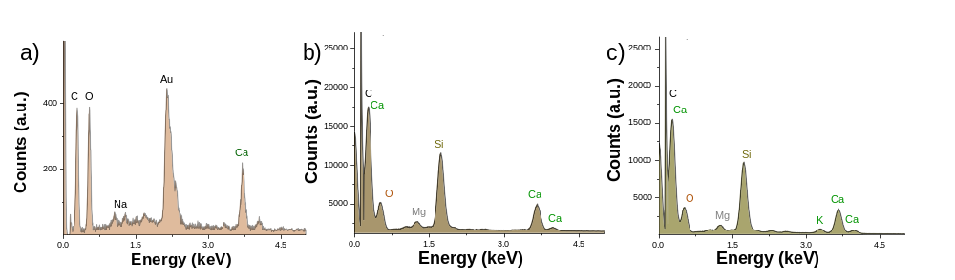
Fig. S2 Energy-dispersive X-ray spectroscopy (EDS) analysis of a) Sargassum, b) untreated biochar, and c) biochar treated with KOH.

The elemental composition of the activated hydrochar surface was determined by Energy Dispersive X-ray Spectroscopy (EDS) coupled with SEM analysis. The semi-quantitative results are summarized in Table S1.

Table S1 Quantitative results of the EDS analysis of the activated hydrochar.
Element | Peak energy (keV) | Maximum counts | Estimated relative abundance
Carbon (C) | ~0.28 | ~15,500 | Dominant
Oxygen (O) | ~0.51 | ~3,700 | High
Calcium (Ca) | ~3.66 | ~3,500 | High
Magnesium (Mg) | ~1.25 | ~1,300 | Moderate
Potassium (K) | ~3.31 | ~820 | Moderate-high

The analysis revealed that the composition is dominated by Carbon (C) and Oxygen (O), characteristic of a biomass-derived carbonaceous material. In addition, significant amounts of minerals such as Calcium (Ca) and, to a lesser extent, Magnesium (Mg) and Potassium (K) were detected.
The relative abundance of each element is estimated from the maximum number of counts detected for its characteristic energy peak. In EDS, a higher number of counts directly corresponds to a higher concentration of that element in the analyzed area. For example, Carbon shows ~15,500 counts and is "Dominant," while Magnesium, with ~1,300 counts, is "Moderate." This elemental composition is key to identifying potential active sites involved in surface processes, such as adsorption.

Kinetic Studies for the Adsorption of Cationic Dyes
Kinetic studies were performed to determine the adsorption rate and mechanism of Rhodamine B and Methylene Blue onto the hydrochar. The experimental data were fitted to pseudo-first-order and pseudo-second-order models to determine which model best describes the process.

Fig. S3 Calibration curve of methylene blue

Fig. S4 Calibration curve of rhodamine

Using the Beer-Lambert equation, concentrations were calculated from the absorbance data obtained in the degradation kinetics curve over time (10, 20, 30, 40, 50, 60, 90, 120, 1440 min).

Table S2 Concentration of dyes with respect to sampling time
Time | 25 ppm
Time | MB | Concentration | RB | Concentration
 | abs | ppm | abs | ppm
0 | 0 | 0 | 0 | 0
10 | 0.1556 | 1.17 | 0.2376 | 3.798323036
20 | 0.1532 | 1.1563 | 0.2266 | 3.657987643
30 | 0.147 | 1.1014 | 0.2175 | 3.62533098
60 | 0.141 | 1.0486 | 0.1994 | 3.543248014
90 | 0.131 | 0.9619 | 0.1825 | 3.486760812
120 | 0.123 | 0.8916 | 0.1713 | 3.476169462
1440 | 0.12 | 0.8654 | 0.170 | 3.469549868

Dye | $$q_{max}$$  $$(mg g^{-1})$$ | $$K_{L}$$  $$(L mg^{-1})$$ | $$R_{L}$$ | $$R^{2}$$ | $$K_{F}$$  $$(L mg^{-1})$$ | $$n_{L}$$ | $$R^{2}$$ |  | $$K_{RP}$$  $$(L g^{-1})$$ | $$A_{RP}$$  $$(L mg^{-1})$$ | $g$ | $$R^{2}$$
MB | 52±4.9 | 0.009 | 0.213 | 0.981 | 3.158 | 2.296 | 0.901 |  | 0.478 | 0.01 | 0.73 | 99.75
RB | 24±2.7 | 0.0046 | 0.350 | 0.989 | 0.567 | 1.789 |  | 0.995 | 0.243 | 0.14 | 0.59 | 99.7
Table S3 Parameters of isotherm models in the adsorption of methyl blue and rodamine-B

Removal efficiency as a function of contact time at different initial concentrations.
Figure S5 illustrates the effect of contact time on the adsorption capacity of the hydrochar at four different initial concentrations. Results demonstrate that increasing the organic dye concentration increases the adsorption capacity. The system approaches equilibrium significantly within the first 120 minutes; beyond this point, up to 24 hours, no significant variation in removal was observed. This behavior is attributed to a higher concentration, which acts as the driving force for mass transfer. The maximum removal obtained for methylene blue was 49.5±3 % at 50 ppm with a contact time of 24 hours between the adsorbent and the adsorbate. Similar results were obtained with rhodamine, with 24% removal.
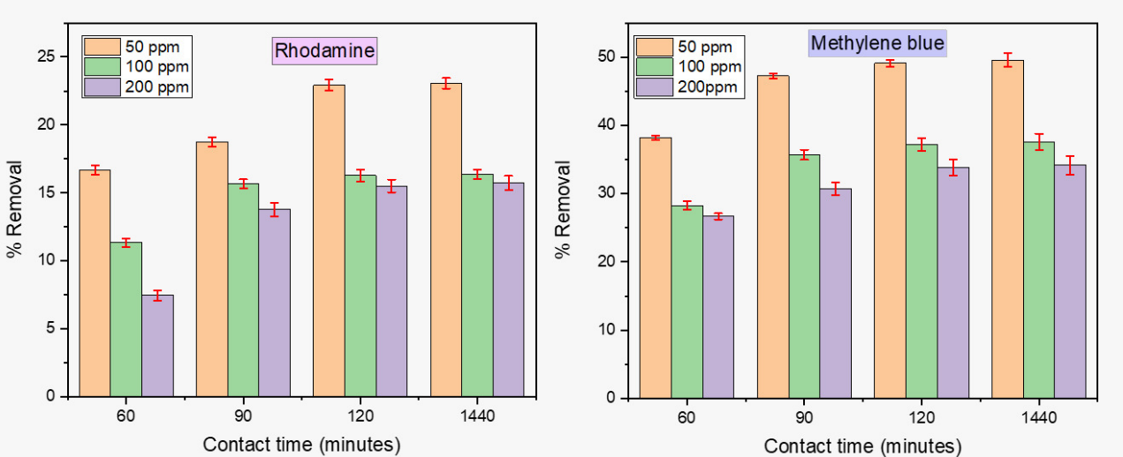
Fig. S5 Removal efficiency of methylene blue and rhodamine as a function of time at different initial concentrations.
For the removal of dyes, 200 mL of dye solution and 0.1 g of hydrochar were used, the exact quantities used in the calculation of qt (quantity of dye adsorbed per unit mass of adsorbent).
$$q_{t}=\frac{\left(C_{o}-C_{t}\right)*V}{m}$$
where:
- $Co$ is the initial dye concentration (for methylene blue and for rhodamine).
- $Ct$ is concentration over time.
- $V$ is the volume of the solution (200 mL)
- $m$ is the mass of hydrochar used (0.1 g).
 | $$q_{t}(mg/g)$$
Time | MB | RD
0 | 0 | 0
10 | 0.11888 | 0.07855
20 | 0.22727 | 0.14475
30 | 0.33217 | 0.30185
60 | 0.50699 | 0.44925
90 | 0.64685 | 0.48632
120 | 0.6993 | 0.58252
1440 | 0.7106 | 0.69991
Table S4 q_{t} calculation of rhodamine and blue methylene for 25ppm.

Once the amount of adsorbed dye is determined, the pseudo-first-order (PFO) and pseudo-second-order (PSO) models are applied, which are well-suited to carbonaceous materials.
The pseudo-first-order equation is as follows.
$$\frac{dqt}{dt}=k_{1}(q_{e}-q_{t})$$
where:
- $q_{t}$is the amount adsorbed at time t,
- $q_{e}$is the amount adsorbed at equilibrium
- $k_{1}$is the first-order adsorption rate constant (1/min)
- $t$ is the time in minutes.
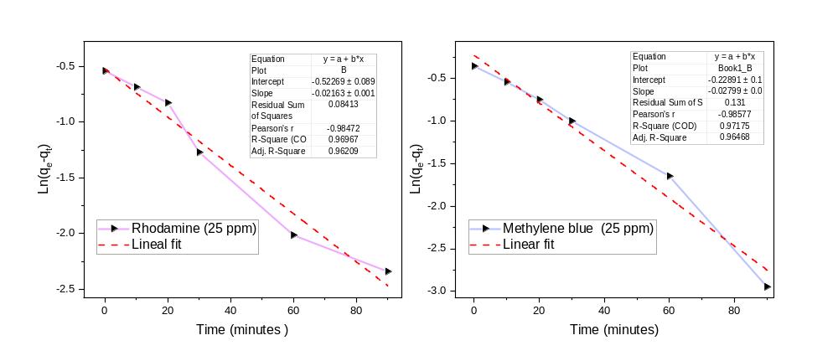
Fig. S6 Pseudo first-order fit to rhodamine and methylene for 25 ppm

Table S5 First pseudo-order calculation for rhodamine 25 ppm
Time | $$mg/g$$ | $$q_{t}$$ | $$q_{e}-q_{t}$$ | $${ln(q}_{e}-q_{t})$$
0 | 0 | 0 | 0.58252 | -0.54
10 | 3.798323036 | 0.07855 | 0.50397 | -0.685
20 | 3.657987643 | 0.14475 | 0.43777 | -0.826
30 | 3.62533098 | 0.30185 | 0.28067 | -1.271
60 | 3.543248014 | 0.44925 | 0.13327 | -2.015
90 | 3.486760812 | 0.48632 | 0.0962 | -2.341
120 | 3.476169462 | 0.58252 | - | -
1440 | 3.469549868 | 0.59991 | - | -

Therefore, in the ${ln⁡(q}_{e}-q_{t})=k_{1}t+b$
$$y = -0.021x - 0.522 \\ R² = 0.967$$
The slope is $m=-0.021$
$k_{1}=0.02277 \min^{-1}$.
The intercept is $b=-0.52$
$q_{e}$=$e$^{b}≈$0.59 (mg/g)$
$$q_{e}≈0.70 mg/g$$
This discrepancy indicates that the pseudo-first-order model adequately describes the rhodamine data (the $R^{2}$ of 0.9671, while linear, is lower than the second-order fit).
However, the model suggests that physisorption is not negligible and likely contributes to the overall process. A two-step adsorption mechanism can be postulated: an initial, rapid physical attraction (physisorption) of Rhodamine B molecules to the hydrochar surface, followed by a slower, more stable chemical interaction (chemisorption) that dictates the overall rate of the system. Similarly, it applies to methylene blue, as in the pseudo-first-order calculation.
Table S6 First pseudo-order calculation for methylene blue for 25ppm
Time | Calculated concentration | $$q_{t}$$ | $${q_{e}-q}_{t}$$ | $${{ln(q}_{e}-q}_{t})$$
0 | 0 | 0 | 0.6993 | -0.358
10 | 1.17 | 0.11888 | 0.58042 | -0.544
20 | 1.1563 | 0.22727 | 0.47203 | -0.751
30 | 1.1014 | 0.33217 | 0.36713 | -1.002
60 | 1.0486 | 0.50699 | 0.19231 | -1.649
90 | 0.9619 | 0.64685 | 0.05245 | -2.948
120 | 0.8916 | 0.6993 | - | -
1440 | 0.8654 | 0.7286 | - | -

Therefore, using the data in Table S4
$${ln(q}_{e}-q_{t})=k_{1}t+b$$
$$y = -0.02799x-0.22891 \\ R² = 0.971$$
The slope $m= 0.002$
$k_{1}=0.0279 \min^{-1}$.
The intercept is $b=-0.2289$
$q_{e}$=$e$^{b}≈$0.78 mg/g$
$$q_{e}≈0.78 mg/g$$

This indicates that the pseudo-first-order model fits the methylene blue data, yielding an R² of 0.971. While this value suggests an acceptable correlation between the experimental data and the model, the value $q_{e}≈0.72 mg/g$ is not enough to confirm that this mechanism is the predominant one.
Pseudo-second order
The pseudo-second-order model is suitable when the adsorption process involves more complex interactions or when the adsorbate adheres more stably to the adsorbent (chemisorption).

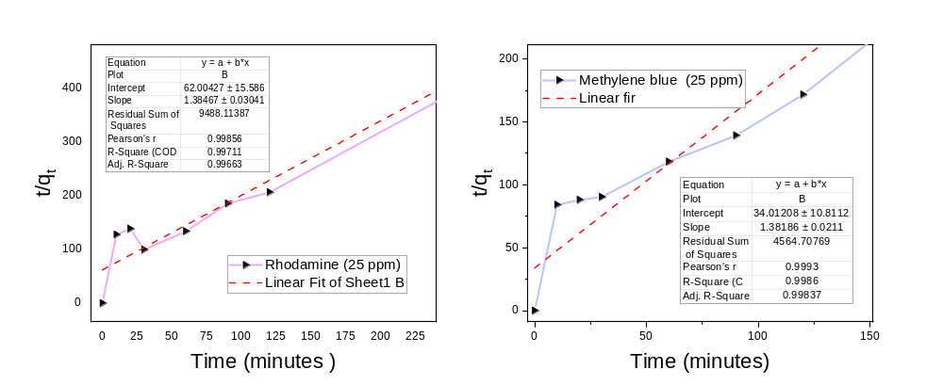

Fig. S7 Pseudo-second-order to rhodamine and methylene blue for 25 ppm

Table S7 Kinetic parameters of rhodamine B adsorption for 25 ppm for pseudo-second-order model fitting.
Time | q_{t} (mg/g) | t/q_{t} (min*g/mg)
0 | 0 | -
10 | 0.07855 | 127.31
20 | 0.14475 | 138.17
30 | 0.30185 | 99.39
60 | 0.44925 | 133.56
90 | 0.48632 | 185.06
120 | 0.58252 | 206
1440 | 0.69991 | 2057.41

Subsequently, it is obtained $q_{e} and K_{2}$
Taking the values ​​of the $q_{e}= 1.38467t+62=\frac{t}{q_{t}}$
Comparing with the equation: $\frac{t}{q_{t}}=\frac{1}{q_{t}}+\frac{1}{K^{2}q_{c}^{2}}$
$The slope m=1.38=1/ qe$
$Intercept b=\frac{1}{k_{2}q_{c}^{2}}$

$$q_{e}≈0.72 mg/g$$
$$K_{2}≈\frac{0.039g}{mg*min}$$
$$h≈0.0161=\frac{1}{b}$$
$$R² = 0.997$$

Time | qt (mg/g) | t/qt (min*g/mg)
0 | 0 | -
10 | 0.11888 | 84.12
20 | 0.22727 | 88
30 | 0.33217 | 90.32
60 | 0.50699 | 118.35
90 | 0.64685 | 139.14
120 | 0.6993 | 171.6
1440 | 0.7296 | 2026.46
Table S8 Kinetic parameters of methylene blue adsorption for pseudo-second-order model fitting with 25ppm.

The fit to the pseudo-first-order model yielded a coefficient $R^{2}=0.997$. Although this value indicates a correlation, the equilibrium adsorption capacity calculated from the model showed a notable difference with the experimental value. This inconsistency suggests that the adsorption process is not primarily driven by physisorption or diffusion-controlled mechanisms. The same data were subsequently fitted to the pseudo-second-order model, whose linearization plot ($t/qt$vs. $t$) is presented in Figure S8. The result suggests that the rate-limiting step in the process is chemisorption, in which adsorption occurs through the formation of chemical bonds between methylene blue molecules and the active sites on the hydrochar surface. The fit of the pseudo-first-order model indicates that physisorption also contributes to the overall mechanism. In Fig.S8, kinetic analysis of Rhodamine B adsorption on the hydrochar demonstrates that the process fits the pseudo-second-order model exceptionally well, as confirmed by its high coefficient determination ($R^{2}$ = 0.9998). This result indicates that the rate-limiting step is chemisorption, a process mediated by the formation of chemical bonds between the dye molecules and the adsorbent surface.

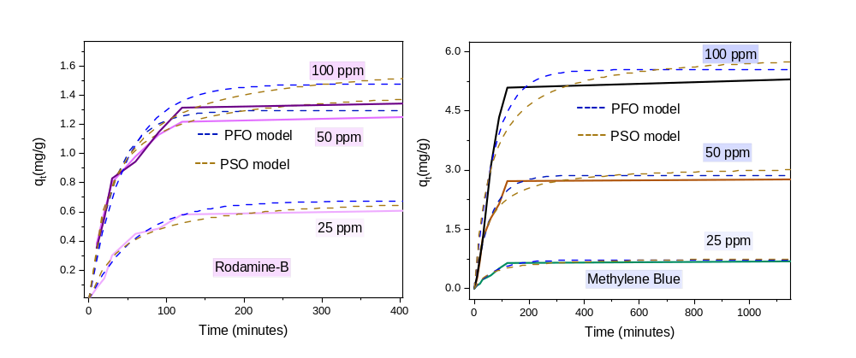
Fig. S8 PFO and PSO models for rhodamine and methylene blue fit with different concentrations

Table S9 Removal capacity of carbonaceous materials to adsorb contaminants in aqueous solution.
Sample | Process | Activation | Temperature | Time(h) | Pollutant | Adsortion isotherm model | Langmuir parametrs |  | Freundlich parametrs |  | Reference
 |  |  |  |  |  |  | qe(mg/g) | b(L/mg) | Kf | Nf | Reference
Oak seeds | Biochar | KOH | 450°C | 1 | MB | Freundlich | 187 | 1.58 | 0.45 | 0.619 | [1]
corncobs | Hydrochar | KOH | 180°C | 6 | MB | Langmuir | 489 | 0.26 | 0.91 | 1.97 | [2]
Agro-residues | Hydrochar | N/A | 200°C | 4 | MB | Langmuir | 64 | 0.07 | 30.37 | 5.65 | [3]
Sewage sludge | Hydrochar | KOH | 160°C | 1 | MB | Langmuir | 454 | 0.095 | 66.2 | 2.32 | [4]
Waste biomass | Hydrochar | N/A | 220°C | 2 | MB | Langmuir | 49.37 | 0.695 | 15.742 | 2.244 | [5]
Grape pomace | Hydrochar | Mg-GP | 220°C | 2 | MB | Freundlich | N/A | N/A | N/A | N/A | [6]
Sargassum | Biochar | KOH | 220°C | 0.5 | MB | Langmuir | 641.03 | 0.68 | 516.64 | 24.84 | [7]
Algal | Biochar | Fe(II) and Fe(III) ions | 500°C | 3 | MB | Freundlich | 60.6 | 0.53 | 18.88 | 2.37 | [8]
Red algae | Hydrochar | ZnCl2 | 200°C | 5 | As (III/V) | Langmuir | 3.8314 | 0.0123 | 0.031 | 0.403 | [9]
Sargazo | Hydrochar | KOH | 240°C | 5 | MB | Langmuir | 52±4.9 | 0.0046 | 3.158 | 2.296 | This study

.
References
[1] M. J. Ahmed, S. K. Theydan, Synthesis of multi-application activated carbon from oak seeds by KOH activation for methylene blue adsorption and electrochemical supercapacitor electrode, Arabian Journal of Chemistry, 14 (2021) DOI:10.1016/j.arabjc.2020.102958
[2] D. T. Nguyen et al., A sustainable, low-cost carbonaceous hydrochar adsorbent for methylene blue adsorption derived from corncobs, Environmental Research, 212 (2022) DOI:10.1016/j.envres.2022.113178
[3] X. Zhang et al., Synthesis, characterization, and methylene blue adsorption isotherms of hydrochars derived from forestry waste and agro-residues, Biomass Conversion and Biorefinery, 14 (2024) DOI:10.1007/s13399-021-02241-y
[4] R. Ferrentino, R. Ceccato, V. Marchetti, G. Andreottola, L. Fiori, Sewage sludge hydrochar: An option for removal of methylene blue from wastewater, Applied Sciences, 10 (2020) DOI:10.3390/app10103445
[5] R. Saini et al., Adsorption potential of hydrochar derived from hydrothermal carbonization of waste biomass towards the removal of methylene blue dye from wastewater, Biomass Conversion and Biorefinery, 15 (2025) DOI:10.1007/s13399-024-05743-7
[6] M. Petrović et al., Novel Mg-doped pyro-hydrochars as methylene blue adsorbents: Adsorption behavior and mechanism, Journal of Molecular Liquids, 376 (2023) DOI:10.1016/j.molliq.2023.121424
[7] C. Chambers et al., Physical and morphological alteration of Sargassum-derived ultraporous superactivated hydrochar with remarkable cationic dye adsorption, Biomass Conversion and Biorefinery, 14 (2024) DOI:10.1007/s13399-023-04326-2
[8] R. Foroutan et al., Performance of algal activated carbon/Fe₃O₄ magnetic composite for cationic dyes removal from aqueous solutions, Algal Research, 40 (2019) DOI:10.1016/j.algal.2019.101509
[9] A. K. Khanzada et al., Removal of arsenic from wastewater using hydrochar prepared from red macroalgae: Investigating its adsorption efficiency and mechanism, Water, 15 (2023) DOI:10.3390/w15213866

