Supplementary Information

The role of TiN particles in enhancing the microstructure, tensile, and wear behavior of stir-cast AA7075-Zn alloy composites
Oluwasegun Falodun^{a,b}*, Chidera Onwurah^{c}, Victor Iyamu^{c}, Abiodun Bayode^{b}
ªDepartment of Materials and Metallurgical Engineering, University of Ilorin, Ilorin, Nigeria
^{b}Department of Mechanical Engineering, North-West University, Potchefstroom, South Africa
^{c}Department of Mechanical Engineering, Covenant University, Ota, Nigeria
*Corresponding author: oefalodun@gmail.com

Figure S1. Transmission electron microscope micrograph of titanium nitride (TiN) powder.

Figure S2. Microhardness of AA7075-Zn alloy strengthened with titanium nitride powder.
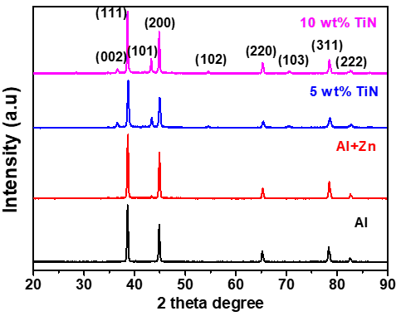
Figure S3. X-ray diffraction pattern of AA7075-Zn matrix composites.

Table S1: Chemical composition of AA7075 alloy
Elements | Al | Si | Mg | Mn | Cu | Fe | Cr | Zn | Ti
percentage (wt%) | Bal | 0.42 | 2.21 | 0.29 | 1.50 | 0.47 | 0.21 | 5.23 | 0.24

Table S2: Chemical composition of titanium nitride powder
Elements | C | Si | Ni | N | Ti | Fe
percentage (wt%) | 0.03 | <0.003 | <0.001 | 21.91 | 77.83 | <0.001

