Supplementary Data

External Strengthening of Reinforced Concrete Beam with Opening by Bamboo Fiber Reinforced Composites

Siew Choo Chin^{1,2}, Kong Fah Tee^{2*}, Foo Sheng Tong¹, Shu Ing Doh¹ and Jolius Gimbun³

¹Department of Civil Engineering, College of Engineering, Universiti Malaysia Pahang, Lebuhraya Tun Razak, 26300 Gambang, Kuantan Pahang, Malaysia
²University of Greenwich, Faculty of Engineering & Science, Central Avenue, Chatham Maritime, Kent ME4 4TB, United Kingdom
³Center of Advanced Research in Fluid Flow, Universiti Malaysia Pahang, Lebuhraya Tun Razak, 26300 Gambang, Kuantan Pahang, Malaysia
*Corresponding author: K.F.Tee@gre.ac.uk

Figure A1 shows the preparation of bamboo fiber reinforced composite using a hand-lay-up method steel mould. Meanwhile Figures A2 to A4 shows the reinforcement detailing of solid RC beam, RC beams with openings at the shear zones as well as RC beams without shear links in the flexure zone.

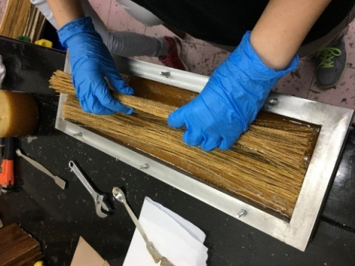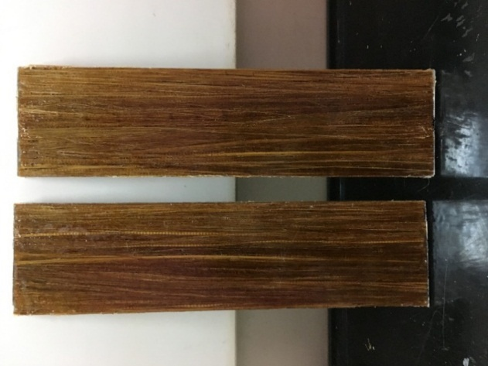
Figure A1. Fabrication of BFRC plate and the finished BFRC plates for beam strengthening

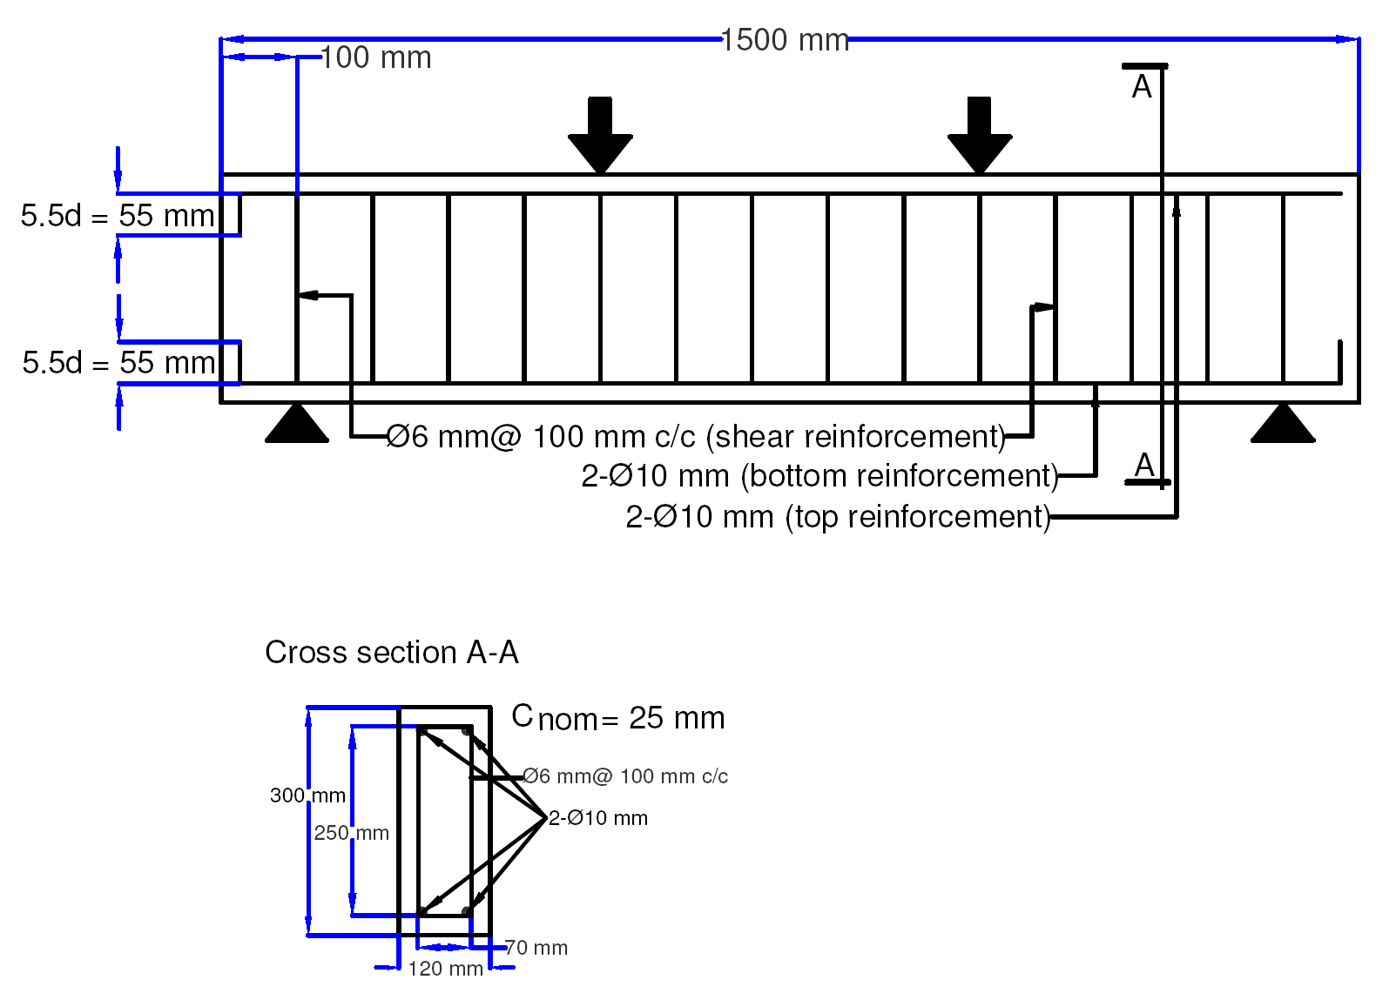
Figure A2. Reinforcement detailing of solid RC beam

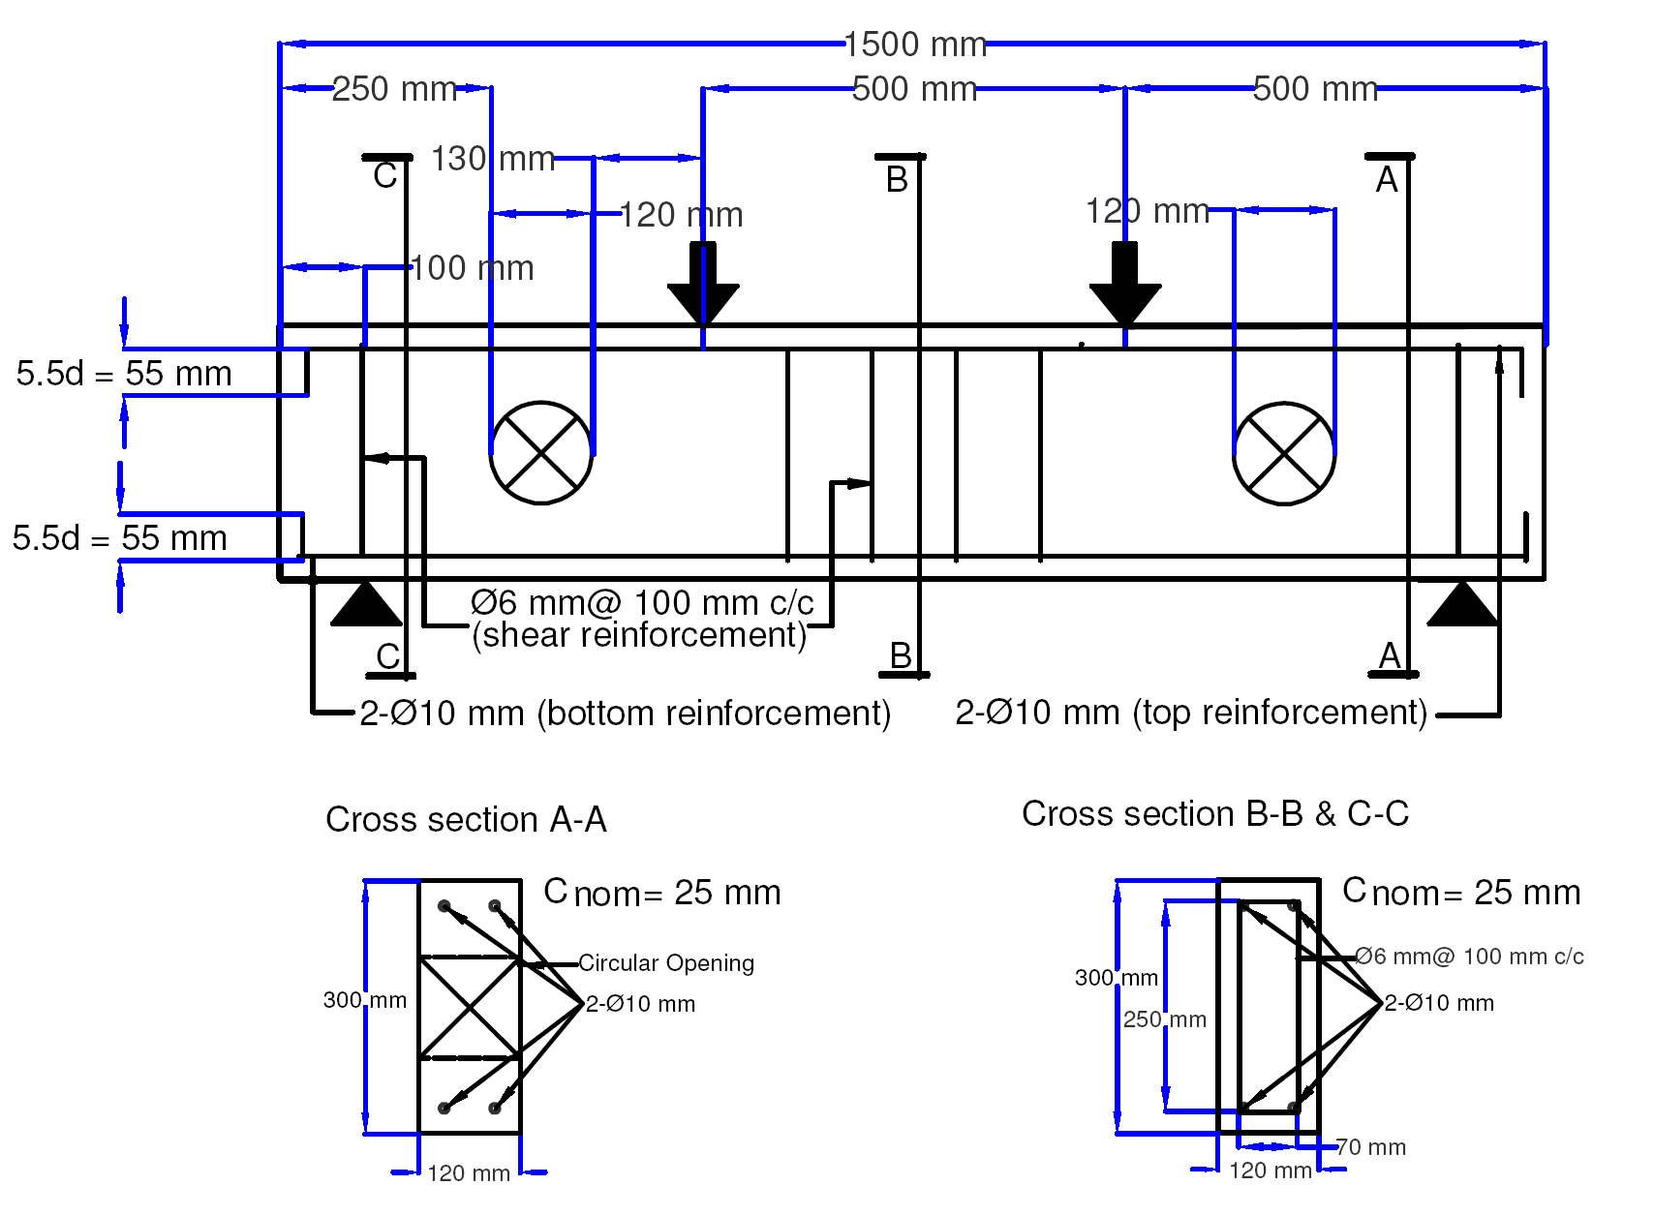
Figure A3. Reinforcement detailing of RC beam with openings in shear

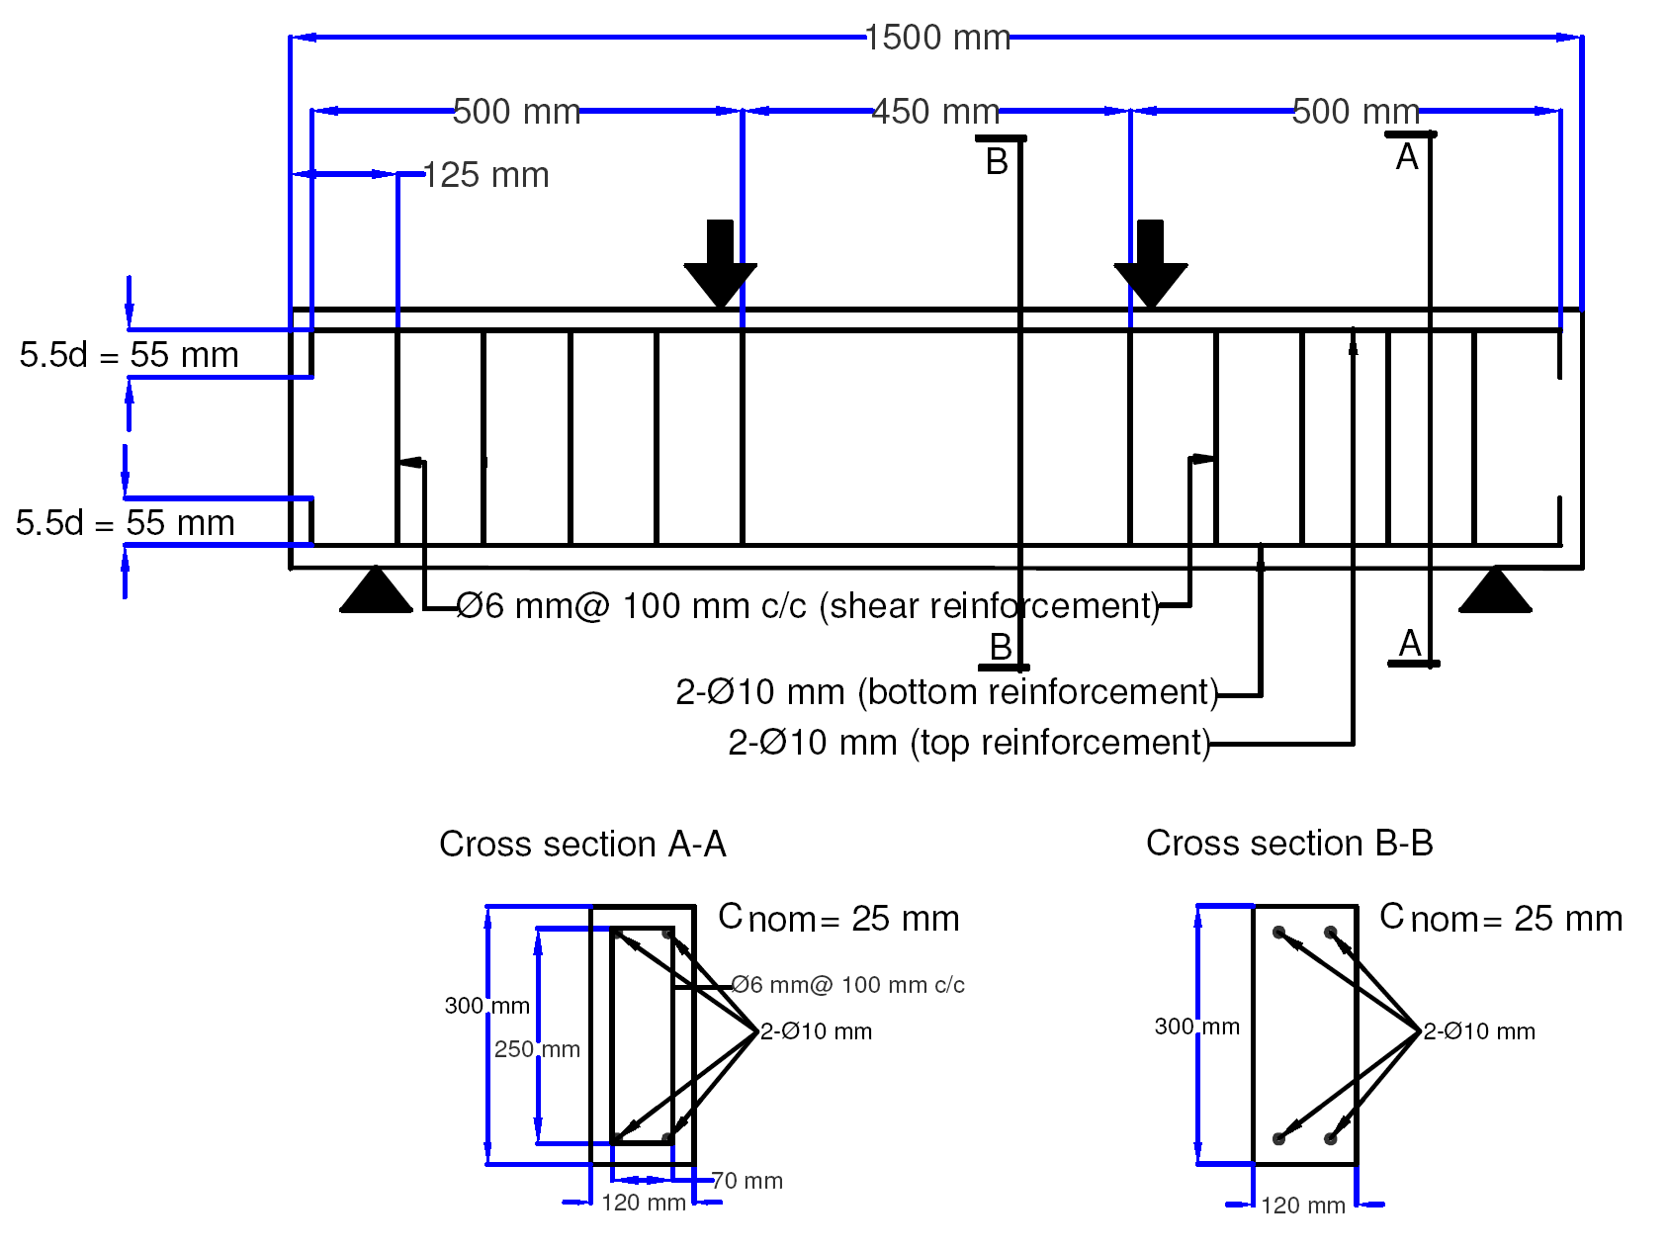
Figure A4. Reinforcement detailing of RC beam without shear links in flexure

