SUPPLEMENTARY MATERIALS

Densities of calcium sulfate phases

Fig. 1 The densities of calcium sulfate phases, according to Wirsching (1984)

Thermal analysis (TG, DSC, and TD)

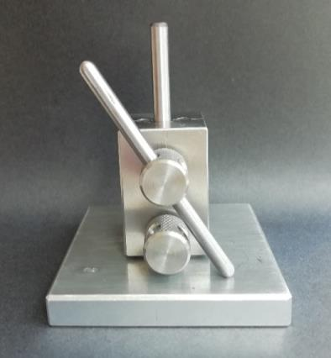
a
b
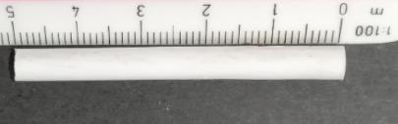
Fig. 2 Mould for preparation of a sample for dilatometry (a) and an example of an actual sample for dilatometry (b)

Fig. 3 TG curves of the studied GP with different initial mass, heating rate, and final temperature of the experiment

Fig. 4 TG curves – Detail A

Fig. 5 DTG curves

Fig. 6 DTG curves – detail B

1
Fig. 7 TG and DTG curves of raw gypsum powder (50.2 mg; heating rate 5 °C/min)

The small peak (1) on the DTG curve of the gypsum binder (Fig. 7) at temperatures between 50 °C and 100 °C can be attributed to the transition from gypsum (contained as impurity in the amount of 14.4% in the gypsum binder) to bassanite (calcium sulfate hemihydrate) and to the partial transition of bassanite to anhydrite II (results of XRD showed that anhydrite II can arise at this temperature range).

Fig. 8 Heat flow of the studied GP (crucibles were without a lid); 26.1 mg; 3°C/min

The results of differential scanning calorimetry (DSC) using crucibles without a lid (Fig. 8) showed a significant exothermic peak, indicating sintering. It is a typical crystallization peak because it is not associated with a mass change.

Fig. 9 Heat flow of raw gypsum binder (50.2 mg; 5 °C/min)

The heat flow of non-hydrated gypsum binder in Fig. 9 differs from the heat flow of the gypsum paste in the absence of a double peak at temperatures below 220 °C (there is only the peak representing the transition from bassanite to anhydrite).

Shrinkage ↔ Extension
Fig. 10 Dilatometry of the GP

XRD analysis
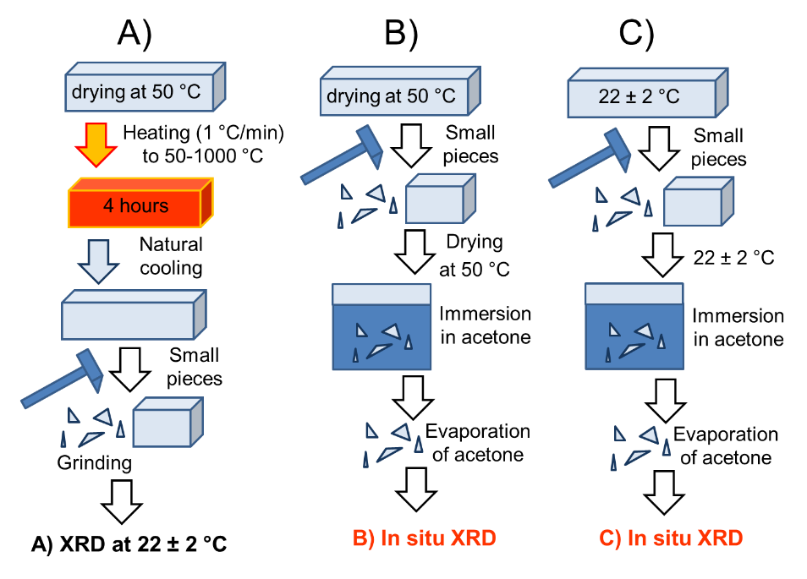
Fig. 11 XRD – procedures A, B, and C

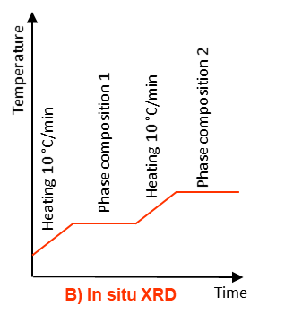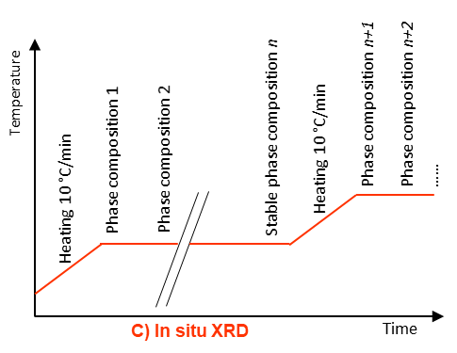
Fig. 12 XRD – procedures B and C – details

Table 1. PDFs of structures for Rietveld analysis
Mineral | Chemical formula | PDF
Gypsum | CaSO₄·2H₂O | 00-033-0311
Bassanite | CaSO₄·0.5H₂O | 01-078-8131
Anhydrite II (insoluble) | CaSO₄ | 00-037-1496
Anhydrite III (soluble) | CaSO₄ | 04-011-1764
Portlandite | Ca(OH)₂ | 00-044-1481
Calcite | CaCO₃ | 01-072-1937

Fig. 13 In situ XRD analysis – detail at 90 °C (procedure C, corundum bowl)

Fig. 14 In situ XRD analysis – detail at 100 °C and 300 °C (procedure C, platinum strip)

Fig. 15 In situ XRD – cooling and reheating a); procedure C, platinum strip | Fig. 16 In situ XRD – cooling and reheating b); procedure C, platinum strip
AII
Fig. 17 Diffractogram – 1 day after heat treatment at 1200 °C

The peak detected at temperatures over 800 °C belongs to platinum at a diffraction angle of approximately 46 [2θ]. Another platinum peak can be seen at a diffraction angle of approximately 67 [2θ]. Other assigned peaks belong to anhydrite II and free lime (CaO).

Fig. 18 Diffractogram – 7 days after heat treatment at 1300 °C

The diffractogram of the gypsum paste measured 7 days after cooling from the exposure to 1300 °C, displayed in Fig. 18, showed that this sample consisted mainly of free lime (CaO) and anhydrite II.

pH
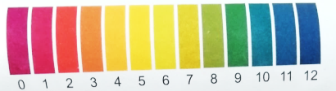
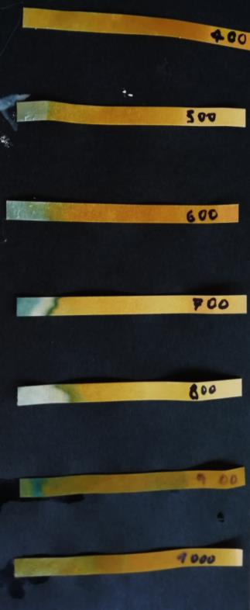
Fig. 19 Samples 30 minutes after the contact with the pH indicator

References
Wirsching F (1984) Drying and Agglomeration of Flue Gas Gypsum, in: R. Kuntze, The Chemistry and Technology of Gypsum (pp. 160-174).

