Supplementary Material
Microstructural Insights of Geopolymer Mortar Containing Cenosphere: Effects on
Fresh Properties and Durability
S.1. Fine Aggregate Particle Size Distribution
Fig. S.1 shows the particle size distribution of the natural sand used in the studied geopolymers.
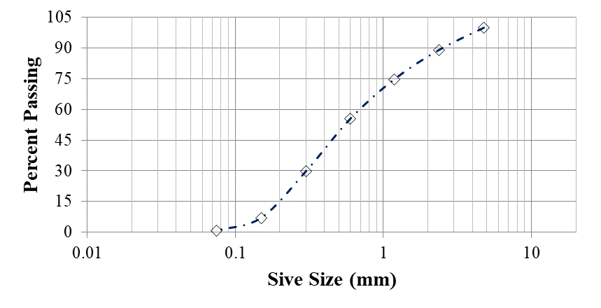
Fig. S.1: Particle size distribution curve of fine aggregate
S.2. Flowability
Fig. S.2 illustrates the appearance of the geopolymers and OPC mortar just after the flowability test. All geopolymer mixtures were fabricated without adding excessive water or superplasticizers. The formulation emphasized the alkali activator, which constituted 60% of the binder, and absorption water for fine aggregates as a liquid component. Given that, a shiny, sticky, and highly cohesive nature of geopolymer mortar was observed in contrast to OPC. This effect can be attributed to the high viscosity of the Na₂SiO₃ solution and glass content [4]. Moreover, the geopolymer mortar indicated a higher tendency to flow by the action of gravity than OPC in the fresh state.
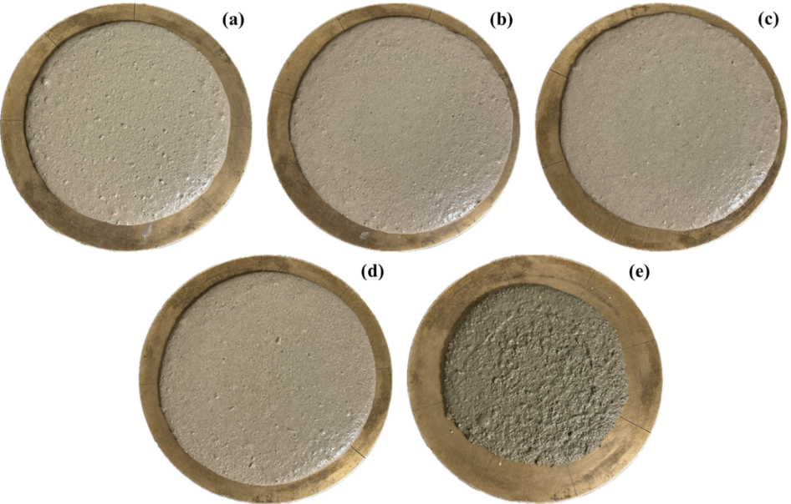
Fig. S.2: Flow table (a) S100, (b) S75-CE25, (c) S50-CE50, (d) S25-CE75, and (e) OPC
S.3. Water Absorption
Water absorption tests were conducted on 50.8x50.8x50.8 mm samples. The procedure for water absorption was adopted from ASTM C642 [2] to measure it at 28 and 91 days. The specimens were first cured in a curing chamber till testing age and then placed in an oven at 105 ± 5°C for 24 hours. Water absorption was calculated by Eq. S1 as shown below.
$$Water Absorption \left(\%\right)=\frac{m_{1}-m_{2}}{m_{2}} x 100$$ | Eq. S1
Where m₁= Saturated surface dry (SSD) mass; m₂= Oven dry mass
Fig. S.3 shows the water absorption of all geopolymer specimens and OPC mortar at 28 and 91 days. The water absorption of all mix designs increased with age and can be related to the increased porosity of mixtures over time. The OPC mortar showed the least water absorption among all mixes.
Cenosphere incorporation effectively increased water absorption with increasing percentage substitution. The maximum water absorption was recorded for S25-CE75, reaching up to 19.3% at 91 days followed by S50-CE50, S75-CE25, and S100. The water absorption values for S50-CE50, S75-CE25, and S100 were found to be 13.4%, 12.1%, and 10.2%, respectively at 91 days.
The elevated water absorption observed with greater cenosphere integration can be ascribed to its spherical morphology, increased porosity, reduced packing density, and equilibrium moisture content (EMC) approximately 18 times greater than that of sand [11-13]. Barbare et al. [14] also documented that cenospheres exhibit a notable capacity for water absorption, surpassing even that of sand by a significant margin. This occurrence can be ascribed to open pores arising from the spherical shape and hollow interior of the cenospheres [15, 16].
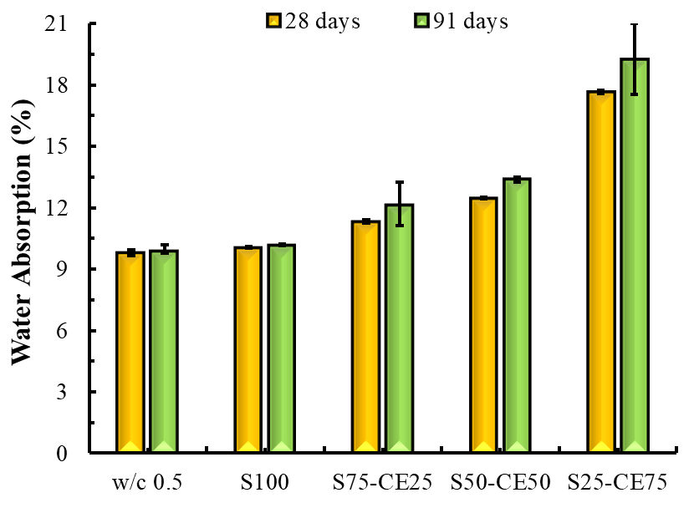
Fig. S.3: Water absorption of all geopolymers and OPC mixtures at 28, and 91 days
S.4. Surface Electrical Resistivity
Electrical resistivity is a key parameter that provides reasonable information about the resistance capacity of a material against the flow of current. In this study, electrical resistivity was determined by the Resipod Proceq apparatus. This simple apparatus includes 4 probes having a space of 38 mm between each other which meets the guidelines of the AASHTO T 358 surface resistivity test method [3]. The Resipod Proceq method for assessing electrical resistivity involves passing current through the outer probe and measuring the resulting potential difference with the inner probes. The tests were conducted on 40x40x160 mm specimens. The ions in the mortar's pore solution enable the current flow, and the corresponding resistivity in (Ω∙m) can be calculated using Eq. S2.
$$ρ = \frac{2π a V}{I} (Ω∙m)$$ | Eq. S2
Where: “ρ” is the electrical resistivity; “a” depicts spacing in probes; “V” corresponds to the potential difference; and “I” shows the current.
The surface electrical resistivity of OPC mortar and geopolymer mixes with different substitution levels of cenosphere at 3, 7, 28, 56, 91, and 119 days are exemplified in Fig. S.4. The surface electrical resistivity of a material is indicative of its capacity to conduct electrical charge [17]. This characteristic serves as a valuable metric for assessing the pore connectivity in saturated materials. Composites with well-interconnected pores and less compact structures enhance the flow of electrical ions, resulting in lower electrical resistivity, and conversely, materials with denser structures exhibit higher resistivity [18]. Moreover, understanding electrical resistivity offers valuable insights into a material's susceptibility to the penetration of detrimental substances like salts, chlorides, and atmospheric CO₂. This information proves crucial in gauging the material's resistance against deteriorating agents, thereby contributing to a comprehensive assessment of its durability and performance [17, 19].
The surface electrical resistivity of all specimens increased with age. However, the extent of enhancement was different for each mix design depending upon the interconnected pores and characteristics of the microstructure. The enhanced electrical resistivity observed can be attributed to the gradual strengthening of mortar mixes, resulting in a more compact microstructure. This phenomenon is a consequence of the progressive filling of interconnected pores with hydration products over time [20].
The surface electrical resistivity assessment of the S100 specimen indicated the highest value among all mixes, peaking at nearly 700 Ω-m. After S100, the electrical resistivity of OPC was higher than all other mixes till 91 days, afterwards, S75-CE25 surpassed the OPC at 119 days. The S50-CE50 and S25-CE75 showed much less surface electrical resistivity than other formulations. The decrease in electrical resistance of geopolymer specimens with higher cenosphere incorporation can be attributed to the higher water absorption capacity of the cenosphere owing to its porous nature which is also evident from Fig. 6 [12]. Moreover, the spherical morphology of the cenosphere can generate pores in the microstructure resulting in reduced electrical resistivity [16].
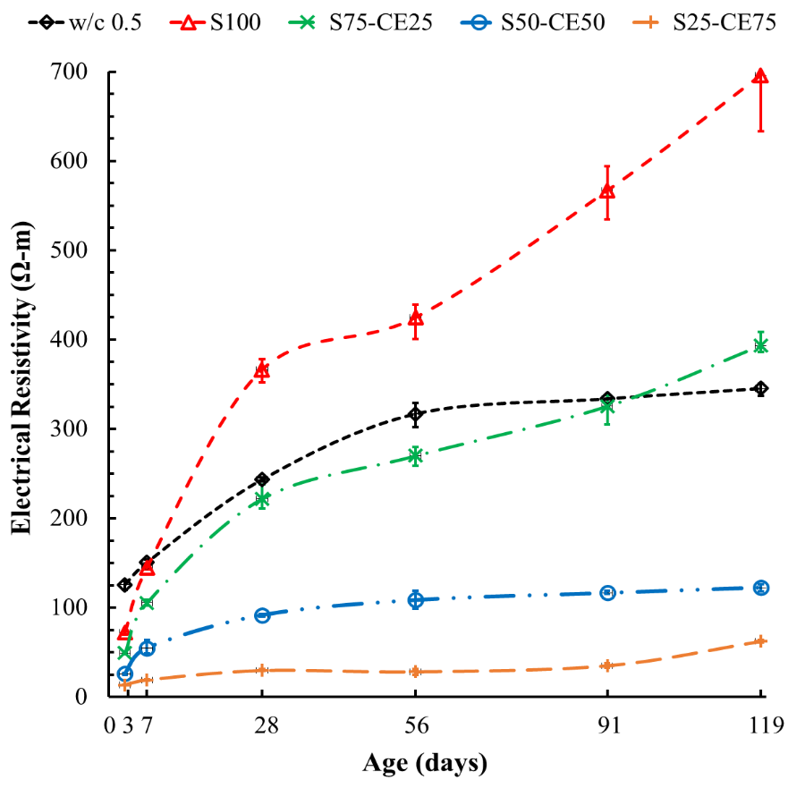
Fig. S.4: Surface electrical resistivity of all geopolymers and OPC mixtures at different ages

References:
[1] ASTM C349 - Standard Test Method for Compressive Strength of Hydraulic-Cement Mortars (Using Portions of Prisms Broken in Flexure), American Society for Testing and Materials (ASTM), West Conshohocken, PA, 2018. [Online]. Available: https://compass.astm.org/document/?contentCode=ASTM%7CC0349-18%7Cen-US
[2] A. ASTM C642, "Standard test method for density, absorption, and voids in hardened concrete," ASTM, ASTM International, 2013.
[3] M. Almarshoud et al., "Use of Electrical Resistivity-Based Tests for Concrete Penetrability Measurement," ACI Materials Journal, vol. 118, no. 1, 2021, doi: 10.14359/51729334.
[4] P. Nath and P. K. Sarker, "Effect of GGBFS on setting, workability and early strength properties of fly ash geopolymer concrete cured in ambient condition," Constr. Build. Mater., vol. 66, pp. 163-171, 2014, doi: 10.1016/j.conbuildmat.2014.05.080.
[5] S. Aydın and B. Baradan, "Effect of activator type and content on properties of alkali-activated slag mortars," Composites Part B: Engineering, vol. 57, pp. 166-172, 2014, doi: 10.1016/j.compositesb.2013.10.001.
[6] A. A. Alnkaa et al., "Performance evaluation and cost analysis of ternary blended geopolymers for sustainable built environment under different curing regimes," Construction and Building Materials, vol. 409, p. 133842, 2023, doi: 10.1016/j.conbuildmat.2023.133842.
[7] H. Zhang, X. Shi, and Q. Wang, "Effect of Curing Condition on Compressive Strength of Fly Ash Geopolymer Concrete," ACI Materials Journal, vol. 115, no. 2, 2018, doi: .14359/51701124.
[8] P. Chen, J. Wang, L. Wang, and Y. Xu, "Perforated cenospheres: A reactive internal curing agent for alkali activated slag mortars," Cement and Concrete Composites, vol. 104, p. 103351, 2019, doi: 10.1016/j.cemconcomp.2019.103351.
[9] Z. Najeeb and M. A. Mosaberpanah, "Mechanical and durability properties of modified High-Performance mortar by using cenospheres and Nano-Silica," Construction and Building Materials, vol. 362, p. 129782, 2023, doi: 10.1016/j.conbuildmat.2022.129782.
[10] A. Hanif, P. Parthasarathy, H. Ma, T. Fan, and Z. Li, "Properties improvement of fly ash cenosphere modified cement pastes using nano silica," Cement and Concrete Composites, vol. 81, pp. 35-48, 2017, doi: 10.1016/j.cemconcomp.2017.04.008.
[11] M. U. Salim and M. A. Mosaberpanah, "Mechanical and durability properties of high-performance mortar containing binary mixes of cenosphere and waste glass powder under different curing regimes," Journal of Materials Research and Technology, vol. 13, pp. 602-617, 2021, doi: 10.1016/j.jmrt.2021.04.077.
[12] R. Vijayalakshmi, S. Naganathan, and S. Ramanagopal, "Study on the Compressive Strength and Water Absorption Characteristics of Mortar Blocks with Cenosphere as Partial Replacement for Cement," in Sustainable Practices and Innovations in Civil Engineering: Select Proceedings of SPICE 2021, 2022: Springer, pp. 251-263, doi: 10.1007/978-981-16-5041-3_19.
[13] A. Hanif, Z. Lu, S. Diao, X. Zeng, and Z. Li, "Properties investigation of fiber reinforced cement-based composites incorporating cenosphere fillers," Constr. Build. Mater., vol. 140, pp. 139-149, 2017, doi: 10.1016/j.conbuildmat.2017.02.093.
[14] N. Barbare, A. Shukla, and A. Bose, "Uptake and loss of water in a cenosphere–concrete composite material," Cem. Concr. Res., vol. 33, no. 10, pp. 1681-1686, 2003, doi: 10.1016/S0008-8846(03)00148-0.
[15] H. Satpathy, S. Patel, and A. Nayak, "Development of sustainable lightweight concrete using fly ash cenosphere and sintered fly ash aggregate," Construction and Building Materials, vol. 202, pp. 636-655, 2019, doi: 10.1016/j.conbuildmat.2019.01.034.
[16] X. Liu, M.-H. Zhang, K. S. Chia, J. Yan, and J. R. Liew, "Mechanical properties of ultra-lightweight cement composite at low temperatures of 0 to− 60° C," Cement and Concrete Composites, vol. 73, pp. 289-298, 2016, doi: 10.1016/j.cemconcomp.2016.05.014.
[17] C. Andrade, "Resistivity test criteria for durability design and quality control of concrete in chloride exposures," Concr. Aust, vol. 40, no. 4, pp. 57-64, 2014.
[18] E. I. Nadelman and K. E. Kurtis, "A resistivity-based approach to optimizing concrete performance," Concrete international, vol. 36, no. 5, pp. 50-54, 2014.
[19] A. Noushini and A. Castel, "The effect of heat-curing on transport properties of low-calcium fly ash-based geopolymer concrete," Construction and Building Materials, vol. 112, pp. 464-477, 2016, doi: 10.1016/j.conbuildmat.2016.02.210.
[20] F. F. Zainal et al., "The electrical resistivity of geopolymer paste by using wenner four probe Method," Key Engineering Materials, vol. 660, pp. 28-33, 2015, doi: 10.4028/www.scientific.net/KEM.660.28.

