Reactivity and Reaction Kinetics of Calcium Aluminosilicate Glasses
Subhashree Panda¹, Luis Ruiz Pestana¹, Prannoy Suraneni¹
¹Civil and Architectural Engineering, University of Miami, Coral Gables, Florida 33146
*Corresponding author: Prannoy Suraneni, suranenip@miami.edu

Table S1. X-ray fluorescence oxide contents for selected compositions.
Compositions | Weight%
Compositions | CaO | Al₂O₃ | SiO₂
C₆₅A₂₀S₁₂ | 67.4 | 19.2 | 15.2
C₅₃A₃₅S₁₂ | 50.2 | 39.4 | 11.3
C₅₀A₃₀S₂₀ | 52.5 | 27.4 | 20.7
C₄₀A₁₀S₅₀ | 37.4 | 13.3 | 48.4
C₃₃A₃₃S₃₃ | 35.5 | 29.8 | 35.4
C₃₀A₅₀S₂₀ | 30.4 | 51.8 | 22.6
C₂₁A₁₈S₆₁ | 19.4 | 19.2 | 60.7
C₁₀A₁₀S₈₀ | 10.5 | 11.2 | 83.1

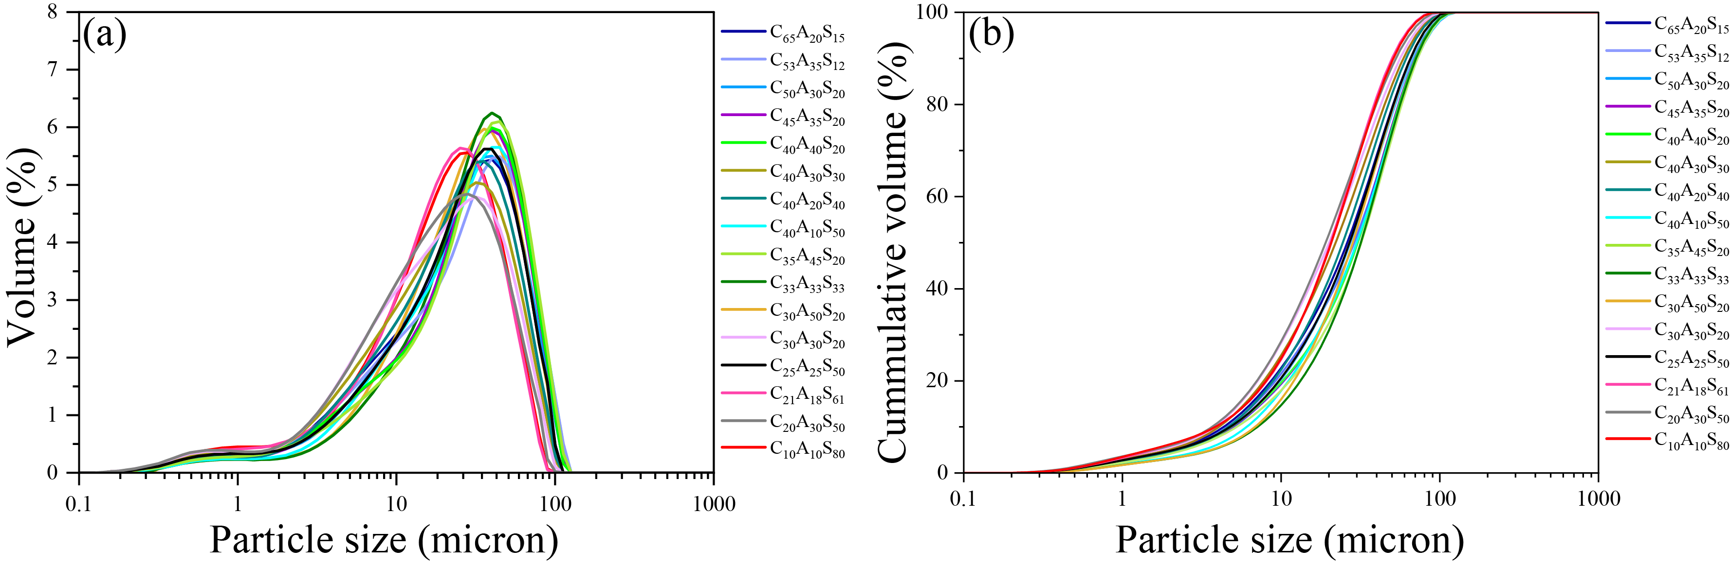
Figure S1. (a) Differential PSD data; (b) Cumulative PSD data of the synthesized CAS glasses.
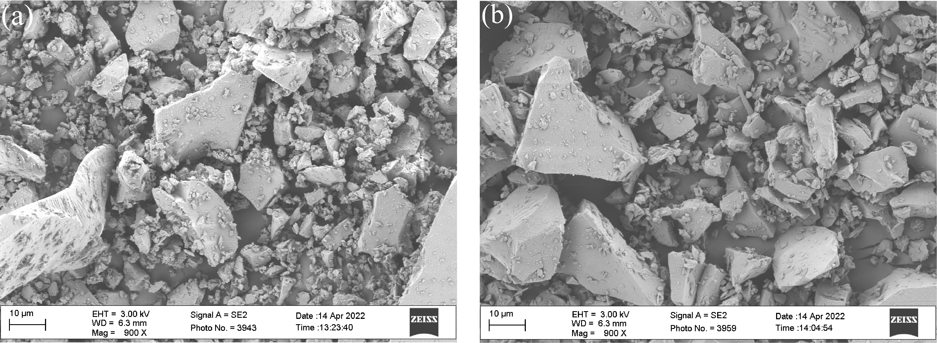
Figure S2. SEM images of (a) C₆₃A₂₀S₁₅ glass; (b) C₃₀A₅₀S₂₀ glass.

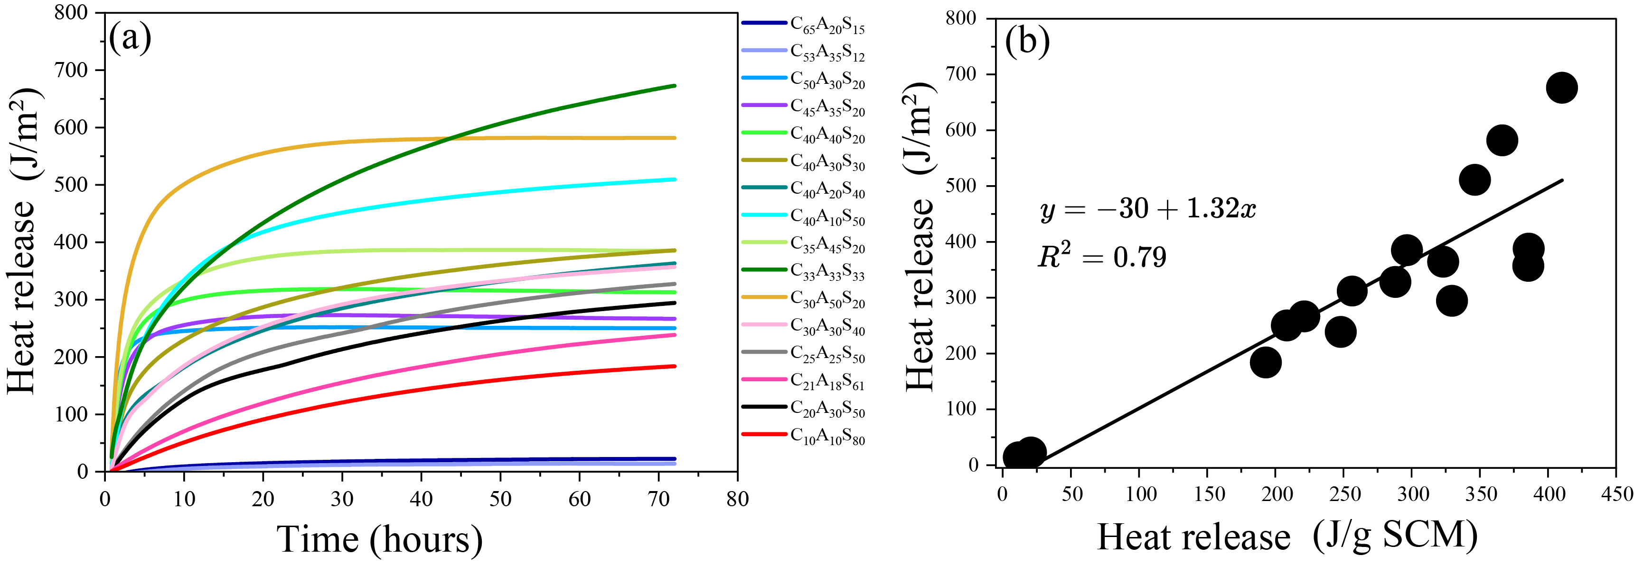
Figure S3. (a) Heat release normalized to SCM specific surface area plotted against time; (b) Heat release normalized to SCM specific surface area plotted against heat release normalized to SCM mass.

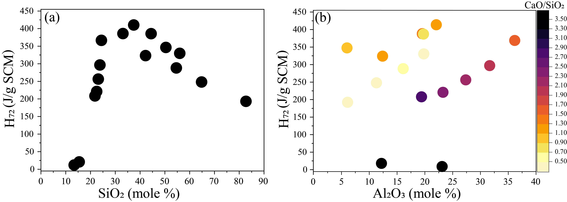
Figure S4. H₇₂ plotted against (a) SiO₂; (b) Al₂O₃ with Ca/Si ratio in colormap.

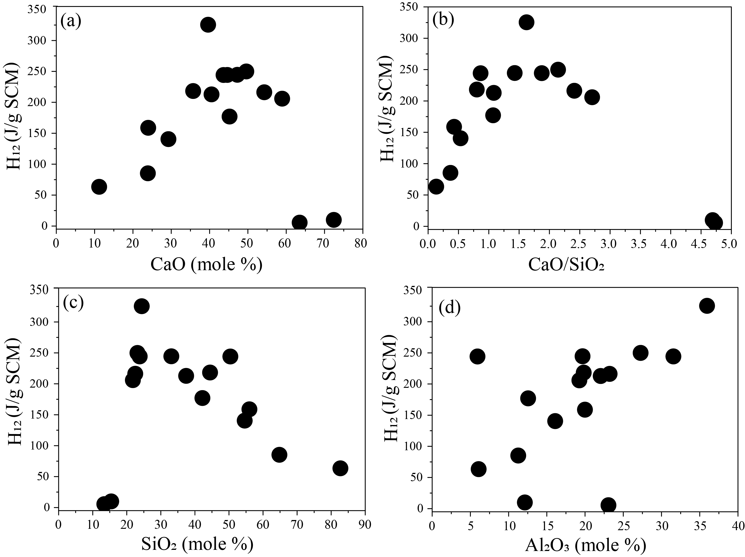
Figure S5. H₁₂ plotted against (a) CaO; (b) CaO/SiO₂; (c) SiO₂; (d) Al₂O₃.
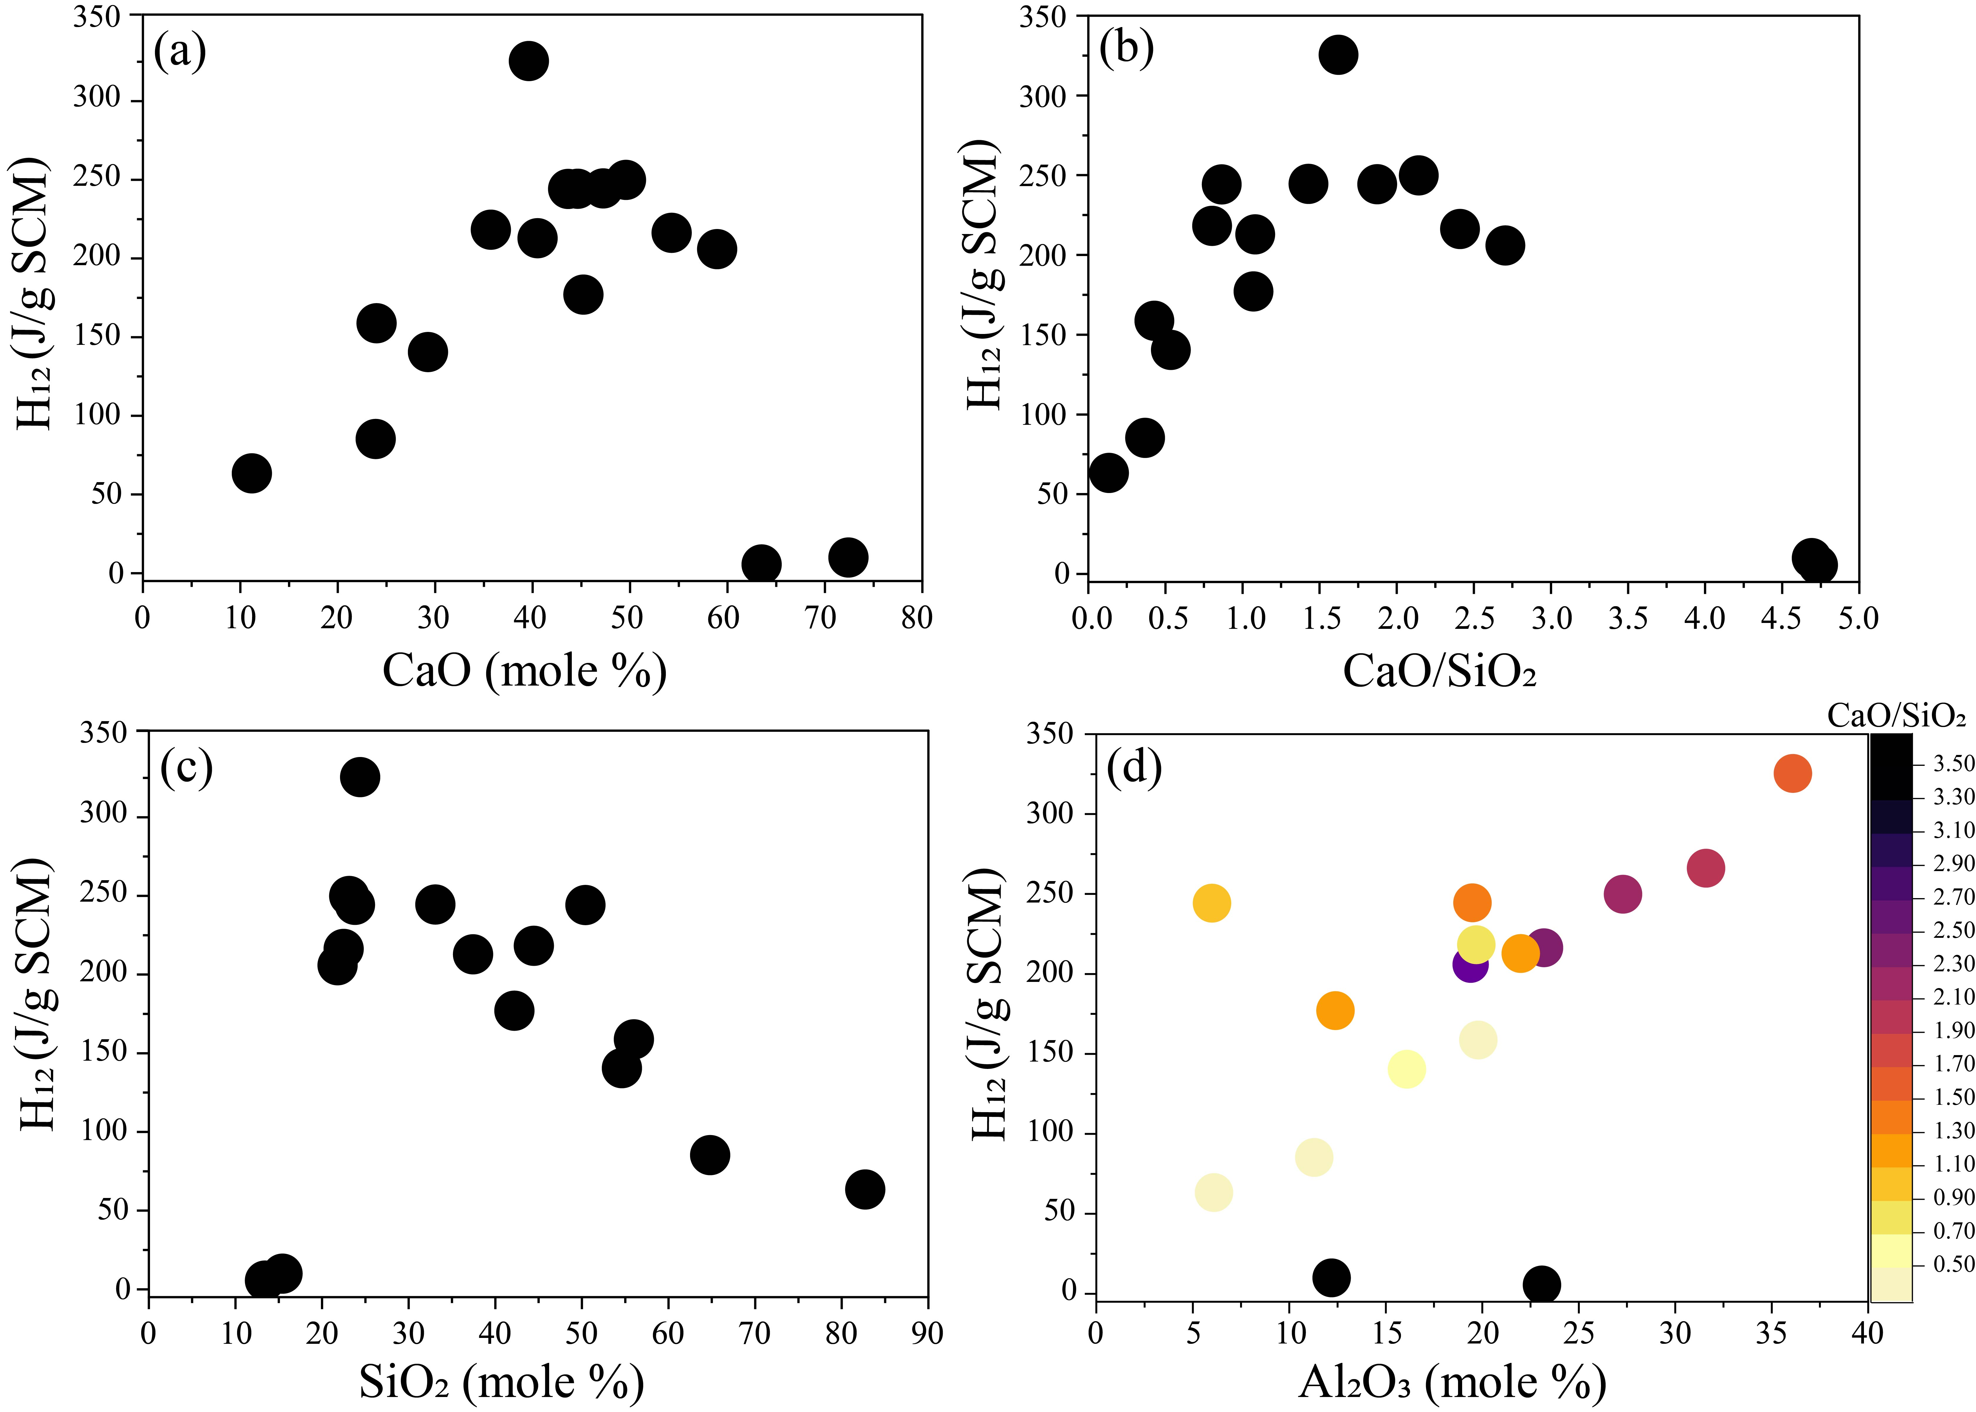
Figure S5. H₁₂ plotted against (a) CaO; (b) CaO/SiO₂; (c) SiO₂; (d) Al₂O₃ with Ca/Si ratio in colormap.

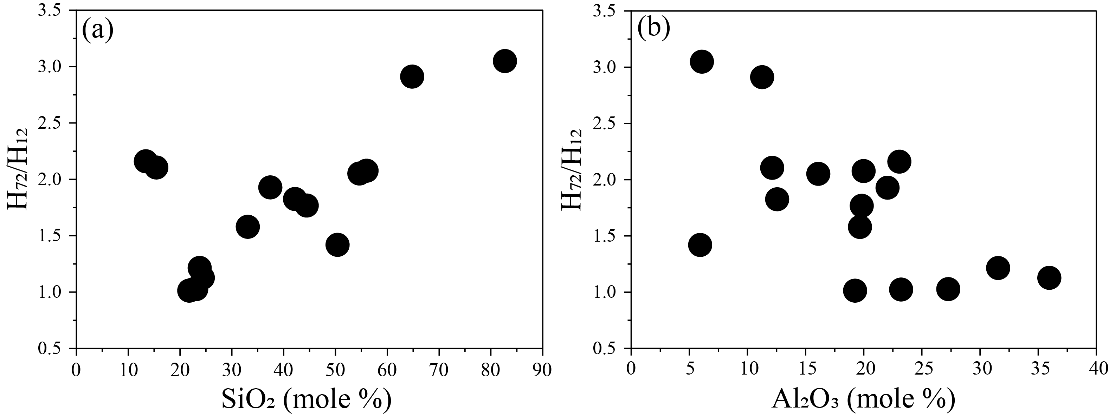
Figure S6. H₇₂/H₁₂ plotted against (a) SiO₂; (b) Al₂O₃.
Table S2. Band maxima locations for various bands obtained from FTIR deconvolution.
Composition | Bending vibration T-O-T’ | Symmetric stretching vibration T-O-T’ | Q¹ (Si) | Q² (Si) | Q³ (Si) | Q⁴ (Si)
C₆₅A₂₀S₁₅ | 653 | 779 | 850 | 935 | - | -
C₅₃A₃₅S₁₂ | 653 | 782 | 860 | 965 | - | -
C₅₀A₃₀S₂₀ | 658 | 790 | 890 | 990 | - | -
C₄₅A₃₅S₂₀ | 658 | 795 | 874 | 972 | - | -
C₄₀A₄₀S₂₀ | 658 | 792 | 865 | 974 | - | -
C₄₀A₃₀S₃₀ | 662 | 799 | 860 | 967 | - | -
C₄₀A₂₀S₄₀ | 661 | - | 856 | 939 | 1021 | -
C₄₀A₁₀S₅₀ | 672 | - | 855 | 950 | 1035 | 1115
C₃₅A₄₅S₂₀ | 663 | 797 | 858 | 964 | - | -
C₃₃A₃₃S₃₃ | 673 | 808 | 895 | 993 | 1085 | -
C₃₀A₅₀S₂₀ | 662 | 805 | 885 | 998 | - | -
C₃₀A₃₀S₄₀ | 664 | - | 873 | 958 | 1075 | -
C₂₅A₂₅S₅₀ | 667 | - | 899 | 953 | 1062 | 1161
C₂₁A₁₈S₆₁ | 685 | - | 897 | 948 | 1045 | 1155
C₂₀A₃₀S₅₀ | 669 | - | 896 | 957 | 1068 | 1163
C₁₀A₁₀S₈₀ | 695 | 799 | - | 952 | 1080 | 1202

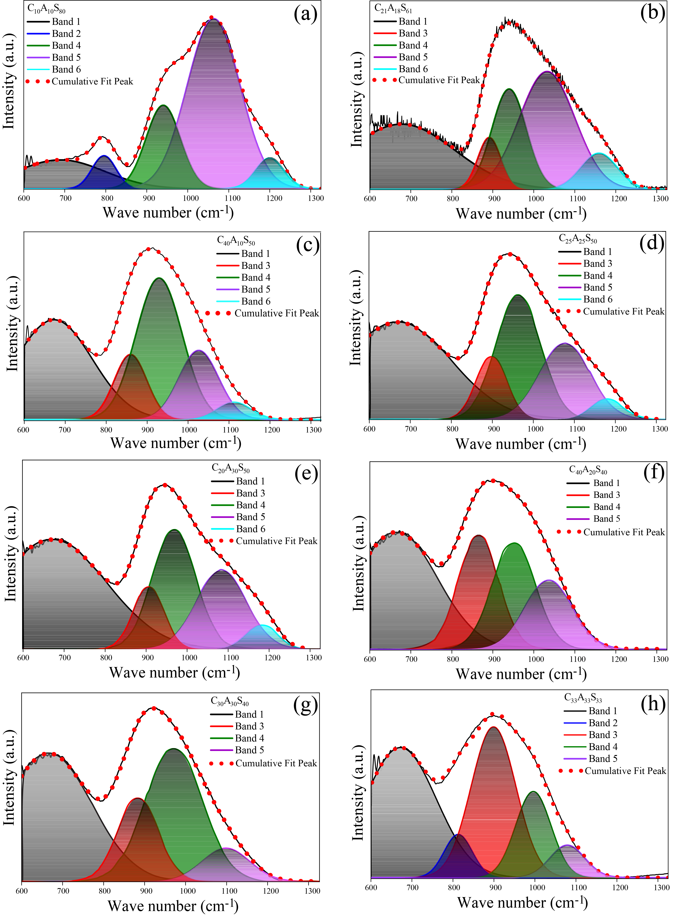
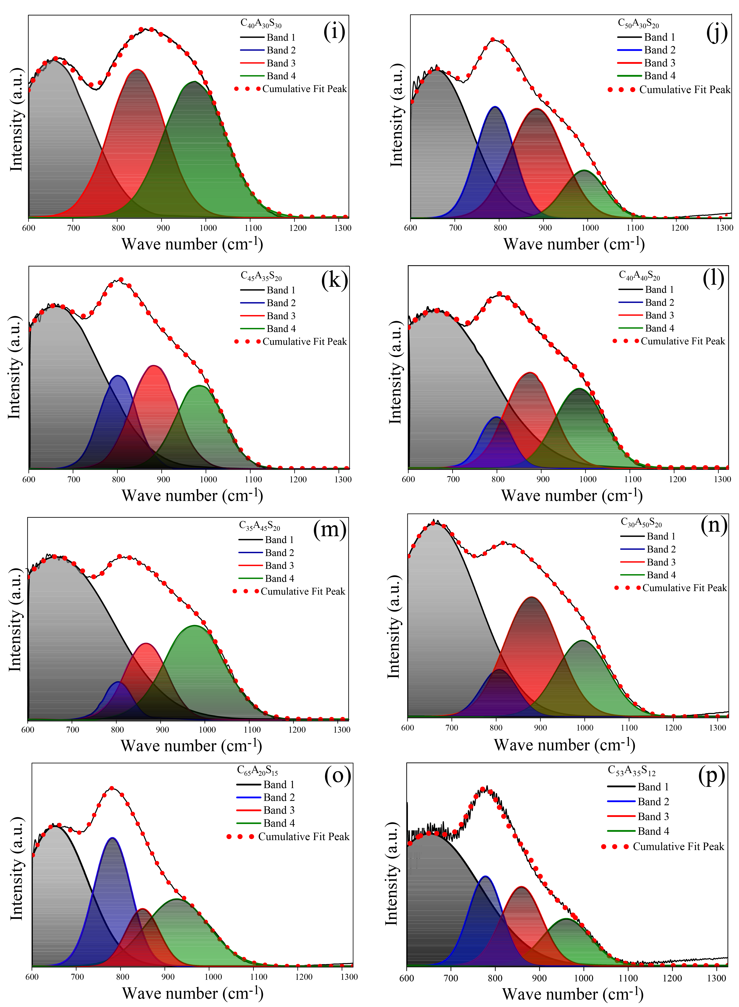
Figure S7. The deconvoluted FTIR spectra of the CAS glasses.
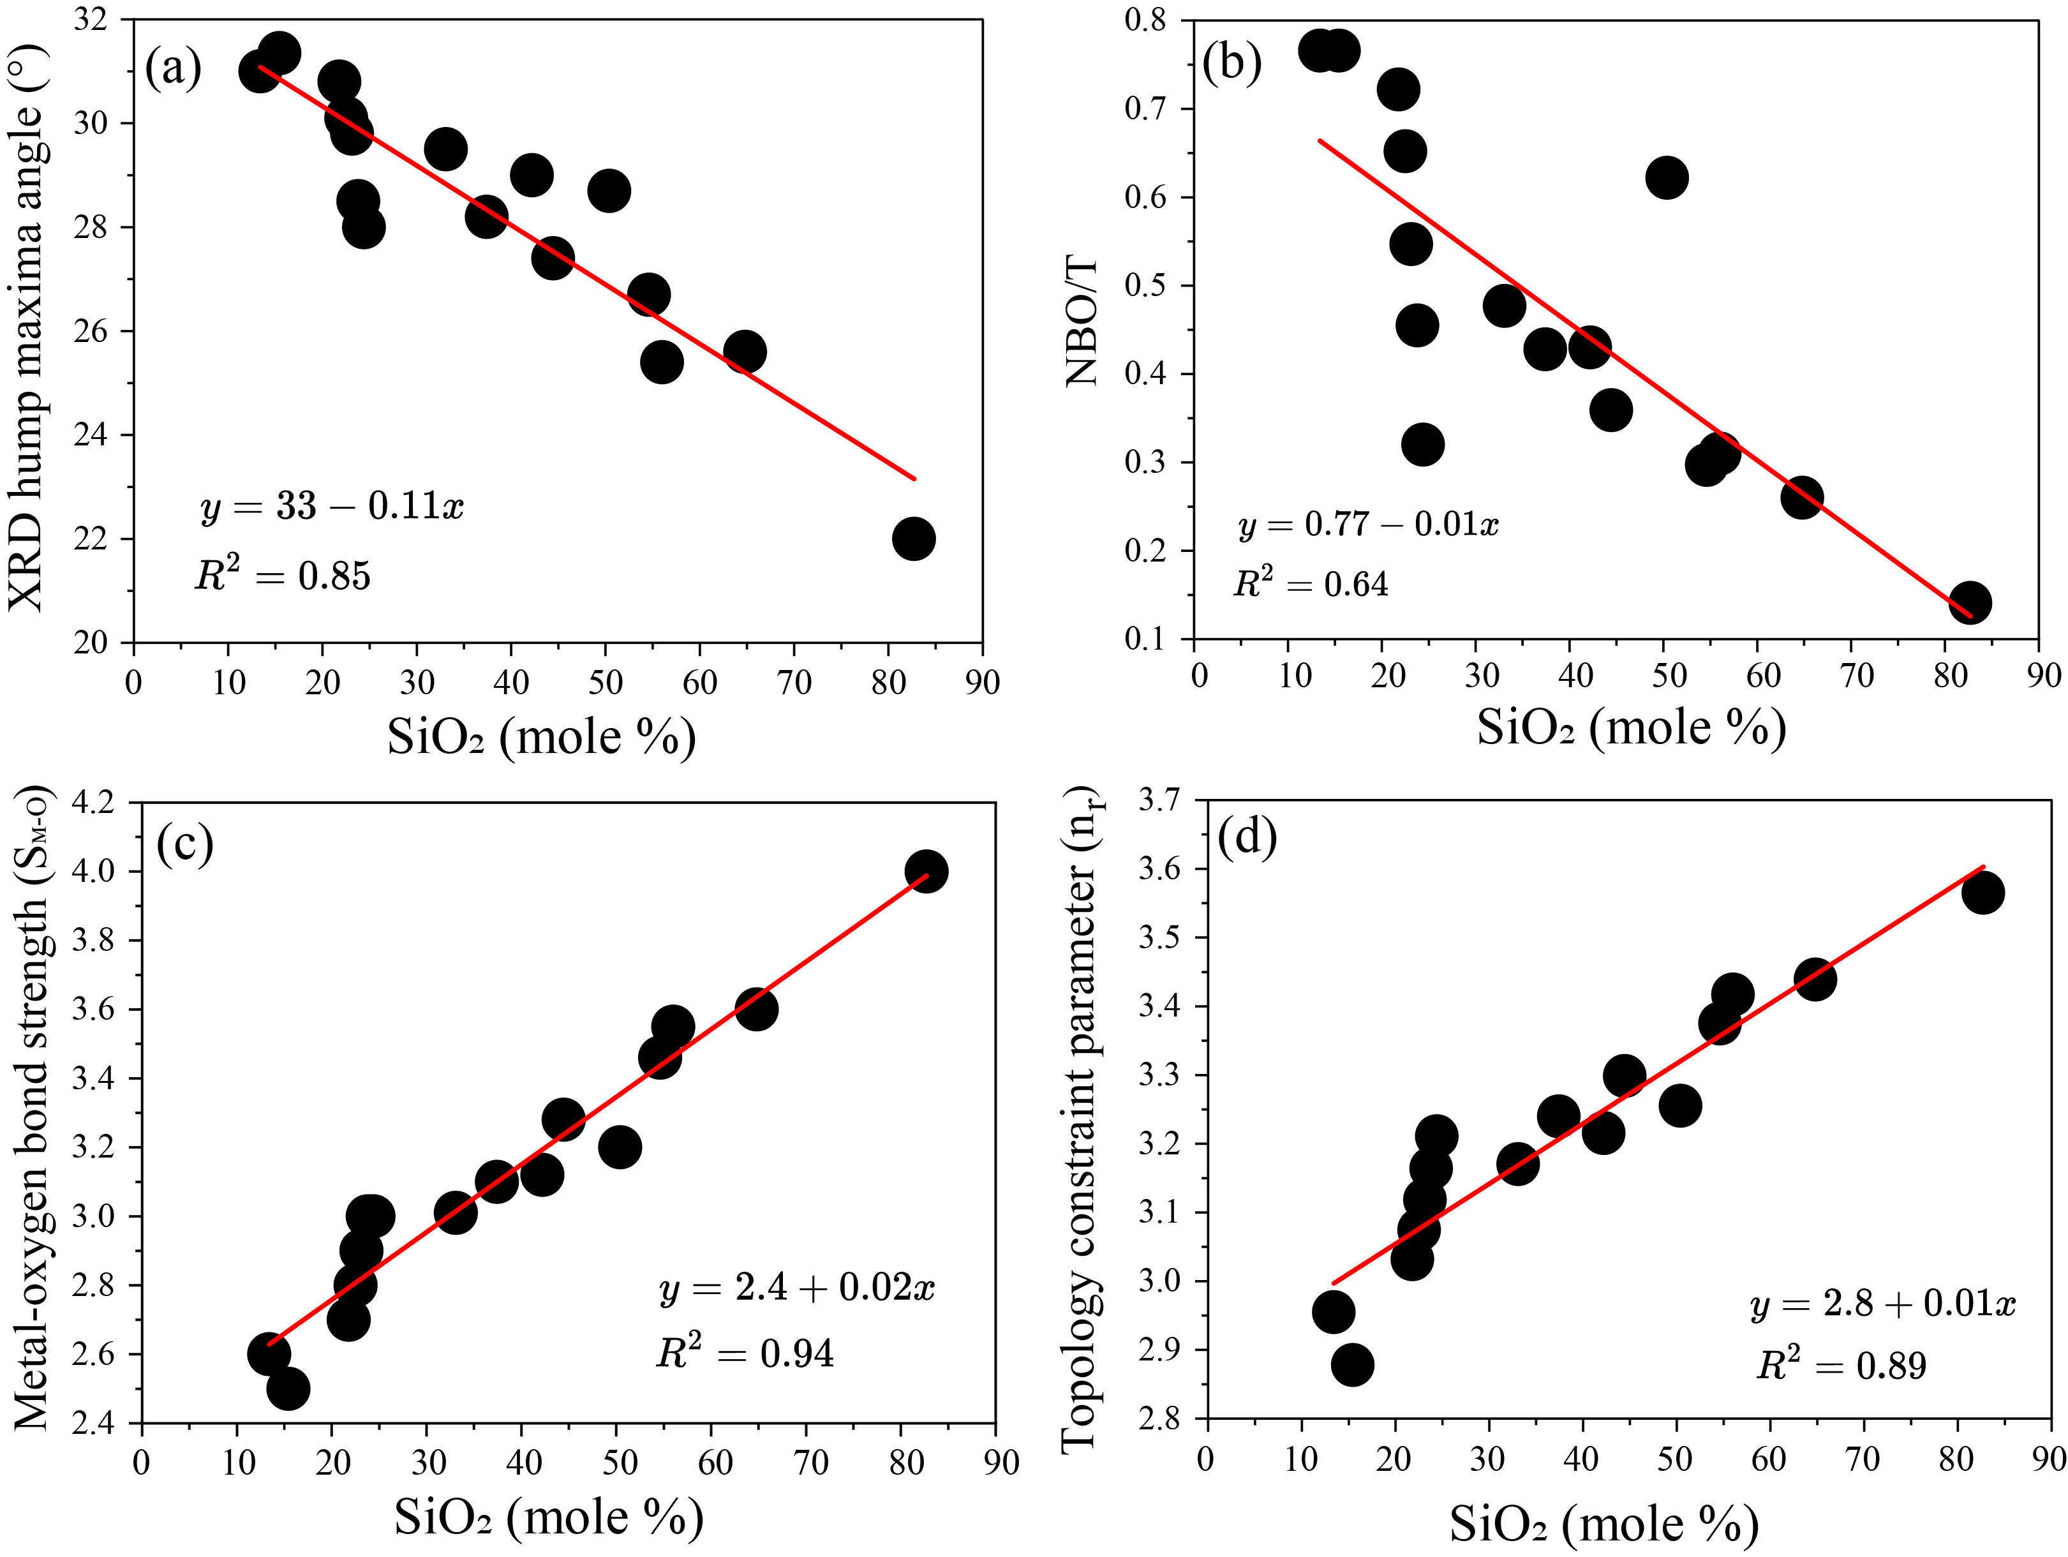
Figure S8. (a) XRD hump maxima angle plotted against SiO₂; (b) NBO/T plotted against SiO₂ [1]; (c) Metal-oxygen bond strength (S_{M-O}) plotted against SiO₂ [2]; (d) Topological constraint parameter plotted against SiO₂ [3].
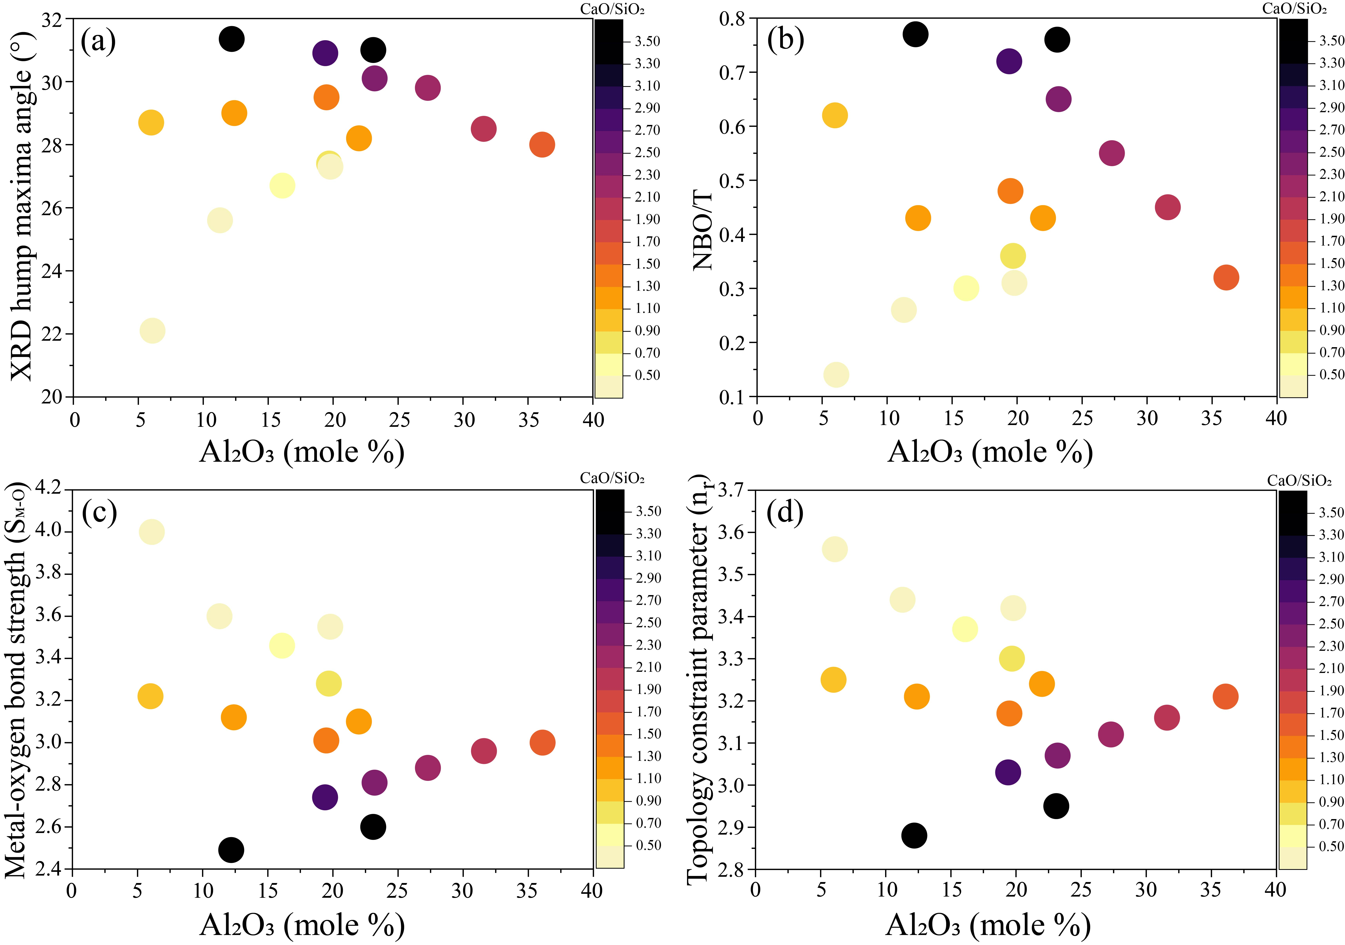
Figure S9. (a) XRD hump maxima angle plotted against Al₂O₃; (b) NBO/T plotted against Al₂O₃ [1]; (c) Metal-oxygen bond strength (S_{M-O}) plotted against Al₂O₃ [2]; (d) Topological constraint parameter plotted against Al₂O₃ [3]. Ca/Si ratio is plotted in the colormap.

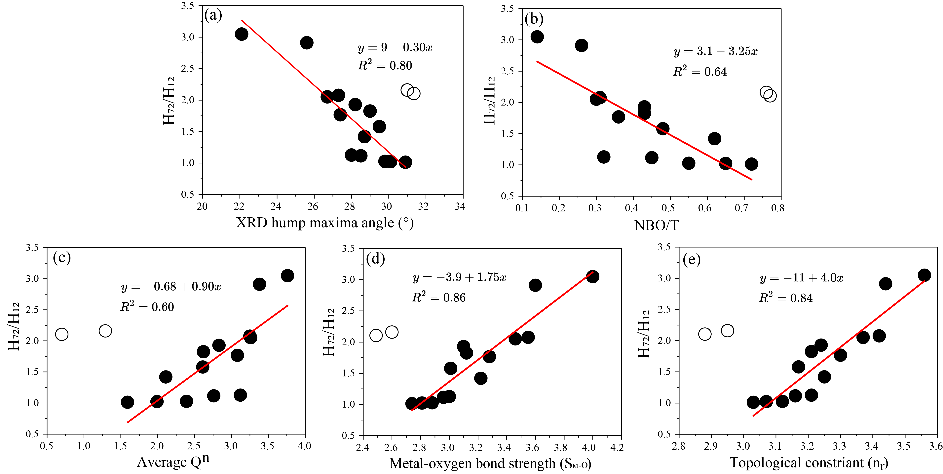
Figure S10. H₇₂/H₁₂ plotted against (a) XRD hump maxima angle; (b) NBO/T [1]; (c) Average Q^{n} [1]; (d) Metal-oxygen bond strength (S_{M-O}) [2]; (e) Topological constraint parameter [3]. The linear fit only includes the solid points, as the two hollow points (C₆₅A₂₀S₁₅ and C₅₃A₃₅S₁₂) show low values of H₁₂ and H₇₂, and the H₇₂/H₁₂ values are likely unreliable.

References
- Liu, M., Panda, S., Suraneni, P. and Pestana, L.R., 2023. Insights from molecular dynamics into the chemistry-structure relationships of calcium aluminosilicate glasses. Journal of Non-Crystalline Solids, 618, p.122545. https://doi.org/10.1016/j.jnoncrysol.2023.122545
- Gong, K. and Olivetti, E.A., 2022. Development of structural descriptors to predict dissolution rate of volcanic glasses: Molecular dynamic simulations. Journal of the American Ceramic Society, 105(4), pp.2575-2594. https://doi.org/10.1111/jace.18265
- Gong, K. and White, C.E., 2023. Development of physics-based compositional parameters for predicting the reactivity of amorphous aluminosilicates in alkaline environments. Cement and Concrete Research, 174, p.107296. https://doi.org/10.1016/j.cemconres.2023.107296

