Endodontics-Inspired Vasculature in Aged-Damaged Cementitious Composites for Targeted Delivery of Healing Agents
Mohammad Irfan Iqbal^{1,5}, Hsiao Wei Lee^{2,3}, Geetika Mishra¹, Irene Verdu¹, Li Meng³, Ethan Yen¹, Ahmad R. Najafi³, Christopher M. Sales¹, Mija H. Hubler⁴, Yaghoob (Amir) Farnam¹

¹Department of Civil, Architectural, and Environmental Engineering, Drexel University, Philadelphia, PA 19104, USA
²Department of Aeronautics and Astronautics, National Cheng Kung University, Tainan, Taiwan, ROC
³Department of Mechanical Engineering and Mechanics, Drexel University, Philadelphia, PA 19104, USA
⁴Department of Civil, Environmental, and Architectural Engineering, University of Colorado Boulder, Boulder, CO 80309, USA
⁵SusMaX, 3675 Market Street, Philadelphia, PA, 19104, USA
Corresponding author: irfan.iqbal@susmax.com

Table S1. Chemical and Bogue composition of OPC Type I

Item | Percentage by mass (%)
SiO₂ | 19.22
Al₂O₃ | 5.92
Fe₂O₃ | 2.73
CaO | 62.59
MgO | 2.76
SO₃ | 4.15
Na₂O | 0.34
K₂O | 1.04
Loss on Ignition (LOI) | 2.70
Total Alkali | 1.02
Insoluble Residue | 0.24
Limestone | <=5.0
C₃S (Bogue) | 53.30
C₂S (Bogue) | 14.90
C₃A (Bogue) | 11.10
C₄AF (Bogue) | 8.30

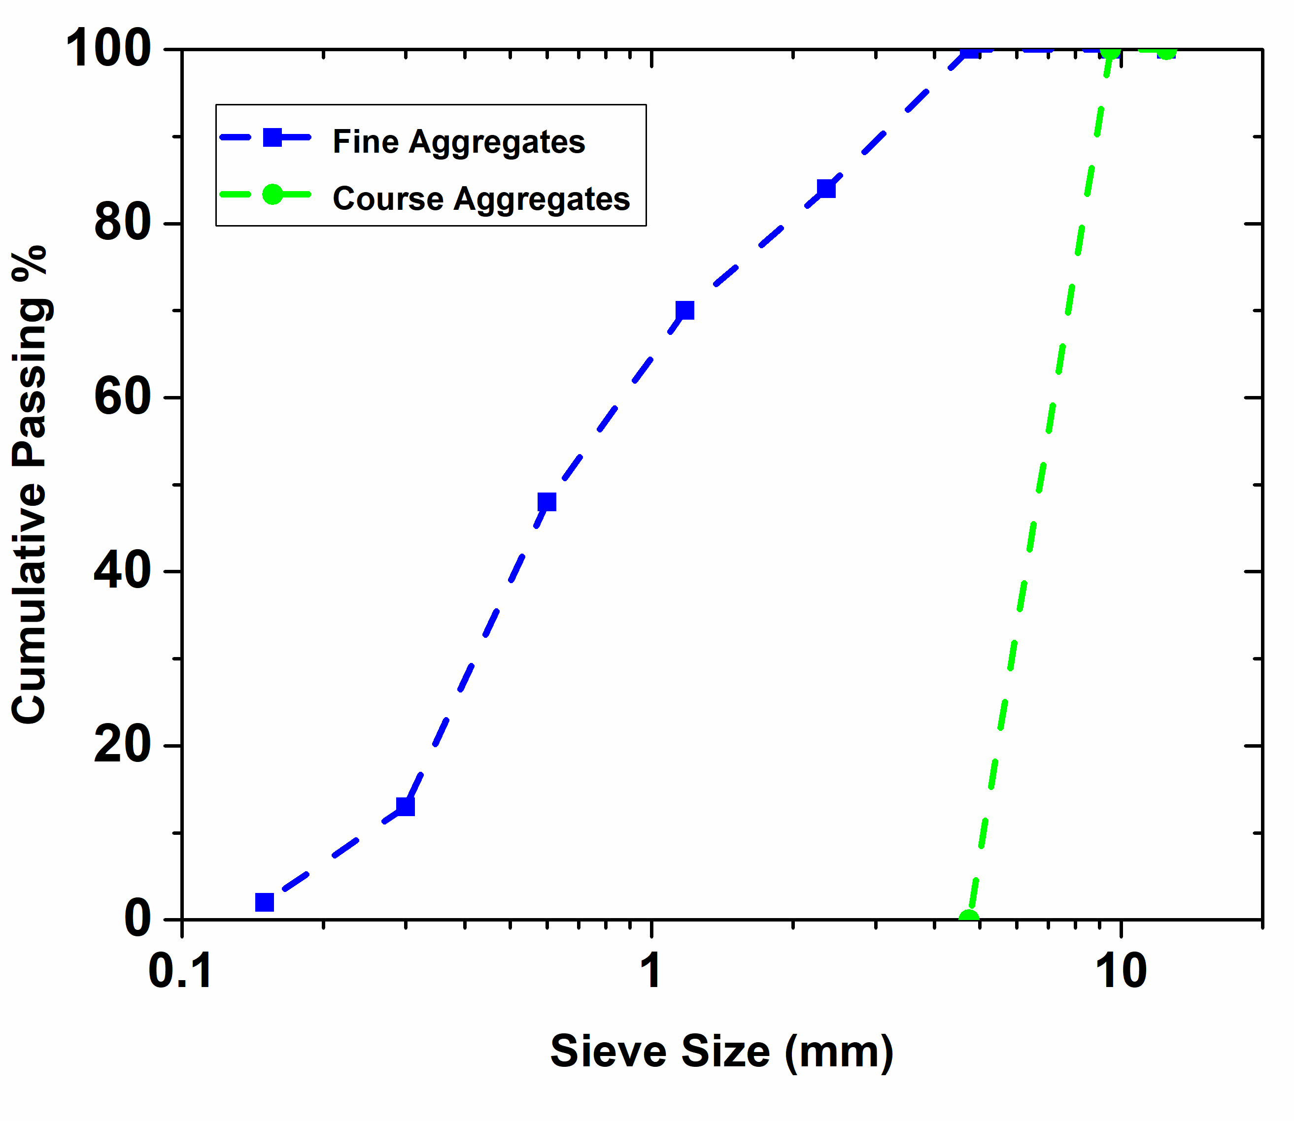
Figure S1. Sieve analysis for Maximum Aggregates Size (9.5 mm and 4.5 mm) as per ASTM C136 [1]
Figure S2. Sample preparation and application of agar

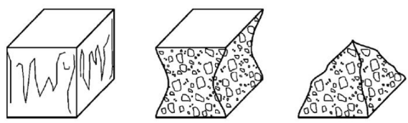 | 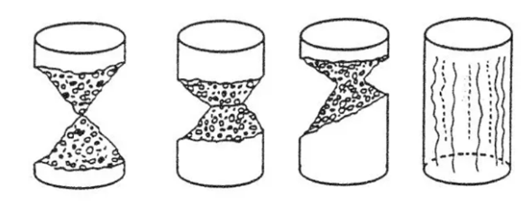
(a) | (b)
Figure S3. The satisfactory failure pattern for correctly measuring compressive strength of (a) concrete block and (b) concrete cylinder.[2]
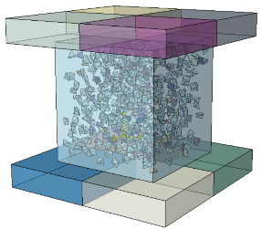 | 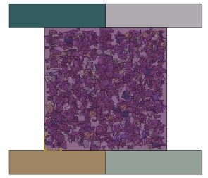 | 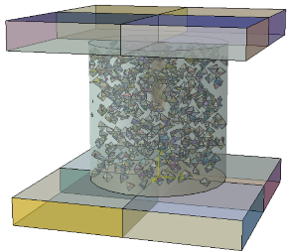 | 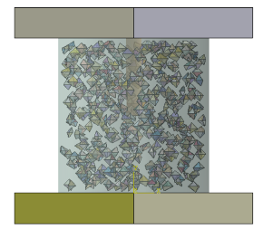
(a) | (b) | (c) | (d)
Figure S4. Incorporation of spatial distribution of aggregates into the cubic and cylindrical concrete samples. (a)–(b) Side and front views of the cubic sample placed between two steel plates. (c)–(d) Side and front views of the cylindrical sample placed between two steel platens.
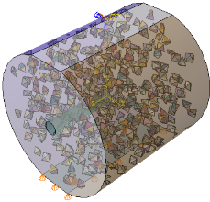 | 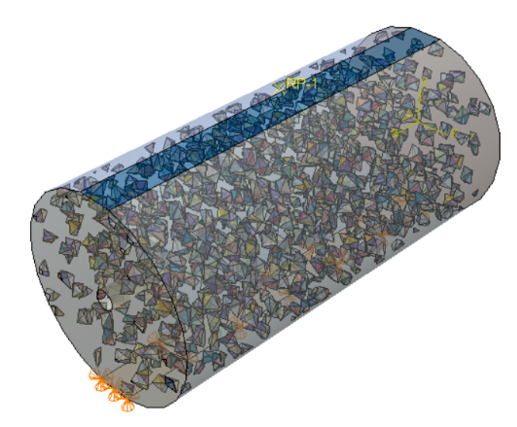 | 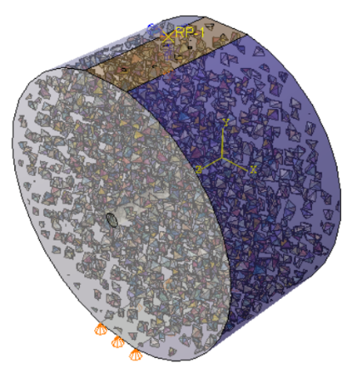
(a) | (b) | (c)
Figure S5. The setup of the model to investigate sample size effect. (a) dimension 2”X2”, (b) dimension 2”X4”, and (c) dimension 4”X2”.
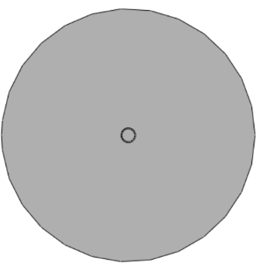 | 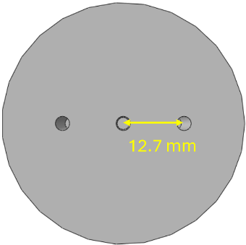 | 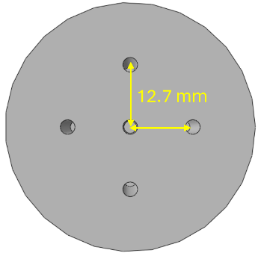 | 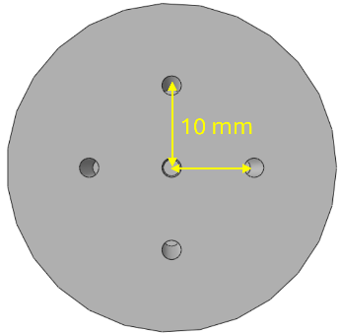
(a) | (b) | (c) | (d)
Figure S6. Top view of the cylindrical concrete sample with different channel architectures: (a) single channel, (b) three channels, (c) five channels, and (d) five channels with closer vertical alignment. Configurations (c) and (d) are used to investigate the impact of closer channel alignment on crack propagation in the sample.

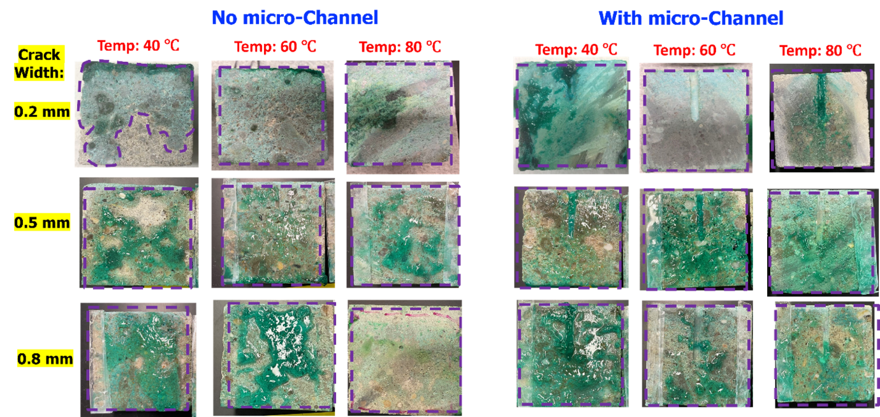
Figure S7. Samples showing transport of agar (0.5 %) at different crack widths and temperatures inside the microcracks with and without channel.
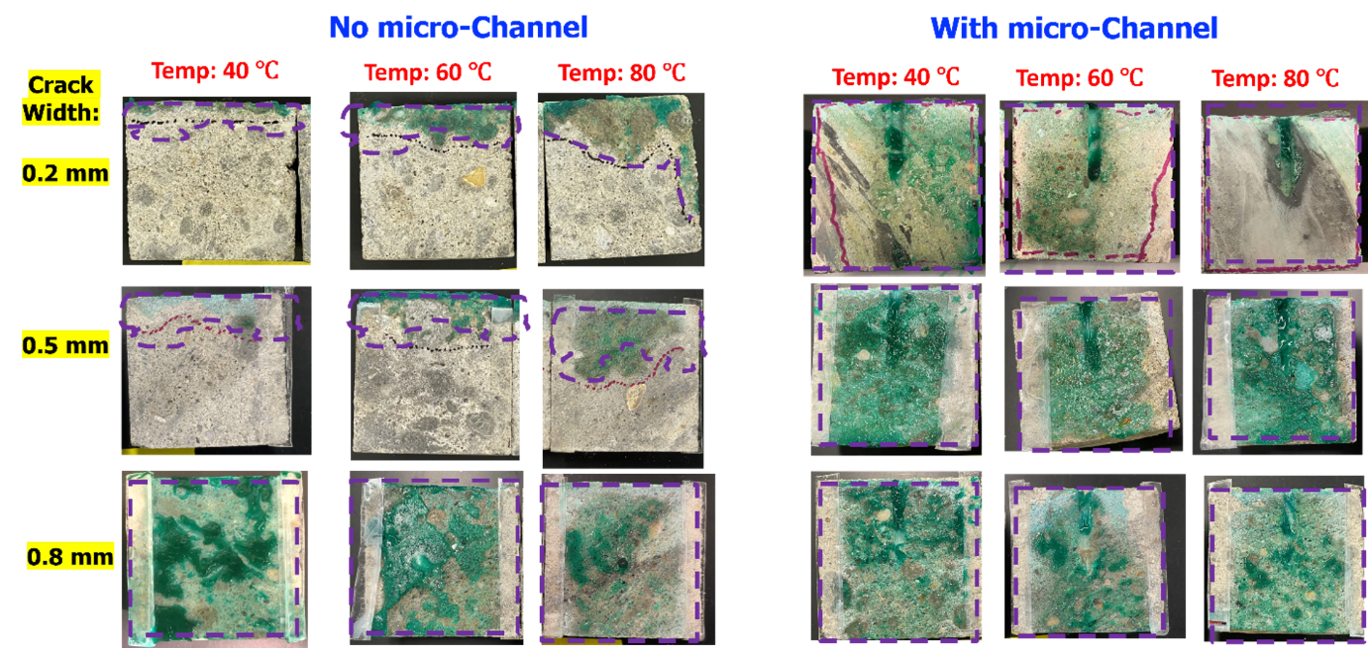
Figure S 8. Samples showing transport of agar (1 %) at different crack widths and temperatures inside the microcracks with and without channel.

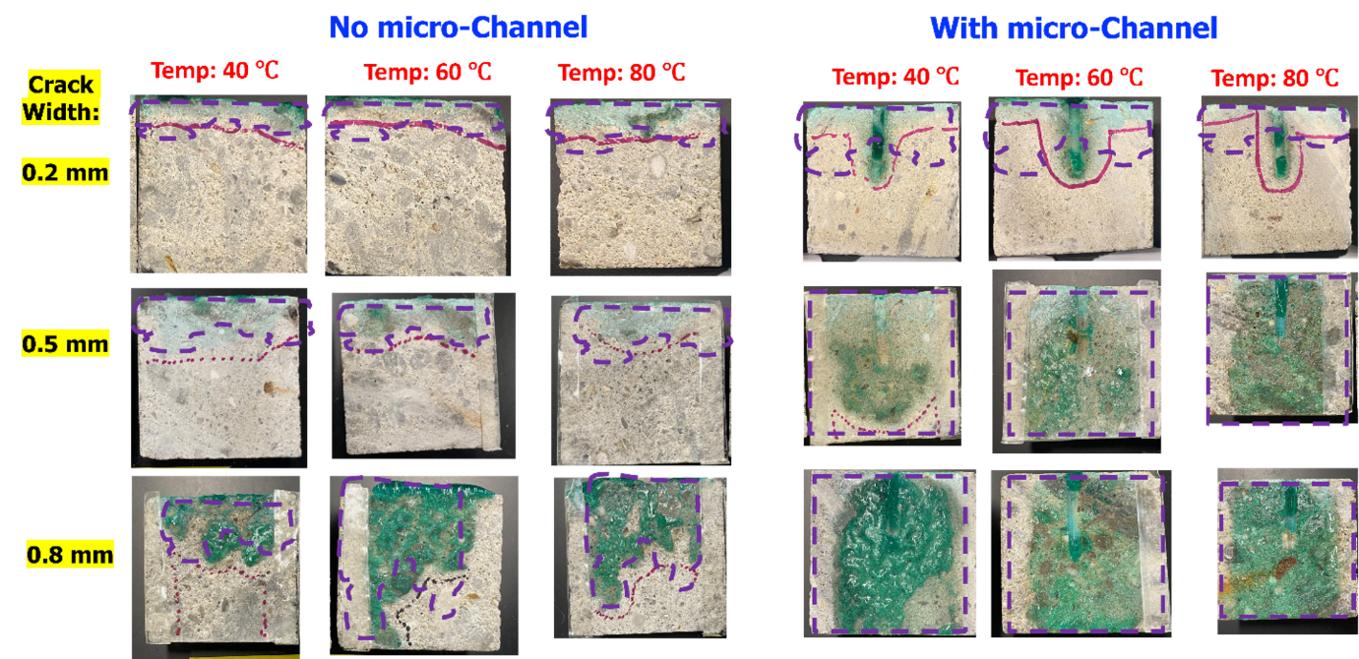
Figure S9. Samples showing transport of agar (1.5 % ) at different crack widths and temperatures inside the microcracks with and without channel.

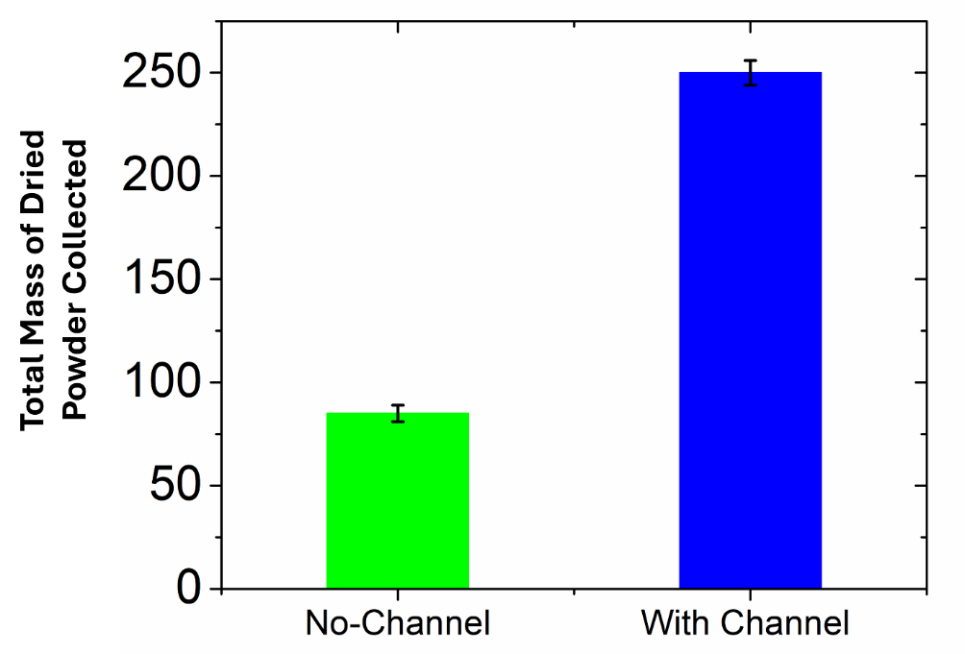
Figure S10. Dry mass of collected biological products in concrete

References:
1. ASTM, A. C496/C496M-17 Standard test method for splitting tensile strength of cylindrical concrete specimens. in American Society for Testing and Materials. 2017.
2. En, B., 12390-3:(2009). Testing Hardened Concrete. Compressive Strength of Test Specimens. British Standard Institution, London, 2019. 16.

