Supplementary Material

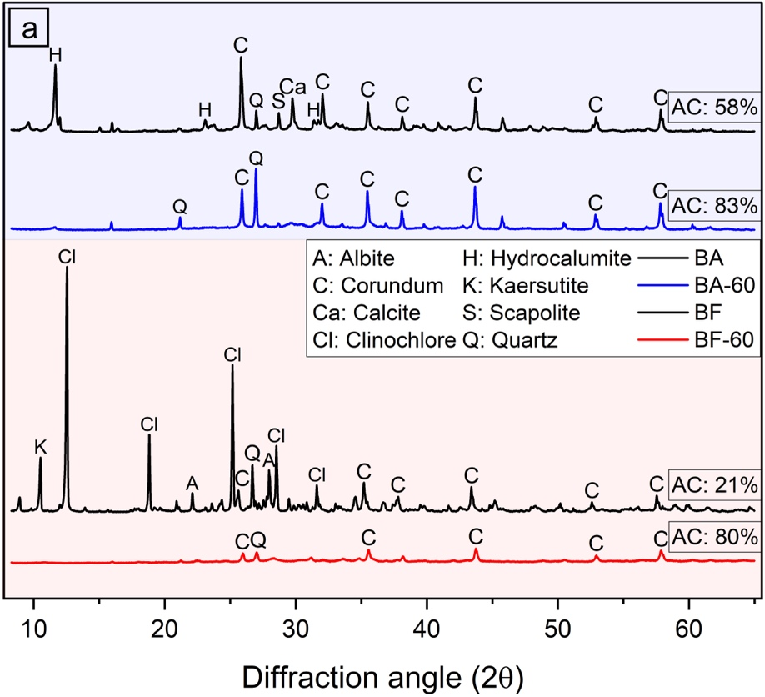
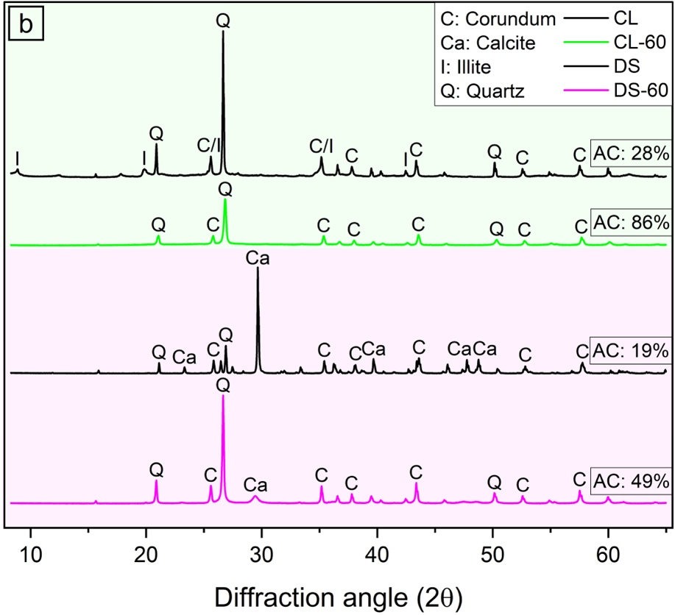
Fig S1. XRD plots before and after MCA for a. BA and BF, b. CL and DS.
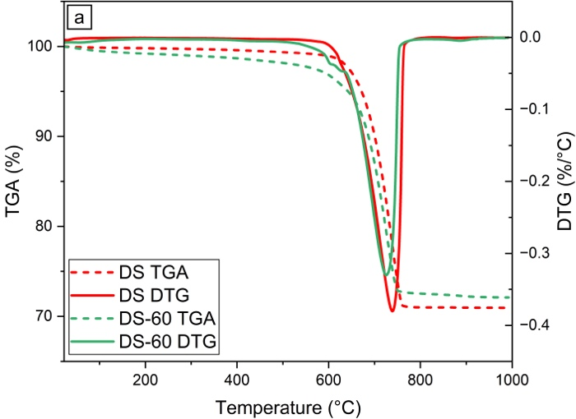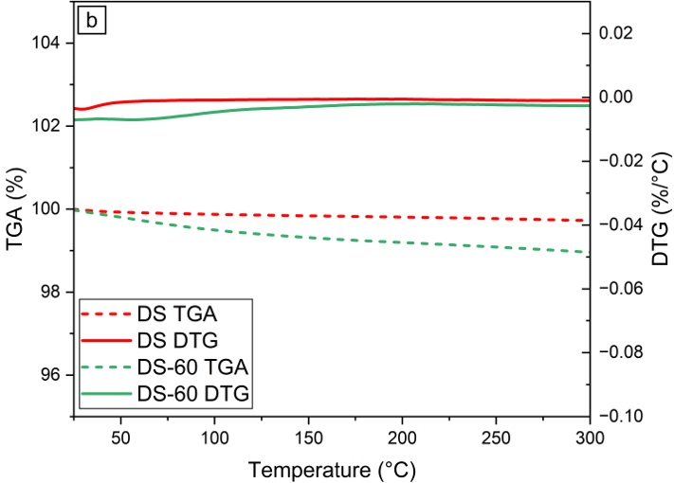
Fig. S2a. TGA and differential thermogravimetric analyses (DTG) for DS and DS-60, b. TGA and DTG of DS and DS-60 (25 °C to 300 °C).

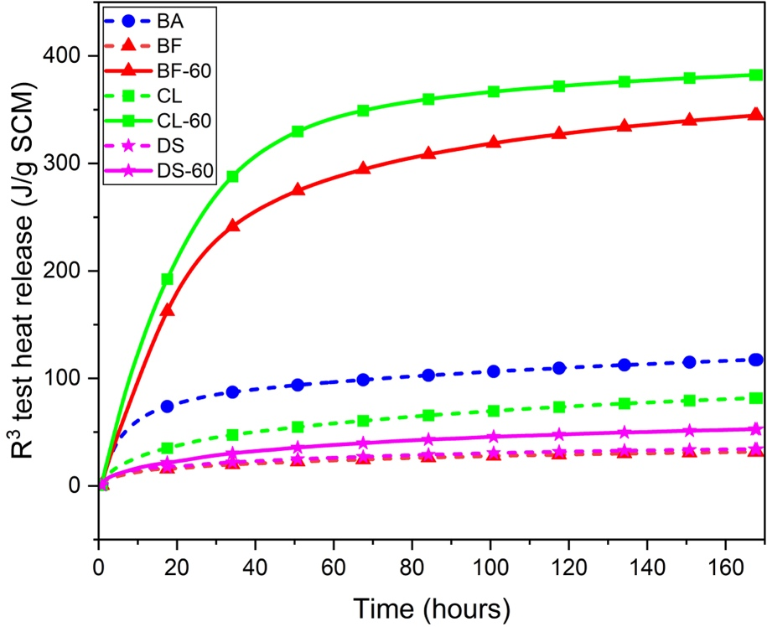
Fig S3. R³ test heat release over time.

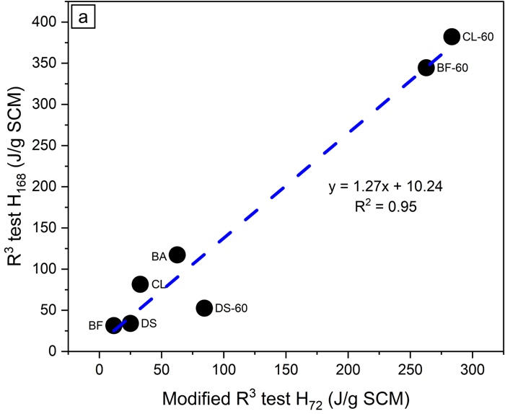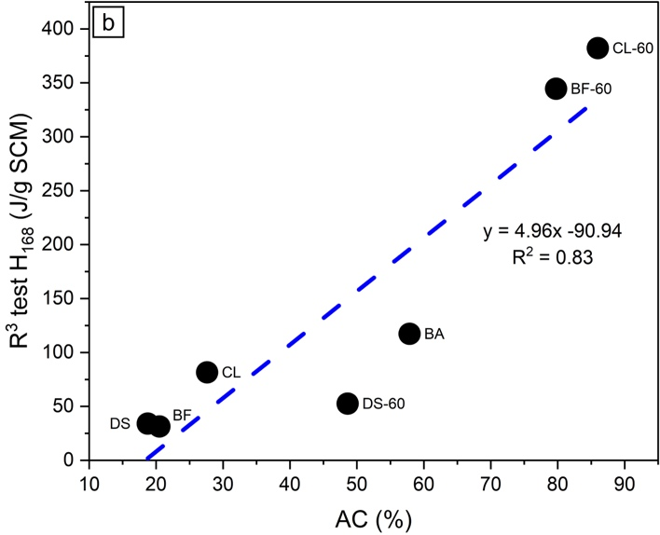
Fig. S4a. R³ test H₁₆₈ as a function of the modified R³ test H₇₂, b. R³ test H₁₆₈ as a function of AC.

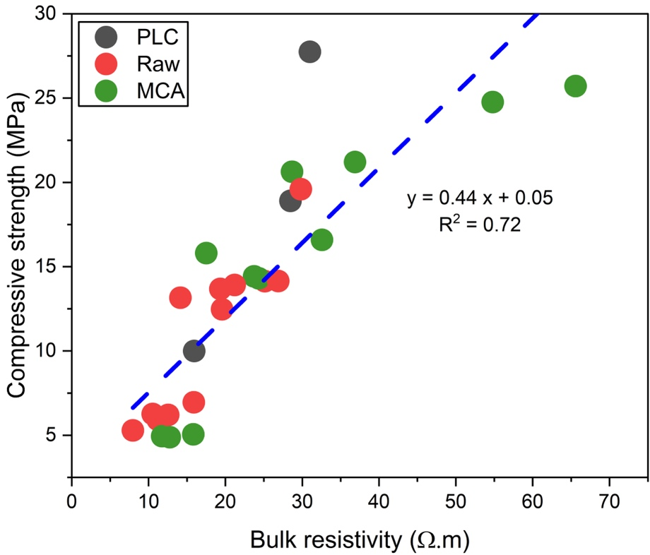
Fig. S5. Compressive strength as a function of bulk resistivity.

Table S1. H∞ values of the different systems.
System | 7-day heat release (J/g) | H∞ (J/g)
PLC | 295 | 406
BA | 210 | 255
BA-60 | 266 | 358
BF | 227 | 294
BF-60 | 257 | 369
CL | 233 | 296
CL-60 | 254 | 348
DS | 234 | 280
DS-60 | 264 | 348

