Supporting Information
Toward continuous shrinkage measurement of poured earth: practical setup and underlying shrinking mechanisms
Yi Du^{1,2*}, Ellina Bernard^{1,2}, Janis Justs¹, Guillaume Habert², Pietro Lura^{1,3}
¹Empa, Swiss Federal Laboratories for Materials Science and Technology, Laboratory for Concrete and Asphalt, Dübendorf CH-8600, Switzerland
²Institute of Construction and Infrastructure Management, Chair of Sustainable Construction, Swiss Federal Institute of Technology (ETH Zurich), Zurich CH-8093, Switzerland
³Institute for Building Materials, ETH Zurich, Swiss Federal Institute of Technology (ETH Zurich), Zurich CH-8093, Switzerland
*Correspondence: yi.du@empa.ch

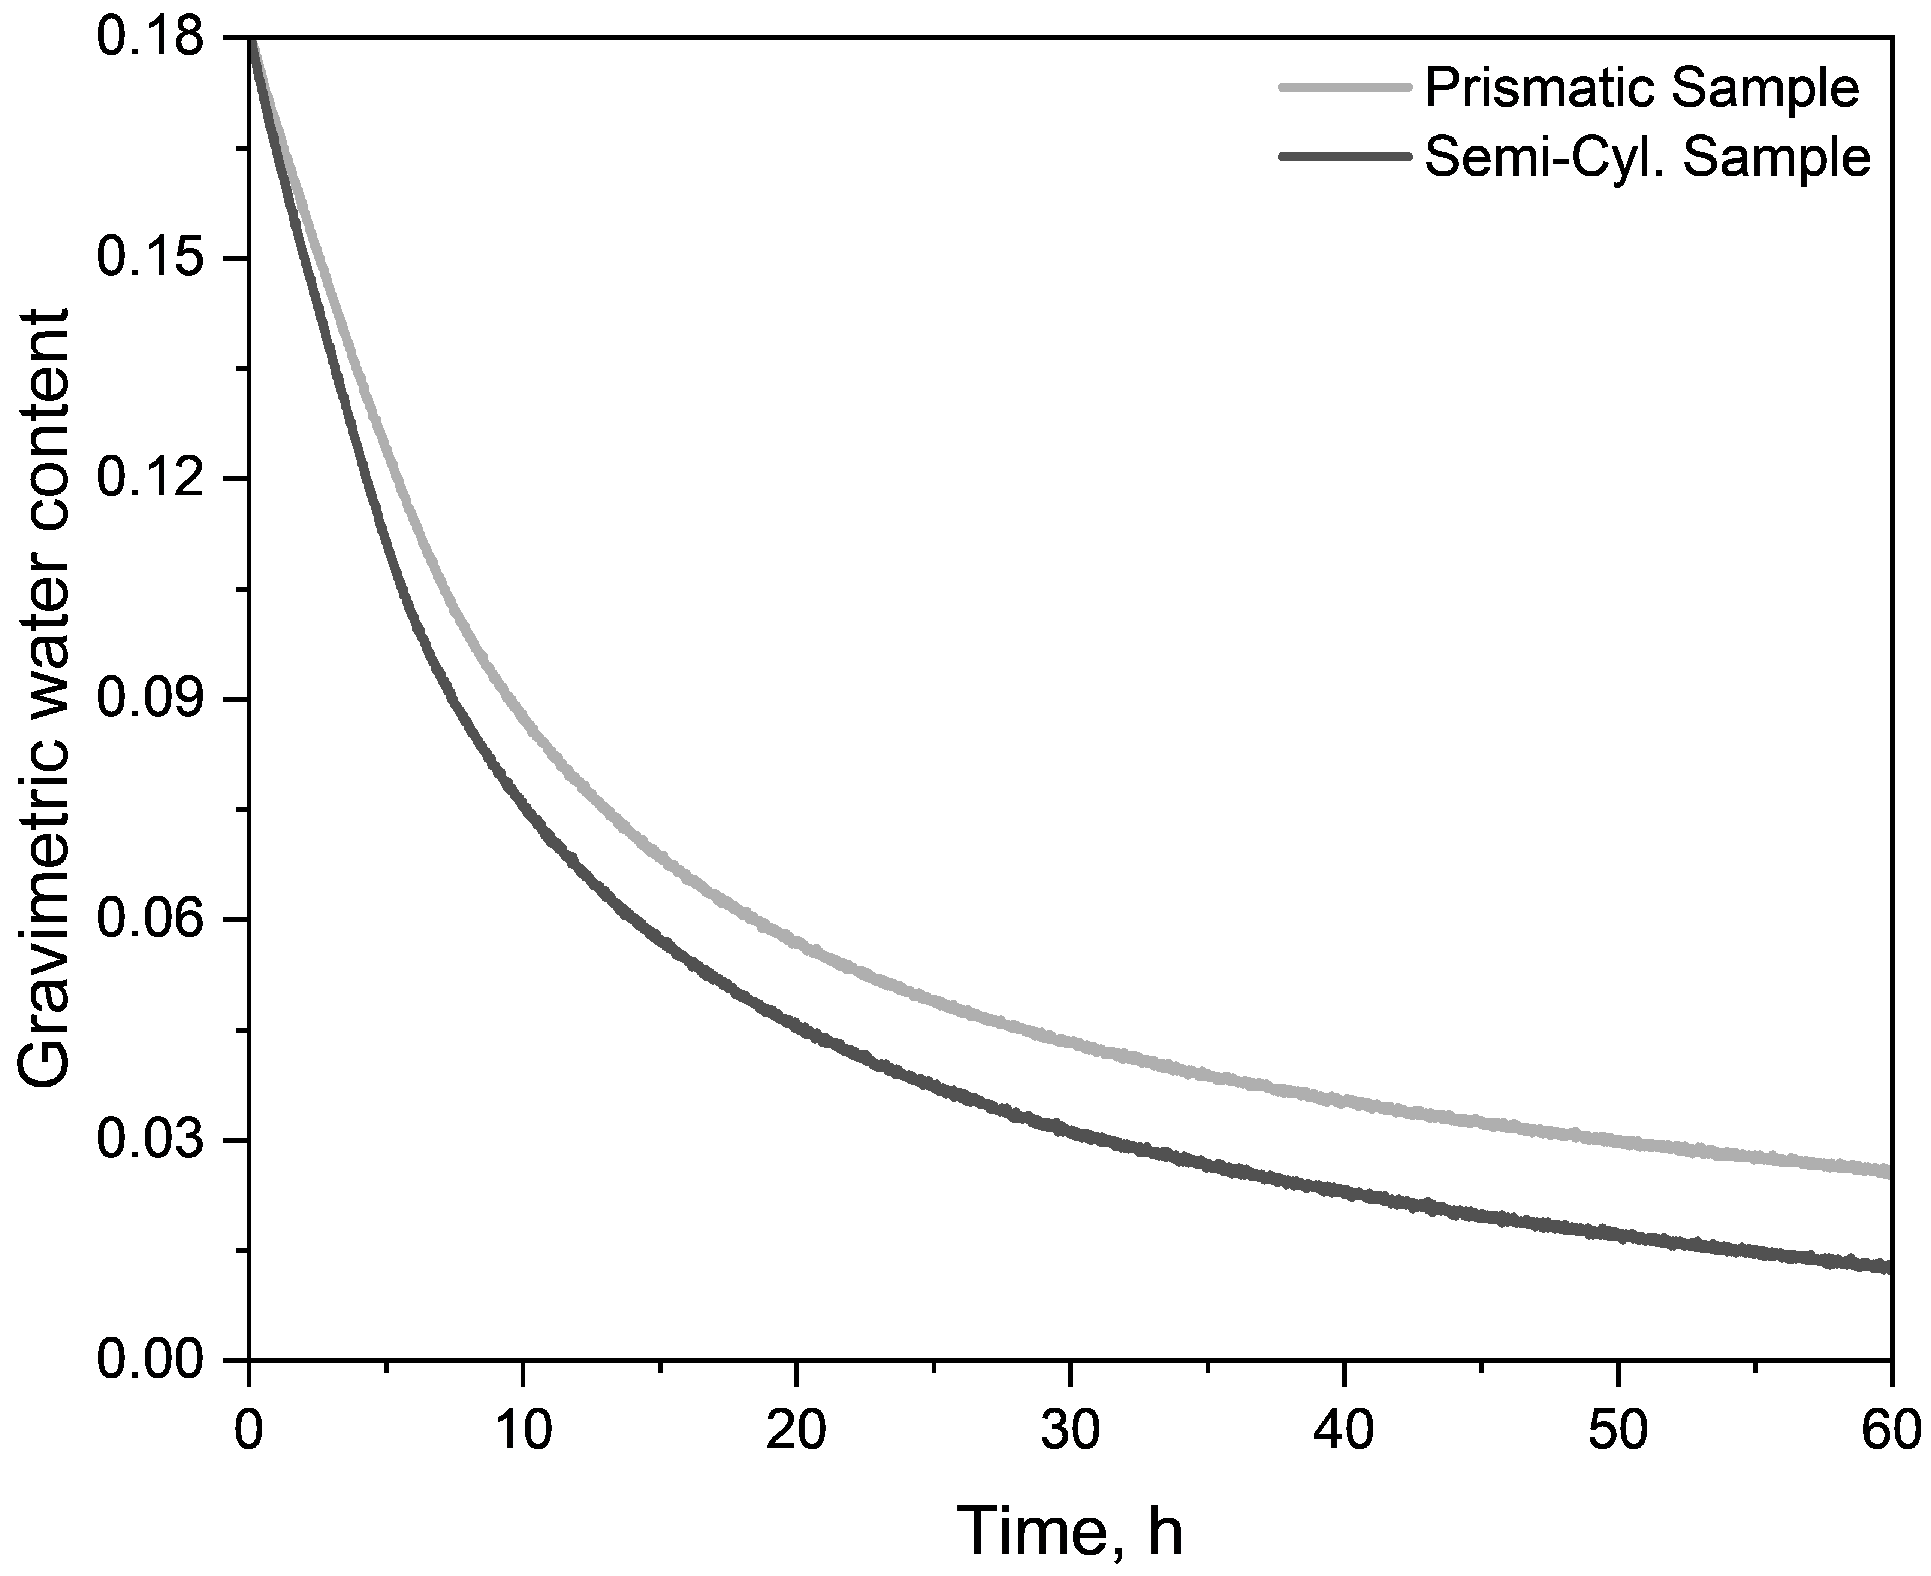
Fig. S1. Gravimetric water content evolution of prismatic and semi-cylindrical samples following drying. Note that the water content was calculated based on the mass loss curves.

Table S1. Duration, mass loss, and water content of the CRP stage for prismatic and semi-cylindrical samples during drying
Sample | CRP stage
Prismatic  Sample | Duration, h | 5.5-6
Prismatic  Sample | Mass loss, kg/m² | 5.7 ~ 6.0
Prismatic  Sample | Water content | 0.12-0.115
Semi-Cyl.  Sample | Duration, h | 4-5
Semi-Cyl.  Sample | Mass loss, kg/m² | 4.7-5.7
Semi-Cyl.  Sample | Water content | 0.12-0.11

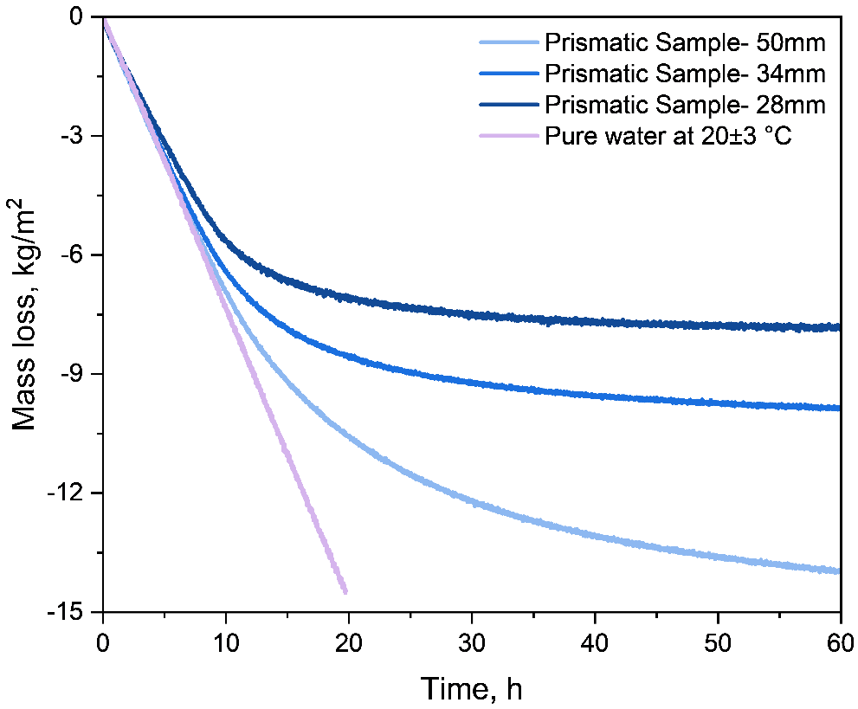
Fig. S2. Mass loss of square samples with different thicknesses over drying time.

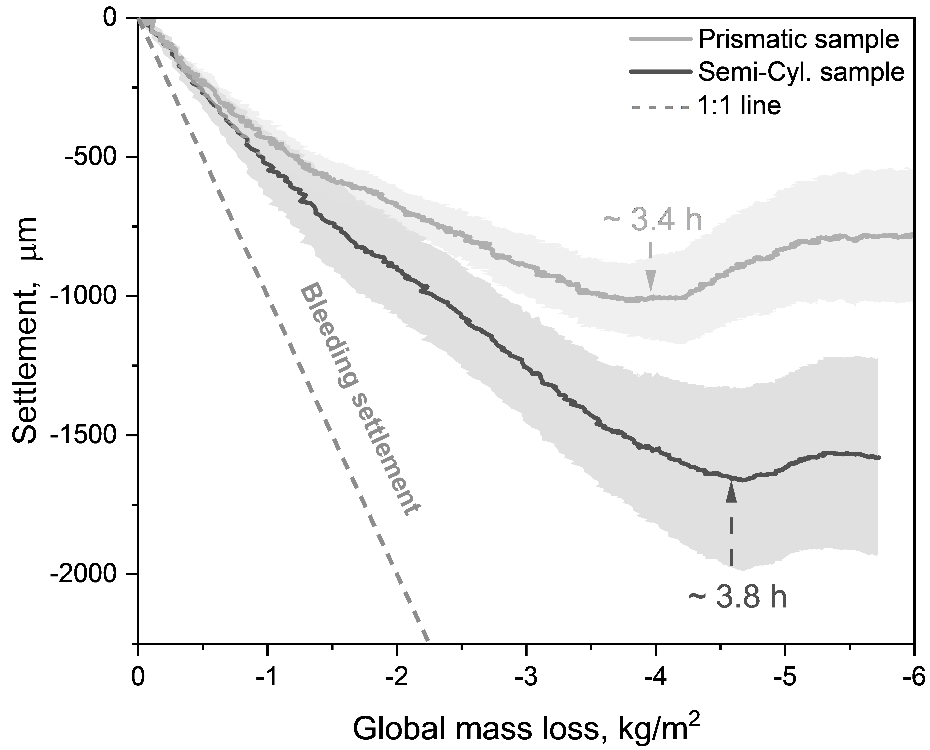
Fig. S3. Vertical deformation of square and semi-cylindrical sample measured by DIC as a function of mass loss. The dashed line represents the bleeding settlement calculated from mass loss.

