Supplementary material

Article title: Measuring the long-term impact of the COVID-19 pandemic on HPV vaccination in Quebec, Canada : a cohort study from the Canadian Immunization Research Network.
Journal name: Canadian Journal of Public Health

Table S1 Vaccination coverage for vaccines in Grade 4 and Grade 9 from the 2019-2020 to the 2022-2023 school year with and without catch-up vaccination activitiesª
Grade | Vaccine | Dose | Catch-up | School year
 |  |  |  | 2019-2020 | 2020-2021 | 2021-2022 | 2022-2023
 |  |  |  | VC % (95% CI) | VC % (95% CI) | VC % (95% CI) | VC % (95% CI)
4 | HPV (girls) | ≥1 dose | With | 87.4 (87.0-87.7) | 85.6 (85.2-85.9) | 84.4 (84.1-84.8) | 82.9 (82.6-83.3)
4 | HPV (girls) | ≥1 dose | Without | 86.0 (85.6-86.3) | 52.3 (51.8-52.8) | 82.8 (82.4-83.1) | -
4 | HPV (boys) | ≥1 dose | With | 85.2 (84.9-85.6) | 83.0 (82.7-83.4) | 81.3 (80.9-81.6) | 80.3 (79.9-80.7)
4 | HPV (boys) | ≥1 dose | Without | 83.8 (83.5-84.2) | 50.7 (50.3-51.2) | 79.3 (79.0-79.7) | -
4 | HPV (all) | ≥1 dose | With | 86.1 (85.8-86.3) | 84.3 (84.0-84.5) | 82.8 (82.5-83.0) | 81.6 (81.3-81.8)
4 | HPV (all) | ≥1 dose | Without | 84.7 (84.4-84.9) | 51.5 (51.2-51.8) | 81.0 (80.7-81.3) | -
4 | HAHB | ≥1 dose | With | 92.7 (92.5-92.9) | 91.0 (90.8-91.2) | 89.9 (89.7-90.1) | 92.8 (92.7-93.0)
4 | HAHB | ≥1 dose | Without | 92.3 (92.1-92.5) | 68.1 (67.8-68.4) | 88.7 (88.5-88.9) | -
9 | HPV (girls) | ≥1 dose | With | 92.7 (92.4-93.0) | 91.9 (91.6-92.1) | 90.8 (90.5-91.1) | 90.7 (90.5-91.0)
9 | HPV (girls) | ≥1 dose | Without | 91.1 (90.8-91.3) | 85.9 (85.6-86.3) | 90.3 (90.1-90.6) | -
9 | HPV (girls) | 2 doses | With | 87.3 (87.0-87.6) | 86.9 (86.6-87.3) | 86.4 (86.1-86.7) | 85.1 (84.8-85.4)
9 | HPV (girls) | 2 doses | Without | 79.6 (79.2-80.0) | 78.9 (78.6-79.3) | 84.9 (84.5-85.2) | -
9 | HPV (boys) | ≥1 dose | With | 84.3 (84.0-84.7) | 83.0 (82.6-83.3) | 86.2 (85.9-86.5) | 88.5 (88.2-88.8)
9 | HPV (boys) | ≥1 dose | Without | 79.0 (78.6-79.4) | 52.7 (52.3-53.2) | 85.4 (85.1-85.8) | -
9 | HPV (boys) | 2 doses | With | 65.6 (65.1-66.0) | 64.7 (64.3-65.2) | 78.4 (78.0-78.8) | 81.8 (81.5-82.2)
9 | HPV (boys) | 2 doses | Without | 11.1 (10.8-11.4) | 22.1 (21.7-22.5) | 75.9 (75.5-76.3) | -
9 | HPV (all) | ≥1 dose | With | 88.2 (87.9-88.4) | 87.3 (87.0-87.5) | 88.4 (88.2-88.6) | 89.6 (89.4-89.8)
9 | HPV (all) | ≥1 dose | Without | 84.6 (84.4-84.9) | 68.8 (68.4-69.1) | 87.8 (87.6-88.0) | -
9 | HPV (all) | 2 doses | With | 75.8 (75.6-76.1) | 75.4 (75.2-75.7) | 82.2 (82.0-82.4) | 83.4 (83.1-83.6)
9 | HPV (all) | 2 doses | Without | 43.9 (43.6-44.3) | 49.5 (49.2-49.8) | 80.2 (79.9-80.4) | -
9 | Men-C-C | ≥1 dose after 10yrs | With | 87.8 (87.5-88.0) | 86.8 (86.5-87.0) | 85.5 (85.2-85.7) | 84.3 (84.1-84.5)
9 | Men-C-C | ≥1 dose after 10yrs | Without | 80.9 (80.6-81.2) | 51.3 (51.0-51.7) | 83.7 (83.5-83.9) | -
9 | Td | 4 doses including ≥1 dose after 10yrs | With | 79.3 (79.0-79.6) | 81.0 (80.7-81.3) | 80.5 (80.2-80.7) | 80.1 (79.8-80.3)
9 | Td | 4 doses including ≥1 dose after 10yrs | Without | 72.9 (72.6-73.2) | 49.4 (49.1-49.7) | 78.2 (78.0-78.5) | -
ªHPV: human papillomavirus (HPV) vaccine. HAHB: combined hepatitis A and hepatitis B vaccine. Men-C-C: meningococcal serogroup C conjugate. Td: tetanus and diphtheria vaccine
Figure S1 Characteristics associated with HPV vaccination (at least 1 dose) – Grade 4 – univariate analysis

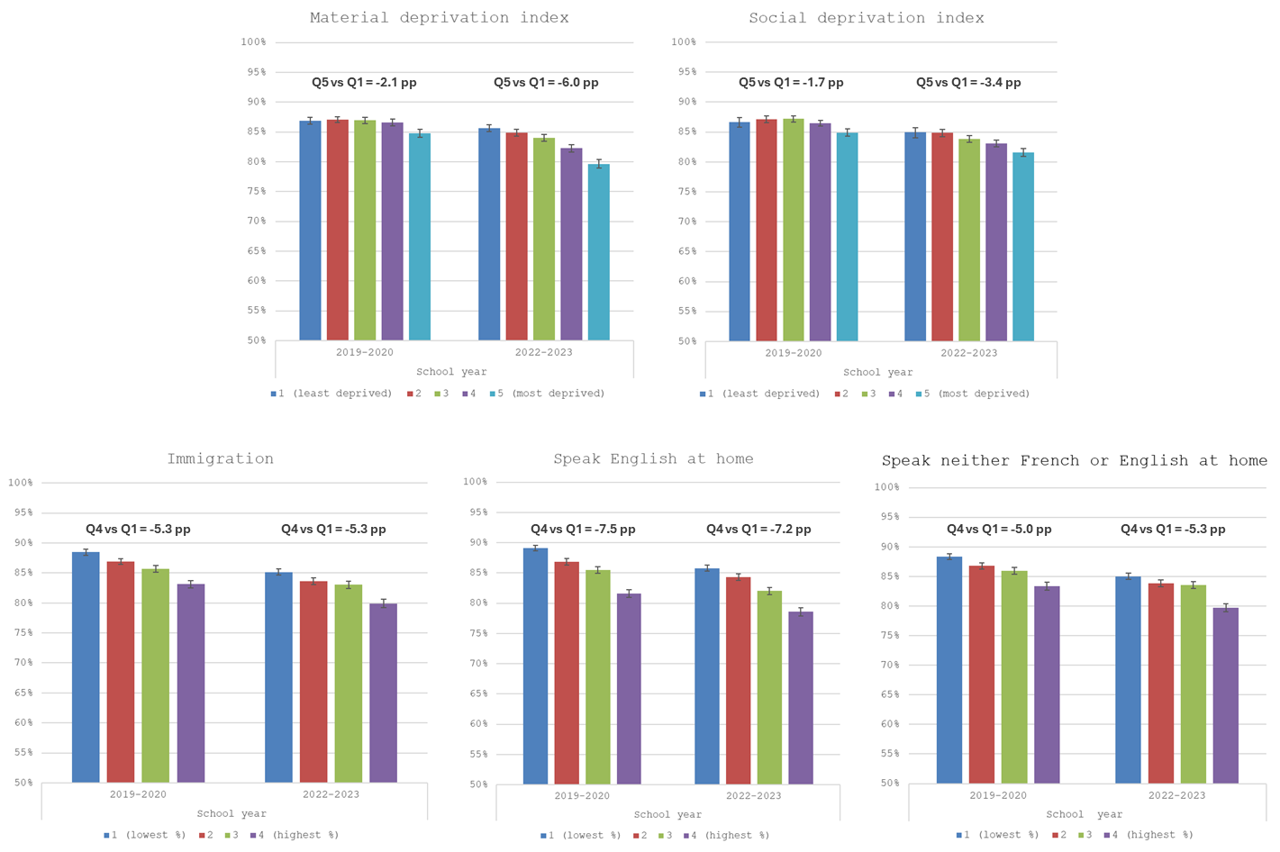
Vaccination coverage (%)
Vaccination coverage (%)
pp: percentage points. Vaccination coverage assessed by August 31st of each school year.

