Supplementary material

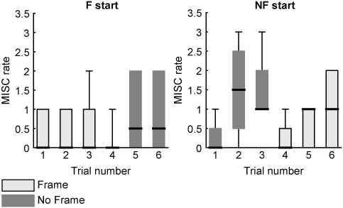
Supplementary figure 1. Boxplots of the MISC rates separated for participants starting with the NF condition (left) and with the F condition (right). The solid black lines indicate the median MISC rate.

