Supplementary Information

We carried out two additional experiments that were conceptually closely related to Experiment 3a in that they involved changes to the distribution of candidate stimuli. Effectively, we introduced an artificial perceptual bias by changing the values of two of the four candidate stimuli by a fixed amount. This change was not incorporated into the MAPS model. This way we could quantify whether the estimate of perceptual bias for these candidate locations counteracted the artificial biases.

Experiment S1: Artificial size bias

This was a basic MAPS experiment to measure the perceptual heterogeneity of size judgments. However, in some trials we added a fixed amount to one candidate stimulus and subtracted a fixed amount from another.

Methods

Participants
Fifteen participants (3 authors; 7 female; 1 left-handed; ages 20-37) took part in this experiment.

Procedure
The procedure was identical to the basic MAPS experiment on size perception as described in the main text. Within a single session, each observer completed four experimental runs comprising 200 trials each that were subdivided into 10 blocks of 20 trials. Half of the experimental runs participants performed measured their baseline biases. The other half of the runs contained artificially induced biases: two of the four candidate stimuli were altered subtly, one by adding and one by subtracting a fixed amount from these candidates. Which two targets were altered was counterbalanced across observers, as was the order of experimental runs.

Stimuli & Task
The stimuli were generated in the same way as in the main experiments, and the task was identical. However, in the experimental runs with artificially induced biases, we added 0.1 log units to one candidate stimulus and subtracted 0.1 log units from another.

Results and Discussion

The results suggest that MAPS reliably detected the spatial pattern of the artificially induced biases in this experiment (Figure S1). There was a significant difference in the perceptual bias estimates (F(3,42)=15.9, p<0.001) depending on the sign and magnitude of the artificially induced biases (for this analysis, we averaged the perceptual bias estimates for the two candidate locations that did not contain an artificial bias: “unbiased”). Importantly, as expected the direction of the perceptual bias estimates went in the opposite direction of the artificial biases. So when candidates were made to look larger than they should, the perceptual bias estimate was reduced and, vice versa, if the artificial bias made the candidate appear smaller, the perceptual bias estimate was shifted to be larger. These results conceptually replicate the findings of Experiment 3a because the estimates of perceptual biases adjust for the artificial shift in the candidate distribution. However, in the present experiment two opposing shifts occurred within the same trial.

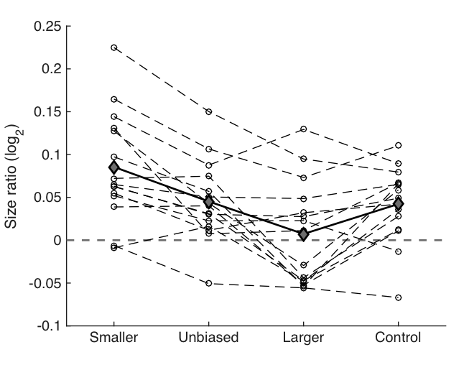
Figure S1. Results of Supplementary Experiment S1. Perceptual bias was plotted for the three manipulations of candidate locations, that is, candidates that were shifted to be 0.1 log units smaller or larger than they should be nominal as well as candidates that were unbiased. Control refers to experimental runs in which all four candidate locations were unbiased. Grey filled diamonds and solid black lines denote the mean across observers. Open circles and dashed lines denote individual observers.

Experiment S2: Artificial orientation bias

All of our experiments so far had only tested size judgments, so we decided to conduct an experiment to generalize the findings to another visual attribute. Therefore, we conducted a basic MAPS experiment to measure the perceptual heterogeneity of orientation judgments. As in Experiment S1, in some trials we added a fixed amount to one candidate stimulus and subtracted a fixed amount from another.

Methods

Participants
Ten participants (1 author; 4 female; 2 left-handed; ages 21-32) took part this experiment.

Procedure
Observers were recruited for two sessions on separate days comprising four runs each. Half of the runs contained artificial biases. Each run consisted of 200 trials, subdivided into 10 blocks of 20 trials.

Stimuli
The stimuli contained five small Gabor patches (sinusoidal grating with wavelength: 0.62°; contrast: 50% convolved with a Gaussian envelope with standard deviation: 0.49°) presented on a grey background (54cd/m²). The central patch was the reference and was oriented either at 30° or 120° counterclockwise from horizontal. From trial to trial the target orientations varied relative to the reference by drawing orientation offsets from the reference from a Gaussian distribution with standard deviation of 15°. The artificial bias added or subtracted from two candidate stimuli in the artificial bias runs was 5°. The ‘ripple’ effect indicating the observer’s behavioral response was a non-Cartesian grating, a concentric sinusoidal grating (wavelength: 2.48°) convolved with a Gaussian envelope increasing from 0.49° in steps of 0.33° and decreasing in contrast from 50% in steps of 10%.

Task
The task in this experiment was conceptually the same as for the size perception experiments. Observers were presented with a stimulus array comprising five Gabor patches. The central patch indicated the reference orientation and was constant throughout the experiment but it was counterbalanced across observers to be either 30° or 120° counterclockwise from horizontal. Observers were instructed to indicate which of the candidates appeared to be most parallel to the reference patch.

Results and Discussion

The results suggest that MAPS reliably detected the spatial pattern of the artificially induced biases also for orientation judgments (Figure S2). There was a significant difference in the perceptual bias estimates (F(3,27)=39.4, p<0.001) depending on the sign and magnitude of the artificially induced biases (for this analysis, we again averaged the perceptual bias estimates for the two candidate locations that did not contain an artificial bias). Importantly, as expected the direction of the perceptual bias estimates went in the opposite direction of the artificial biases. So when candidates were made to look larger than they should, the perceptual bias estimate was reduced and, vice versa, if the artificial bias made the candidate appear smaller, the perceptual bias estimate was shifted to be larger. These results also conceptually replicate the findings of Experiment 3a and Experiment S1 and generalize these findings to a different visual attribute.
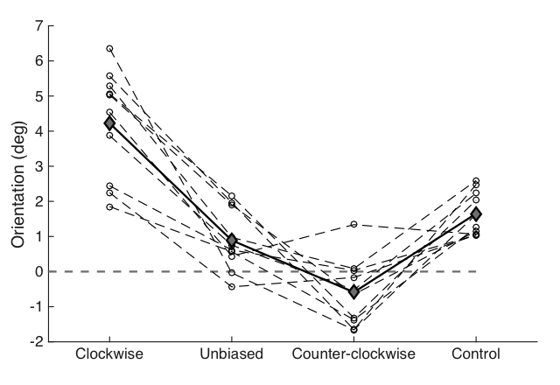
Figure S2. Results of Supplementary Experiment S2. Perceptual bias was plotted for the three manipulations of candidate locations, that is, candidates that were shifted to be 5° more clockwise or counter-clockwise than they should be nominal as well as candidates that were unbiased. Control refers to experimental runs in which all four candidate locations were unbiased. Grey filled diamonds and solid black lines denote the mean across observers. Open circles and dashed lines denote individual observers.

