Supplementary Material

Asynchronous condition:
difference wave (INC – CON) with different filter settings
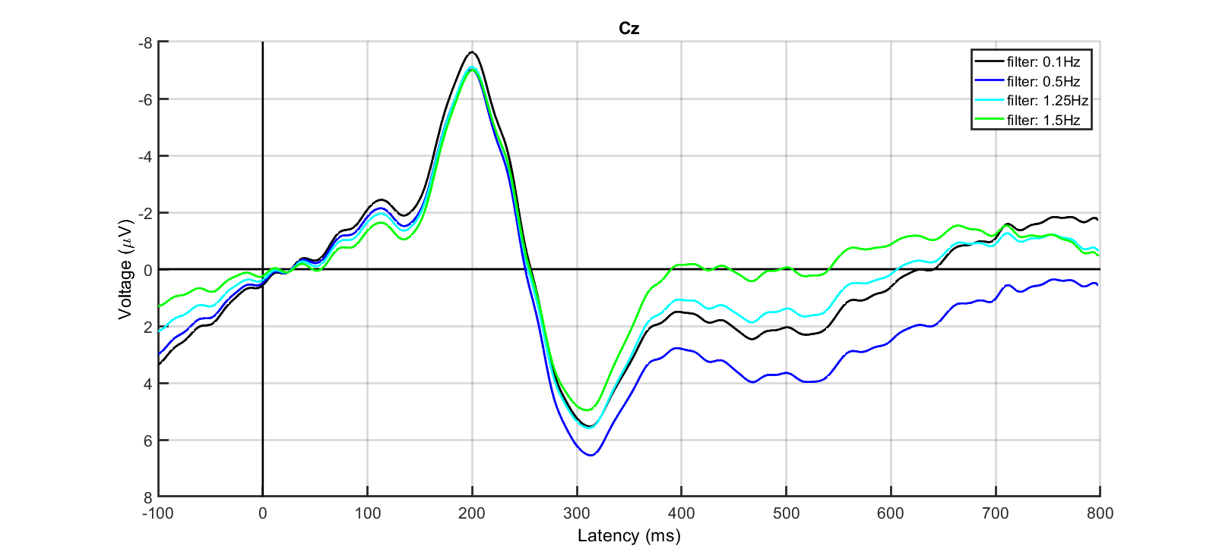
Synchronous condition:
difference wave (INC – CON) with different filter settings
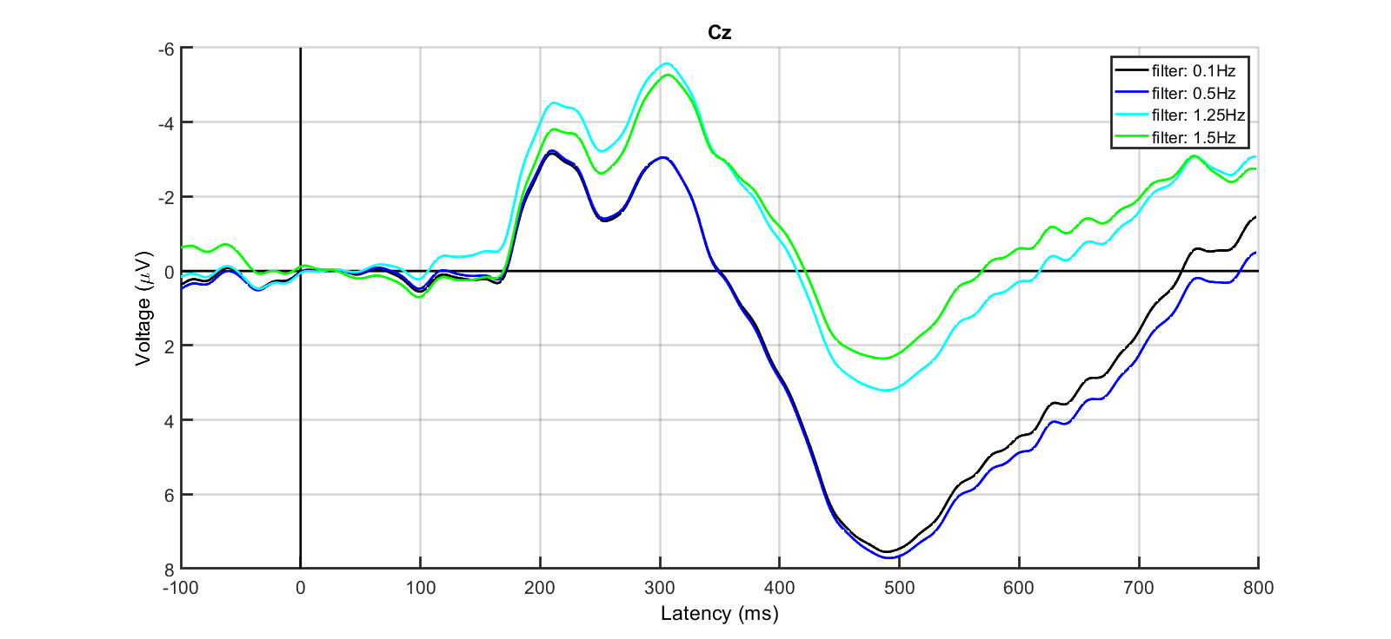
Figure S1: Difference waveforms (INC – CON) for asynchronous (top) and synchronous (bottom) conditions from -100 to 800 ms relative to sound onset. Different high-pass filter settings are contrasted (black: 0.1 Hz high-pass filter cutoff, blue: 0.5 Hz high-pass filter cutoff, cyan: 1.25 Hz high-pass filter cutoff, green: 1.5 Hz high-pass filter cutoff). The data was low-pass filtered with 48 Hz cutoff and baseline corrected from 0 to +50 ms.

