Supplementary figures

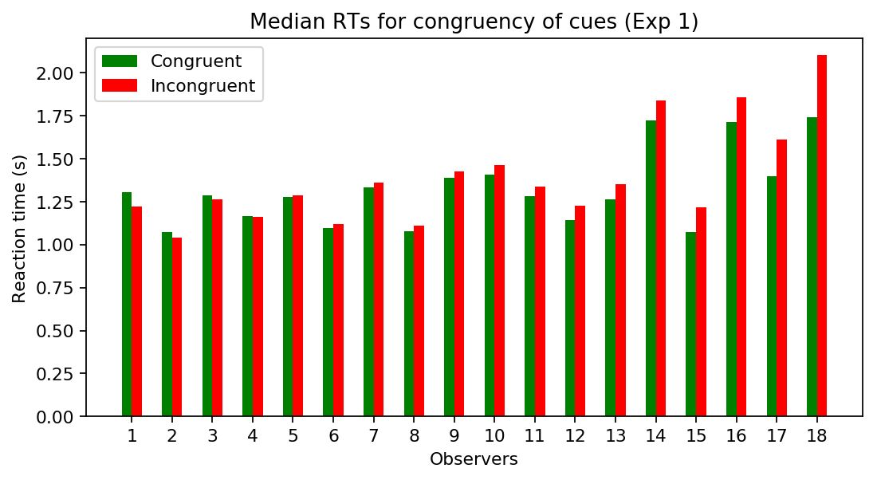
Figure S1. Individual results for Experiment 1, per observer pooled over the timing of the auditory cue.

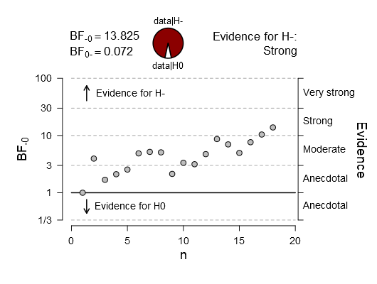
Figure S2. Results of the Bayesian stopping rule in Experiment 1. Data collection was terminated after the Bayes Factor reached a factor of 10 or higher (or 1/10 or lower).

