Supplementary Figure 1: Mean RT for icons varying in appeal and complexity in Experiment 1 for (A) target present and (B) target absent trials. Error bars indicate standard error of the mean.
(A)
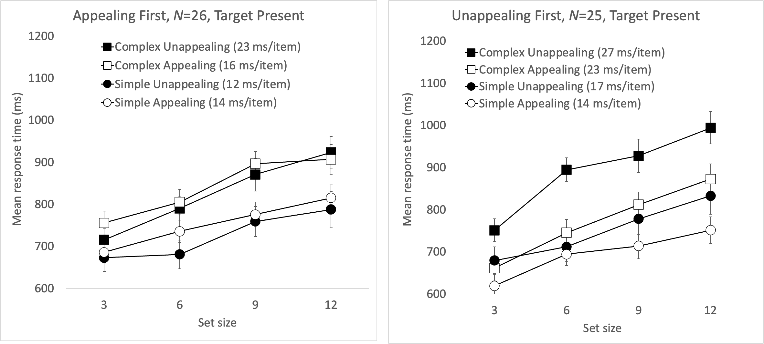
(B)
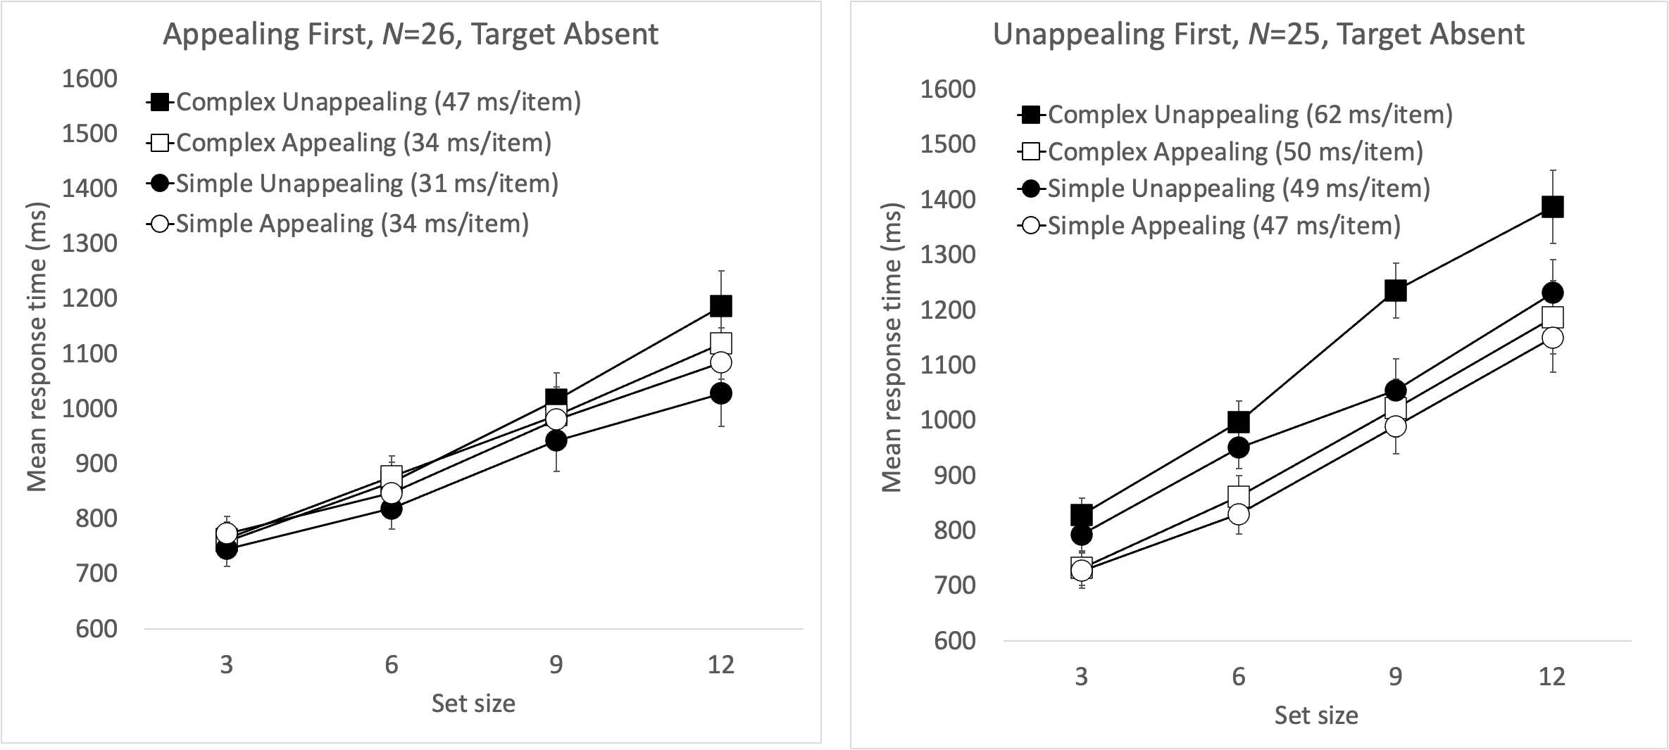

Supplementary Figure 2: Mean RT per condition in Experiment 2, for (A) target present and (B) target absent trials. Error bars indicate standard error of the mean.

(A) 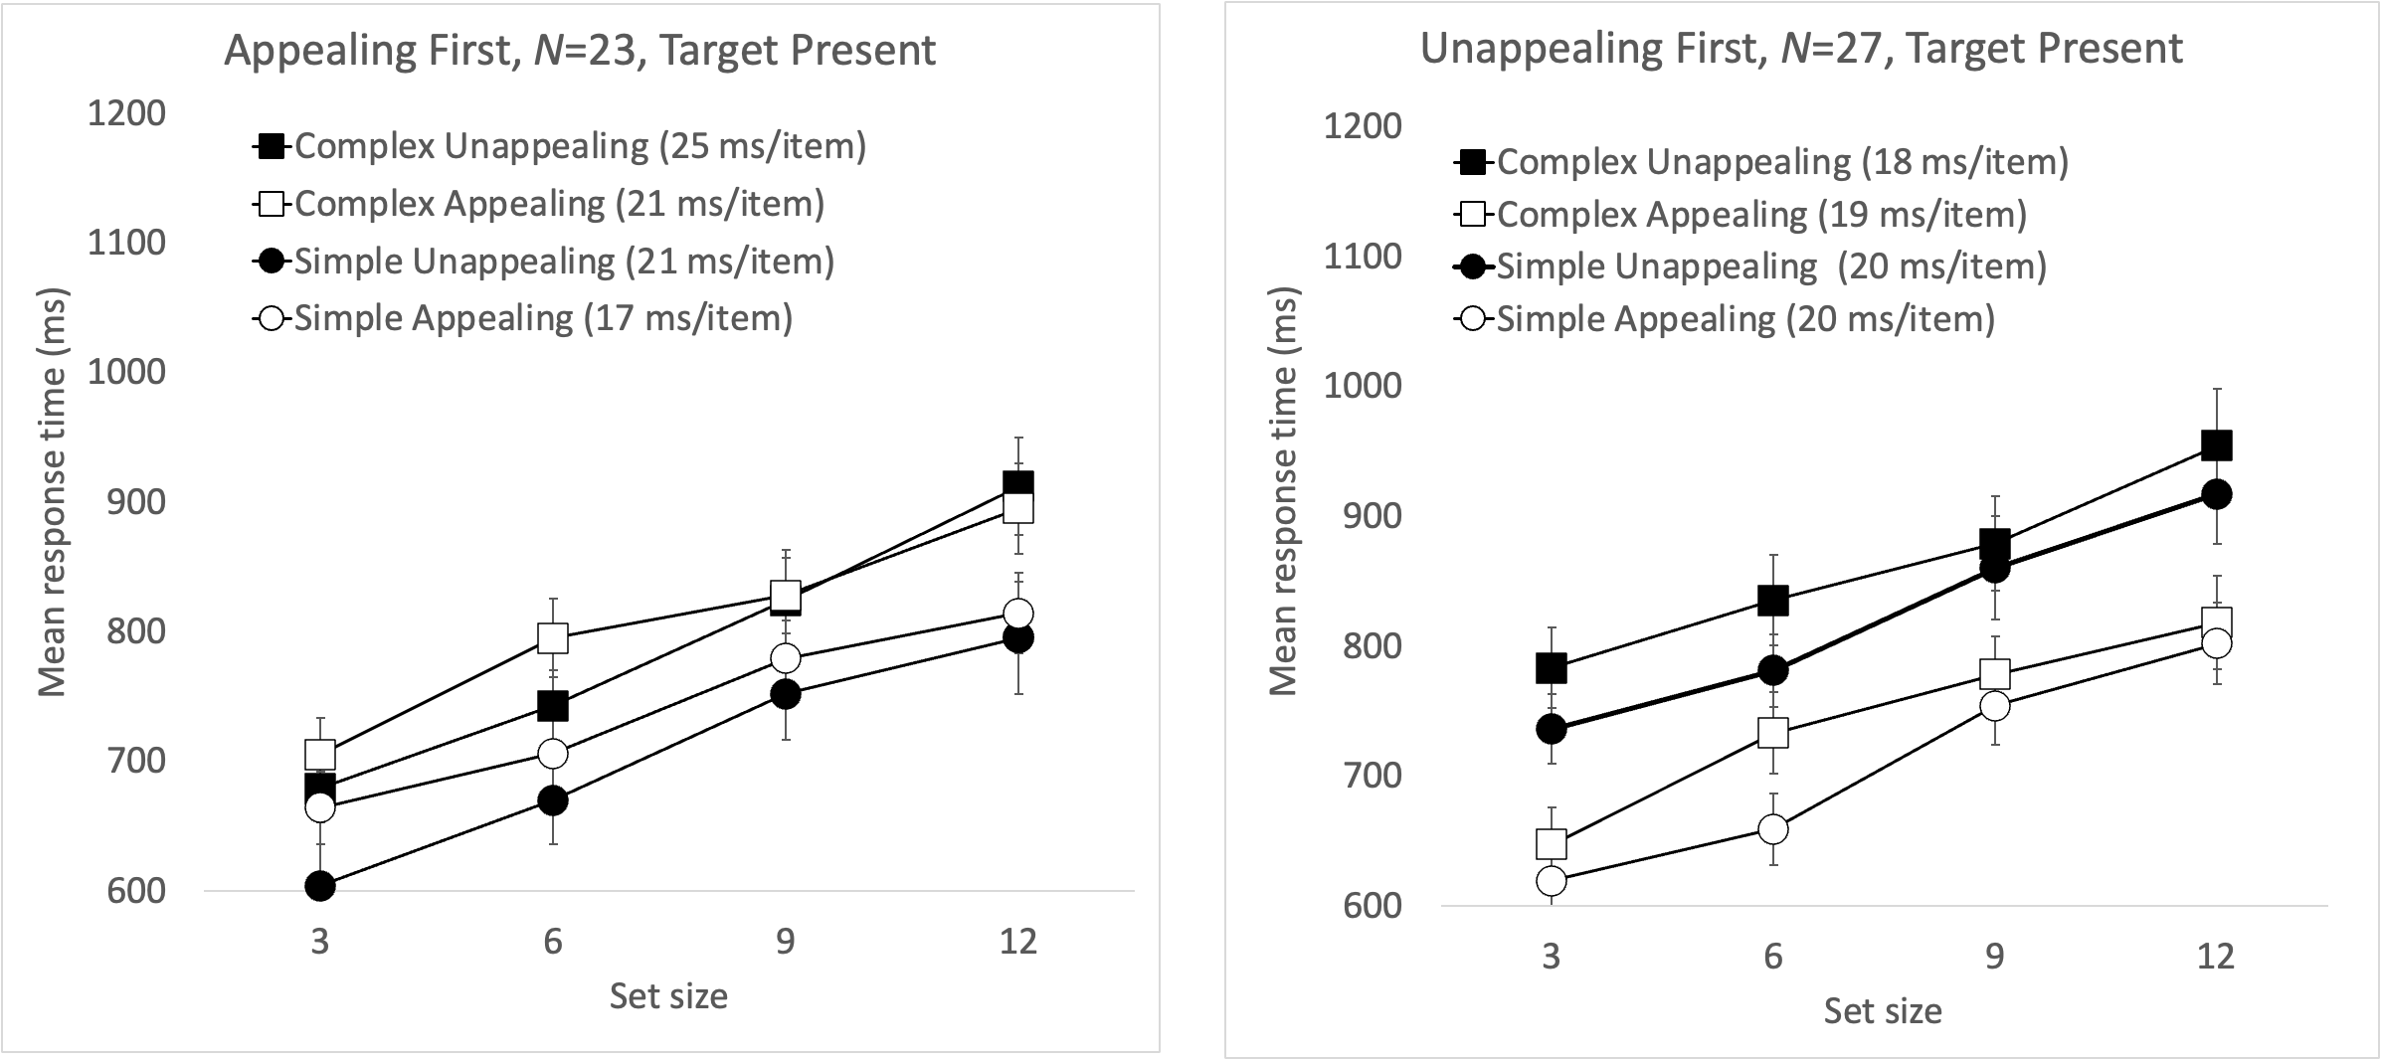

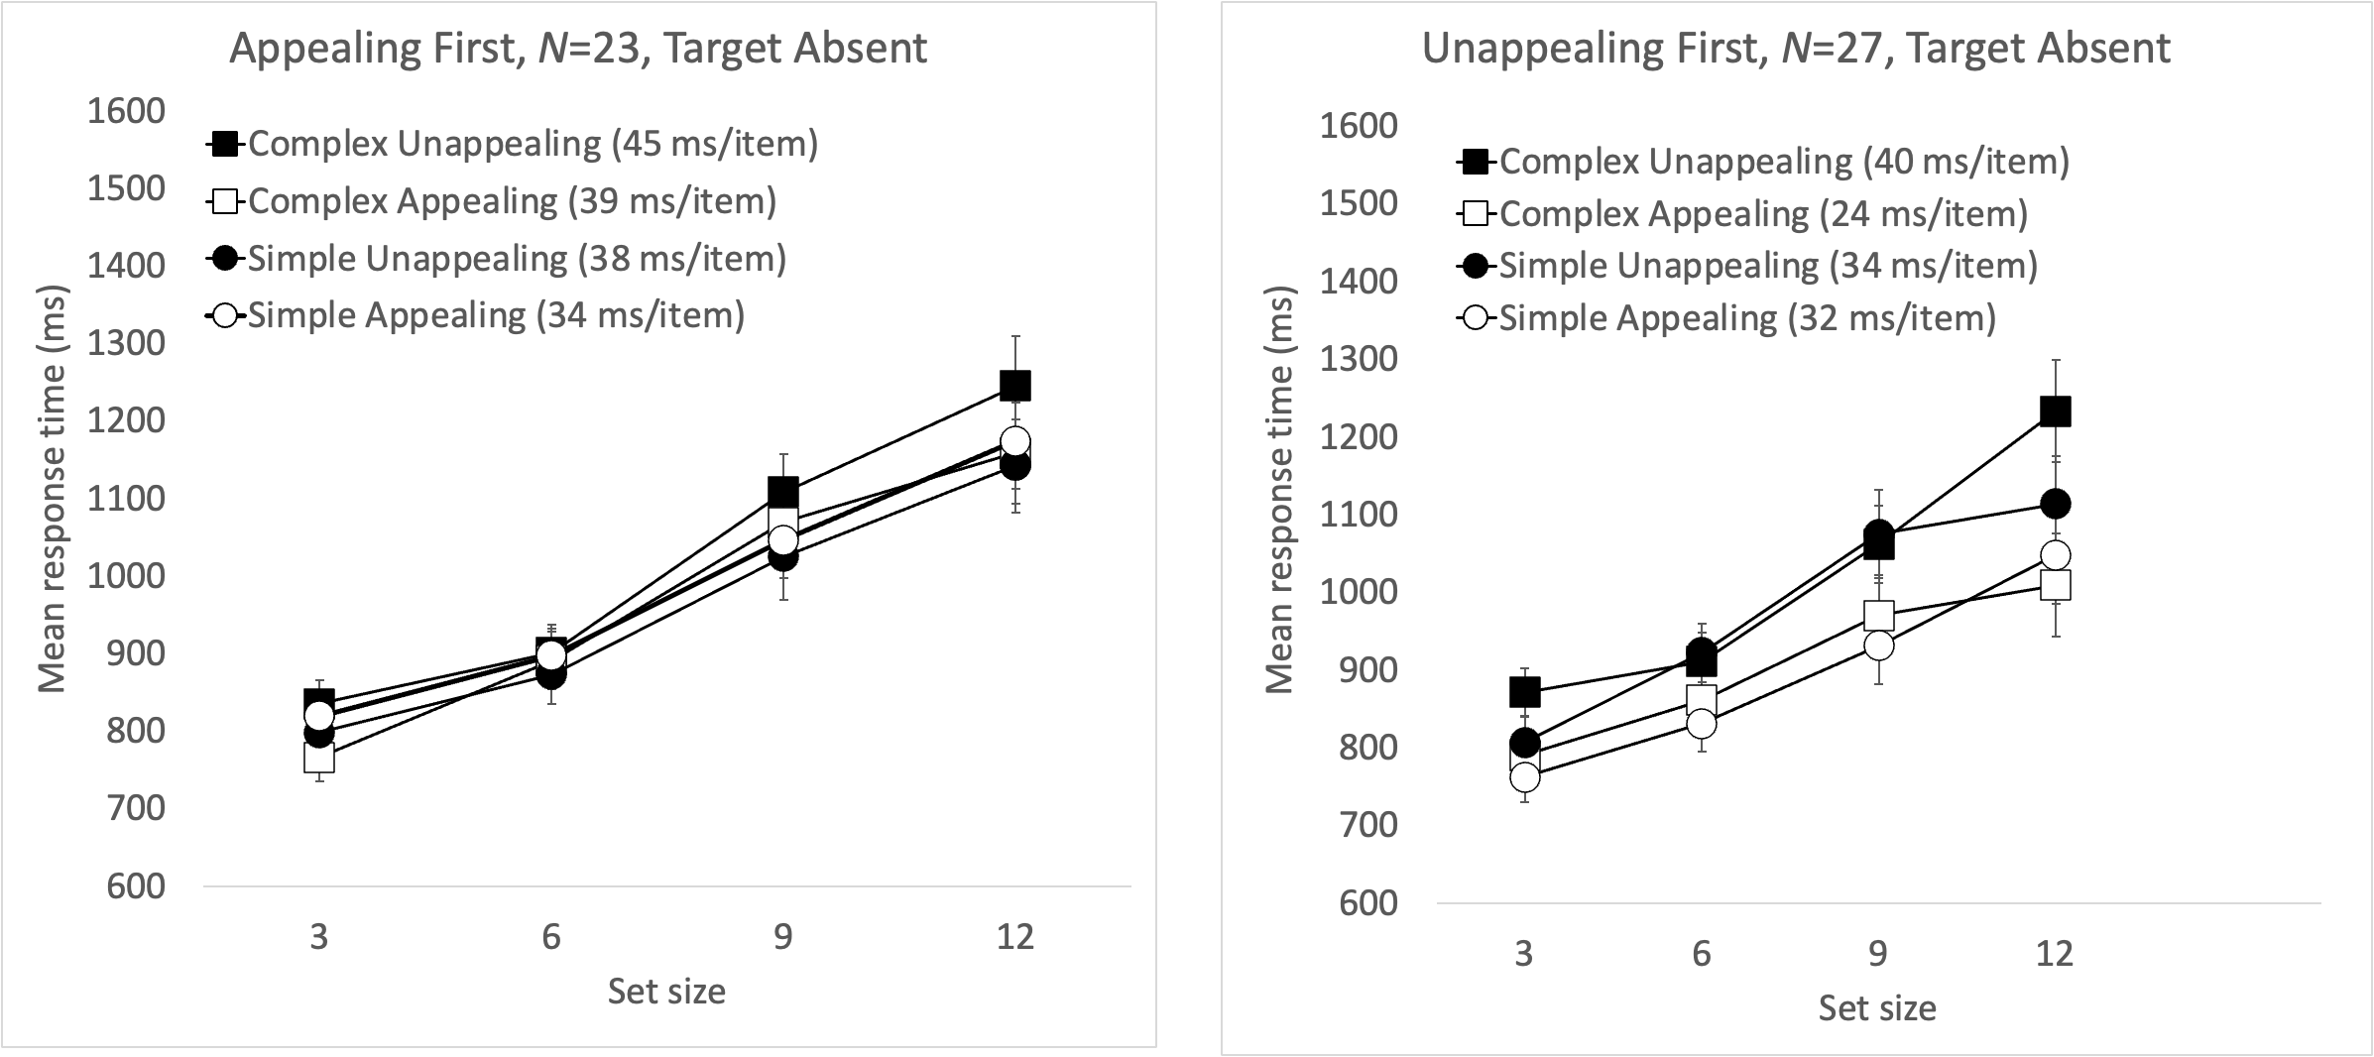
(B)

