Supplementary 1A

Exp1: ANOVA output (RT)

Predictor | df_{Num} | df_{Den} | F | p | η²_{p}
(Intercept) | 1 | 60 | 2399.46 | .000 | .98
Response Relation | 1 | 60 | 20.86 | .000 | .26
Distractor Relation | 1 | 60 | 22.43 | .000 | .27
Action Effect Condition | 1 | 60 | 0.64 | .428 | .01
Response Relation x Distractor Relation | 1 | 60 | 46.34 | .000 | .44
Response Relation x Action Effect Condition | 1 | 60 | 11.81 | .001 | .16
Distractor Relation x Action Effect Condition | 1 | 60 | 5.76 | .020 | .09
Response Relation x Distractor Relation x Action Effect Condition | 1 | 60 | 3.27 | .076 | .05

Note. df_{Num} indicates degrees of freedom numerator. df_{Den} indicates degrees of freedom denominator. η²_{p} indicates partial eta-squared.

Lineplot showing the reaction times for all conditions in Experiment 1.
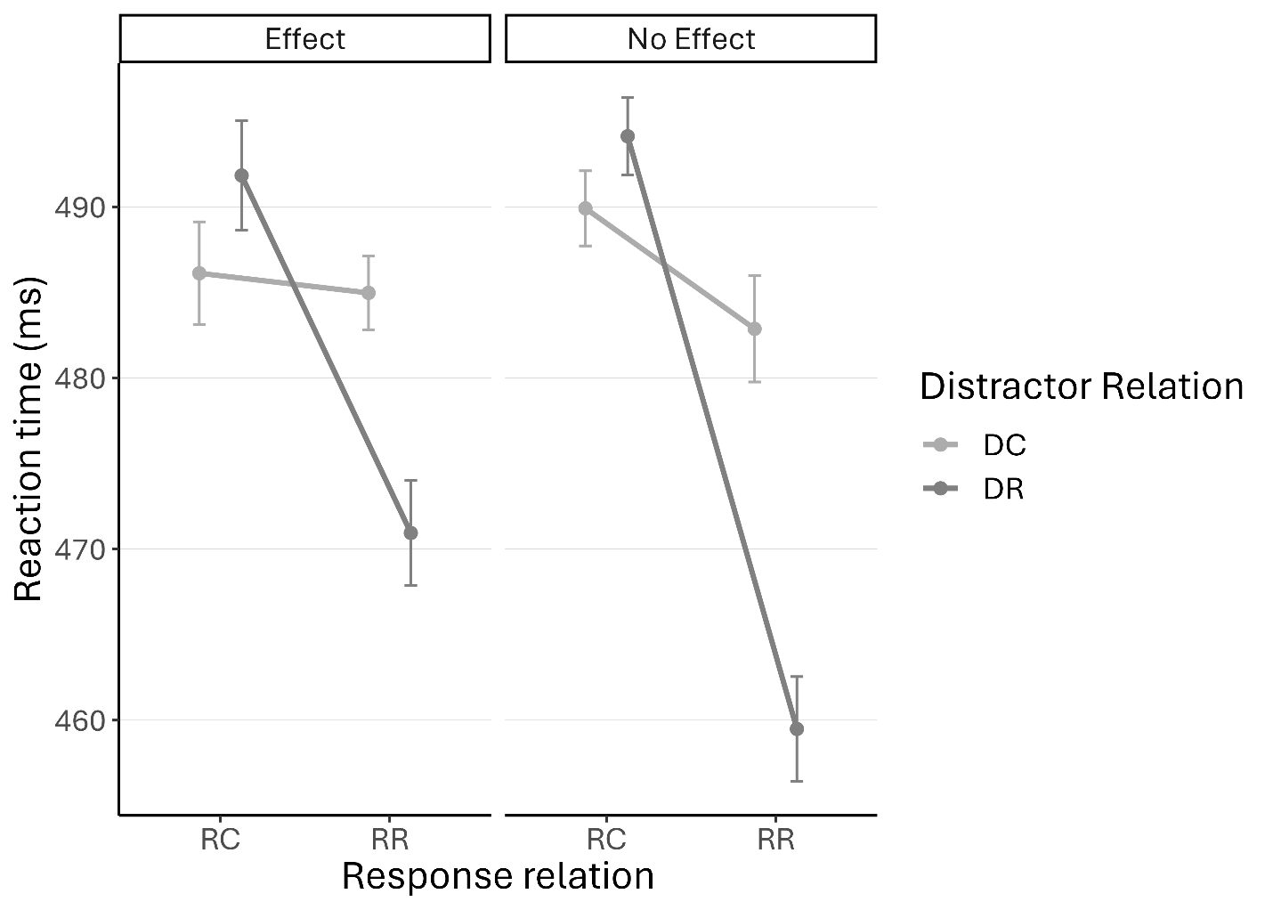
Note. Error bars depict the standard error of the mean.

Supplementary 1B

Exp1: ANOVA output (Error rates)

Predictor | df_{Num} | df_{Den} | F | p | η²_{p}
(Intercept) | 1 | 60 | 167.43 | .000 | .74
Response Relation | 1 | 60 | 0.03 | .868 | .00
Distractor Relation | 1 | 60 | 33.83 | .000 | .36
Action Effect Condition | 1 | 60 | 0.01 | .925 | .00
Response Relation x Distractor Relation | 1 | 60 | 37.75 | .000 | .39
Response Relation x Action Effect Condition | 1 | 60 | 9.05 | .004 | .13
Distractor Relation x Action Effect Condition | 1 | 60 | 0.06 | .803 | .00
Response Relation x Distractor Relation x Action Effect Condition | 1 | 60 | 5.34 | .024 | .08

Note. df_{Num} indicates degrees of freedom numerator. df_{Den} indicates degrees of freedom denominator. η²_{p} indicates partial eta-squared.

Lineplot showing the error rates for all conditions in Experiment 1.
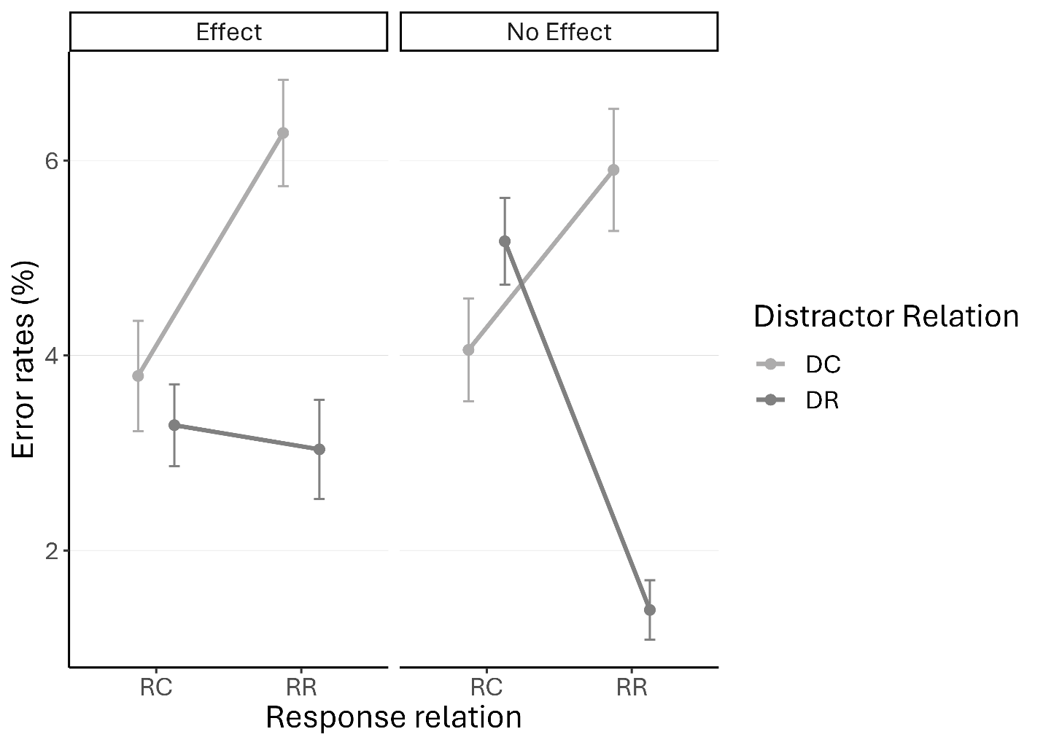
Note. Error bars depict the standard error of the mean.

Supplementary 2A

Exp2: ANOVA output (RT)

Predictor | df_{Num} | df_{Den} | F | p | η²_{p}
(Intercept) | 1 | 59 | 3586.31 | .000 | .98
Response Relation | 1 | 59 | 17.07 | .000 | .22
Distractor Relation | 1 | 59 | 10.34 | .002 | .15
Action Effect Contingency | 1 | 59 | 1.57 | .215 | .03
Response Relation x Distractor Relation | 1 | 59 | 49.39 | .000 | .46
Response Relation x Action Effect Contingency | 1 | 59 | 0.67 | .417 | .01
Distractor Relation x Action Effect Contingency | 1 | 59 | 0.34 | .564 | .01
Response Relation x Distractor Relation x Action Effect Contingency | 1 | 59 | 0.12 | .731 | .00

Note. df_{Num} indicates degrees of freedom numerator. df_{Den} indicates degrees of freedom denominator. η²_{p} indicates partial eta-squared.

Lineplot showing the reaction times for all conditions in Experiment 2.
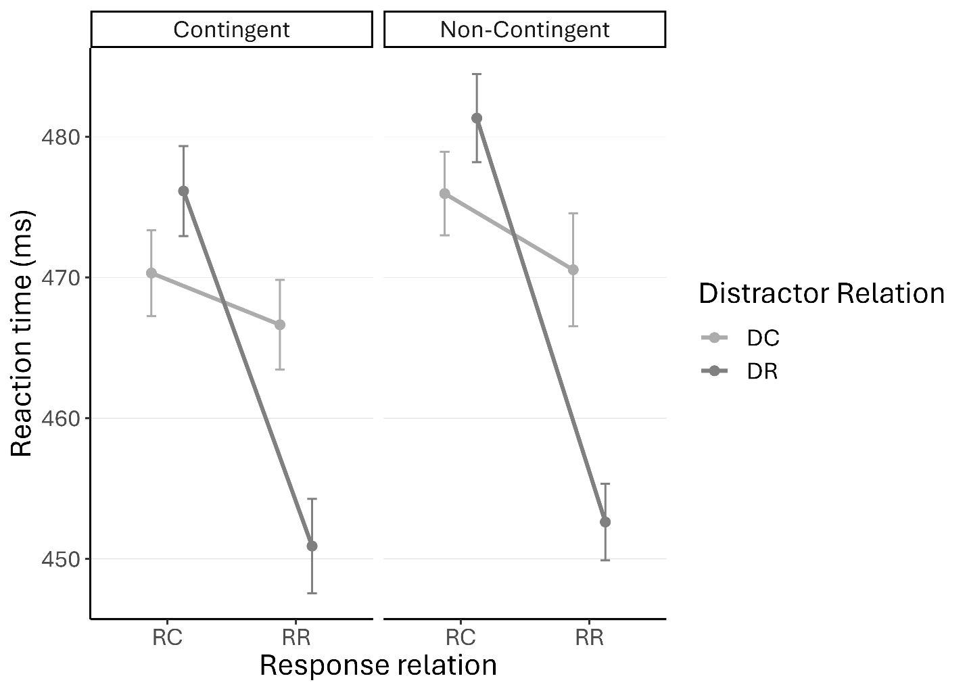
Note. Error bars depict the standard error of the mean.

Supplementary 2B

Exp2: ANOVA output (Error rates)

Predictor | df_{Num} | df_{Den} | F | p | η²_{p}
(Intercept) | 1 | 59 | 140.05 | .000 | .70
Response Relation | 1 | 59 | 0.08 | .772 | .00
Distractor Relation | 1 | 59 | 30.33 | .000 | .34
Action Effect Contingency | 1 | 59 | 2.21 | .143 | .04
Response Relation x Distractor Relation | 1 | 59 | 6.37 | .014 | .10
Response Relation x Action Effect Contingency | 1 | 59 | 0.35 | .555 | .01
Distractor Relation x Action Effect Contingency | 1 | 59 | 0.23 | .632 | .00
Response Relation x Distractor Relation x Action Effect Contingency | 1 | 59 | 0.02 | .888 | .00

Note. df_{Num} indicates degrees of freedom numerator. df_{Den} indicates degrees of freedom denominator. η²_{p} indicates partial eta-squared.

Lineplot showing the error rates for all conditions in Experiment 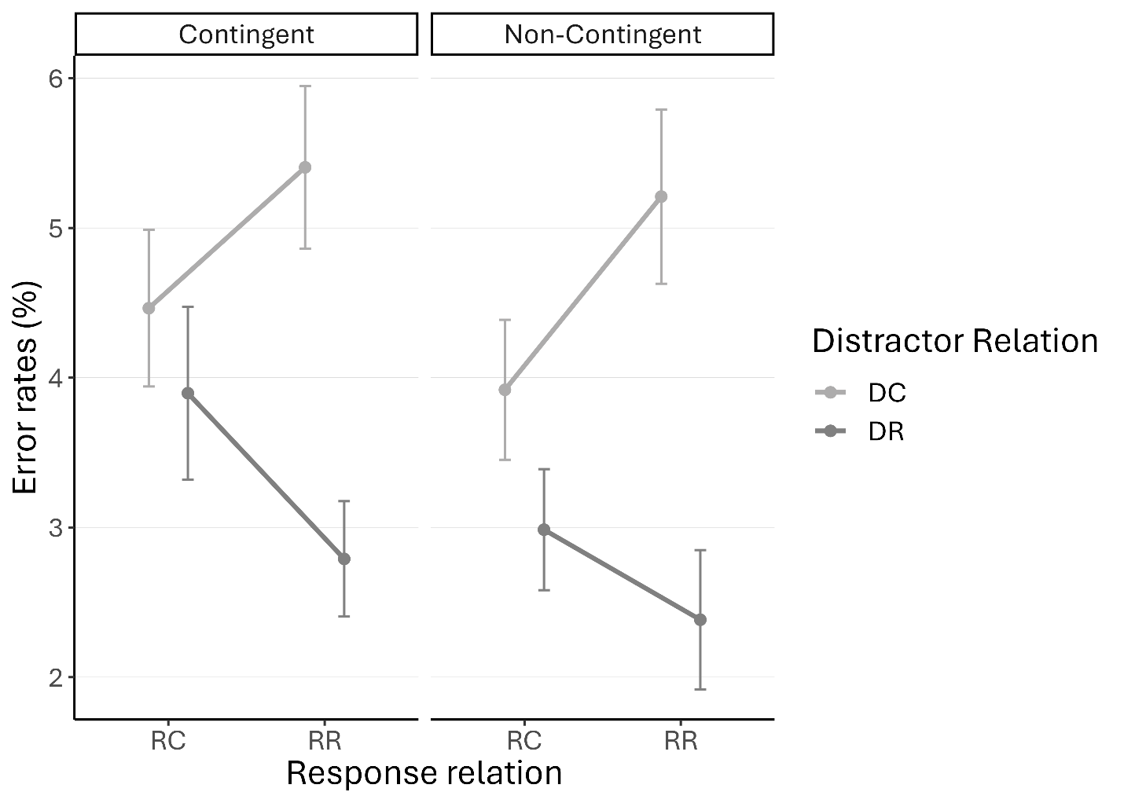
Note. Error bars depict the standard error of the mean.
Supplementary 3A

Exp3: ANOVA output (RT)

Predictor | df_{Num} | df_{Den} | F | p | η²_{p}
(Intercept) | 1 | 58 | 5519.72 | .000 | .99
Response Relation | 1 | 58 | 42.23 | .000 | .42
Distractor Relation | 1 | 58 | 19.38 | .000 | .25
Action Effect Type | 1 | 58 | 11.23 | .001 | .16
Response Relation x Distractor Relation | 1 | 58 | 28.54 | .000 | .33
Response Relation x Action Effect Type | 1 | 58 | 13.27 | .001 | .19
Distractor Relation x Action Effect Type | 1 | 58 | 0.37 | .546 | .01
Response Relation x Distractor Relation x Action Effect Type | 1 | 58 | 0.64 | .426 | .01

Note. df_{Num} indicates degrees of freedom numerator. df_{Den} indicates degrees of freedom denominator. η²_{p} indicates partial eta-squared.

Lineplot showing the reaction times for all conditions in Experiment 3.
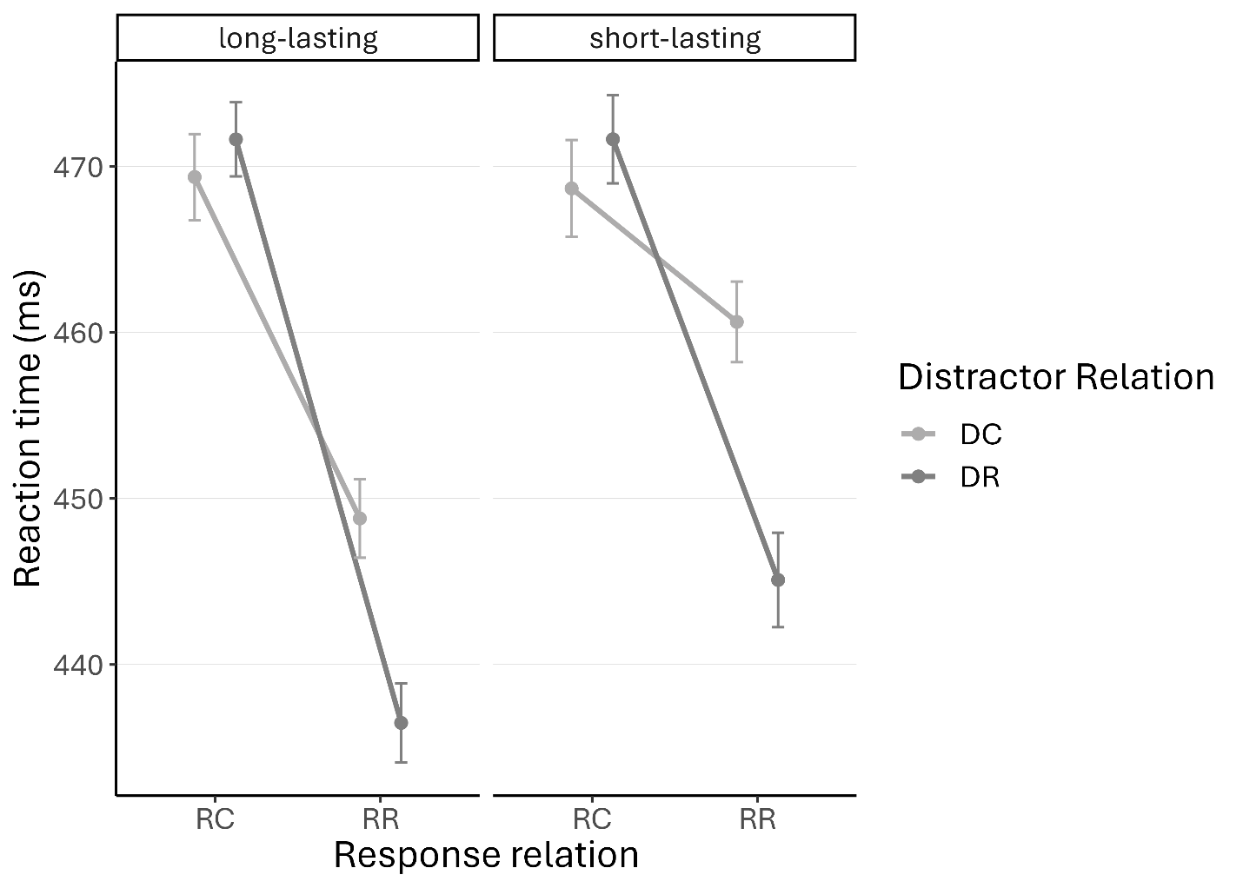
Note. Error bars depict the standard error of the mean.
Supplementary 3B

Exp3: ANOVA output (Error rates)

Predictor | df_{Num} | df_{Den} | F | p | η²_{p}
(Intercept) | 1 | 58 | 170.62 | .000 | .75
Response Relation | 1 | 58 | 0.94 | .337 | .02
Distractor Relation | 1 | 58 | 13.84 | .000 | .19
Action Effect Type | 1 | 58 | 0.04 | .848 | .00
Response Relation x Distractor Relation | 1 | 58 | 36.09 | .000 | .38
Response Relation x Action Effect Type | 1 | 58 | 7.11 | .010 | .11
Distractor Relation x Action Effect Type | 1 | 58 | 0.14 | .713 | .00
Response Relation x Distractor Relation x Action Effect Type | 1 | 58 | 1.83 | .181 | .03

Note. df_{Num} indicates degrees of freedom numerator. df_{Den} indicates degrees of freedom denominator. η²_{p} indicates partial eta-squared.

Lineplot showing the error rates for all conditions in Experiment 3.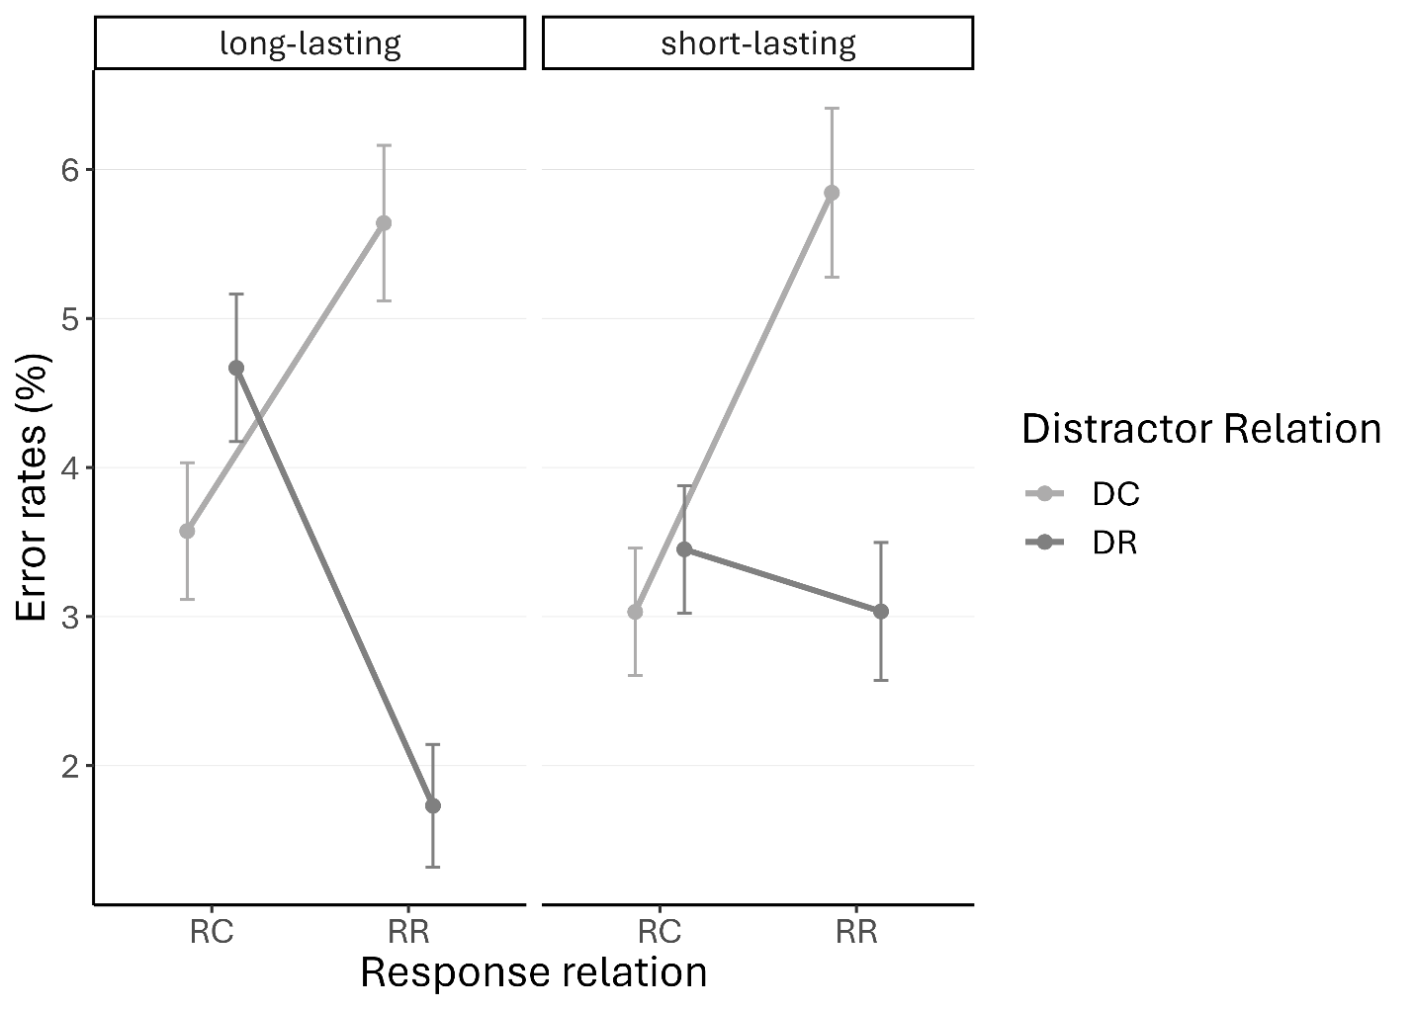
Note. Error bars depict the standard error of the mean.
Supplementary 4
Results of an additional experiment testing short-lasting action effects against no action effects.
64 participants took part in this experiment (Exp4). Two participants were excluded due to the criteria defined in the main text. 62 participants remained (41 female; 56 right-handed, M = 22.94 years, range 19 to 34). Stimulus material and procedure were the same as in Experiment 1, with one exception: long-lasting action effects were replaced with short-lasting action effects.
Significant S-R binding effects emerged for both effect conditions in both reaction times and error rates (against zero: reaction times: effect: t(61) = 3.17, p = .002, d = 0.40; no effect: t(61) = 3.50, p = .001, d = 0.44; error rates: effect: t(61) = 4.37, p < .001, d = 0.56; no effect: t(61) = 5.66, p < .001, d = 0.72). No difference were found in the observed S-R binding effects between both action effect conditions, reaction times: t(61) = 0.53, p = .596, d = 0.07; error rates: t(61) = 0.78, p = .439, d = 0.10.
Results demonstrate that the presence of a short-lasting effect did not affect S-R binding effects.
Supplementary 4A
Experimental Procedure in additional Experiment 4: Short-lasting effect versus no effect.
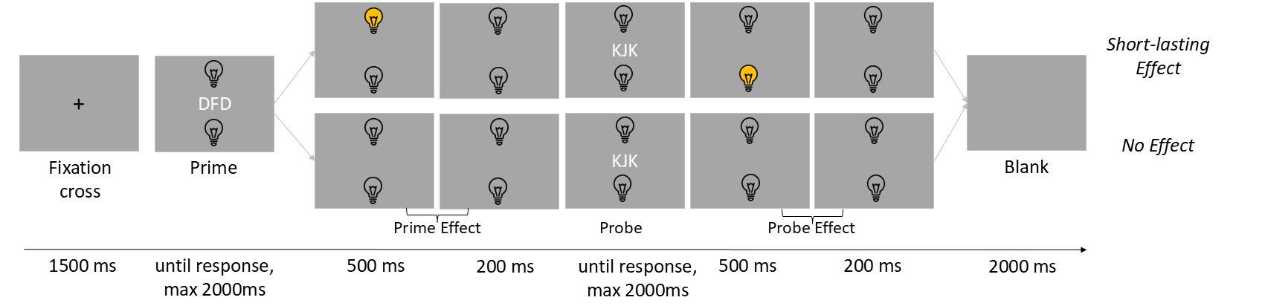Note. Shown are trials with no action effect and short-lasting action effect. Stimuli are not drawn to scale.
Supplementary 4B

Exp4: ANOVA output (RT)

Predictor | df_{Num} | df_{Den} | F | p | η²_{p}
(Intercept) | 1 | 61 | 2763.97 | .000 | .98
Response Relation | 1 | 61 | 68.85 | .000 | .53
Distractor Relation | 1 | 61 | 10.29 | .002 | .14
Action Effect Condition | 1 | 61 | 1.60 | .211 | .03
Response Relation x Distractor Relation | 1 | 61 | 16.22 | .000 | .21
Response Relation x Action Effect Condition | 1 | 61 | 0.11 | .739 | .00
Distractor Relation x Action Effect Condition | 1 | 61 | 2.15 | .148 | .03
Response Relation x Distractor Relation x Action Effect Condition | 1 | 61 | 0.28 | .596 | .00

Note. df_{Num} indicates degrees of freedom numerator. df_{Den} indicates degrees of freedom denominator. η²_{p} indicates partial eta-squared.

Lineplot showing the reaction times for all conditions in Experiment 4.
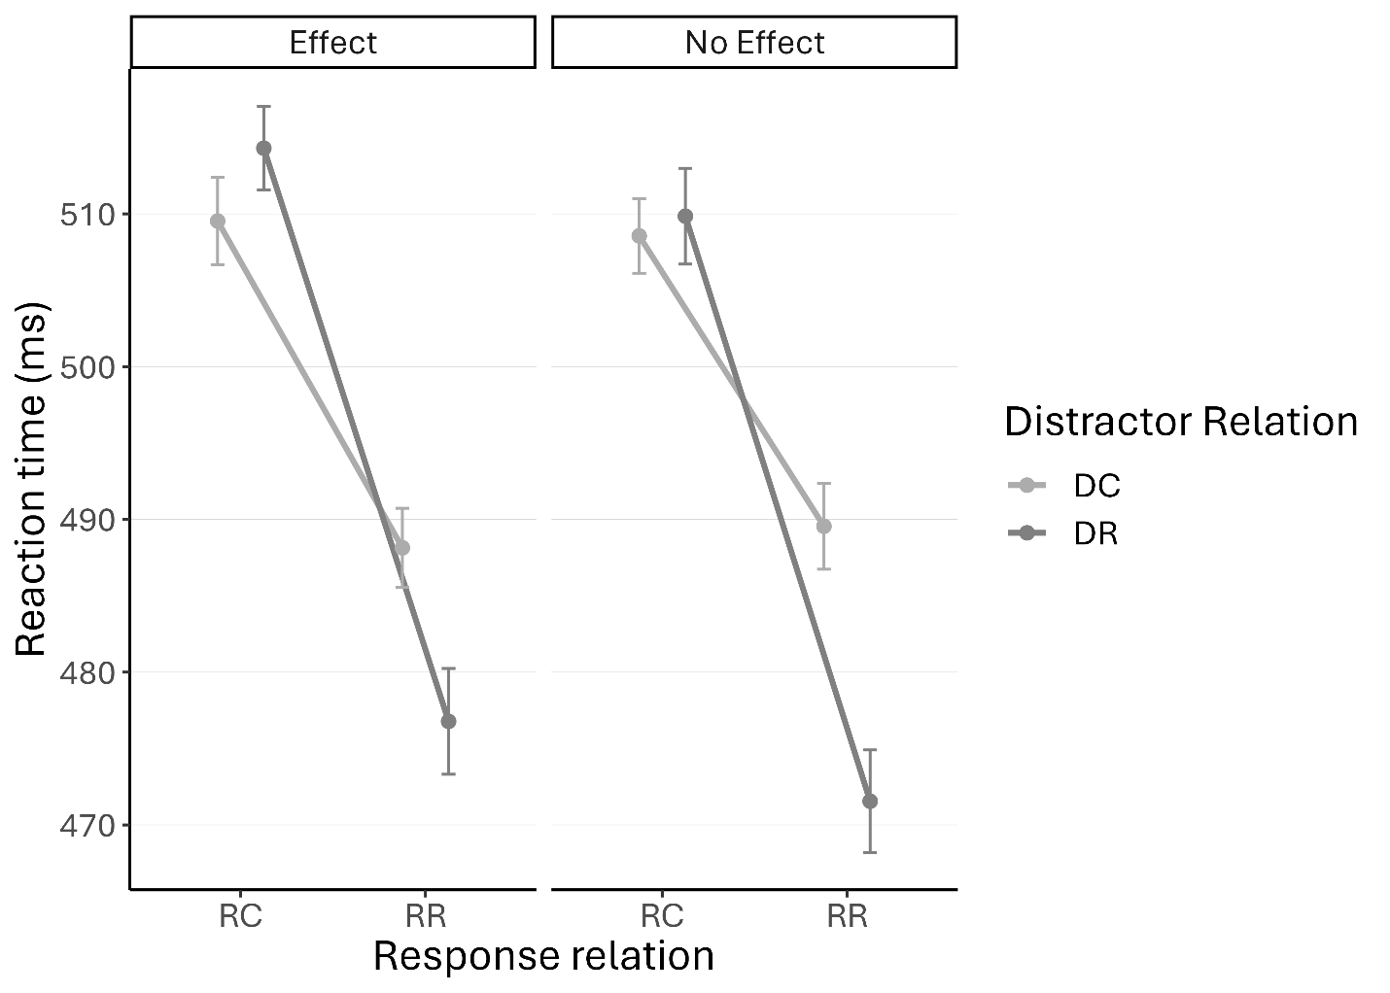
Note. Error bars depict the standard error of the mean.

Supplementary 4C

Exp4: ANOVA output (Error rates)

Predictor | df_{Num} | df_{Den} | F | p | η²_{p}
(Intercept) | 1 | 61 | 53.08 | .000 | .47
Response Relation | 1 | 61 | 3.64 | .061 | .06
Distractor Relation | 1 | 61 | 3.70 | .059 | .06
Action Effect Condition | 1 | 61 | 0.04 | .840 | .00
Response Relation x Distractor Relation | 1 | 61 | 55.95 | .000 | .48
Response Relation x Action Effect Condition | 1 | 61 | 0.49 | .486 | .01
Distractor Relation x Action Effect Condition | 1 | 61 | 0.41 | .523 | .01
Response Relation x Distractor Relation x Action Effect Condition | 1 | 61 | 0.61 | .439 | .01

Note. df_{Num} indicates degrees of freedom numerator. df_{Den} indicates degrees of freedom denominator. η²_{p} indicates partial eta-squared.

Lineplot showing the error rates for all conditions in Experiment 4.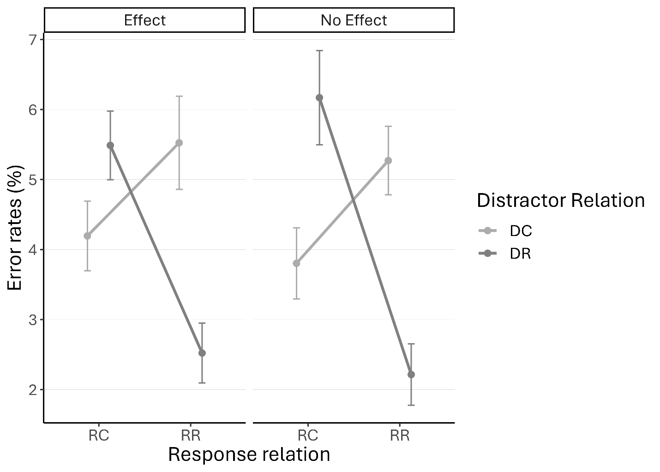
Note. Error bars depict the standard error of the mean.
Supplementary 5

Descriptive data for Experiments 1 and 3: Main effect action effect order.
Experiment | Action Effect Order | Reaction Times (ms)
Exp. 1 | ER | 483.94
Exp. 1 | EC | 481.03
Exp. 3 | ER | 461.70
Exp. 3 | EC | 459.94
Note. Action effect order refers to the relation of action effects in trial n-1 and trial n (ER = Effect Repetition, EC = Effect Change). Experiment 1 looked at long-lasting action effect versus no action effect and Experiment 2 looked at long-lasting action effect versus short-lasting action effect.

