Supplementary Material for Figure disembedding facility and reduced left visual field bias are linked to the social dimension of autistic traits
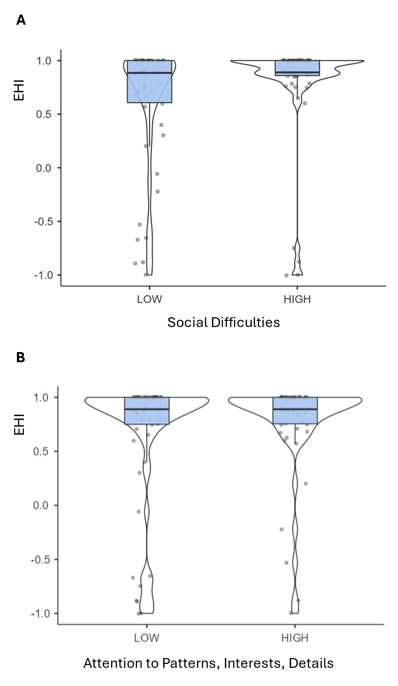
Figure S1. Distributions of Edinburgh Handedness Inventory (EHI) scores as a function of Social Difficulties (Panel A) and Attention to Patterns, Interests, and Details (Panel B).

