Supplemental Figures

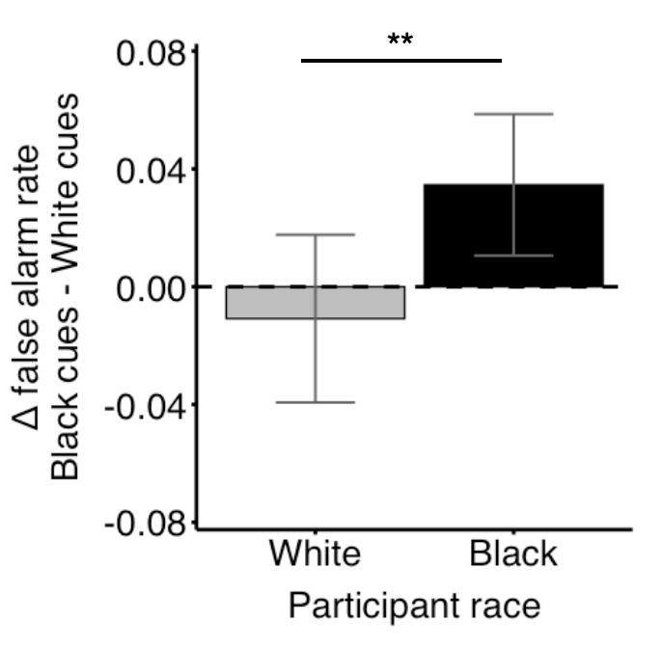

Figure S1. Visualization of participant race x stimulus race interaction predicting false alarm rates. Black participants make more false alarms to Black versus White faces compared to White participants. Error bars represent 95% confidence intervals.

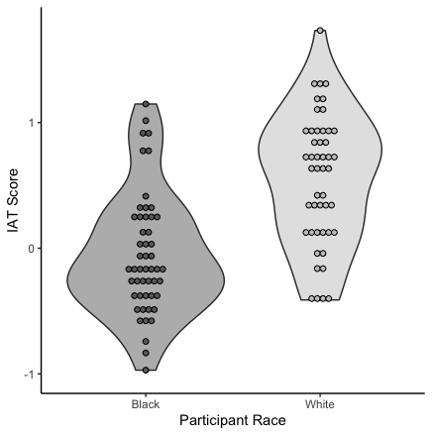
Figure S2. Distribution of Implicit Association Test scores for Black and White participants.

Table S1. Linear mixed effects analysis comparing models predicting false alarm rates with and without a stimulus race x uncertainty condition interaction.
 | Dependent variable:
False alarm rate - centered
Beta value (Standard Error)
 | Full model | Null interaction model
Stimulus Race | -0.050 | 0.055
 | (0.062) | (0.036)
Uncertainty condition (Reward) | -0.046 | -0.046
 | (0.044) | (0.044)
Uncertainty condition (Threat) | 0.134** | 0.134**
 | (0.044) | (0.044)
Participant race | -0.033 | -0.033
 | (0.176) | (0.176)
Participant gender | -0.528** | -0.528**
 | (0.169) | (0.169)
Stimulus race x Uncertainty condition (Reward) | 0.070
 | (0.088)
Stimulus Race x Uncertainty condition (Threat) | 0.245**
 | (0.088)
Participant race x Uncertainty condition (Reward) | 0.290* | 0.212**
 | (0.124) | (0.072)
Stimulus race x Participant race | 0.091 | 0.091
 | (0.088) | (0.089)
Participant race x Uncertainty condition (Threat) | -0.120 | -0.120
 | (0.088) | (0.089)
Participant race x Stimulus race x Uncertainty condition (Reward) | -0.210
 | (0.175)
Participant race x Stimulus race x Uncertainty condition (Threat) | -0.023
 | (0.175)
constant | -0.017 | -0.017
 | (0.088) | (0.088)
Observations | 630 | 630
Log Likelihood | -552.107 | -557.106
Akaike Inf. Crit. | 1,138.215 | 1,140.211
Bayesian Inf. Crit. | 1,213.792 | 1,198.006
 | *p<0.05; **p<0.01; ***p<0.001
Note: White stimuli, the no uncertain event condition, White participants, and male participants are reference groups.

Table S2. Summary of False Alarm Rates by Stimulus Race and Uncertainty Condition
Stimulus Race | Condition | Mean False Alarm Rate | Standard Deviation
Black | No Uncertain Event | 0.3157407 | 0.08752737
White | No Uncertain Event | 0.3378307 | 0.09699766
Black | Uncertain Reward | 0.3133598 | 0.09289379
White | Uncertain Reward | 0.3215608 | 0.09557102
Black | Uncertain Threat | 0.3701058 | 0.09110608
White | Uncertain Threat | 0.3398148 | 0.08951791

Table S3. Linear mixed effects analysis comparing models predicting correlation distance with and without a factor of uncertainty condition

 | Dependent variable:
Correlation distance
Beta value (Standard Error)
 | Full model | Null state model
Uncertainty condition (Reward) | 0.012
 | (0.022)
Uncertainty condition (Threat) | 0.031
 | (0.022)
Network (Frontoparietal) | 0.032 | 0.024
 | (0.022) | (0.013)
Network (Default) | 0.030 | 0.023
 | (0.022) | (0.013)
Network (Dorsal Attention) | 0.006 | -0.003
 | (0.022) | (0.013)
Network (Limbic) | 0.007 | 0.017
 | (0.022) | (0.013)
Network (Salience/Ventral Attention) | 0.009 | -0.001
 | (0.022) | (0.013)
Network (Visual) | -0.033 | -0.050***
 | (0.022) | (0.013)
Uncertainty condition (Reward) x Network (Frontoparietal) | -0.020
 | (0.031)
Uncertainty condition (Threat) x Network (Frontoparietal) | -0.005
 | (0.031)
Uncertainty condition Reward) x Network (Default) | -0.030
 | (0.031)
Uncertainty condition (Threat) x Network (Default) | 0.010
 | (0.031)
Uncertainty condition (Reward) x Network (Dorsal Attention) | -0.020
 | (0.031)
Uncertainty condition (Threat) x Network (Dorsal Attention) | -0.007
 | (0.031)
Uncertainty condition (Reward) x Network (Limbic) | -0.013
 | (0.031)
Uncertainty condition (Threat) x Network (Limbic) | 0.042
 | (0.031)
Uncertainty condition (Reward) x Network (Salience/Ventral Attention) | -0.016
 | (0.031)
Uncertainty condition (Threat) x Network (Salience/Ventral Attention) | -0.015
 | (0.031)
Uncertainty condition (Reward) x Network (Visual) | -0.041
 | (0.031)
Uncertainty condition (Threat) x Network (Visual) | -0.011
 | (0.031)
Constant | 0.502*** | 0.516***
 | (0.017) | (0.011)
Observations | 2,079 | 2,079
Log Likelihood | 853.174 | 835.753
Akaike Inf. Crit. | -1,656.348 | -1,649.506
Bayesian Inf. Crit. | -1,515.357 | -1,587.470
 | *p<0.05; **p<0.01; ***p<0.001
Note: The no uncertain event condition and Somatomotor network are reference groups.

