Supplemental Table 1. Contrasts were conducted at an individual voxel threshold of p < .005 with a minimum cluster size of k = 10. Beta weights from each cluster were extracted and a condition (prewarnings, no warning) x trial type (consistent, neutral, misleading) ANOVAs were conducted for each region and reported in the Cond., Trial, and Int. columns. Pearson correlations were conducted to assess the relationship between beta weight magnitudes on misleading trials and memory performance on misleading trials on the final memory test.

Region BA x y z t k Cond. Trial Int. Corr.
- Prewarning > No warning: Misleading – Arrows
Inferior Frontal Gyrus 44 48 18 8 3.90 61 .003 .603 .024 .005
Frontal Eye Fields 8 14 28 48 4.12 23 .110 .738 .008 .078
Visual Area 18 26 -86 -4 3.90 23 .002 .295 .622 .014
Fusiform 37 44 -54 8 3.73 23 .001 .389 .332 .022
Anterior PFC 10 -18 50 14 3.47 16 .032 .422 .067 .007
Frontal Eye Fields 8 30 4 38 3.37 13 .005 .524 .380 <.001
Anterior Cingulate 24 0 24 18 3.64 12 .047 .255 .010 .103
Posterior Parietal 7 10 -52 48 2.99 10 .182 .363 .015 .006

- Prewarning < No Warning: All Trials – Arrows
Dorsolateral PFC 46 -40 38 0 3.75 51 <.001 .944 .522 .036 #
Superior Temporal 22 48 -34 4 3.70 31 .001 .712 .968 .809 #
Insula 13 -40 -2 -6 3.25 14 .002 .383 .365 .490 #

- Prewarning > No Warning: All Trials – Arrows
Fusiform 37 42 -52 8 3.69 23 <.001 .334 .539 .007
Visual Area 18 26 -86 -4 3.48 19 .002 .383 .365 .010
Parietal 7 26 -66 50 3.18 13 <.001 .839 .644 .159
Supramarginal Gyrus 40 -36 -40 48 3.15 12 .008 .106 .764 .169
Note: Whole-brain contrasts were conducted at p < .005, k = 10; BA = Brodmann Area. Cond. Reports the p-value of the main effect of condition, Trial reports the p-value of the main effect of trial type, and Int. reports the p-values of the interaction between condition and trial type. Corr refers to the p-value for the correlation between extracted beta weights from that region during encoding of misleading trials and performance on misleading trials on the final memory test. A # next to the p-value indicates a negative correlation, whereas no # indicates a positive correlation.

Supplemental Figure 1. Prewarning > No Warning: Misleading – Baseline. Mean beta weights from each region identified by this contrast are plotted by condition (prewarnings, no warning) and trial type (consistent, neutral, misleading). Statistics are included in Supplemental Table 1.
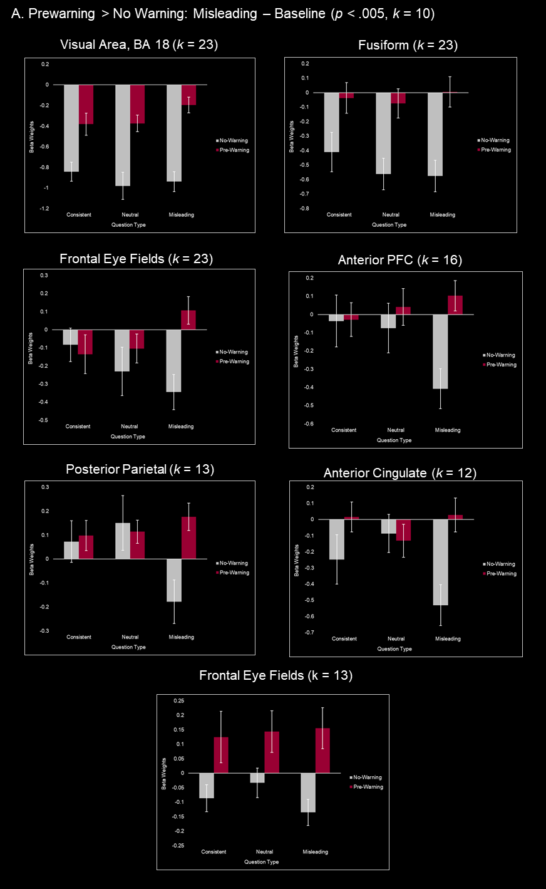
Supplemental Figure 2. Prewarning < No Warning: All Trials – Baseline. Mean beta weights from each region identified by this contrast are plotted by condition (prewarnings, no warning) and trial type (consistent, neutral, misleading). Statistics are included in Supplemental Table 1.
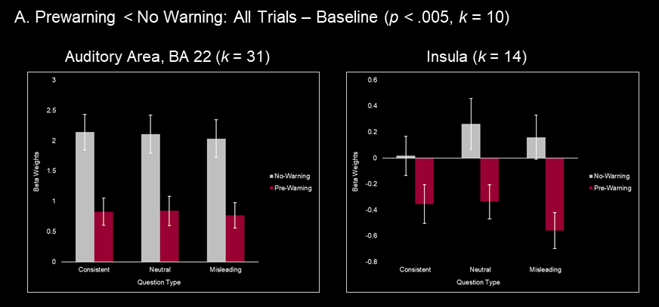

Supplemental Figure 3. Prewarning > No Warning: All Trials – Baseline. Mean beta weights from each region identified by this contrast are plotted by condition (prewarnings, no warning) and trial type (consistent, neutral, misleading). Statistics are included in Supplemental Table 1.
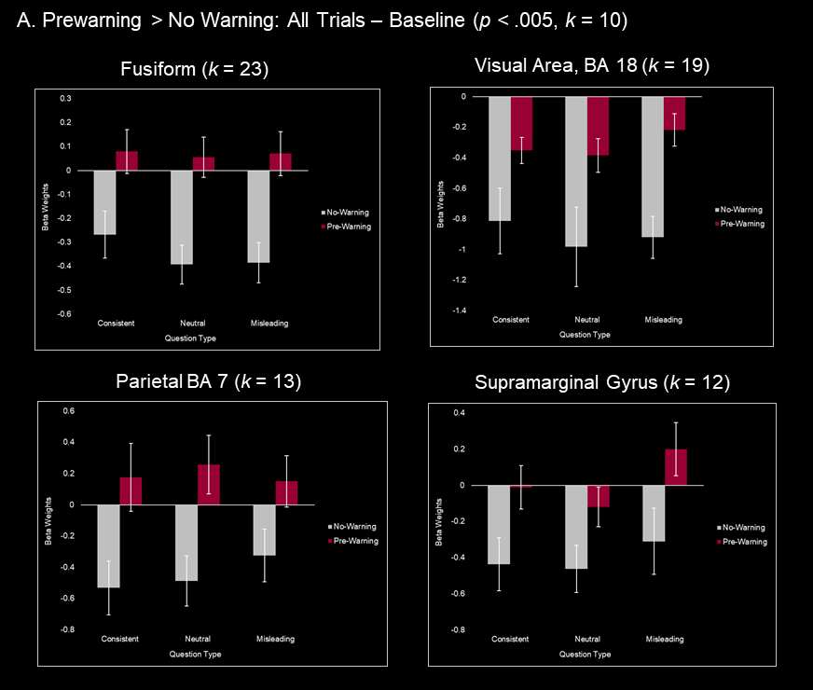

Appendix A
No Warning:
- Prior to the audio narrative: "You will now hear an audio narrative of the video you just watched. During the narrative, please keep your eyes fixed on the cross on the screen.”
- After the audio narrative: "You will now answer a series of questions relating to the video you watched at the beginning of this experiment. Please answer each question to the best of your ability. If you do not know the answer, make your best guess. All questions must be answered. Select your answer using the numbers and then wait for the screen to advance. After each question, please rate your confidence in your answer on the scale from 1, complete guess to 4, high confidence.”

Pre-warning
- Prior to paying the audio narrative: “You will have to answer questions regarding the video you previously watched for a second time. We will play a narrative of that video; however, we are uncertain as to the source of the narrative. Therefore, we were unable to verify the accuracy of the narrative. As such, base your answers only on what you saw in the video, and not on what you hear in the narrative. During the narrative, please keep your eyes fixed on the cross on the screen.”

- After playing the audio narrative: "You will now answer a series of questions relating to the video you watched at the beginning of this experiment. Please answer each question to the best of your ability. If you do not know the answer, make your best guess. All questions must be answered. Select your answer using the numbers and then wait for the screen to advance. After each question, please rate your confidence in your answer on a scale from 1, complete guess to 4, high confidence.”

Post-warning
- Prior to playing the audio narrative: "You will now hear an audio narrative of the video you just watched. During the narrative, please keep your eyes fixed on the cross on the screen.”
- After playing the audio narrative: “You will have to answer questions regarding the video you previously watched for a second time. We just played a narrative of that video; however, we are uncertain as to the source of the narrative. Therefore, we were unable to verify the accuracy of the narrative. As such, base your answer only on what you saw in the video, and not on what you heard in the narrative. Please answer each question to the best of your ability. If you do not know the answer, make your best guess. All questions must be answered. Select your answer using the numbers and then wait for the screen to advance. After each question, please rate your confidence in your answer on a scale from 1, complete guess to 4, high confidence.”

Declarations
Funding
This material is based upon work supported by the National Science Foundation under Grant 1728764 and NIH under Shared Instrumentation Grant S10OD021569.

Conflicts of interest/Competing interests
Not applicable

Ethics approval
Appropriate ethics approval was obtained from Tufts University and the Massachusetts Institute of Technology.

Consent to participate (include appropriate statements)
Informed consent was obtained from all individual participants included in the study.

Consent for publication (include appropriate statements)
Not applicable

Availability of data and materials
Data will be made available on OSF.

Code availability
Not applicable

Authors' contributions (Optional)
J.M.K., A.K.T., and E.R. designed research, J.M.K. A.K.T. and E.R. performed research, J.M.K. and E.R. analyzed data, and J.M.K., A.K.T., and E.R. wrote the paper.

