SUPPLEMENTAL MATERIAL
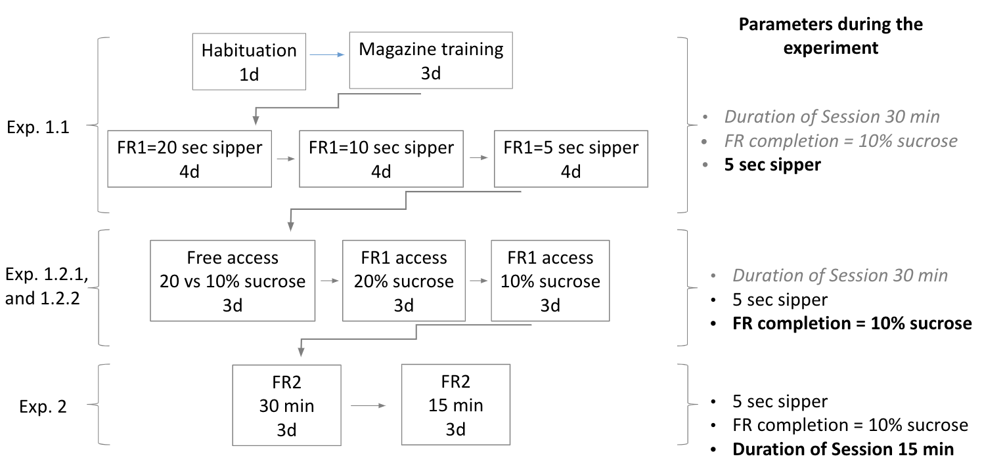
Supp. fig.1. Schematic of the experimental parameters being tested, and time sequence.

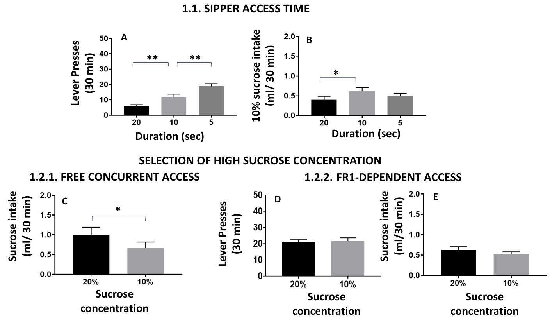
Supp. fig. 2. Upper part: Effect of access time to the reinforcer on lever presses (A) and 10% sucrose intake (B). Lower part: Effect of sucrose concentration under free concurrent presentation on sucrose intake (C), or under FR1 responding: lever presses (D), and sucrose intake (E). Bars represent the mean ± SEM number of lever presses or ml consumed during 30 minutes. *p<0.05, **p<0.01 significant differences between groups.

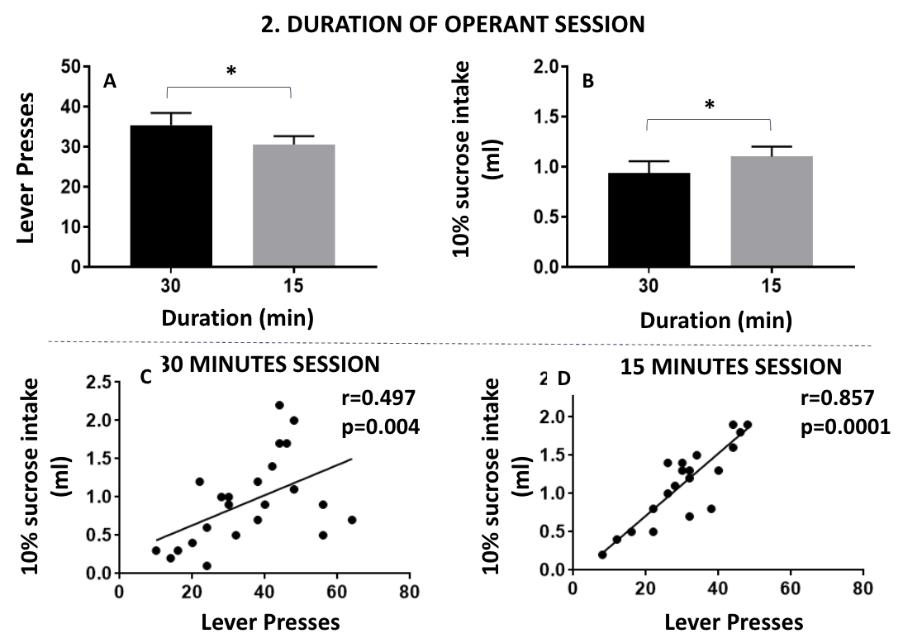

Supp. fig. 3. Upper part: Effect of introducing free choice conditions on FR8 lever presses (A), operant-dependent 10% sucrose intake (B) and free sucrose intake (C). Lower part: Effect of concurrent free access presentation in the operant box of two concentrations of sucrose (10 and 3%) on volume consumed in a session of 15 minutes. Bars represent the mean ± SEM of lever presses or ml consumed. *p<0.05, **p<0.01, significant differences between experimental conditions.
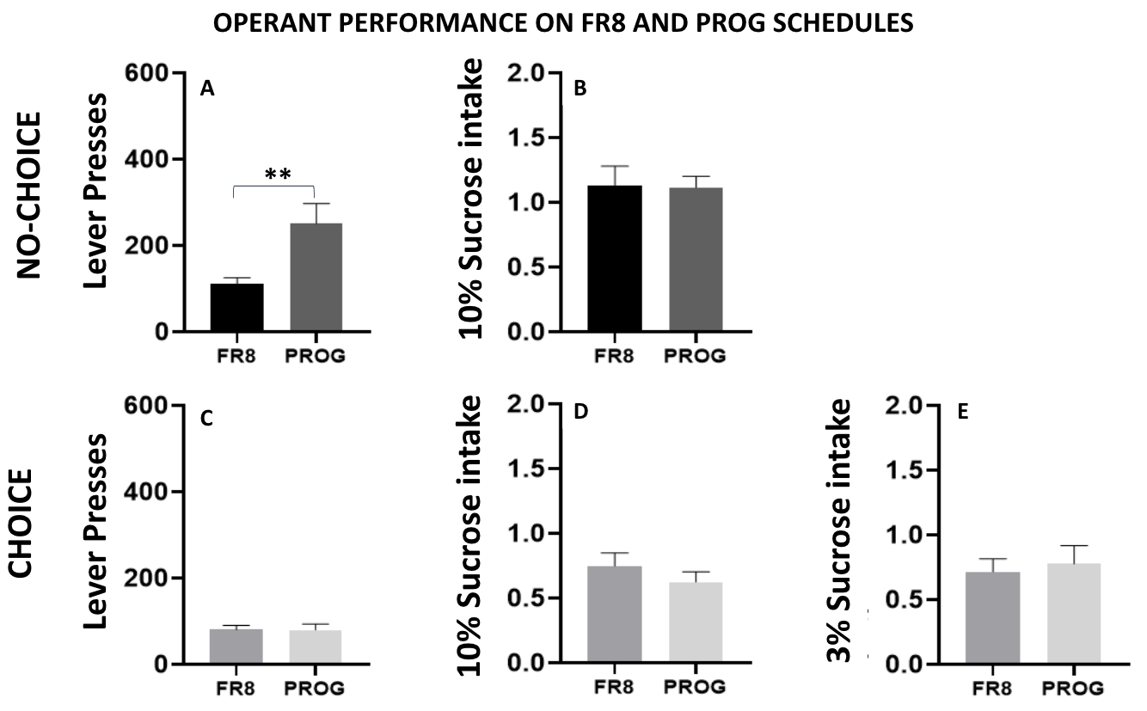

Supp. fig. 4. Average performance during 5 weeks of FR8 followed by 5 weeks of PROG schedules. Bars represent the mean ± SEM total lever presses (A, C), ml of 10% sucrose consumed (B, D), and ml of 3% sucrose consumed (E) in 15 minutes sessions. **p<0.01, significant differences between operant schedules.

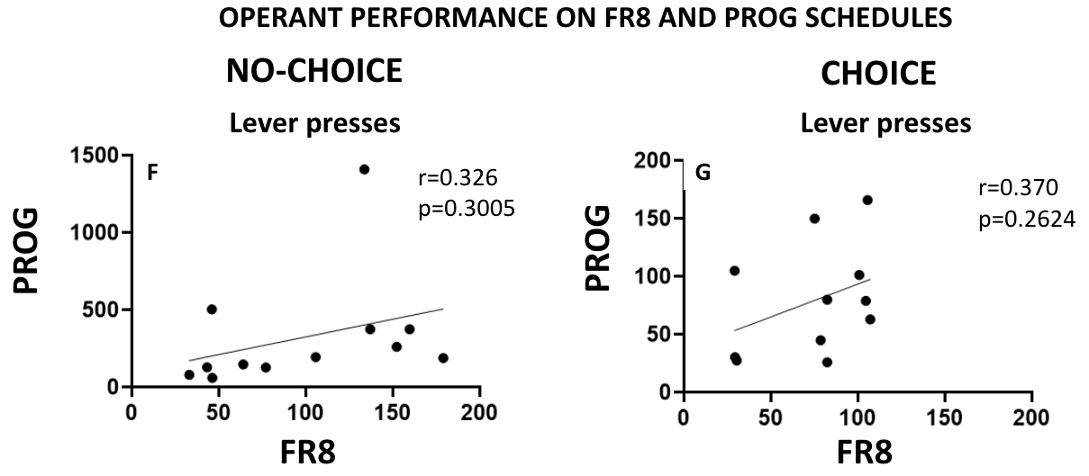
Supp. fig. 5. Correlation between the average of the lever presses for every mice during the last week of each schedule. Individual data for the no-choice group (A), and the choice group (B). in 15 minute sessions.

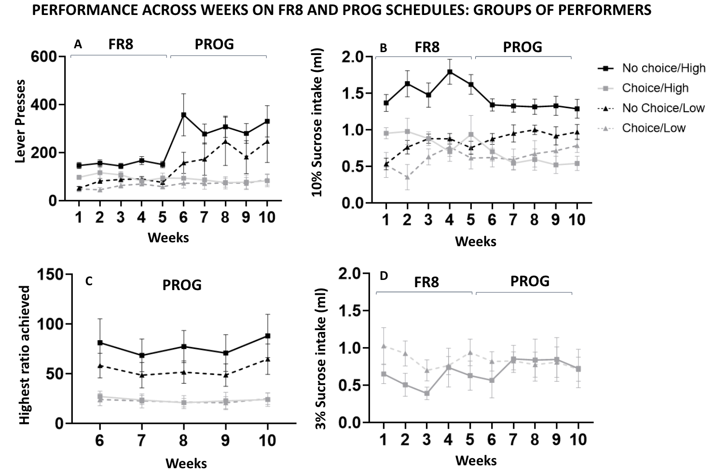
Supp. fig. 6. Effect of choice conditions during operant sessions with different work requirements (FR8 and PROG schedules), according to type of performer (N=22). Data represent the mean ± SEM number of lever presses (A), 10% sucrose ml consumed (B), highest ratio achieved during the PROG weeks (C), and free 3% sucrose ml consumed for the choice groups (D) in 15 minutes sessions.

For these results, a three-way repeated measures ANOVA was conducted to evaluate the effects of Week (within-subject factor), Choice condition ("Choice" vs "No Choice"), and Type of Performer ("High Performer" vs "Low Performer") on Lever Presses, 10% sucrose intake, and highest ratio achieved.
For Lever Presses, there was a significant main effect of Week (F(9, 162)=6.650, p<0.001, η²p=0.270), a significant main effect of Choice condition (F(1, 18) = 17.801, p<0.001, η²p =0.497) and of Type of Performer (F(1, 18)=5.351, p=0.033, η²p =0.229). There was also a significant interaction between Week and Choice condition (F(9, 162)=6.317, p<0.001, η²p=0.260), while the interactions between Week and Type of Performer (F(9, 162)=0.548, p=0.837, η²p=0.030), between Choice condition and Type of performer was not significant (F(1, 18)=1.784, p=0.198, η²p=0.090), and the three-way interaction (F(9, 162)=0.698, p=0.710, η²p=0.037) were not significant.
For 10% sucrose intake, there was a significant main effect of Choice condition (F(1, 18)=24.250, p<0.001, η²p=0.574) and Type of Performer (F(1, 18)=13.657, p=0.002, η²p=0.431), but no main effect of Week (F(9, 162)=1.773, p=0.077, η²p=0.090). There was a significant interaction between Week and Type of Performer (F(9, 162)=7.215, p<0.001, η²p=0.286), as well as a significant interaction between Choice condition and Type of Performer (F(1, 18)=6.582, p=0.019, η²p=0.268), while the interaction between Week and Choice condition (F(9, 162)=1.387, p=0.198, η²p=0.072), and the three-way interaction (F(9, 162)=1.225, p=0.283, η²p=0.064) were not significant.
For the highest ratio achieved, there was a significant main effect of Choice condition (F(1, 18)=12.663, p=0.002, η²p=0.413), but the main effect of Type of Performer (F(1, 18)=0.984, p=0.334, η²p=0.052) and Week factor (F(4, 72)=2.211, p=0.076, η²p=0.109) were not significant. The two way-interaction between Choice condition and Type of Performer (F(1, 18)=0.842, p=0.371, η²p=0.045), Week and Choice condition (F(4, 72)=1.209, p=0.315, η²p=0.063), or Week and Type of Performer (F(4, 72)=0.032, p=0.998, η²p=0.002), as well as the three-way interaction (F(4, 72)=0.071, p=0.991, η²p=0.004) were not significant.
Finally, a two-way repeated measures ANOVA was conducted for 3% sucrose intake, showing no significant main effect of Week (F(9, 81)=0.870, p=0.556, η²p=0.088), Type of Performer (F(1, 9)=0.524, p=0.487, η²p=0.055), and no interaction between Week and Type of Performer (F(9, 81)=1.000, p=0.447, η²p=0.100).

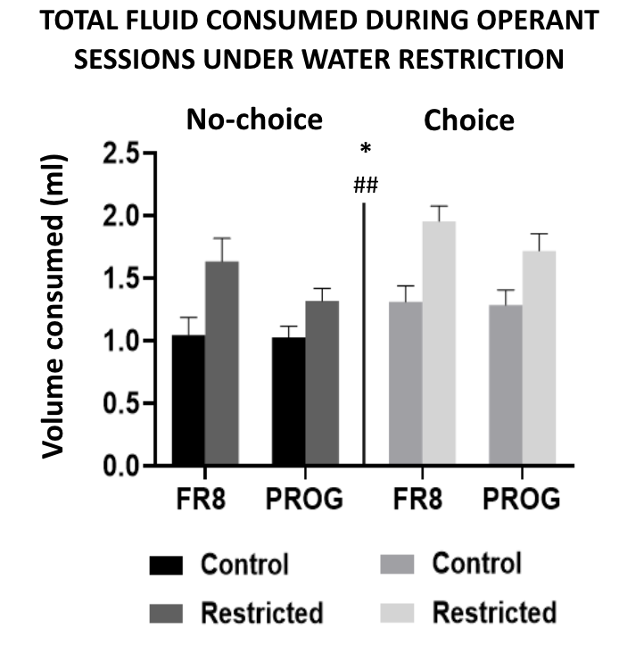

Supp. fig. 7. Total volume consumed during the operant session comparing both choice groups. ##p<0.01 denotes significance for the main factor water restriction. *p<0.05 denotes significance for the main factor operant schedule in a three way ANOVA: type of restriction x operant schedule x choice condition.

