Supplementary Materials 1

Supplementary Table 1
Mean RTs for condition for each quantile in Experiments 1A (single-task procedure) and 1B (dual-task procedure).

Condition |  | Quantiles
 |  | 1 | 2 | 3 | 4 | 5
 |  | Single Task
Semantic |  | 474 | 574 | 654 | 765 | 1056
Control |  | 473 | 569 | 649 | 757 | 1049
Difference |  | 1 | 5 | 5 | 8 | 7
 |  | Dual Task
Semantic |  | 577 | 694 | 801 | 947 | 1300
Control |  | 574 | 691 | 800 | 954 | 1312
Difference |  | 3 | 3 | 1 | -7 | -12

Supplementary Table 2
Mean RTs for condition for each quantile in Experiments 2A (single-task procedure) and 2B (dual-task procedure).

Condition |  | Quantiles
 |  | 1 | 2 | 3 | 4 | 5
 |  | Single Task
Semantic |  | 461 | 556 | 628 | 723 | 944
Control |  | 460 | 552 | 620 | 707 | 927
Difference |  | 1 | 4 | 8 | 16 | 17
 |  | Dual Task
Semantic |  | 556 | 658 | 743 | 854 | 1081
Control |  | 552 | 653 | 738 | 852 | 1082
Difference |  | 4 | 5 | 5 | 2 | -1

Supplementary Materials 2

Delta-plot analyses of Kinoshita et al.’s (2018) data
Before reporting our delta-plot analyses, we briefly summarize Kinoshita et al.’s experiments. For all the details the reader may directly refer to the original article.
Experiment 2
Three experimental conditions were used: color associated words – i.e., words associated with one of the response colors (e.g., lemon) –, control words – i.e., words not associated with any color (e.g., mercy) –, and neutral strings – i.e., strings of #. Stimuli were presented in four colors: Red, yellow, green, and blue, and participants were asked to categorize the color in which the stimuli were presented manually, i.e., by button press.
Two different lists were used. In the high-neutral proportion list, neutral stimuli occurred on 75% of the trials, whereas in the low-neutral proportion list, neutral trials appeared on 25% of the trials. Note that the two lists featured different proportions of the different types of conflict involved. Specifically, in the 25%-neutral condition, 25% of the trials (the neutral ones) involve strings of non-alphabetic characters (######), which do not trigger any type of conflict. Next, 37.5% of the trials involve color-unrelated words (e.g., MERCY), which trigger only task conflict. Finally, the remaining 37.5% of the trials involve color-associated words (e.g., SKY), which trigger both task and semantic conflict. In contrast, in the 75%-neutral condition, 75% of the trials are neutral (i.e., #####) and do not trigger any type of conflict. Next, 12.5% of the trials involve color-unrelated words (e.g., MERCY) and thus trigger only task conflict. Finally, the remaining 12.5% of the trials are color-associated words (e.g., SKY) and trigger both task and semantic conflict.
In sum, the 25% and the 75% neutral condition clearly involve different proportions of trials in which any type of conflict occurs (i.e., 75% in the 25%-neutral condition vs. only 25% in the 75% neutral condition) and in which semantic conflict occurs (i.e., 37.5% of trials in the 25%-neutral condition vs only 12.5% of trials in the 75%-neutral condition). On the basis of these characteristics, the critical list for our hypothesis (i.e., that a reduction of proactive control is associated with a semantic interference effect occurring throughout the RTs distribution) was the high-neutral proportion one. The reason is that, since proactive control is assumed to be positively correlated with the frequency of conflict (either semantic, task, or both; see, e.g., Botvinick et al., 2001; Kalanthroff et al., 2018), a list in which conflict of either type is infrequent, such as Kinoshita et al.’s high-neutral proportion list, would provide little reason for participants to maintain effortful proactive control and should bias them towards reactive control. Therefore, our delta-plot analyses focused on the high-neutral proportion list. Differently, the relative occurrence of conflicting trials in the low-neutral proportion list falls in a somewhat grey area between the standard task configuration (50% color-associated words, 50% color-unrelated control words) used in our experiments and a low-conflict list such as Kinoshita et al. high-neutral proportion list. As this complicates any clear-cut comparison and interpretation, we refrain from considering the low-neutral proportion condition further.
We ran delta-plot analyses identical to those conducted in our experiments. Within each participant and within each condition, RTs were partitioned into 5 quantiles: The first quantile included the fastest 20% of responses, the second quantile the next fastest 20%, and so on, until the fifth quantile, which included the slowest 20% of the responses. Changes in semantic Stroop effects as a function of response latency were assessed by entering the variables Stroop condition (color-associated vs neutral), quantile (considered as numerical), and their interaction as fixed effects in the statistical model. Participants and target colors were included as random intercepts.
Supplementary Table 3 reports mean RTs for each condition in each quantile. The interference effect across quantiles is showed in Supplementary Figure 1a. The analysis showed simple effects of Stroop condition (χ² (1) = 8.47, p = .003, b = -16.95, SE = 5.82, t = -2.91) and quantile (χ² (1) = 2004.19, p < .001, b = 126.41, SE = 2.03, t = 61.99), but no interaction (χ² (1) = 1.84, p = .17) even though the last quantile showed the largest semantic interference effect (46 ms, but do note the large error bar associated with it in Supplementary Figure 1a).

Supplementary Table 3
Mean RTs for condition and quantile in Kinoshita et al.’s (2018) Experiment 2, high-neutral proportion list.
Condition |  | Quantiles
 |  | 1 | 2 | 3 | 4 | 5
Semantic |  | 462 | 567 | 648 | 743 | 1023
Control |  | 450 | 555 | 640 | 740 | 977
Difference |  | 7 | 12 | 8 | 3 | 46

Experiment 4
Three experimental conditions were used: One with color names (i.e., green, yellow, grey, and pink) that were not the response colors, one with control noncolor words (twice, winner, grip, and thank), and one with neutral strings – i.e., strings of #. Stimuli were presented in four colors: Red, blue, orange, and white. The other experimental details paralleled those of Experiment 2.
The same statistical approach adopted for Experiment 2 was also adopted here, and we again focused on the high-neutral proportion list. Supplementary Table 4 reports mean RTs for each condition in each quantile. The interference effect across quantiles is showed in Supplementary Figure 1b. The results show simple effects of Stroop condition (χ² (1) = 46.24, p < .001, b = -44.67, SE = 6.51, t = -6.85) and quantile (χ² (1) = 1382.73, p < .001, b = 105.27, SE = 2.12, t = 49.45), but no interaction (χ² (1) = 0.09, p = .76) (and note that this time, the last quantile showed the smallest semantic interference effect – 22 ms – contrary to what was found for Kinoshita et al.’s (2018) Experiment 2).

Supplementary Table 4
Mean RTs for conditions for each quantile in Kinoshita et al.’s (2018) Experiment 4 – high-neutral proportion list.
Condition |  | Quantiles
 |  | 1 | 2 | 3 | 4 | 5
Semantic |  | 481 | 573 | 636 | 726 | 922
Control |  | 441 | 528 | 589 | 669 | 900
Difference |  | 40 | 45 | 47 | 57 | 22

Supplementary Figure 1
Results of the delta-plot analyses for Kinoshita et al.’s (2018) Experiments 2 and 4, high-neutral proportion lists.

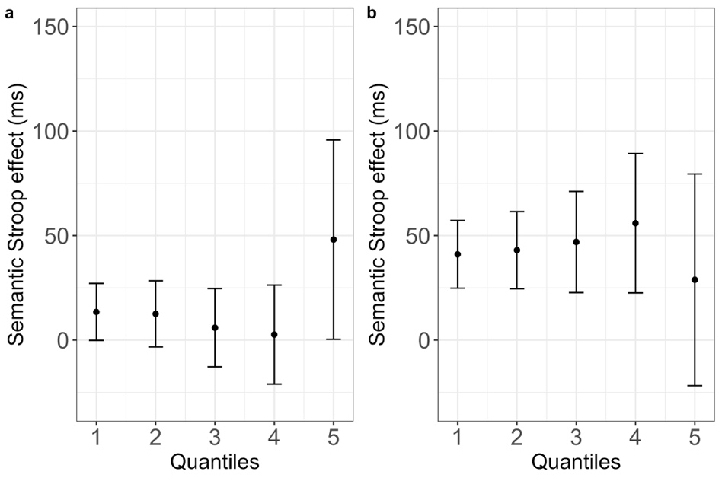

Note. Mean semantic Stroop effect (Experiment 2: color-associated – control; Experiment 4: non-response-set color names – control; y axis) as a function of trial quantile (x axis) for the high-neutral list in Experiment 2 (panel a) and Experiment 4 (panel b). Points represent empirical means, and error bars reflect corresponding 95% confidence intervals.

References

Botvinick, M. M., Braver, T. S., Barch, D. M., Carter, C. S., & Cohen, J. D. (2001). Conflict monitoring and cognitive control. Psychological Review, 108, 624-652.
Kalanthroff, E., Davelaar, E. J., Henik, A., Goldfarb, L., & Usher, M. (2018). Task conflict and proactive control: A computational theory of the Stroop task. Psychological Review, 125, 59-82.

