Supplementary Materials
Experiment 1
Average JOL across the training phase was 50.07 (SD = 25.28). JOLs drawn from the six training blocks was subjected to a multilevel model. JOLs increased significantly across training (β = .15, p < .001), see Figure S1.

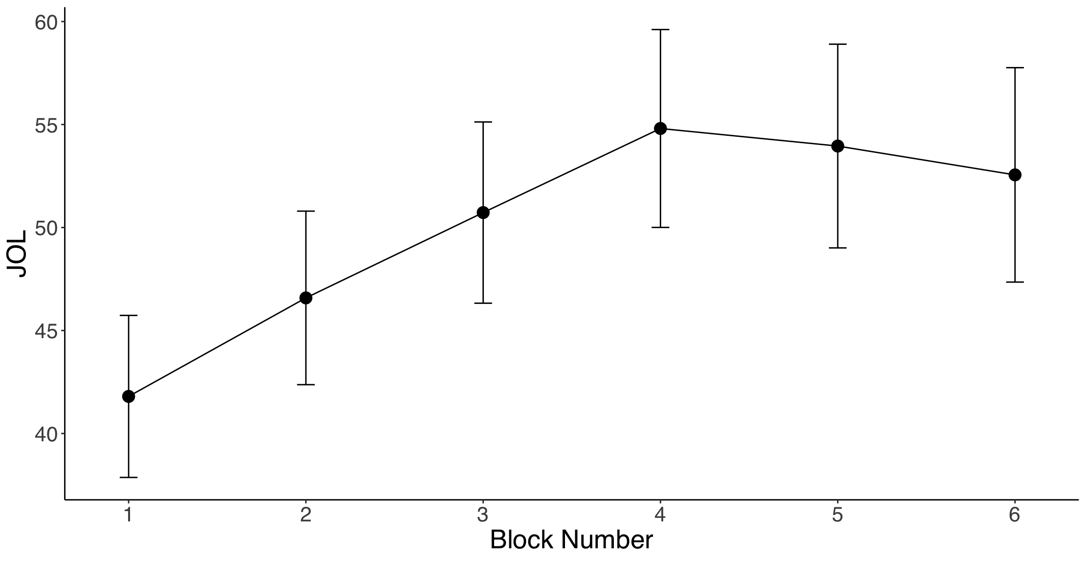
Figure S1. JOLs as a function of training block. Error bars are +1 standard error of the mean

Experiment 2
Average JOL across the training phase was 38.84 (SD = 22.91). JOLs drawn from the six training blocks was subjected to a multilevel model with the interaction between hint condition and block number included. JOLs increased significantly across training (β = .15, p < .001) but the main effect of hint condition and the interaction between hint condition and block number were not significant, see Figure S2.

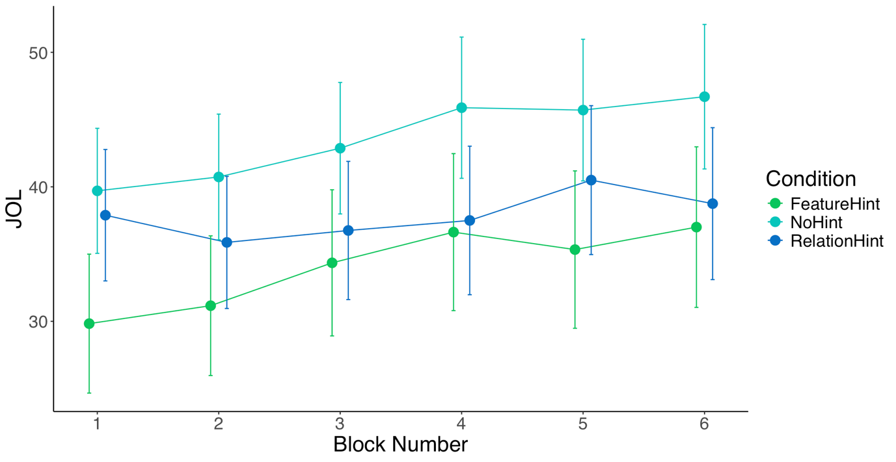
Figure S2. JOLs as a function of training block. Error bars are +1 standard error of the
Experiment 3
Average JOL across the training phase was 41.08 (SD = 27.14). JOLs drawn from the six training blocks was subjected to a multilevel model. JOLs increased significantly across training (β = .13, p < .001), see Figure S3.

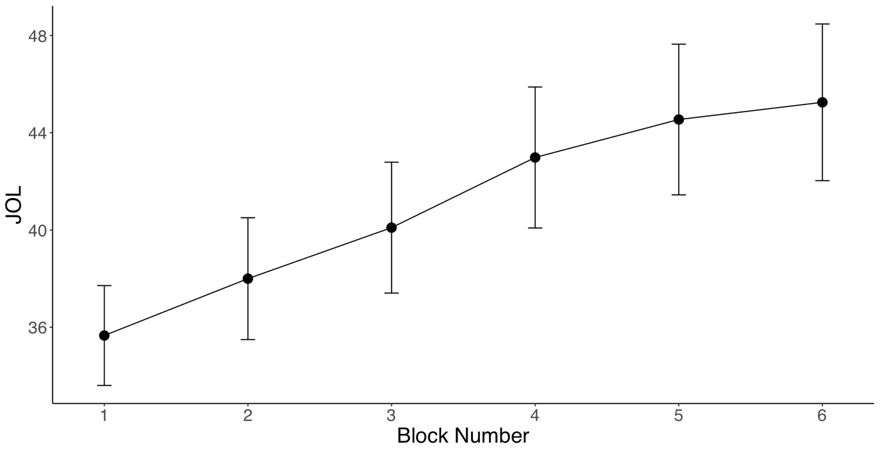
Figure S3. JOLs as a function of training block. Error bars are +1 standard error of the mean

