Electronic Supplementary Material

Model comparison
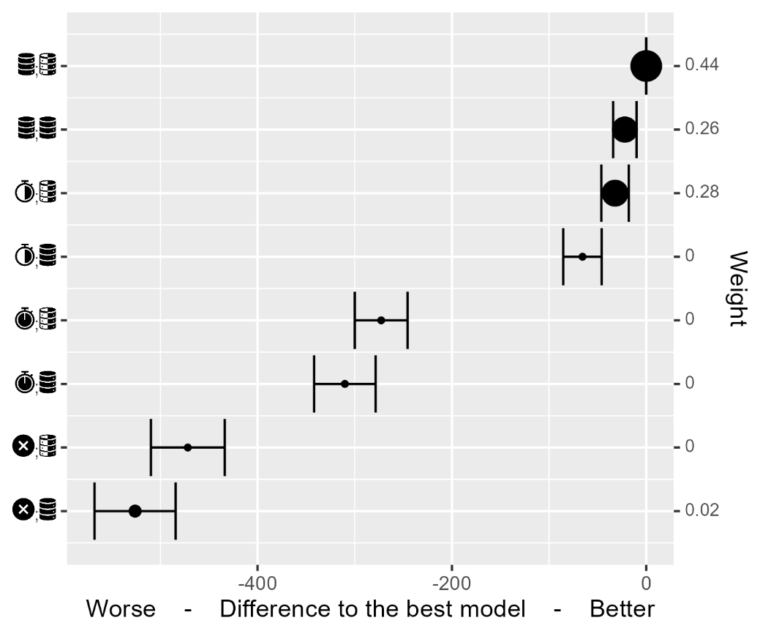
Figure S1. Easy: Model comparison via leave-one out information criterion. Difference and standard error of difference in ELPD relative to the best (top) model. Circle size and right y-axis show relative model weight computed via stacking algorithm (see Methods for details on LOO information criterion and stacking algorithm). Icons on the left depict model components (set and object only), please refer to Table 3 for information.
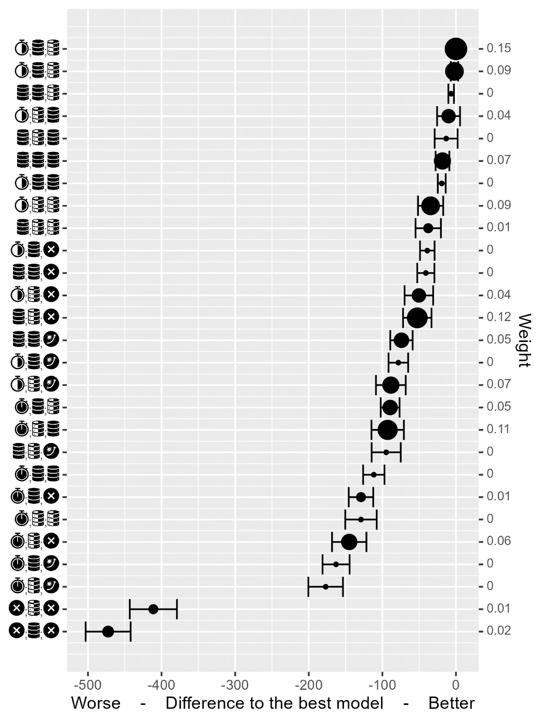
Figure S2. Medium: Model comparison via leave-one out information criterion. Difference and standard error of difference in ELPD relative to the best (top) model. Circle size and right y-axis show relative model weight computed via stacking algorithm (see Methods for details on LOO information criterion and stacking algorithm). Icons on the left depict model components (set, object, and color), please refer to Table 3 for information.

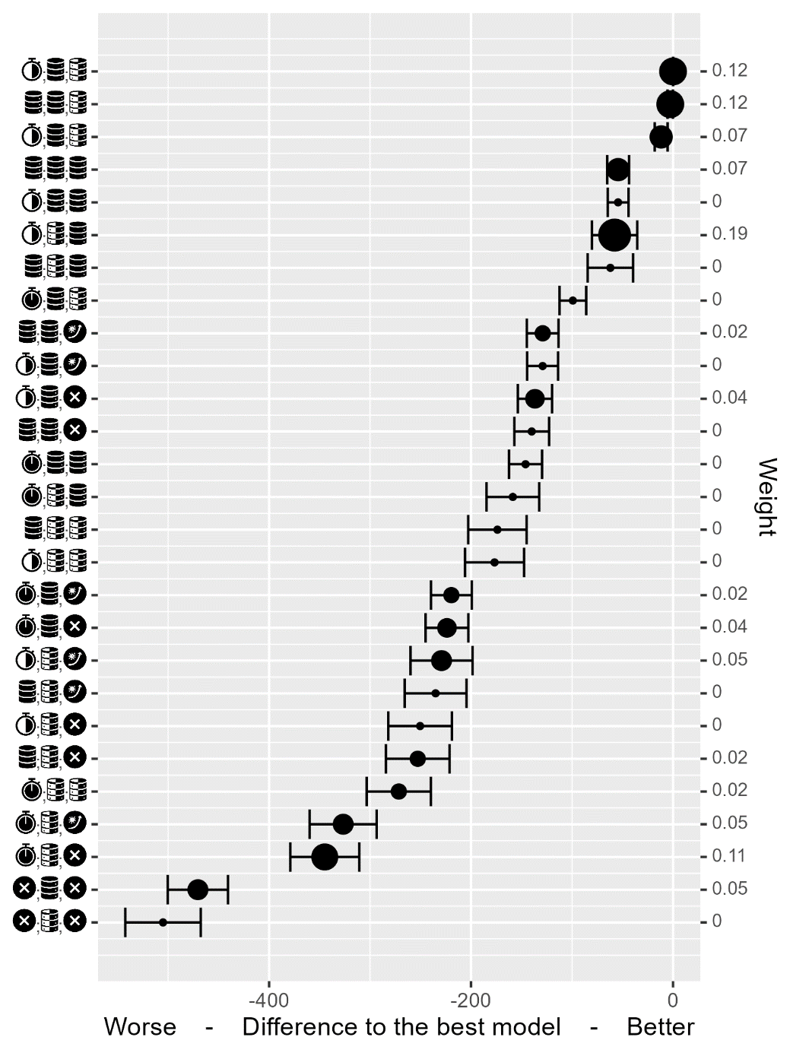
Figure S3. Hard: Model comparison via leave-one out information criterion. Difference and standard error of difference in ELPD relative to the best (top) model. Circle size and right y-axis show relative model weight computed via stacking algorithm (see Methods for details on LOO information criterion and stacking algorithm). Icons on the left depict model components (set, object, and color), please refer to Table 3 for information.

Analysis of subsets of trials, easy
Table S1. Easy: repetition of attentional set and object. Comparison of ideal observer models via leave-one-out information criterion. See Table 3 and Model section in the main text for details on the correspondence between component labels and implemented mechanisms. ΔELPD refers to difference in the expected log predictive density relative to the best performing (top) model. Weight shows a relative model goodness-of-fit weight computed via stacking. Please refer to (Vehtari et al., 2017a) for details.
Set | Object | ΔELPD | Weight
memory | common |  | 0.41
memory | per set | -4.86±8.49 | 0.3
different | common | -31.08±12.73 | 0.15
different | per set | -38.88±15.61 | 0.12
same | common | -243.91±25.11 | 0
same | per set | -251.29±25.45 | 0
none | common | -392.97±35.34 | 0.02
none | per set | -412.29±35.52 | 0

Table S2. Easy: repetition of object but not of an attentional set. See caption of Table S1 for details.
Set | Object | ΔELPD | Weight
memory | per set |  | 0.33
memory | common | -6.96±10.37 | 0.25
different | per set | -12.9±8.65 | 0.25
different | common | -23.03±13.81 | 0.17
same | per set | -141.05±13.57 | 0
same | common | -153.48±17.23 | 0
none | per set | -219.53±17.03 | 0
none | common | -242.54±19.86 | 0

Table S3. Easy: repetition of an attentional set but not of an object. See caption of Table S1 for details.
Set | Object | ΔELPD | Weight
memory | common |  | 0.05
different | common | -8.91±8.68 | 0.52
memory | per set | -9.01±7.39 | 0.42
different | per set | -27.65±12.07 | 0
same | common | -116.26±13.43 | 0
same | per set | -137.52±15.92 | 0
none | common | -189.48±15.74 | 0
none | per set | -220.26±18.69 | 0

Analysis of subsets of trials, medium
Table S4. Medium: repetition of attentional set and object. See caption of Table S1 for details.
Set | Object | Color | ΔELPD | Weight
different | common | per set |  | 0.21
memory | common | per set | -6.67±3.23 | 0
different | common | common | -8.39±4.37 | 0
different | per set | common | -21.41±12.53 | 0.03
memory | common | common | -21.67±7.77 | 0.06
Memory | per set | common | -22.82±12.34 | 0
different | per set | per set | -24.62±11.52 | 0.02
different | common | none | -25.14±9.02 | 0
Memory | per set | per set | -26.03±11.49 | 0.03
Memory | common | none | -38.97±10.05 | 0
different | per set | none | -41.38±14.21 | 0.06
Memory | per set | none | -41.54±13.94 | 0.12
Same | common | per set | -50.22±11.36 | 0.07
Same | common | common | -58.02±12.61 | 0.03
different | common | object boost | -61.1±11.57 | 0
Same | per set | common | -65.33±18.57 | 0.12
different | per set | object boost | -66.43±15.49 | 0.08
Same | per set | per set | -66.61±15.07 | 0
Memory | per set | object boost | -69.92±14.78 | 0
Memory | common | object boost | -71.15±12.62 | 0.04
Same | common | none | -73.69±14.7 | 0.04
Same | per set | none | -83.89±17.4 | 0
Same | common | object boost | -104.85±15.79 | 0
Same | per set | object boost | -105.29±17.85 | 0
None | common | none | -308.33±27.68 | 0.09
None | per set | none | -317.95±28.51 | 0

Table S5. Medium: repetition of object but not of an attentional set. See caption of Table S1 for details.
Set | Object | Color | ΔELPD | Weight
different | per set | common |  | 0.14
memory | per set | common | -3.32±1.62 | 0
same | per set | common | -4.36±7.3 | 0.14
different | common | per set | -11.89±11.59 | 0.17
memory | common | per set | -15.52±11.73 | 0
different | common | common | -20.84±12.78 | 0
memory | common | common | -21.44±13.22 | 0.11
different | common | none | -21.68±13 | 0.04
memory | common | none | -25.04±13.38 | 0
same | common | per set | -30.27±13.18 | 0
memory | common | object boost | -31.37±12.12 | 0
different | common | object boost | -31.39±11.58 | 0
different | per set | none | -41.28±6.82 | 0.09
same | common | common | -41.93±14.44 | 0
same | common | none | -43.73±14.63 | 0.12
memory | per set | none | -44.39±6.94 | 0.01
different | per set | per set | -44.81±6.91 | 0.03
memory | per set | per set | -46.9±6.99 | 0.02
same | common | object boost | -50.34±13.31 | 0.03
different | per set | object boost | -53.69±7.4 | 0
memory | per set | object boost | -60.52±7.46 | 0
same | per set | none | -61.67±9.46 | 0.09
same | per set | per set | -64.43±9.27 | 0
same | per set | object boost | -69.87±9.42 | 0
none | per set | none | -148.11±11.74 | 0
none | common | none | -182.53±18.78 | 0

Table S6. Medium: repetition of an attentional set but not of an object. See caption of Table S1 for details.
Set | Object | Color | ΔELPD | Weight
same | per set | common |  | 0.13
same | common | none | -11.67±9.87 | 0.15
different | common | none | -13.67±11.04 | 0.06
same | common | common | -15.59±9.22 | 0
different | per set | common | -19.84±7.23 | 0.18
different | common | common | -20.51±10.42 | 0
same | common | per set | -22.04±9.83 | 0
memory | per set | common | -23.15±7.27 | 0
same | per set | none | -23.24±6.98 | 0.01
different | common | per set | -23.77±10.75 | 0.12
same | common | object boost | -29.97±9 | 0.02
same | per set | per set | -30.17±7.08 | 0.07
memory | common | per set | -30.39±11.1 | 0
memory | common | none | -32.64±12.12 | 0.01
same | per set | object boost | -36.44±7.36 | 0
memory | common | common | -37.51±12.4 | 0.07
different | per set | none | -38.33±10.26 | 0.11
different | common | object boost | -38.84±10.87 | 0
memory | per set | none | -41.66±10.17 | 0
different | per set | per set | -46.06±10.43 | 0.01
memory | per set | per set | -47.74±10.32 | 0
different | per set | object boost | -54.34±10.92 | 0.02
memory | common | object boost | -55.53±12.13 | 0
memory | per set | object boost | -61.54±10.82 | 0
none | common | none | -96.35±13.09 | 0.04
none | per set | none | -126.01±12.42 | 0

Table S7. Medium: repetition of color and attentional set but not of an object. See caption of Table S1 for details.
Set | Object | Color | ΔELPD | Weight
same | common | common |  | 0.04
same | common | none | -1.74±4.07 | 0.14
same | common | per set | -2.9±3.26 | 0.07
same | per set | common | -5.81±10.16 | 0.15
different | common | none | -12.55±9.21 | 0.02
different | common | common | -13.2±8.24 | 0
different | common | per set | -13.82±9.16 | 0.15
different | per set | common | -15.51±12.5 | 0.1
memory | common | per set | -15.97±9.06 | 0
memory | per set | common | -16.89±12.34 | 0.01
same | common | object boost | -22.69±5.26 | 0.01
memory | common | common | -23.37±9.14 | 0.05
memory | common | none | -23.64±9.52 | 0
same | per set | per set | -28.54±10.01 | 0
same | per set | none | -30.41±10.85 | 0
different | common | object boost | -33.19±9.64 | 0
different | per set | per set | -36.01±13.93 | 0
memory | per set | per set | -36.21±13.79 | 0.06
different | per set | none | -36.87±14.35 | 0.12
memory | per set | none | -38.27±13.97 | 0
memory | common | object boost | -43.32±10.22 | 0.01
same | per set | object boost | -43.87±11.38 | 0
different | per set | object boost | -50.46±14.93 | 0.03
memory | per set | object boost | -53.96±14.24 | 0
none | common | none | -147.76±16.16 | 0.05
none | per set | none | -180.75±19.38 | 0

Analysis of subsets of trials, hard
Table S8. Hard: repetition of attentional set and object. See caption of Table S1 for details.
Set | Object | Color | ΔELPD | Weight
different | common | per set |  | 0.22
memory | common | per set | -3.56±4.52 | 0.05
different | common | common | -11.27±7.96 | 0
memory | common | common | -16.47±10.73 | 0.09
different | per set | common | -48.96±17.36 | 0.13
memory | per set | common | -49.27±17.36 | 0
same | common | per set | -56.89±10.55 | 0
same | common | common | -65.89±13.17 | 0
different | common | object boost | -73.8±12.81 | 0.01
memory | common | object boost | -78.6±14.27 | 0.03
different | per set | per set | -97.53±19.53 | 0.01
memory | per set | per set | -97.77±19.5 | 0.13
different | common | none | -97.9±14.62 | 0
memory | common | none | -101.19±15.96 | 0
same | per set | common | -102.05±20.01 | 0.09
same | common | object boost | -128.99±16.46 | 0
same | per set | per set | -143.61±20.91 | 0.01
same | common | none | -144.84±17.88 | 0.06
memory | per set | object boost | -146.64±21.22 | 0
different | per set | object boost | -155.03±22.21 | 0
different | per set | none | -173.69±22.8 | 0
memory | per set | none | -175.52±22.72 | 0
same | per set | object boost | -189.13±22.51 | 0.06
same | per set | none | -214.57±23.97 | 0.04
none | common | none | -315.03±26.42 | 0.07
none | per set | none | -390.74±31.32 | 0

Table S9. Hard: repetition of object but not of an attentional set. See caption of Table S1 for details.
Set | Object | Color | ΔELPD | Weight
different | common | per set |  | 0.14
memory | common | per set | -1.09±3.52 | 0
memory | common | common | -6.87±9.2 | 0.05
memory | common | none | -7.01±8.37 | 0.04
same | common | per set | -7.75±5.46 | 0
different | common | none | -10.69±6.35 | 0.04
different | common | common | -12.1±7.99 | 0.06
memory | common | object boost | -12.37±10.84 | 0.07
same | common | none | -16.08±7.94 | 0.07
different | common | object boost | -17.18±10.03 | 0
same | common | common | -18.65±9.07 | 0
same | common | object boost | -23.33±10.88 | 0.05
different | per set | common | -26.07±18.32 | 0.15
memory | per set | common | -29.41±18.33 | 0
same | per set | common | -32.02±18.9 | 0.03
none | common | none | -141.23±12.04 | 0
different | per set | none | -148.17±26.94 | 0.02
memory | per set | none | -151.51±26.91 | 0
same | per set | none | -156.34±27.34 | 0.13
different | per set | per set | -160.55±27.34 | 0.1
memory | per set | per set | -163.14±27.3 | 0
memory | per set | object boost | -165.36±27.31 | 0
different | per set | object boost | -167.61±27.71 | 0
same | per set | per set | -169.87±27.77 | 0
same | per set | object boost | -171.89±27.71 | 0.06
none | per set | none | -210.68±26.64 | 0

Table S10. Hard: repetition of an attentional set but not of an object. See caption of Table S1 for details.
Set | Object | Color | ΔELPD | Weight
different | common | common |  | 0
same | common | common | -0.01±5.74 | 0
same | common | per set | -8.05±8.53 | 0
memory | common | common | -8.33±6.29 | 0.04
different | common | per set | -8.37±6.4 | 0.12
memory | common | per set | -12.74±7.24 | 0
same | per set | common | -15.87±14.98 | 0.11
same | common | object boost | -17.26±8.45 | 0.03
different | common | object boost | -18.42±6.4 | 0
same | common | none | -21.23±9.57 | 0.1
different | common | none | -23.66±7.5 | 0.07
memory | common | object boost | -24.83±8.45 | 0.08
different | per set | common | -25.62±14.92 | 0.19
memory | per set | common | -26.31±14.85 | 0.01
memory | common | none | -31.83±9.34 | 0.04
same | per set | per set | -86.22±20.51 | 0.04
none | common | none | -92.34±12.15 | 0
same | per set | none | -95.17±20.33 | 0.05
same | per set | object boost | -97.24±21.02 | 0.05
different | per set | per set | -101.63±21.3 | 0
memory | per set | per set | -101.77±21.21 | 0.08
different | per set | none | -112.27±21.03 | 0
memory | per set | object boost | -112.95±21.54 | 0
memory | per set | none | -113.21±20.89 | 0
different | per set | object boost | -120.38±22.54 | 0
none | per set | none | -194.29±23.88 | 0

Table S11. Hard: repetition of color and attentional set but not of an object. See caption of Table S1 for details.
Set | Object | Color | ΔELPD | Weight
different | common | per set |  | 0.25
memory | common | per set | -0.04±3.73 | 0.04
same | common | per set | -2.83±7.87 | 0
different | common | common | -7.99±5.75 | 0
same | common | common | -11.25±9.9 | 0
memory | common | common | -11.99±9.03 | 0.08
different | per set | common | -31.74±13.37 | 0.07
memory | per set | common | -32.24±13.37 | 0.01
different | common | object boost | -33.92±7.94 | 0
same | per set | common | -38.73±15.82 | 0.13
memory | common | object boost | -38.84±10.27 | 0.04
same | common | object boost | -40.13±11.45 | 0
same | common | none | -56.72±13.05 | 0.09
memory | common | none | -58.35±12.2 | 0.03
different | common | none | -59.89±10.65 | 0
same | per set | per set | -88.05±18.08 | 0.12
memory | per set | per set | -88.91±17.16 | 0.03
different | per set | per set | -89.05±17.25 | 0.03
same | per set | object boost | -115.11±18.76 | 0
memory | per set | object boost | -116.87±17.9 | 0
different | per set | object boost | -123.37±18.77 | 0
same | per set | none | -132.15±19.73 | 0.06
different | per set | none | -135.8±19 | 0
memory | per set | none | -135.98±18.87 | 0
none | common | none | -171.32±18.49 | 0.02
none | per set | None | -250.06±24.71 | 0

