Appendix B
NASA workload experience analysis
We compared how participants evaluated experienced workload in the cued and voluntary tasks in the load and no-load conditions. We coded load condition and switching task into one variable condition with four levels (cued_load, cued_no-load, voluntary_load, and voluntary_no-load). A linear mixed-effects model was fitted to assess the effect of condition on participants’ perceived cognitive load. The model included condition as a fixed effect and random intercepts for subject.
The model revealed a significant main effect of condition. Compared to the baseline condition (cued_load), participants reported significantly lower perceived load in all other conditions: cued_no-load (β = -1.17, SE = 0.26, t = - 4.56, p < .01), voluntary_load (β = -1.31, SE = 0.25, t = -5.17, p < .01), and voluntary_no-load (β = -2.10, SE = 0.26, t = -8.21, p < .01). These results suggest that both the removal of load and voluntary switching led to significant reductions in perceived cognitive effort relative to the loaded condition. Therefore, our cognitive load manipulation effectively increased the experienced cognitive effort among the participants.
Tone monitoring (secondary task) performance analysis
The mean RTs and accuracy per condition on the secondary tone monitoring task are shown in Table AB1. A linear mixed-effects model was used to examine the effect of the switching mode (no switching in single language blocks, cued and voluntary switching in the mixed language blocks) on RTs, with switching mode as a fixed effect and by-subject random intercepts and slopes for switching mode. Visual examination of RTs shows a normal distribution; therefore, raw RTs were used in the model.
There was a significant main effect of switching mode. Compared to the baseline condition (cued switching), response times were significantly faster in both the no switching condition (β = -42.22, SE = 7.05, t = -5.99, p < .01) and the voluntary switching condition (β = -23.71, SE = 7.13, t = -3.33, p < .01). This suggests that participants responded more quickly on the secondary task when there was either no switching or switching was self-initiated, relative to externally cued switching. Additionally, post hoc analysis also shows that secondary task RTs were faster in no switching compared to the voluntary switching condition (β = -18.5, SE = 6.38, t = -2.90, p = .01). As a result, secondary task RTs showed a linear increase under cognitive load – progressing from no switching to voluntary switching, and finally to cued switching.

Table AB1 Mean reaction times (RTs, in milliseconds) and accuracy (in %) in the tone monitoring secondary task by switching mode of the main naming task (no switching, cued and voluntary switching) and language (naming in Chinese or English on the primary task). Standard errors are shown in parentheses
 | Chinese |  | English
 | RTs | Accuracy | RTs | Accuracy
No switching | 620 (4.70) | 87.4 (1.04) | 629 (4.90) | 86.4 (1.08)
Voluntary switching | 647 (5.71) | 82.0 (1.40) | 641 (4.41) | 87.2 (0.92)
Cued switching | 670 (5.17) | 79.8 (1.26) | 664 (5.29) | 77.2 (1.32)
For accuracy, a generalized linear mixed-effects model with a binomial link function was fitted to examine the effect of switching mode on accuracy. The model included switching mode as a fixed effect and by-subject random intercepts and slopes for switching mode. The analysis revealed a significant main effect of switching mode. Compared to the cued switching condition, accuracy was significantly higher in the no switching condition (β = 0.60, SE = 0.18, z = 3.44, p < .01) and the voluntary switching condition (β = 0.45, SE = 0.18, z = 2.55, p = .01). These results mirror the findings of RT data, suggesting that participants were more accurate when there was no switching or switching was self-initiated. Post hoc analysis indicates that secondary task accuracy was not significantly different between no switching and voluntary switching conditions. In summary, analysis results of the secondary task performance suggest that language switching undermines the performance in tone monitoring as reflected by RTs and error rates, and this is particularly evident during cued switching.
Lexical availability analysis in voluntary switching
To test whether voluntary language choice was influenced by relative cross-language accessibility, items were first nested within load type (itemload), because different item sets were used in the load and no-load sessions. We then derived a relative L2 advantage index from single-block naming performance, incorporating both L2 easiness and L1 difficulty. For each item, L2 easiness was indexed by the mean inverse-square-root-transformed RT in the L2 single-language block, with faster L2 responses indicating greater L2 easiness. L1 difficulty was indexed by the mean inverse-square-root-transformed RT in the L1 single-language block, with slower L1 responses indicating greater L1 difficulty. Both indices were standardised within each load type and then combined, so that higher values indicated items for which L2 was relatively more accessible than L1. Voluntary-switching trials were then subsetted, and the dependent variable was whether participants chose L2 English rather than L1 Chinese. Descriptively, the proportion of L2 choices was similar across load types (load: 0.64; no-load: 0.64).
A logistic mixed-effects model predicting L2 choice from relative L2 advantage, load condition, and their interaction included by-subject random intercepts and random slopes for relative L2 advantage, plus a random intercept for itemload. The overall effect of relative L2 advantage was marginal (β = 0.06, SE = 0.03, z = 1.95, p = .051), suggesting weak evidence that participants were more likely to choose L2 for items with greater relative L2 accessibility. The main effect of load was not significant (β = −0.002, SE = 0.03, z = −0.07, p = .94), consistent with the similar overall proportion of L2 choices across load conditions.
The interaction between relative L2 advantage and load condition was also marginal (β = −0.05, SE = 0.03, z = −1.68, p = .093). Simple-slope estimates showed that relative L2 advantage did not predict L2 choice in the no-load condition (β = 0.01, SE = 0.04, 95% CI [−0.08, 0.10]), but did predict L2 choice in the load condition (β = 0.11, SE = 0.04, 95% CI [0.03, 0.20]). However, the difference between these slopes did not reach significance (z = −1.68, p = .093). Thus, this exploratory analysis provides suggestive, but not conclusive, evidence that under cognitive load, participants were more likely to choose L2 when L2 was relatively more accessible than L1.

L2 reaction-time distribution analysis
To examine whether L2 reaction-time distributions differed between voluntary switching and single-language naming, the data were first restricted to L2 English trials and split into (a) single-block trials and (b) voluntary-switching trials. For each participant and load type, vincentiles (0.10–0.90) were computed from inversely transformed RT separately for the single and voluntary conditions. A within-participant shift function was then calculated at each vincentile as voluntary − single, such that negative values indicate faster responses during voluntary switching.
A linear mixed-effects model tested whether the shift became more negative at higher vincentiles, and whether this quantile pattern differed by load type (diff ~ quantile × load, with by-subject random intercepts and random slopes for quantile). The model showed a reliable overall negative shift, indicating faster L2 English responses in voluntary than single-language trials (intercept: β = −0.002, SE = 0.0002, t = −10.57, p < .001). Critically, the shift became increasingly negative at higher vincentiles (see Fig. AB1), indicating that the voluntary advantage was larger in the slower tail of the distribution (quantile: β = −0.003, SE = 0.0003, t = −8.01, p < .001; F = 64.14, p < .001). There was also a robust main effect of load (β = −0.001, SE = 0.00004, t = −12.49, p < .001; F = 155.92, p < .001), reflecting an overall difference in the magnitude of the voluntary–single shift between the two load sessions. However, the interaction between quantile and load type was not reliable, indicating that the vincentile pattern (i.e., how the voluntary advantage scaled from faster to slower responses) did not differ by load.

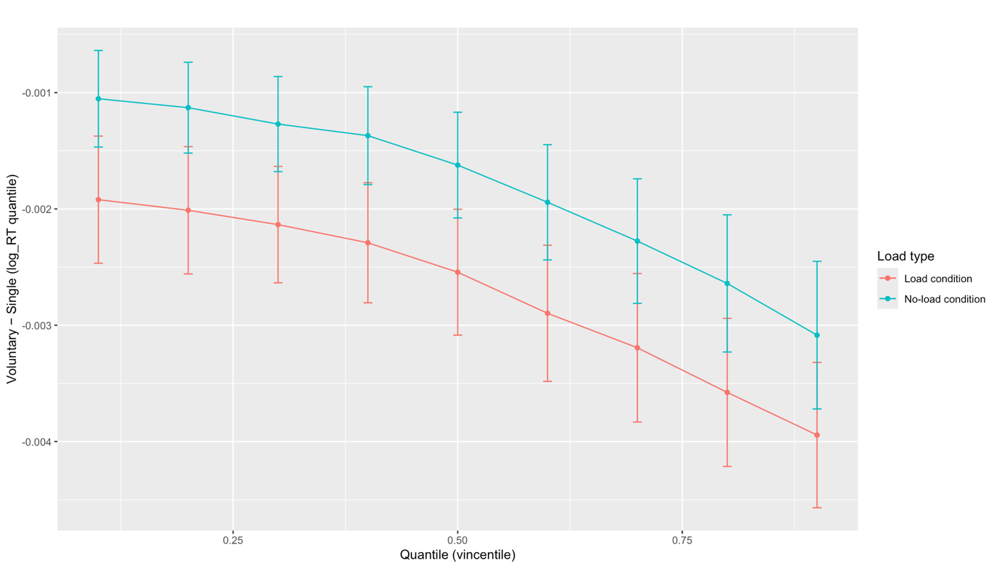
Fig. AB1 Shift function for L2: voluntary vs. single, by load type

Exploratory analysis of immediate carryover from tone monitoring to picture naming
To examine whether picture naming in the load condition was influenced by events in the immediately preceding tone-monitoring task, we conducted two exploratory RT analyses. These analyses were restricted to the load condition, because the tone-monitoring task was absent in the no-load condition. We focused on correct naming trials from the mixed-language blocks, consistent with the main RT analyses.

First, we tested whether naming RTs were affected by tone-monitoring accuracy. In the available trial-level data, the tone-monitoring variable distinguished trials with a correct tone response from trials with a tone-monitoring error. Naming RTs were predicted from language, trial type, switching mode, and tone-monitoring outcome, with random intercepts for subjects and items and by-subject random slopes for switching mode. Tone-monitoring outcome significantly predicted subsequent naming RT (β < 0.001, SE < 0.001, t = −10.04, p < .001). Given the contrast coding used for tone-monitoring outcome, this effect indicated that naming responses were slower following tone-monitoring errors than following correct tone responses. Importantly, including tone-monitoring outcome did not alter the critical language-specific switching pattern under load: the interaction between language, trial type, and switching mode remained non-significant (β < 0.001, SE < 0.001, t = 0.41, p = .683).
Second, we tested whether the latency of the tone-monitoring response predicted subsequent naming RT. This analysis was restricted to trials with a recorded tone response. Tone-response latency was standardised and added to a model predicting naming RT from language, trial type, and switching mode, again with random intercepts for subjects and items and by-subject random slopes for switching mode. Tone-response latency significantly predicted subsequent naming RT (β < 0.001, SE < 0.001, t = 9.63, p < .001), indicating that later tone responses were associated with slower picture naming. However, including tone-response latency again did not alter the critical language-specific switching pattern under load: the interaction between language, trial type, and switching mode remained non-significant (β < 0.001, SE < 0.001, t = 0.57, p = .568).
Together, these exploratory analyses suggest that the tone-monitoring task produced an immediate carryover effect on subsequent picture naming. Naming responses were slower following tone-monitoring errors and following later tone responses. However, these carryover effects appeared to be general. They did not account for the language-specific switching pattern reported in the main analyses.

