Supplementary Materials

Odor-Color Associations Differ with Verbal Descriptors for Odors: A Comparison of Three Linguistically Diverse Groups
Josje M. de Valk, Ewelina Wnuk, John L. A. Huisman, and Asifa Majid

Figure S: Color chart used in the odor-color association task (cf. Majid, 2008). Note the colors are only an approximation of the Munsell chart used in the actual experiment.

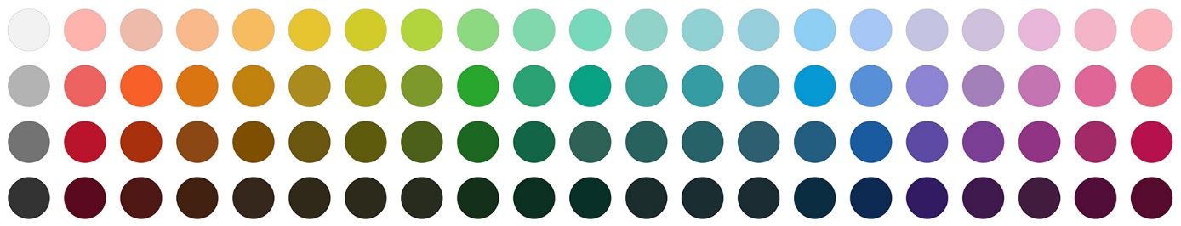
Consistency of Odor-Color Associations By Color Categories.
In the main analyses, we tested whether participants were consistent in which colors they assigned to which odors over the two test sessions using a strict criterion of exact match. According to this test, Maniq speakers were not consistent in matching odors to colors. Here we ask whether a different result would be obtained if we used a more liberal criterion of consistency, where a consistent color response is one which is from the same color category.
It is known that color categories vary across cultures (Berlin & Kay, 1969; Malt & Majid, 2013; Regier & Kay, 2009), so we first established for each language their color terms for the colors used in this experiment using the methods from the Language of Perception survey (Majid, 2008; Majid & Levinson, 2007). In a separate test Thai, Dutch, and Maniq participants were asked to name the colors used in this experiment one-by-one. Accordingly, we were able to establish that Thai and Dutch both used 10 distinct color terms to exhaustively name the colors, whereas Maniq only used 6 terms (roughly black, white, red, yellow, grue and purple; see also Wnuk, 2016).
We tested if participants’ responses differed from chance where expected chance of a consistent response was $\frac{1}{number of color terms}$. Note, this further favors finding consistency in responses amongst the Maniq, and that is what we find N = 150, observed proportion = .273, p < .001. Binomial tests also confirmed both Thai and Dutch were more consistent in their odor-color mappings than expected by chance using color terms as criterion – Thai: N = 360, observed proportion = .397, p < .0001; Dutch: N = 360, observed proportion = .383, p< .0001.

References
Berlin, B., & Kay, P. (1969). Basic color terms: Their universality and evolution. Berkeley: University of California Press.
Majid, A. (2008). Focal colors. In Field Manual (Vol. 11, pp. 8–10). Nijmegen: Max Planck Institute for Psycholinguistics.
Majid, A., & Levinson, S. C. (2007). The language of vision I: Color. In Field Manual Volume 10. Nijmegen: Max Planck Institute for Psycholinguistics.
Malt, B. C., & Majid, A. (2013). How thought is mapped into words. Wiley Interdisciplinary Reviews: Cognitive Science, 4(6), 583–597.
Regier, T., & Kay, P. (2009). Language, thought, and color: Whorf was half right. Trends in Cognitive Sciences, 13(10), 439–446.
Wnuk, E. (2016). Semantic specificity of perception verbs in Maniq (PhD dissertation). Radboud University, Nijmegen.

