Supplementary material

Table S.1Descriptive statistics (mean % correct recall (SD)) for each measure of each subtest, across each age group
 |  | 8-9y | 10-11y | 12-13y | 14-15y | 16-18y
Learning | Spoken words | 54(19) | 55(23) | 58(19) | 56(22) | 70(21)
Learning | Written words | 50(23) | 51(25) | 68(25) | 68(25) | 76(20)
Learning | Objects | 56(21) | 53(23) | 63(24) | 59(25) | 80(13)
Learning | Designs | 27(15) | 33(17) | 43(16) | 51(22) | 59(17)
Learning | Pseudowords | 28(21) | 32(17) | 35(18) | 42(24) | 52(21)
Delayed recall | Spoken words | 65(24) | 66(27) | 71(24) | 70(29) | 84(21)
Delayed recall | Written words | 58(32) | 62(30) | 80(25) | 80(25) | 87(20)
Delayed recall | Objects | 64(25) | 61(29) | 74(25) | 71(28) | 91(11)
Delayed recall | Designs | 43(19) | 42(22) | 49(23) | 59(23) | 73(21)
Delayed recall | Pseudowords | 32(23) | 35(24) | 41(25) | 51(31) | 63(26)
Delayed recognition | Spoken words | 89(17) | 93(11) | 93(10) | 95(11) | 96(10)
Delayed recognition | Written words | 86(15) | 88(19) | 96(8) | 96(12) | 97(12)
Delayed recognition | Objects | 91(12) | 91(13) | 94(10) | 94(12) | 99(6)
Delayed recognition | Designs | 82(17) | 78(17) | 90(12) | 93(11) | 93(14)
Delayed recognition | Pseudowords | 83(21) | 83(23) | 88(15) | 85(22) | 94(9)
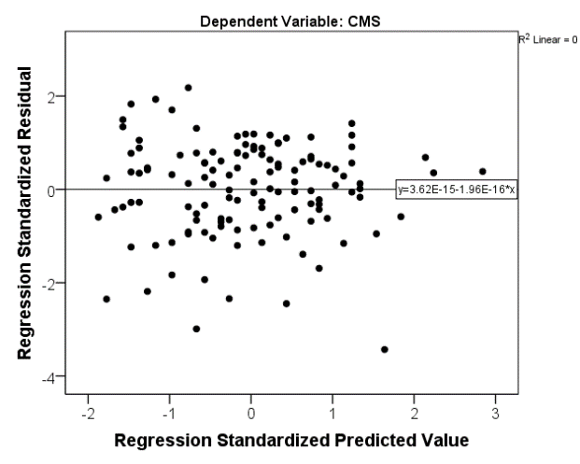
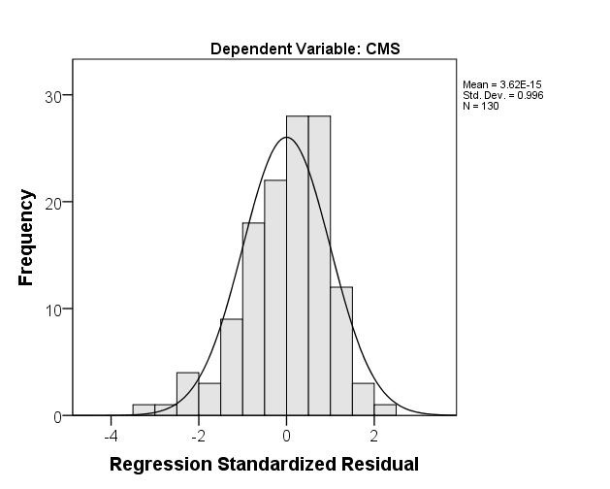
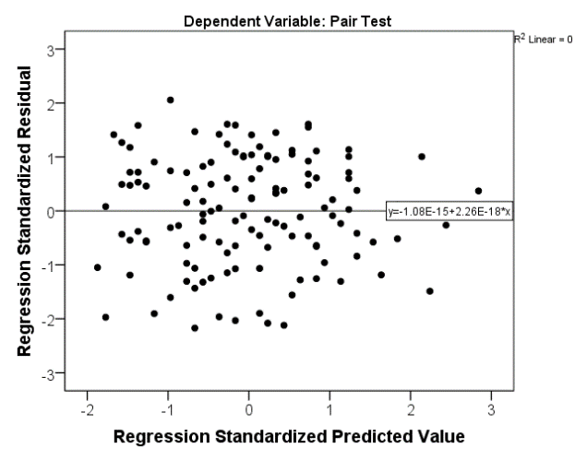
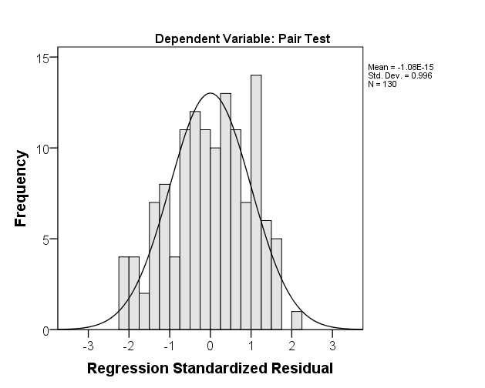
Figure S.1 Normality of residuals and homoscedasticity, for the Pair Test and the CMS.

