SUPPLEMENTAL MATERIALS

Supplemental Table 1A. Correlation matrix for task-unrelated thought (TUT) rate and questionnaire measures in the total sample.
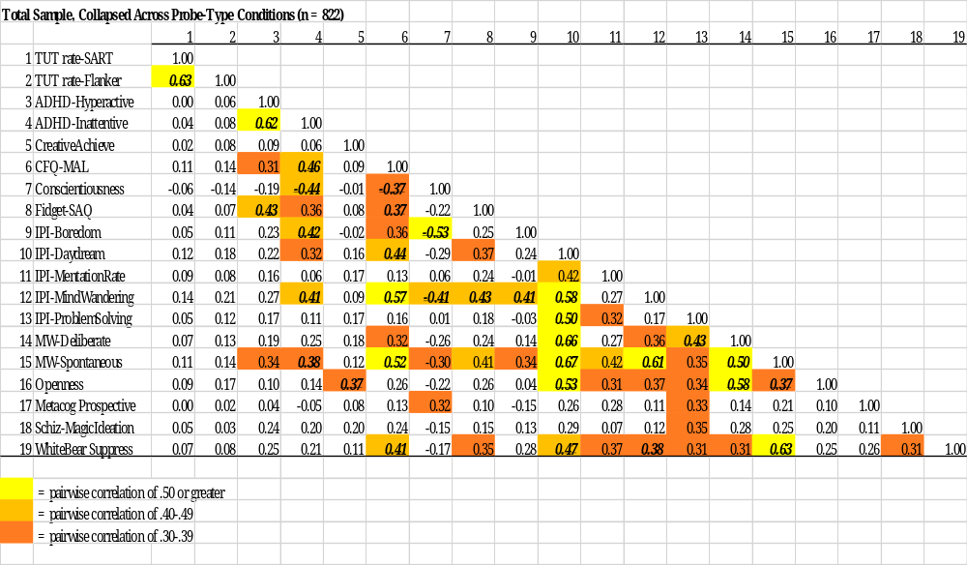
Note. Bolded italicized correlations: ≥.30 across all 5 correlation matrices.
Supplemental Table 1B. Correlation matrix for task-unrelated thought (TUT) rate and questionnaire measures in the content-probe condition.
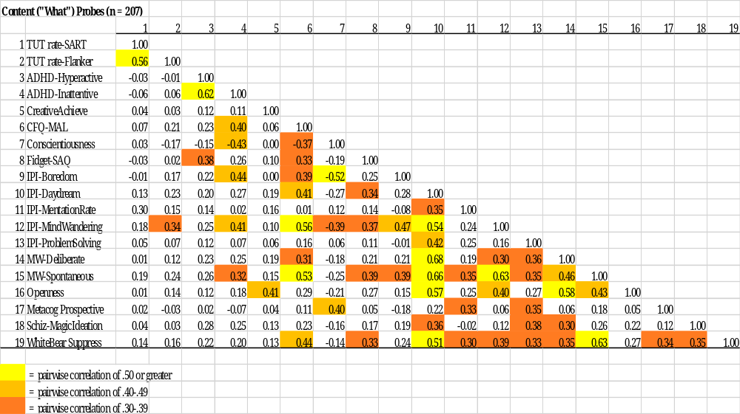

Supplemental Table 1C. Correlation matrix for task-unrelated thought (TUT) rate and questionnaire measures in the intentionality-probe condition.
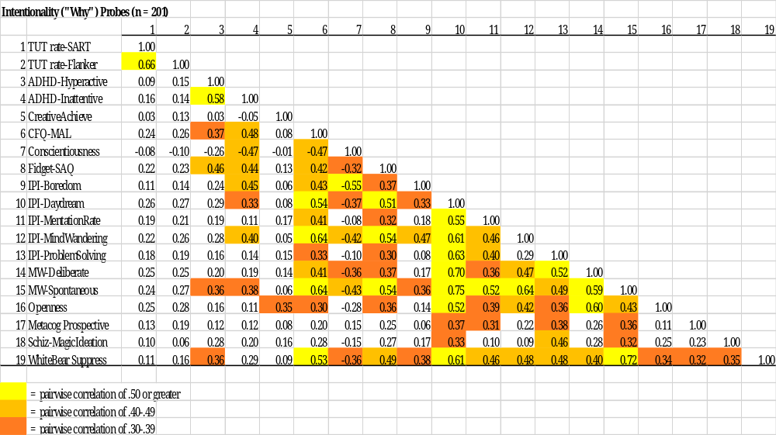

Supplemental Table 1D. Correlation matrix for task-unrelated thought (TUT) rate and questionnaire measures in the depth-probe condition.
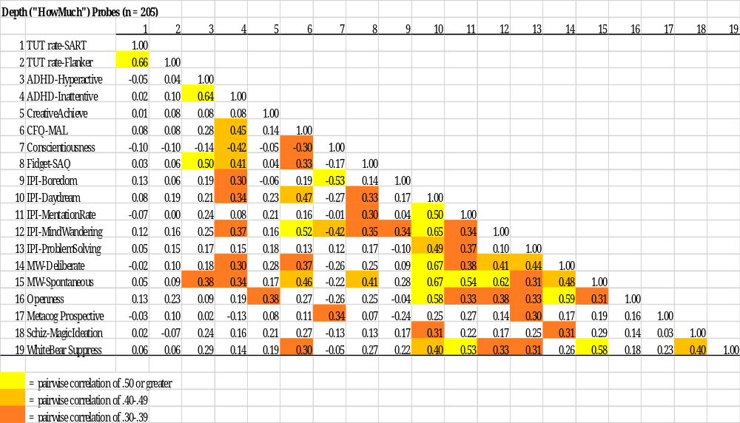

Supplemental Table 1E. Correlation matrix for task-unrelated thought (TUT) rate and questionnaire measures in the content-probe condition without a task-related interference (TRI) response option.
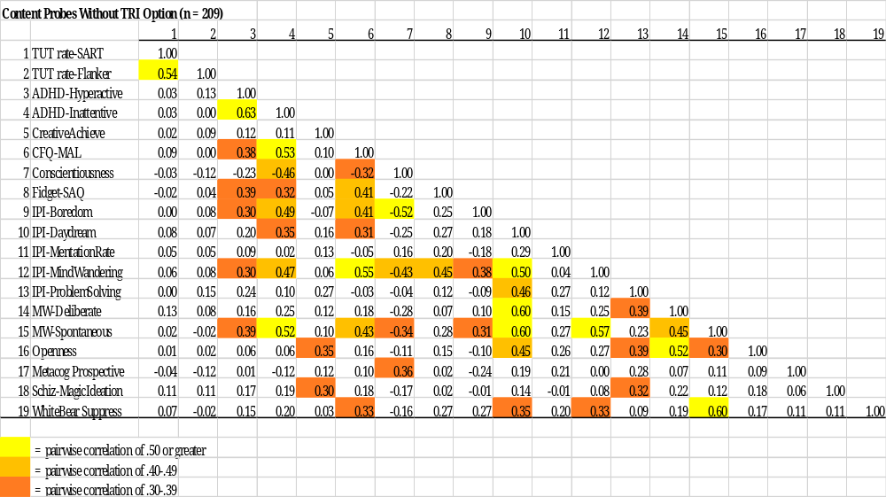

Supplemental Table 2. Details about the questionnaire factor analyses.
Exploratory factor analyses (with promax rotation) for each probe condition separately yielded two factors with Eigenvalues >1 and two factors above the scree (see Supplemental Table 3); re-running each analysis to force a two-factor solution yielded results presented in Supplemental Table 4. As in the correlations, there is some consistency among probe-type conditions: One factor (“Apathetic Inattention”) was primarily loaded by measures of conscientiousness (negatively), boredom proneness, inattentiveness, and mind wandering; another factor (“Positive Daydreaming But Pressured Thought”) was primarily loaded by daydreaming frequency, problem-solving and purposeful daydreaming, openness, and racing and unwanted thoughts. However, these thematically central measures varied in their relative loadings (and some cross-loadings) across probe conditions, and additional measures varied in whether they loaded moderately or not on these factors.
Because our goal was to simplify our questionnaire measures into a few interpretable constructs (rather than to discover some “true” latent structure for the entire battery), we attempted to maximize the chance of finding factor invariance across probe-type conditions by conducting a multigroup CFA on only a subset of measures with relatively consistent loadings across groups: The “Apathetic Inattention” factor was indicated by 8 measures (ADHD–Hyperactivity, ADHD–Inattentiveness, CFQ–MAL, Conscientiousness, Fidgeting–SAQ, IPI–Boredom Proneness, IPI–Mind Wandering, and Mind Wandering–Spontaneous) and the “Positive Daydreaming But Pressured Thought” factor was indicated by 9 measures (IPI–Daydream Frequency, IPI–Mentation Rate, IPI–Problem-Solving Daydreams, Mind Wandering–Deliberate, Mind Wandering–Spontaneous, Openness, Metacognitive Prospective Memory, Schizotypy–Magical Ideation; White Bear Suppression Inventory). Perhaps unsurprisingly, given the exploratory factor analysis results, the multigroup CFA failed to indicate factor invariance (see Supplemental Table 5): The baseline, configural model did not adequately fit the data for all groups, indicated by a significant chi-square test, χ²(408) = 1843.81, p < .001, and constraining factor loadings to be equal across groups (“weak invariance”) significantly hurt model fit versus the configural model.

Supplemental Table 3. Scree plots from exploratory factor analyses (promax rotation) of the questionnaire battery, by probe-type condition.
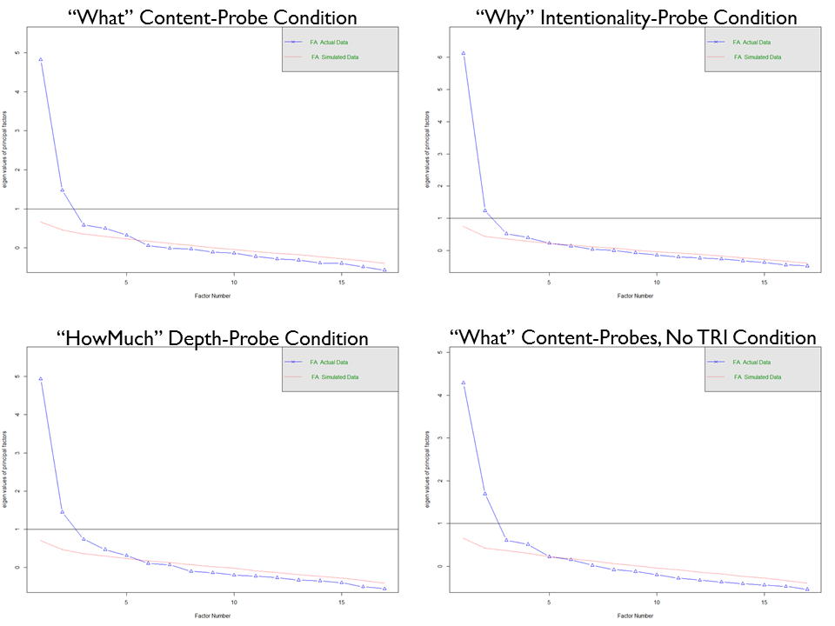

Supplemental Table 4. Factor loadings from exploratory factor analyses (promax rotation) of the questionnaire battery, by probe-type condition.
 | “What” Probes | “What” Probes | “Why” Probes | “Why” Probes | “How Much” Probes | “How Much” Probes | “What” Probes (no TRI) | “What Probes (no TRI)
Measure | Factor 1 | Factor 2 | Factor 1 | Factor 2 | Factor 1 | Factor 2 | Factor 1 | Factor 2
ADHD-Hyperactive |  | .323 |  | .530 | .223 | .316 | .533
ADHD-Inattentive |  | .603 |  | .766 |  | .566 | .761
CreativeAchieve | .235 |  | .221 |  | .330 |  |  | .323
CFQ-MAL | .301 | .501 | .269 | .586 | .377 | .376 | .658
Conscientiousness |  | −.780 |  | −.699 |  | −.781 | −.630
Fidget-SAQ | .289 | .297 | .294 | .459 | .330 | .261 | .437
IPI-Boredom |  | .718 |  | .716 |  | .650 | .730 | −.258
IPI-Daydream | .745 | .212 | .801 |  | .812 |  | .293 | .689
IPI-MentationRate | .550 | −.221 | .607 |  | .668 |  |  | .468
IPI-MindWandering | .377 | .530 | .352 | .514 | .480 | .459 | .637 | .217
IPI-ProblemSolving | .601 |  | .791 |  | .653 | −.280 |  | .635
MW-Deliberate | .577 |  | .723 |  | .666 |  |  | .609
MW-Spontaneous | .658 | .329 | .621 | .369 | .672 | .248 | .548 | .443
Openness | .522 |  | .585 |  | .573 |  |  | .645
Metacog Prospective | .562 | −.447 | .508 |  | .518 | −.456 | −.234 | .385
Schiz-MagicIdeation | .334 |  | .354 |  | .339 |  |  | .237
WhiteBear Suppress | .621 |  | .519 | .324 | .544 |  | .353 | .267

Note. Factor loadings ≥.200 shown; factor loadings ≥.500 bolded. CreativeAchieve = Creative Achievement Questionnaire; CFQ–MAL = Cognitive Failures Questionnaire–Memory and Attention Lapses; Fidget–SAQ = Spontaneous Activity Questionnaire; IPI = Imaginal Process Inventory; MW = Mind Wandering; Metacog Prospective = Metacognitive Prospective Memory Battery; Schiz–MagicIdeation = Schizotypy–Magical Ideation Scale; WhiteBear Suppress = White Bear Suppression Inventory.

Supplemental Table 5. Test for measurement invariance in questionnaire measures with multigroup confirmatory factor analysis.
Models | Df | AIC | BIC | χ² | χ² diff | Df diff | p
Configural Model | 408 | 21301 | 22243 | 1843.8
Constrain Loadings | 453 | 21274 | 22005 | 1907.5 | 63.69 | 45 | 0.035
Constrain Intercepts | 495 | 21241 | 21773 | 1957.8 | 50.32 | 42 | 0.177
Constrain Means | 501 | 21234 | 21738 | 1963.0 | 5.22 | 6 | 0.516

