Supplementary materials 1 - Mood differences between conditions
Mood scale reliability
McDonald’s Omega (ω) was calculated as a metric of reliability using multilevel confirmatory factor analysis (Geldhof, Preacher, & Zyphur, 2014). The scales all had acceptable levels of reliability - calmness (ω_{within} = .85, ω_{between} = .77), valence (ω_{within} = .88, ω_{between} = .78), and energetic arousal (ω_{within} = .91, ω_{between} = .67).
Mood effects Task 1
Differences in calmness, energetic arousal and valence were evaluated using repeated measures ANCOVAs. For all mood scales, the mouse versus throttle condition variable was the within-person factor, the condition (order) variable was used as a between person variable, and the baseline mood ratings were used as a covariate.
For calmness, participants in the throttle condition (M = 4.24, SD = 1.10) reported greater calmness compared to the mouse condition (M = 3.78, SD = 1.20), F(1,57) = 5.34, p = .02. There was no significant effect of order of task, F(1,57) = 0.24, p = 0.63, nor was there a significant interaction between condition and order, F(1,57) = 0.02, p = .89. Participants that reported lower calmness before the task also reported lower calmness after the tasks, F(1,57) = 19.91, p < .001.
For energetic arousal, participants in the throttle condition (M = 4.62, SD = 1.13) reported similar arousal compared to the mouse condition (M = 3.88, SD = 1.28), F(1,57) = 0.005, p = .94. There was no significant effect of order of task, F(1,57) = 0.14, p = 0.71, nor was there a significant interaction between condition and order, F(1,57) = 0.97, p = .33. Participants that reported lower arousal before the task also reported lower arousal after the tasks, F(1,57) = 80.01, p <.001.
For valence, participants in the throttle condition (M = 4.28, SD = 1.13) reported similar valence compared to the mouse condition (M = 4.07, SD = 1.27), F(1,57) = 0.62, p = .43. There was no significant effect of order of task, F(1,57) = 2.11, p = 0.15, nor was there a significant interaction between condition and order, F(1,57) = 1.71, p = .20. Participants that reported more positive valence before the task also reported more positive valence after the tasks, F(1,57) = 19.33, p <.001.
Mood effects Task 2
Differences in mood (calmness, energetic arousal and valence) were evaluated using between-participant ANOVAs. For all mood scales, the condition variable was the fixed factor, and the baseline mood ratings (mood following previous task) were used as a covariates.
For calmness, participants in the one throttle condition (M = 5.03, SD = 0.87) reported similar levels of calmness compared to the two throttle condition (M = 4.83, SD = 1.30), and the mouse condition (M = 4.43, SD = 1.21), F(2,56) = 2.73, p = .07. Participants that reported lower calmness before the task, also reported lower calmness after the tasks, F(1,56) = 23.40, p < .001.
For arousal, participants in the one throttle condition (M = 4.78, SD = 1.07) reported similar arousal compared to, the two throttle condition (M = 4.53, SD = 1.24), and the mouse condition (M = 4.15, SD = 1.24), F(2,56) = 0.68, p = .38. Participants that reported lower arousal before the task, also reported lower arousal after the tasks, F(1,56) = 60.97, p <.001.
For valence, significant differences were observed between participants in the one throttle condition (M = 5.23, SD = 0.88), two throttle condition (M = 5.05, SD = 1.10), and the mouse condition (M = 4.55, SD = 1.30), F(2,56) = 3.63, p = .03. Participants that reported more positive valence before the task also reported more positive valence post the tasks, F(1,56) = 20.08, p <.001.
Mood effects Task 3
Differences in mood (calmness, energetic arousal and valence) were evaluated using between-subject ANOVAs. For all mood scales, the condition variable was the fixed factor, and the baseline mood ratings (mood following previous task) were used as a covariate.
For calmness, participants in the one throttle condition (M = 3.28, SD = 1.37) reported similar levels of calmness compared to the two throttle condition (M = 3.47, SD = 0.95), F(1,57) = 0.23, p = .63. Participants that reported lower calmness before the task also reported lower calmness post the tasks, F(1,57) = 11.66, p < .001.
For arousal, participants in the one throttle condition (M = 4.45, SD = 1.27) reported similar arousal compared to the two throttle condition (M = 4.48, SD = 1.29), F(1,57) = 0.23, p = .64. Participants that reported lower arousal before the task also reported lower arousal post the tasks, F(1,56) = 37.79, p <.001.
For valence, participants in the one throttle condition (M = 3.85, SD = 1.32) reported similar valence compared to the two throttle condition (M = 4.05, SD = 1.28), F(1,57) = 0.11, p = .74. Participants that reported more positive valence before the task also reported more positive valence post the tasks, F(1,56) = 9.66, p = .003.

Supplementary materials 2 – Normality tests and plots for all tasks
Task 1
Condition | Shapiro-Wilk p-value
Mouse first | .11
Mouse second | .03
Throttle first | .002
Throttle second | .30

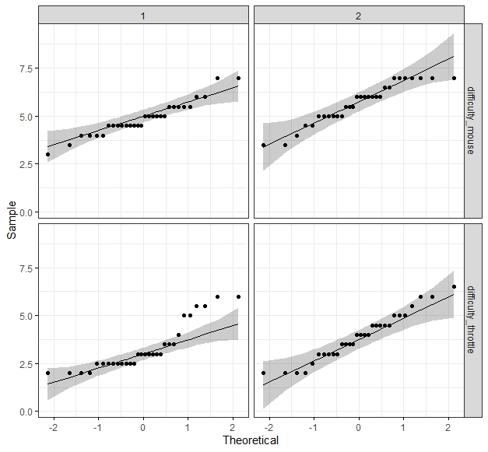

Task 1 – independence between dimensions SDs
Condition | Shapiro-Wilk p-value
Mouse | 3.92E-07
2 throttles | 3.23E-15

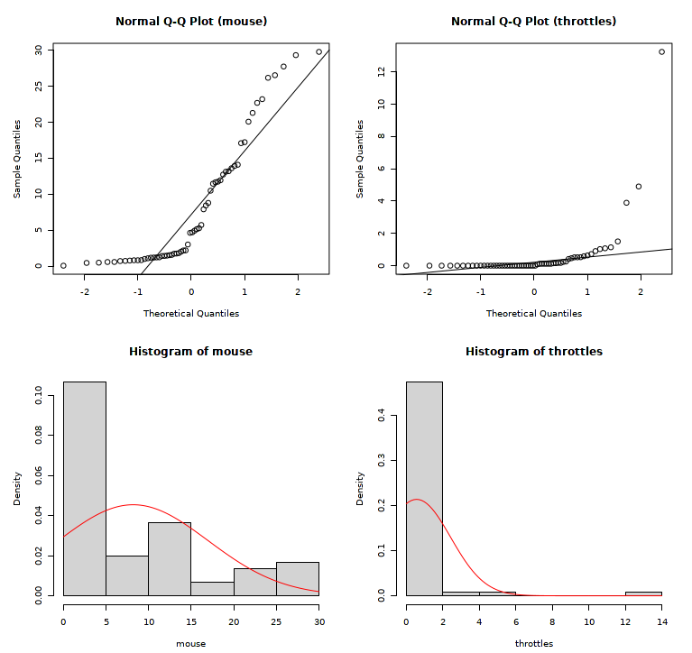

Task 2

Condition | Shapiro-Wilk p-value
Mouse | .44
1 throttle | .02
2 throttles | .41

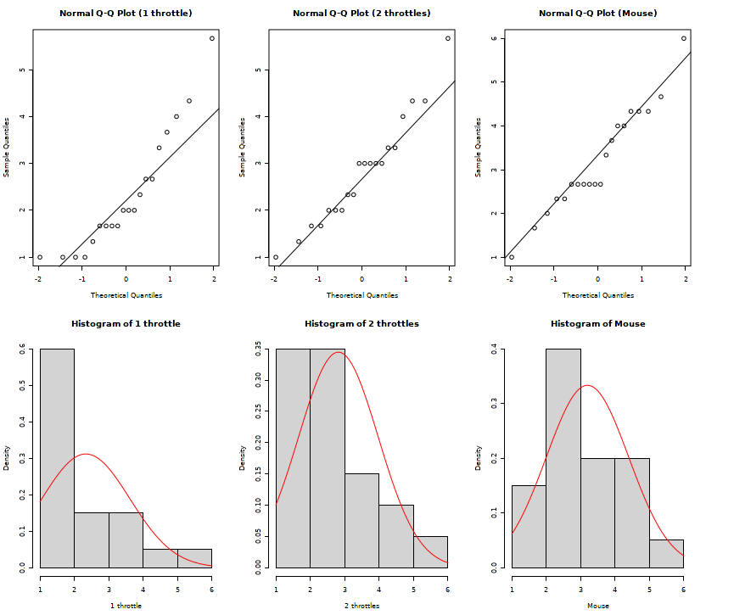

Task 3
Difficulty
Condition | Shapiro-Wilk p-value
1 throttle | .007
2 throttles | .04

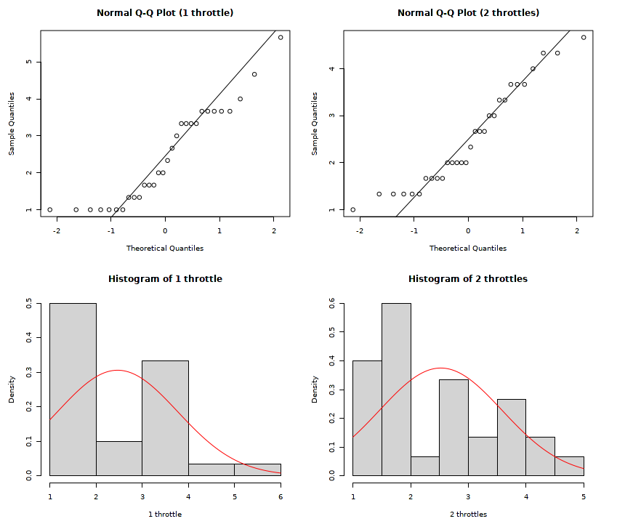

Tiredness

Condition | Shapiro-Wilk p-value
1 throttle | .002
2 throttles | .002

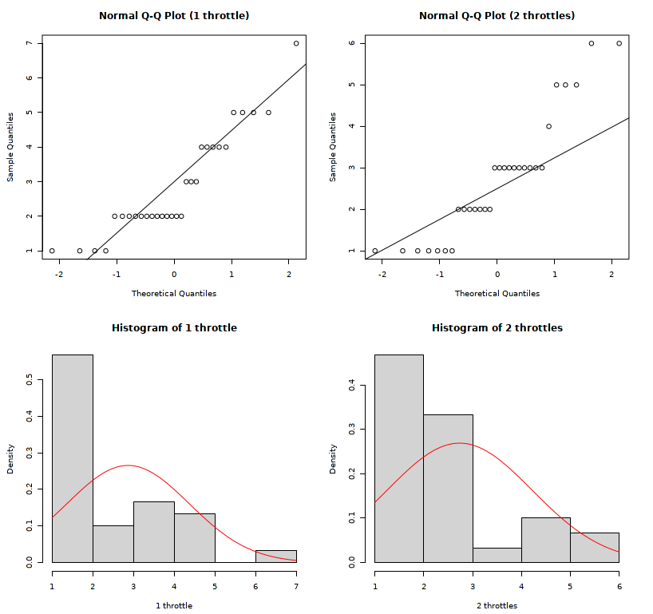

Supplementary materials 3 - Task 3 robust percentage bend correlations
Table S1.
Robust percentage bend correlations between post, mean, peak and end confusion.
 | Post Confusion |  | Mean Confusion |  | Peak Confusion |  | End Confusion
Post Confusion |  |  | .72*** |  | .73*** |  | .69***
Mean Confusion | .64** |  |  |  | .69*** |  | .84***
Peak Confusion | .70*** |  | .83*** |  |  |  | .69***
End Confusion | .86*** |  | .77*** |  | .74***
Note: * p <.05; ** p <.01; *** p<.001; One throttle condition correlations are displayed above the diagonal; Two throttle condition correlations are displayed below the diagonal; Correlations between all variables and post-hoc confusion ratings are based on 19 participants above the diagonal and 20 participants below the diagonal due to missing data. All other correlations are based on 30 participants.
Table S2.
Robust percentage bend correlations between post, mean, peak and end interest.
Variable |  | Mean interest |  | Peak interest |  | End interest
Post interest |  | .40 |  | .37 |  | .49*
Mean interest |  |  |  | .70*** |  | .72***
Peak interest |  |  |  |  |  | .48**
Note: * p <.05; ** p <.01; *** p<.001; Correlations between post-hoc interest ratings and all other variables are based on n = 20 due to missing data. All other correlations are based on n = 30.

Table S3.
Robust percentage bend correlations between post joy, sadness and being moved and sadness and joy.
Variables | Sadness |  |  |  | Joy
Variables | Mean | Peak | End |  | Mean | Peak | End
Post sadness | .53*** | .47** | .16 |  | .21 | .37* | .41**
Post joy | .27 | .18 | .18 |  | .42** | .47** | .57***
Post moved | .34** | .33** | .10 |  | .22 | .43*** | .42***
Note: * p <.05; ** p <.01; *** p<.001; Correlations between post sadness and joy are based on 39 people. All other correlations are based on 60 people.

