Supplemental Online Materials for

“The Emotion-to-Music Mapping Atlas (EMMA): A Systematically Organized Online Database of Emotionally Evocative Music Excerpts”

Table S1
Descriptive Statistics for Socio-Demographic Data for the Total Sample and Across Language Versions
 | Total |  |  | English |  |  | German
 | n | % |  | n | % |  | n | %
Assessment language
English | 306 | 54.0
German | 258 | 45.5
NA | 3 | 0.5
Skills in assessment language
Beginner | 5 | 0.9 |  | 1 | 0.3 |  | 4 | 1.6
Intermediate | 10 | 1.8 |  | 9 | 2.9 |  | 1 | 0.4
Advanced | 37 | 6.5 |  | 28 | 9.2 |  | 9 | 3.5
Mother tongue | 512 | 90.3 |  | 268 | 87.6 |  | 224 | 94.6
NA | 3 | 0.5
Sex
Male | 243 | 42.9 |  | 143 | 46.7 |  | 100 | 38.8
Female | 316 | 55.7 |  | 159 | 52.0 |  | 157 | 60.9
Other | 5 | 0.9 |  | 4 | 1.3 |  | 1 | 0.4
NA | 3 | 0.5
Nationality
Australia | 10 | 1.8 |  | 10 | 3.3 |  | 0 | 0.0
Austria | 47 | 8.3 |  | 1 | 0.3 |  | 46 | 17.8
Canada | 9 | 1.6 |  | 9 | 2.9 |  | 0 | 0.0
Germany | 180 | 31.7 |  | 1 | 0.3 |  | 179 | 69.4
Greece | 2 | 0.4 |  | 2 | 0.7 |  | 0 | 0.0
Italy | 25 | 4.4 |  | 2 | 0.7 |  | 23 | 8.9
Latvia | 2 | 0.4 |  | 1 | 0.3 |  | 1 | 0.4
Malysia | 3 | 0.5 |  | 3 | 1.0 |  | 0 | 0.0
New Zealand | 3 | 0.5 |  | 3 | 1.0 |  | 0 | 0.0
South Africa | 13 | 2.3 |  | 13 | 4.2 |  | 0 | 0.0
United Kingdom or Republic of Ireland | 121 | 21.3 |  | 119 | 38.9 |  | 2 | 0.8
United States of America | 116 | 20.5 |  | 116 | 37.9 |  | 0 | 0.0
Zimbabwe | 2 | 0.4 |  | 2 | 0.7 |  | 0 | 0.0
More than one nationality | 3 | 0.5 |  | 3 | 1.0 |  | 0 | 0.0
Not a nationality | 11 | 1.9 |  | 10 | 3.3 |  | 1 | 0.4
NA | 20 | 3.5 |  | 11 | 3.6 |  | 6 | 2.3
Current or former student
Yes | 458 | 80.8 |  | 222 | 72.5 |  | 236 | 91.5
No | 106 | 18.7 |  | 84 | 27.5 |  | 22 | 8.5
NA | 3 | 0.5
Highest level of education
Compulsory school without vocational training | 15 | 2.6 |  | 10 | 3.3 |  | 5 | 1.9
Compulsory school with vocational training | 13 | 2.3 |  | 9 | 2.9 |  | 4 | 1.6
Vocational school with A-levels/high-school diploma | 59 | 10.4 |  | 41 | 13.4 |  | 18 | 7.0
Academic High School/Grammar School | 180 | 31.7 |  | 40 | 13.1 |  | 140 | 54.3
University/College | 295 | 52.0 |  | 206 | 67.3 |  | 89 | 34.5
NA | 5 | 0.9 |  |  |  |  | 2 | 0.8
Currently or formerly employed
Yes | 405 | 71.4 |  | 263 | 85.9 |  | 142 | 55.0
No | 159 | 28.0 |  | 43 | 14.1 |  | 116 | 45.0
NA | 3 | 0.5

Figure S1
Frequency Distribution of Raters Across Music Excerpts
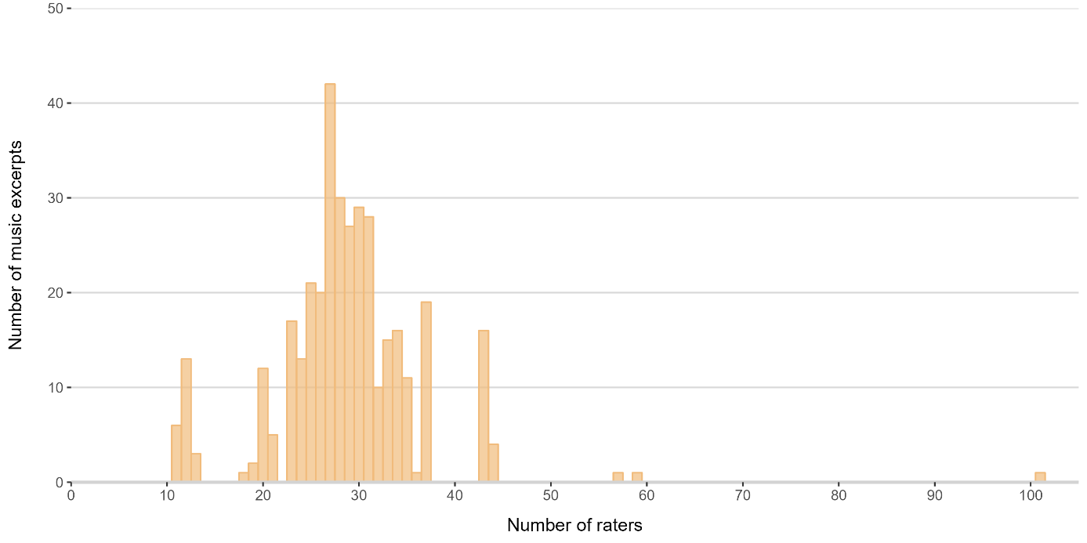
Note. A total of three songs had more than 50 raters as they were accidentally delivered multiple times instead of once.

Table S2
Top and Bottom 5% - Songs With Highest and Lowest Average Inter-Item Correlations (Dimension Level) across Genres
Code | Genre | n | ICC | Average interrater correlation | Title |  | Artist | SUB | VIT | UNE | Familiarity  M (SD) | Liking  M (SD)
All songs |  | 28.76 | .80 | .20 |  |  |  | 12.04 | 15.99 | 5.56 | 2.33 (1.15) | 3.13 (1.20)
Top 5% |  | 29.06 | .94 | .43 |  |  |  | 13.93 | 18.77 | 4.06 | 2.64 (1.00) | 3.36 (1.11)
K096 | C | 23 | .93 | .48 | Preludes op. 32 no. 5 |  | Sergei Rachmaninoff | 21.61 | 3.56 | 1.33 | 1.09 (0.42) | 3.26 (1.29)
H903 | H | 43 | .96 | .47 | Sad octopus |  | Claptu feat. Clows | 18.67 | 1.74 | 1.84 | 1.23 (0.61) | 3.30 (1.19)
K085 | C | 26 | .96 | .47 | Symphony No. 8 (Finale) |  | Anton Bruckner | 7.30 | 29.67 | 7.12 | 1.46 (0.65) | 3.42 (1.21)
P101 | P | 26 | .96 | .47 | Ex's & Oh's |  | Elle King | 11.23 | 41.09 | 2.90 | 3.81 (1.47) | 3.88 (0.86)
K103 | C | 33 | .95 | .44 | Quartet, Op. 3 |  | Alban Berg | 11.01 | 33.30 | 1.91 | 1.30 (0.85) | 1.85 (1.06)
K107 | C | 31 | .95 | .44 | O Fortuna (Carmina Burana) |  | Carl Orff | 5.62 | 5.57 | 17.95 | 3.65 (1.38) | 3.61 (1.20)
P053 | P | 44 | .97 | .44 | Happy |  | Pharrell Williams | 11.31 | 37.07 | 3.94 | 4.50 (1.05) | 3.73 (1.17)
H902 | H | 29 | .96 | .43 | Aurora |  | Brillion | 21.86 | 2.64 | 1.77 | 1.48 (0.95) | 3.41 (0.87)
H904 | H | 25 | .94 | .43 | Aper |  | Claptu feat. Beatmund Noise | 25.94 | 4.84 | 2.25 | 1.04 (0.20) | 3.36 (1.32)
K019 | C | 28 | .95 | .43 | Bénédiction de Dieu Dans la Solitude |  | Franz Liszt | 7.64 | 26.98 | 1.60 | 1.43 (1.00) | 3.61 (1.20)
P042 | P | 28 | .94 | .43 | Fluorescent Adolescent |  | Arctic Monkeys | 20.26 | 2.08 | 3.03 | 3.07 (1.74) | 3.96 (1.23)
P050 | P | 31 | .95 | .43 | I Wish |  | Stevie Wonder | 12.64 | 26.58 | 1.71 | 2.29 (1.42) | 3.39 (1.05)
P003 | P | 12 | .89 | .42 | Heartbeats |  | Jose Gonzales | 9.38 | 36.00 | 2.81 | 2.58 (1.44) | 4.33 (0.78)
P054 | P | 44 | .97 | .42 | Wannabe |  | Spice Girls | 27.49 | 2.90 | 3.11 | 4.41 (1.04) | 3.84 (0.99)
H905 | H | 23 | .92 | .41 | Panther |  | DECAP | 10.29 | 39.94 | 3.29 | 1.00 (0.00) | 1.74 (1.10)
P085 | P | 20 | .90 | .41 | Lush Life |  | Zara Larsson | 20.22 | 3.96 | 2.20 | 2.90 (1.65) | 2.75 (1.16)
P092 | P | 34 | .96 | .41 | I Want It That Way |  | Backstreet Boys | 9.95 | 23.52 | 0.98 | 4.53 (0.93) | 3.65 (1.20)
P136 | P | 31 | .96 | .41 | Uptown Funk |  | Mark Ronson | 4.19 | 11.81 | 15.70 | 4.29 (1.13) | 3.45 (1.41)
P086 | P | 21 | .92 | .40 | Everybody |  | Backstreet Boys | 8.12 | 23.31 | 1.78 | 4.10 (1.04) | 3.29 (0.85)
Bottom 5% |  | 22.53 | 0.31 | .03 |  |  |  | 11.92 | 11.40 | 7.09 | 2.19 (1.17) | 2.94 (1.25)
K005 | C | 12 | .34 | .05 | Piano Sonata BB 88 (Sz. 80) |  | Béla Bartók | 11.79 | 14.41 | 6.73 | 2.08 (1.31) | 2.75 (1.22)
K112 | C | 29 | .64 | .05 | Brandenburg Concertos |  | J. Sebastian Bach | 11.94 | 18.21 | 5.46 | 1.66 (1.23) | 2.76 (1.48)
K001 | C | 13 | .43 | .04 | A Midsummer Night's Dream |  | Felix Mendelssohn | 10.91 | 14.56 | 0.94 | 2.08 (1.19) | 3.46 (0.88)
K007 | C | 11 | .42 | .04 | Prince Igor (Chorus) |  | Alexander Borodin | 16.47 | 10.97 | 2.48 | 2.09 (1.38) | 3.00 (1.26)
K093 | C | 20 | .59 | .04 | The Four Seasons (Spring) |  | Antonio Vivaldi | 11.57 | 17.71 | 4.13 | 3.40 (1.35) | 2.80 (1.32)
P047 | P | 27 | .59 | .04 | Redbone |  | Childish Gambino | 12.08 | 10.91 | 5.78 | 2.67 (1.64) | 3.11 (1.34)
P083 | P | 23 | .51 | .04 | The Village |  | Wrabel | 17.24 | 8.79 | 10.24 | 2.04 (1.40) | 3.43 (1.24)
K045 | C | 27 | .19 | .03 | Piano Sonata No. 3 |  | Johannes Brahms | 11.00 | 16.19 | 9.29 | 1.96 (1.40) | 3.22 (1.12)
K046 | C | 31 | .40 | .03 | Messiah (Hallelujah) |  | Georg F. Händel | 9.92 | 13.43 | 6.87 | 1.94 (1.29) | 2.81 (1.40)
P008 | P | 35 | .57 | .03 | Your Song |  | Elton John | 16.73 | 14.12 | 9.32 | 4.29 (1.02) | 4.09 (0.92)
P119 | P | 25 | .36 | .03 | I Am I Said |  | Neil Diamond | 7.29 | 7.98 | 2.46 | 1.72 (1.17) | 2.52 (0.96)
P088 | P | 21 | .44 | .02 | Hide and Seek |  | Imogen Heap | 9.81 | 3.46 | 11.26 | 2.05 (1.60) | 2.71 (1.35)
P100 | P | 33 | .45 | .02 | Halo |  | Beyonce | 14.46 | 18.60 | 8.12 | 4.09 (1.01) | 3.36 (1.32)
H008 | H | 34 | .17 | .01 | Laura |  | Prinz Pi | 6.31 | 5.80 | 11.55 | 1.24 (0.70) | 2.18 (1.11)
H048 | H | 25 | .07 | .01 | Leaving the past |  | Immortal Technique | 8.92 | 9.19 | 11.98 | 1.00 (0.00) | 2.64 (1.41)
H077 | H | 32 | -.13 | .01 | Too Much |  | Drake | 11.50 | 11.62 | 6.34 | 1.50 (0.84) | 2.84 (1.25)
K008 | C | 12 | .01 | .01 | Gremin's Aria (Onegin) |  | Pyotr I. Tchaikovsky | 13.83 | 7.41 | 4.98 | 2.33 (1.67) | 2.92 (1.62)
K082 | C | 26 | .13 | .01 | Var det en dröm? |  | Jean Sibelius | 13.21 | 6.16 | 12.39 | 1.23 (0.71) | 2.58 (1.21)
K009 | C | 11 | -.25 | .00 | Kol Nidrei, Op. 47 |  | Max Bruch | 11.51 | 7.07 | 4.34 | 2.18 (1.33) | 2.73 (1.35)
Note. n = number of raters per excerpt; SUB = Sublimity; VIT = Vitality; UNE = Unease; C = Classical; H = Hip-hop/Rap; P = Pop.

Figure S2
Mean Frequencies of Percent of Participants Who Selected Different Emotion Terms for a Given Musical Excerpt (Bars) and Mean Intensities of the Different Emotion Terms Across Musical Excerpts (line)
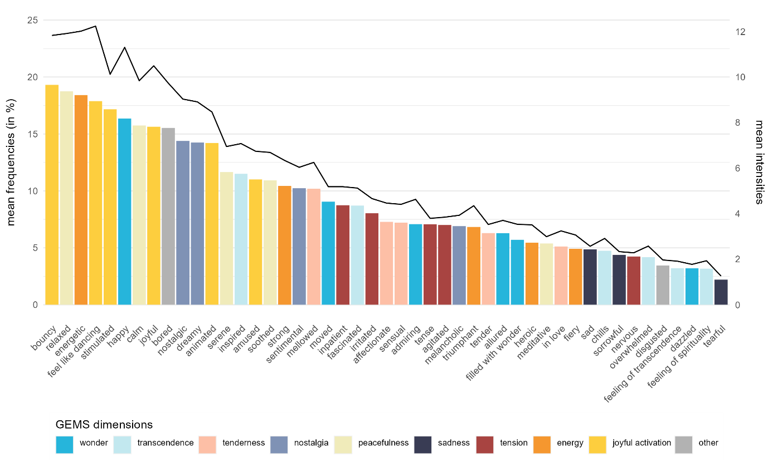

Table S3
Descriptive Summary of the Intensities of the GEMS Dimensions and Their Factor Means
 | M | SD | Mdn | Min | Max
Sublimity | 12.04 | 5.91 | 11.32 | 2.09 | 29.51
Wonder | 13.22 | 6.06 | 13.14 | 0.00 | 37.21
Transcendence | 9.44 | 5.33 | 8.55 | 0.00 | 26.42
Tenderness | 9.42 | 7.69 | 7.56 | 0.00 | 34.97
Nostalgia | 13.10 | 9.13 | 12.40 | 0.00 | 40.71
Peacefulness | 15.01 | 10.18 | 13.20 | 0.00 | 48.16
Vitality | 15.99 | 8.86 | 15.43 | 0.78 | 41.09
Energy | 12.21 | 8.92 | 10.51 | 0.00 | 47.34
Joyful activation | 19.76 | 10.58 | 18.61 | 0.00 | 51.04
Unease | 5.67 | 3.68 | 4.78 | 0.00 | 20.04
Sadness | 3.21 | 4.88 | 1.39 | 0.00 | 29.94
Tension | 8.13 | 6.73 | 6.22 | 0.00 | 34.79
Note. Values are based on all 364 songs.

Table S4
Inter-Correlations and Internal Consistencies for GEMS Dimension and Factor Mean Intensities Across All Music Excerpts
 | 1 | 2 | 3 | 4 | 5 | 6 | 7 | 8 | 9 | 10 | 11 | 12
(1) Wonder | (.54)
(2) Transcendence | .42** | (.57)
(3) Tenderness | .37** | .30** | (.60)
(4) Nostalgia | .47** | .27** | .69** | (.54)
(5) Peacefulness | .26** | .28** | .78** | .62** | (.65)
(6) Energy | .12* | .08 | -.51** | -.36** | -.56** | (.67)
(7) Joyful activation | .27** | -.21** | -.39** | -.20** | -.41** | .65** | (.72)
(8) Sadness | .16** | .26** | .40** | .54** | .30** | -.36** | -.46** | (.63)
(9) Tension | -.38** | -.02 | -.55** | -.58** | -.54** | .24** | -.06 | -.23** | (.64)
(10) Sublimity | .61** | .53** | .87** | .85** | .84** | -.40** | -.29** | .46** | -.59** | (.79)
(11) Vitality | .22** | -.09 | -.49** | -.30** | -.53** | .89** | .92** | -.45** | .08 | -.37** | (.77)
(12) Unease | -.24** | .15** | -.24** | -.17** | -.29** | -.02 | -.36** | .46** | .76** | -.24** | -.22** | (.64)
Note. N = 364; Values in parentheses indicate McDonald’s ω.
* p < .05. ** p < .01.

Genre Differences in Mean Intensities of Emotions Experienced
The strongest differences were found for Transcendence and Nostalgia, with F(2,361) = 92.66 and F(2,361) = 49.71 (all ps < .001) respectively. Mean intensities of Transcendence were significantly higher in classical music (M = 14.29, SD = 4.48) compared to hip-hop/rap (M = 7.13, SD = 4.18) and pop (M = 7.76, SD = 4.39). For Nostalgia, all three genres were found to have significant mean differences, with the highest intensities in pop (M = 17.38, SD = 8.85), followed by classical music (M = 13.97, SD = 8.69) and hip-hop/rap (M = 7.39, SD = 6.54). It is also notable that feelings of tension were significantly less pronounced in pop (M = 4.69, SD = 3.22), compared to hip-hop/rap (M = 11.30, SD = 6.51) and classical music (M = 9.06, SD = 8.21). Out of all nine dimensions, Tension actually proved to be most strongly associated with the average liking of the respective songs (r = -.61, p < .001). Yet, significant mean differences in Tension between pop and the other two genres even held up when controlling for average liking in a one-way ANCOVA, with F(2, 360) = 9.68 (p < .001).

Table S5
Means, Standard Deviations and ANOVA results with Tukey Post-Hoc-Test for Overall Dimension and Factor Intensities Across All Music Excerpts by Genre
 | Classical music |  |  | Hip-hop/Rap |  |  | Pop |  |  | Mean Differences
 | M | SD |  | M | SD |  | M | SD |  | C-H | P-H | P-C |  | F(2,361)
Sublimity | 14.60 | 5.90 |  | 7.95 | 4.67 |  | 13.63 | 4.97 |  | 6.65** | 5.69** | -0.97 |  | 57.25**
Wonder | 14.97 | 4.27 |  | 9.29 | 5.09 |  | 15.30 | 6.35 |  | 5.68** | 6.01** | 0.34 |  | 47.52**
Transcendence | 14.29 | 4.48 |  | 7.13 | 4.18 |  | 7.76 | 4.39 |  | 7.16** | 0.63 | -6.53** |  | 92.66**
Tenderness | 11.05 | 8.03 |  | 5.11 | 5.65 |  | 11.91 | 7.40 |  | 5.94** | 6.81** | 0.86⁺ |  | 33.72**
Nostalgia | 13.97 | 8.69 |  | 7.39 | 6.54 |  | 17.38 | 8.85 |  | 6.57** | 9.99** | 3.42** |  | 49.71**
Peacefulness | 18.74 | 12.38 |  | 10.82 | 9.51 |  | 15.81 | 7.25 |  | 7.92** | 4.99** | -2.93⁺ |  | 19.44**
Vitality | 13.84 | 8.97 |  | 16.52 | 7.89 |  | 17.15 | 9.33 |  | -2.69⁺ | 0.63 | 3.32* |  | 4.60*
Joyful activation | 12.32 | 10.48 |  | 13.25 | 8.44 |  | 11.23 | 7.94 |  | -0.94 | -2.02 | -1.08 |  | 1.67
Energy | 15.36 | 9.09 |  | 19.79 | 8.85 |  | 23.07 | 11.79 |  | -4.43** | 3.28* | 7.71** |  | 17.31**
Unease | 6.35 | 4.30 |  | 6.53 | 3.51 |  | 4.42 | 2.92 |  | -0.18 | -2.11** | -1.93** |  | 14.05**
Sadness | 3.64 | 4.62 |  | 1.76 | 3.29 |  | 4.14 | 5.87 |  | 1.88* | 2.39** | 0.50 |  | 8.59**
Tension | 9.06 | 8.21 |  | 11.30 | 6.51 |  | 4.69 | 3.22 |  | -2.25* | -6.61** | -4.37** |  | 39.39**
Note. N = 364.
⁺ p < .10. * p < .05. ** p < .01.

Order of Songs and Emotions Experienced
In summary, we detected only very weak correlations, of which few were significant. For example, in descending order of effect size, negative correlations were found between performance order and the GEMS items bouncy (r = -.04, p < .001), mellowed (r = -.03, p = .002), relaxed (r = -.03, p = .002), joyful (r = -.03, p = .004), feel like dancing (r = -.03, p = .005) and soothed (r = -.03, p = .006), indicating that these items were selected less often when a piece was presented later. At the dimension and factor level, we found negative correlations between performance order and Vitality (r = -.03, p < .001) and Peacefulness (r = -.02, p = .013). The only significant positive correlation appeared with the items bored (r = .04, p < .001) and melancholic (r = .02, p = .018). These items were thus slightly more likely to be felt when a piece was presented later. However, since all correlations were very weak, the order does not seem to matter too much, at least when 10-12 pieces of music are presented.

