Appendix A
The Items Used in the Online and Paper-and-Pencil Tests
ID | Gradeª | Kanji | Samples^{b} |  | ID | Gradeª | Kanji | Samples^{b} |  | ID | Gradeª | Kanji | Samples^{b}
001 | 1 | 一 | 139 |  | 041 | 3 | 面 | 62 |  | 081 | 5 | 支 | 62
002 | 1 | 川 | 131 |  | 042 | 3 | 動 | 62 |  | 082 | 5 | 賀 | 58
003 | 1 | 口 | 123 |  | 043 | 3 | 丁 | 65 |  | 083 | 5 | 罪 | 58
004 | 1 | 山 | 115 |  | 044 | 3 | 係 | 61 |  | 084 | 5 | 豊 | 55
005 | 1 | 女 | 112 |  | 045 | 3 | 使 | 59 |  | 085 | 5 | 述 | 60
006 | 1 | 水 | 108 |  | 046 | 3 | 表 | 58 |  | 086 | 5 | 能 | 59
007 | 1 | 花 | 99 |  | 047 | 3 | 集 | 53 |  | 087 | 5 | 格 | 60
008 | 1 | 子 | 97 |  | 048 | 3 | 秒 | 56 |  | 088 | 5 | 雑 | 58
009 | 1 | 大 | 94 |  | 049 | 3 | 定 | 62 |  | 089 | 5 | 移 | 61
010 | 1 | 月 | 88 |  | 050 | 3 | 取 | 49 |  | 090 | 5 | 責 | 60
011 | 1 | 赤 | 85 |  | 051 | 3 | 暗 | 60 |  | 091 | 5 | 演 | 73
012 | 1 | 草 | 78 |  | 052 | 3 | 暑 | 60 |  | 092 | 5 | 刊 | 76
013 | 1 | 正 | 77 |  | 053 | 3 | 筆 | 48 |  | 093 | 5 | 示 | 74
014 | 1 | 校 | 72 |  | 054 | 3 | 飲 | 64 |  | 094 | 5 | 久 | 72
015 | 1 | 足 | 69 |  | 055 | 3 | 代 | 62 |  | 095 | 5 | 解 | 60
016 | 1 | 村 | 64 |  | 056 | 3 | 打 | 63 |  | 096 | 5 | 確 | 63
017 | 1 | 百 | 69 |  | 057 | 3 | 緑 | 58 |  | 097 | 5 | 構 | 64
018 | 1 | 先 | 67 |  | 058 | 3 | 根 | 60 |  | 098 | 5 | 寄 | 65
019 | 1 | 虫 | 64 |  | 059 | 3 | 等 | 64 |  | 099 | 5 | 衛 | 63
020 | 1 | 入 | 67 |  | 060 | 3 | 港 | 63 |  | 100 | 5 | 制 | 64
021 | 2 | 広 | 65 |  | 061 | 4 | 争 | 27 |  | 101 | 6 | 宝 | 36
022 | 2 | 書 | 57 |  | 062 | 4 | 夫 | 32 |  | 102 | 6 | 呼 | 37
023 | 2 | 外 | 59 |  | 063 | 4 | 不 | 29 |  | 103 | 6 | 骨 | 33
024 | 2 | 答 | 61 |  | 064 | 4 | 冷 | 28 |  | 104 | 6 | 難 | 31
025 | 2 | 少 | 60 |  | 065 | 4 | 変 | 28 |  | 105 | 6 | 優 | 28
026 | 2 | 行 | 143 |  | 066 | 4 | 億 | 24 |  | 106 | 6 | 聖 | 26
027 | 2 | 家 | 54 |  | 067 | 4 | 束 | 28 |  | 107 | 6 | 乱 | 35
028 | 2 | 台 | 59 |  | 068 | 4 | 機 | 27 |  | 108 | 6 | 痛 | 32
029 | 2 | 作 | 58 |  | 069 | 4 | 梅 | 27 |  | 109 | 6 | 蚕 | 38
030 | 2 | 雲 | 50 |  | 070 | 4 | 健 | 26 |  | 110 | 6 | 郷 | 35
031 | 2 | 紙 | 79 |  | 071 | 4 | 隊 | 55 |  | 111 | 6 | 宣 | 36
032 | 2 | 晴 | 74 |  | 072 | 4 | 良 | 57 |  | 112 | 6 | 傷 | 35
033 | 2 | 東 | 85 |  | 073 | 4 | 候 | 57 |  | 113 | 6 | 臨 | 33
034 | 2 | 元 | 61 |  | 074 | 4 | 昨 | 60 |  | 114 | 6 | 視 | 38
035 | 2 | 行 | 143 |  | 075 | 4 | 借 | 57 |  | 115 | 6 | 律 | 35
036 | 2 | 通 | 61 |  | 076 | 4 | 望 | 60 |  | 116 | 6 | 看 | 30
037 | 2 | 黄 | 70 |  | 077 | 4 | 挙 | 61 |  | 117 | 6 | 頂 | 34
038 | 2 | 矢 | 83 |  | 078 | 4 | 票 | 59 |  | 118 | 6 | 厳 | 27
039 | 2 | 頭 | 76 |  | 079 | 4 | 腸 | 53 |  | 119 | 6 | 陛 | 36
040 | 2 | 合 | 85 |  | 080 | 4 | 刷 | 56 |  | 120 | 6 | 供 | 35
Note. ª “Grade” indicates the grade in which children learn the character according to the national curriculum (Ministry of Education, Culture, Sports, Science and Technology, 2017). ^{b} “Samples” indicate the number of handwriting samples collected using OAHaS.

Appendix B
Example Images of Characters with Orthographic Errors (Dataset 2)
ID | Kanji | Grade | N | Example Image
017-NG1 | 百 | 1 | 69 | 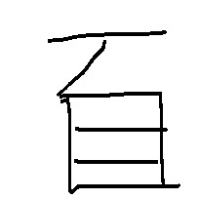
025-NG1 | 少 | 2 | 60 | 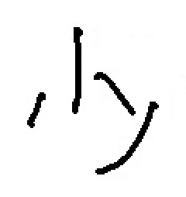
037-NG1 | 黄 | 2 | 70 | 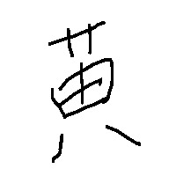
037-NG2 | 黄 | 2 | 70 | 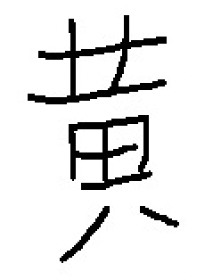
045-NG1 | 使 | 3 | 59 | 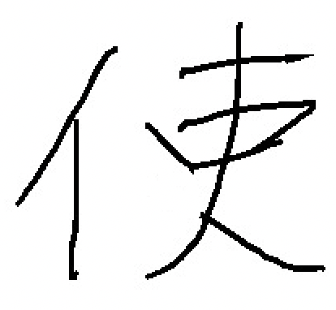
051-NG1 | 暗 | 3 | 60 | 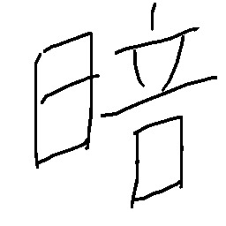
057-NG1 | 緑 | 3 | 58 | 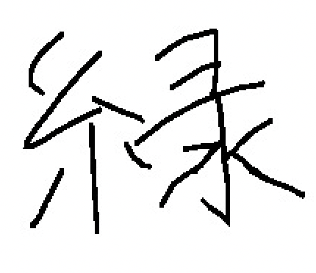
077-NG1 | 挙 | 4 | 61 | 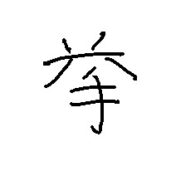
091-NG1 | 演 | 5 | 73 | 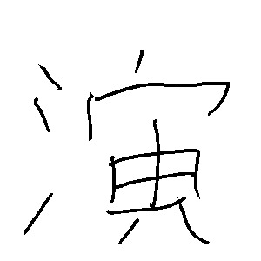
095-NG1 | 解 | 5 | 60 | 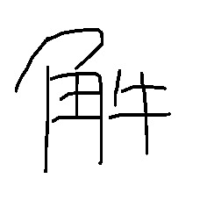
095-NG2 | 解 | 5 | 60 | 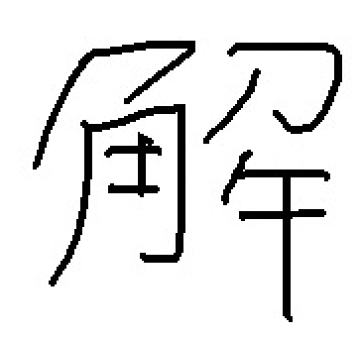
097-NG1 | 構 | 5 | 64 | 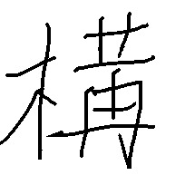
099-NG1 | 衛 | 5 | 63 | 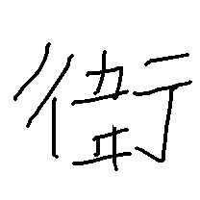
101-NG1 | 宝 | 6 | 36 | 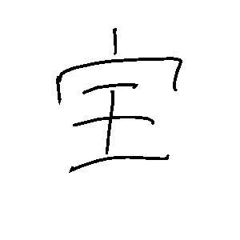
103-NG1 | 骨 | 6 | 33 | 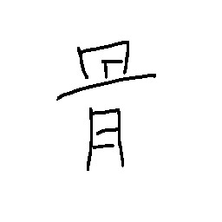
105-NG1 | 優 | 6 | 28 | 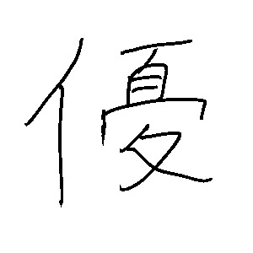
105-NG2 | 優 | 6 | 28 | 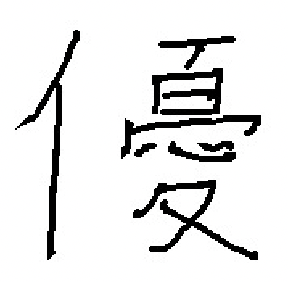
111-NG1 | 宣 | 6 | 36 | 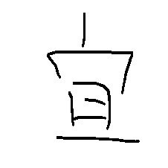
115-NG1 | 律 | 6 | 35 | 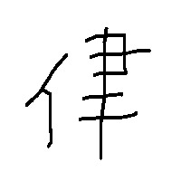
Total |  |  | 1023
Note. All example images are incorrect Kanji characters that contain orthographic errors (e.g., extra/missing strokes or stroke intersections). The full dataset is available at https://osf.io/gver2/.

Appendix C
Example Images of Characters with Semantic/Homophone Errors (Dataset 3)
Unicode | Kanji | Grade | N
0x4e09 | 三 | 1 | 140
0x5c0f | 小 | 1 | 155
0x65e5 | 日 | 1 | 153
0x4ea4 | 交 | 2 | 138
0x5200 | 刀 | 2 | 152
0x5207 | 切 | 2 | 129
0x6b62 | 止 | 2 | 150
0x7dda | 線 | 2 | 108
0x9854 | 顔 | 2 | 75
0x5316 | 化 | 3 | 191
0x554f | 問 | 3 | 181
0x967d | 陽 | 3 | 54
0x968e | 階 | 3 | 69
0x5404 | 各 | 4 | 147
0x6c42 | 求 | 4 | 117
0x9678 | 陸 | 4 | 114
0x8ff7 | 迷 | 5 | 111
0x9632 | 防 | 5 | 119
0x6d25 | 津 | - | 73
0x6ed1 | 滑 | - | 46
Total |  |  | 2422
Note. All Kanji characters are existent characters that do not match the word context given in the test items. The full dataset is available at https://osf.io/gver2/.

Appendix D
Scanned Handwriting Samples for the Model Validation
Item | Grade | Kanji |  | g1f |  |  | g2s
Item | Grade | Kanji |  | Correct | Incorrect |  | Correct | Incorrect
001 | 1 | 一 |  | 153
002 | 1 | 川 |  | 147 |  |  | 135
003 | 1 | 口 |  | 148 | 1
004 | 1 | 山 |  | 139 | 1
005 | 1 | 女 |  | 95 | 3 |  | 133 | 1
006 | 1 | 水 |  | 140 | 1
007 | 1 | 花 |  | 77 | 5 |  | 134 | 1
008 | 1 | 子 |  | 106 | 2 |  | 132 | 1
009 | 1 | 大 |  | 134 | 2
010 | 1 | 月 |  | 120 | 2 |  | 143 | 1
011 | 1 | 赤 |  | 46 | 8 |  | 119 | 12
012 | 1 | 草 |  | 22 | 7 |  | 108 | 15
013 | 1 | 正 |  | 92 | 10 |  | 115 | 9
014 | 1 | 校 |  | 68 | 5 |  | 122 | 4
015 | 1 | 足 |  | 59 | 11 |  | 44 | 10
016 | 1 | 村 |  | 16 | 9 |  | 90 | 14
017 | 1 | 百 |  | 65 | 22 |  | 110 | 12
018 | 1 | 先 |  | 29 | 24 |  | 102 | 12
019 | 1 | 虫 |  | 63 | 11 |  | 103 | 11
020 | 1 | 入 |  | 55 | 15 |  | 42 | 14
021 | 2 | 広 |  | 4 | 2 |  | 38 | 3
022 | 2 | 書 |  | 3 | 11 |  | 102 | 9
023 | 2 | 外 |  | 8 | 2 |  | 37 | 13
024 | 2 | 答 |  | 3 | 2 |  | 8 | 6
025 | 2 | 少 |  | 3 | 2 |  | 18 | 12
026 | 2 | 行 |  | 4 | 7 |  | 71 | 20
027 | 2 | 家 |  | 2 | 4 |  | 12 | 10
028 | 2 | 台 |  | 2 | 21 |  | 9 | 51
029 | 2 | 作 |  | 2 | 9 |  | 15 | 10
030 | 2 | 雲 |  | 2 | 5 |  | 5 | 2
031 | 2 | 紙 |  | 2 | 1 |  | 67 | 11
032 | 2 | 晴 |  | 1 | 1 |  | 74 | 9
033 | 2 | 東 |  | 1 | 2 |  | 8 | 3
034 | 2 | 元 |  |  |  |  | 5 | 3
035 | 2 | 行 |  | 1 |  |  | 3 | 1
036 | 2 | 通 |  | 1 | 1 |  | 2 | 2
037 | 2 | 黄 |  | 1 | 1 |  | 48 | 15
038 | 2 | 矢 |  | 3 | 1 |  | 8 | 10
039 | 2 | 頭 |  | 2 | 1 |  | 6 | 6
040 | 2 | 合 |  |  |  |  | 2
041 | 3 | 面 |  |  | 1 |  | 5 | 6
042 | 3 | 動 |  |  |  |  | 1
043 | 3 | 丁 |  |  | 1 |  | 4 | 3
044 | 3 | 係 |  |  |  |  | 1 | 1
045 | 3 | 使 |  | 1 |  |  | 1
046 | 3 | 表 |  |  |  |  |  | 1
047 | 3 | 集 |  |  |  |  | 3 | 1
048 | 3 | 秒 |  |  | 1 |  |  | 1
049 | 3 | 定 |  |  |  |  | 1 | 1
050 | 3 | 取
051 | 3 | 暗 |  |  |  |  | 1
052 | 3 | 暑 |  |  |  |  | 1 | 1
053 | 3 | 筆 |  |  |  |  | 2
054 | 3 | 飲
055 | 3 | 代
056 | 3 | 打 |  |  |  |  | 1
057 | 3 | 緑
058 | 3 | 根 |  |  |  |  |  | 2
059 | 3 | 等
060 | 3 | 港
Note. The total number of samples was 7,128. The full dataset is available at https://osf.io/gver2/.

Appendix E
Discriminant Accuracy, Precision, Recall, F-measure, and Specificity Values for Google’s Handwriting Recognition Service
Criterion Rank |  | Match |  |  |  | Mismatch
Criterion Rank |  | TP | TN | Total |  | FN | FP | Total |  | Accuracy | Precision | Recall | F-measure | Specificity
1 |  | 2628 | 544 | 3172 |  | 40 | 163 | 203 |  | 93.99 | 94.16 | 98.50 | 96.28 | 76.94
2 |  | 2649 | 509 | 3158 |  | 19 | 198 | 217 |  | 93.57 | 93.05 | 99.29 | 96.07 | 71.99
3 |  | 2652 | 491 | 3143 |  | 16 | 216 | 232 |  | 93.13 | 92.47 | 99.40 | 95.81 | 69.45
4 |  | 2654 | 484 | 3138 |  | 14 | 223 | 237 |  | 92.98 | 92.25 | 99.48 | 95.73 | 68.46
5 |  | 2659 | 477 | 3136 |  | 9 | 221 | 230 |  | 92.92 | 92.04 | 99.66 | 95.70 | 67.47
Note. Criterion rank represents the cutoff used to determine correctness among the five candidates returned by the Google service. For example, if the criterion rank is 3, the answer will be considered correct if the first three candidates contain the target kanji character. TP = true positive; TN = true negative; FN = false negative; FP = false positive.

Appendix F
The Models’ Performance for an Independent Handwriting Sample from Grade 1 Children (g1f)
 |  | Match |  |  |  | Mismatch
Model and Dataset |  | TP | TN | Total |  | FN | FP | Total |  | Accuracy | Precision | Recall | F-measure | Specificity
Xception
Dataset 1 |  | 1790 | 145 | 1935 |  | 30 | 70 | 100 |  | 95.09 | 96.24 | 98.35 | 97.28 | 67.44
Dataset 1+2 |  | 1794 | 156 | 1950 |  | 26 | 59 | 85 |  | 95.82 | 96.82 | 98.57 | 97.69 | 72.56
Dataset 1+3 |  | 1799 | 137 | 1936 |  | 21 | 78 | 99 |  | 95.14 | 95.84 | 98.85 | 97.32 | 63.72
Dataset 1+2+3 |  | 1798 | 165 | 1963 |  | 22 | 50 | 72 |  | 96.46 | 97.29 | 98.79 | 98.04 | 76.74
Inception V3
Dataset 1 |  | 1674 | 147 | 1821 |  | 146 | 68 | 214 |  | 89.48 | 96.10 | 91.98 | 93.99 | 68.37
Dataset 1+2 |  | 1731 | 169 | 1900 |  | 89 | 46 | 135 |  | 93.37 | 97.41 | 95.11 | 96.25 | 78.60
Dataset 1+3 |  | 1788 | 137 | 1925 |  | 32 | 78 | 110 |  | 94.59 | 95.82 | 98.24 | 97.02 | 63.72
Dataset 1+2+3 |  | 1778 | 174 | 1952 |  | 42 | 41 | 83 |  | 95.92 | 97.75 | 97.69 | 97.72 | 80.93
ResNet50
Dataset 1 |  | 1780 | 135 | 1915 |  | 40 | 80 | 120 |  | 94.10 | 95.70 | 97.80 | 96.74 | 62.79
Dataset 1+2 |  | 1784 | 157 | 1941 |  | 36 | 58 | 94 |  | 95.38 | 96.85 | 98.02 | 97.43 | 73.02
Dataset 1+3 |  | 1784 | 136 | 1920 |  | 36 | 79 | 115 |  | 94.35 | 95.76 | 98.02 | 96.88 | 63.26
Dataset 1+2+3 |  | 1794 | 157 | 1951 |  | 26 | 58 | 84 |  | 95.87 | 96.87 | 98.57 | 97.71 | 73.02
Note. The first column indicates the base model and the datasets used to develop the model. TP = true positive; TN = true negative; FN = false negative; FP = false positive.

Appendix G
The Models’ Performance for an Independent Handwriting Sample from Grade 2 Children (g2s)
 |  | Match |  |  |  | Mismatch
Model and Dataset |  | TP | TN | Total |  | FN | FP | Total |  | Accuracy | Precision | Recall | F-measure | Specificity
Xception
Dataset 1 |  | 2150 | 207 | 2357 |  | 41 | 123 | 164 |  | 93.49 | 94.59 | 98.13 | 96.33 | 62.73
Dataset 1+2 |  | 2172 | 227 | 2399 |  | 19 | 103 | 122 |  | 95.16 | 95.47 | 99.13 | 97.27 | 68.79
Dataset 1+3 |  | 2178 | 196 | 2374 |  | 13 | 134 | 147 |  | 94.17 | 94.20 | 99.41 | 96.74 | 59.39
Dataset 1+2+3 |  | 2163 | 221 | 2384 |  | 28 | 109 | 137 |  | 94.57 | 95.20 | 98.72 | 96.93 | 66.97
Inception V3
Dataset 1 |  | 2031 | 224 | 2255 |  | 160 | 106 | 266 |  | 89.45 | 95.04 | 92.70 | 93.85 | 67.88
Dataset 1+2 |  | 2054 | 228 | 2282 |  | 137 | 102 | 239 |  | 90.52 | 95.27 | 93.75 | 94.50 | 69.09
Dataset 1+3 |  | 2141 | 198 | 2339 |  | 50 | 132 | 182 |  | 92.78 | 94.19 | 97.72 | 95.92 | 60.00
Dataset 1+2+3 |  | 2132 | 222 | 2354 |  | 59 | 108 | 167 |  | 93.38 | 95.18 | 97.31 | 96.23 | 67.27
ResNet50
Dataset 1 |  | 2148 | 197 | 2345 |  | 43 | 133 | 176 |  | 93.02 | 94.17 | 98.04 | 96.06 | 59.70
Dataset 1+2 |  | 2145 | 215 | 2360 |  | 46 | 115 | 161 |  | 93.61 | 94.91 | 97.90 | 96.38 | 65.15
Dataset 1+3 |  | 2143 | 195 | 2338 |  | 48 | 135 | 183 |  | 92.74 | 94.07 | 97.81 | 95.91 | 59.09
Dataset 1+2+3 |  | 2130 | 209 | 2339 |  | 61 | 121 | 182 |  | 92.78 | 94.62 | 97.22 | 95.90 | 63.33
Note. The first column indicates the base model and the datasets used to develop the model. TP = true positive; TN = true negative; FN = false negative; FP = false positive.

Appendix H
The Items Used in the Online Handwriting Test (OAHaS)
Items | Kanji | Gradeª | Items used for each grade |  |  |  |  |  |  | Answers
Items | Kanji | Gradeª | 1 | 2 | 3 | 4 | 5 | 6 |  | Correct | Incorrect | No response
001 | 一 | 1 | ✓ |  |  |  |  |  |  | 34 | 1 | 0
003 | 口 | 1 | ✓ |  |  |  |  |  |  | 26 | 1 | 8
005 | 女 | 1 | ✓ |  |  |  |  |  |  | 29 | 2 | 4
007 | 花 | 1 | ✓ |  |  |  |  |  |  | 4 | 1 | 30
009 | 大 | 1 | ✓ |  |  |  |  |  |  | 35 | 0 | 0
011 | 赤 | 1 | ✓ | ✓ |  |  |  |  |  | 44 | 4 | 32
013 | 正 | 1 | ✓ | ✓ |  |  |  |  |  | 70 | 5 | 5
015 | 足 | 1 | ✓ | ✓ |  |  |  |  |  | 47 | 0 | 33
017 | 百 | 1 | ✓ | ✓ |  |  |  |  |  | 38 | 15 | 27
019 | 虫 | 1 | ✓ | ✓ |  |  |  |  |  | 72 | 5 | 3
021 | 広 | 2 | ✓ | ✓ |  |  |  |  |  | 42 | 2 | 36
023 | 外 | 2 | ✓ | ✓ |  |  |  |  |  | 41 | 3 | 36
025 | 少 | 2 | ✓ | ✓ |  |  |  |  |  | 36 | 5 | 39
027 | 家 | 2 | ✓ | ✓ |  |  |  |  |  | 44 | 2 | 34
029 | 作 | 2 | ✓ | ✓ |  |  |  |  |  | 33 | 5 | 42
031 | 紙 | 2 |  | ✓ | ✓ |  |  |  |  | 79 | 1 | 2
033 | 東 | 2 |  | ✓ | ✓ |  |  |  |  | 65 | 10 | 7
035 | 行 | 2 |  | ✓ | ✓ |  |  |  |  | 47 | 3 | 32
037 | 黄 | 2 |  | ✓ | ✓ |  |  |  |  | 57 | 18 | 7
039 | 頭 | 2 |  | ✓ | ✓ |  |  |  |  | 62 | 12 | 8
041 | 面 | 3 |  | ✓ | ✓ |  |  |  |  | 39 | 6 | 37
043 | 丁 | 3 |  | ✓ | ✓ |  |  |  |  | 28 | 16 | 38
045 | 使 | 3 |  | ✓ | ✓ |  |  |  |  | 35 | 10 | 37
047 | 集 | 3 |  | ✓ | ✓ |  |  |  |  | 29 | 8 | 45
049 | 定 | 3 |  | ✓ | ✓ |  |  |  |  | 25 | 7 | 50
051 | 暗 | 3 |  |  | ✓ | ✓ |  |  |  | 69 | 11 | 1
053 | 筆 | 3 |  |  | ✓ | ✓ |  |  |  | 63 | 13 | 5
055 | 代 | 3 |  |  | ✓ | ✓ |  |  |  | 10 | 39 | 32
057 | 緑 | 3 |  |  | ✓ | ✓ |  |  |  | 54 | 22 | 5
059 | 等 | 3 |  |  | ✓ | ✓ |  |  |  | 25 | 31 | 25
061 | 争 | 4 |  |  | ✓ | ✓ |  |  |  | 34 | 6 | 41
063 | 不 | 4 |  |  | ✓ | ✓ |  |  |  | 44 | 3 | 34
065 | 変 | 4 |  |  | ✓ | ✓ |  |  |  | 39 | 12 | 30
067 | 束 | 4 |  |  | ✓ | ✓ |  |  |  | 20 | 12 | 49
069 | 梅 | 4 |  |  | ✓ | ✓ |  |  |  | 44 | 6 | 31
071 | 隊 | 4 |  |  |  | ✓ | ✓ |  |  | 51 | 24 | 17
073 | 候 | 4 |  |  |  | ✓ | ✓ |  |  | 32 | 20 | 40
075 | 借 | 4 |  |  |  | ✓ | ✓ |  |  | 58 | 11 | 23
077 | 挙 | 4 |  |  |  | ✓ | ✓ |  |  | 42 | 20 | 30
079 | 腸 | 4 |  |  |  | ✓ | ✓ |  |  | 16 | 23 | 53
081 | 支 | 5 |  |  |  | ✓ | ✓ | ✓ |  | 90 | 14 | 32
083 | 罪 | 5 |  |  |  | ✓ | ✓ | ✓ |  | 86 | 10 | 40
085 | 述 | 5 |  |  |  | ✓ | ✓ | ✓ |  | 72 | 16 | 48
087 | 格 | 5 |  |  |  | ✓ | ✓ | ✓ |  | 65 | 28 | 43
089 | 移 | 5 |  |  |  | ✓ | ✓ | ✓ |  | 73 | 24 | 39
091 | 演 | 5 |  |  |  |  | ✓ | ✓ |  | 48 | 20 | 24
093 | 示 | 5 |  |  |  |  | ✓ | ✓ |  | 56 | 16 | 20
095 | 解 | 5 |  |  |  |  | ✓ | ✓ |  | 63 | 22 | 7
097 | 構 | 5 |  |  |  |  | ✓ | ✓ |  | 51 | 23 | 18
099 | 衛 | 5 |  |  |  |  | ✓ | ✓ |  | 69 | 12 | 11
101 | 宝 | 6 |  |  |  |  | ✓ | ✓ |  | 77 | 10 | 5
103 | 骨 | 6 |  |  |  |  | ✓ | ✓ |  | 47 | 18 | 27
105 | 優 | 6 |  |  |  |  | ✓ | ✓ |  | 33 | 35 | 24
107 | 乱 | 6 |  |  |  |  | ✓ | ✓ |  | 44 | 10 | 38
109 | 蚕 | 6 |  |  |  |  | ✓ | ✓ |  | 41 | 8 | 43
111 | 宣 | 6 |  |  |  |  |  | ✓ |  | 6 | 14 | 24
113 | 臨 | 6 |  |  |  |  |  | ✓ |  | 21 | 5 | 18
115 | 律 | 6 |  |  |  |  |  | ✓ |  | 31 | 9 | 4
117 | 頂 | 6 |  |  |  |  |  | ✓ |  | 25 | 2 | 17
119 | 陛 | 6 |  |  |  |  |  | ✓ |  | 8 | 16 | 20
Note. The test consisted of 15 items for Grade 1 and 20 items for Grade 2 to Grade 6 (see the Materials and Procedure section in Study 2).
ª “Grade” indicates the grade level at which children learn the character according to the national curriculum (Ministry of Education, Culture, Sports, Science and Technology, 2017).

