Approaches to inducing mental fatigue: A systematic review and meta-analysis of (neuro)physiologic indices

Authors:
Goodman, S.P.J.a, Collins, B.b, Shorter, K.a,c, Moreland, A.T.d, Papic, C.e,a, Hamlin, A.S.a, Kassman, B.ª,
Marino, F.E.f

a School of Science and Technology, University of New England, Armidale, NSW, Australia
b Holsworth Research Initiative, La Trobe Rural Health School, La Trobe University, Victoria, Australia
c Allied Health and Human Performance, University of South Australia, South Australia, Australia
d Re-MIND Institute, Sunbury, Victoria, Australia
^{e} RECOVER Injury Research Centre, Faculty of Health and Behavioural Sciences, The University of Queensland, Brisbane, QLD, Australia
f School of Rural Medicine, Charles Sturt University, Orange, NSW, Australia

Corresponding author:
Dr Stephen Goodman, stephen.goodman@une.edu.au
Phone: 0267733345
Address: Room 251, Building S02, University of New England, Armidale, NSW, 2351, Australia

Supplementary Figure 1. Follow up literature search. Note the change to inclusion criteria to reflect the identification of literature examining (neuro)physiologic indices.

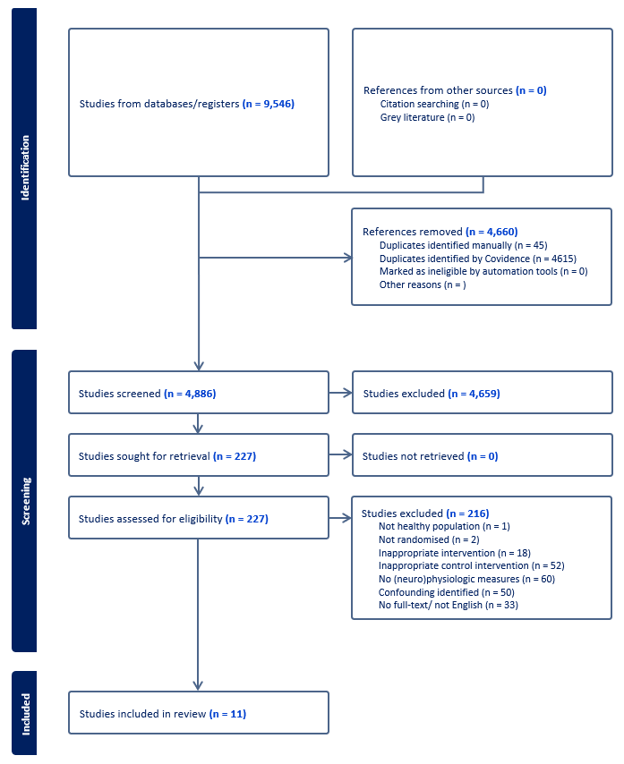

Supplementary Figure 2. Third literature search that combined an unrestricted (except for human participants) literature search for (“cognitive effort” OR “mental effort”) and final iteration of the initial search (with restrictions on human participants, published in English, and between the dates of Feb, 2023 to June, 2024).

Supplementary table 1. Demographic information and outcome measures of (neuro)physiologic function
Citation | Participants (number and sex) | Age (years) | Experimental design | Experimental intervention |  | Control intervention |  | Outcome(s)
 |  |  |  | Type | Duration | Type | Duration | Outcome(s)
Angius, 2022 | 17 (17M) | 26 ± 2 | Within | Stroop (mixed) –  word on red; colour on remaining | 30 min | Video | 30 min | Neuroimaging  Left PFC oxygenated, deoxygenated, and total hemoglobin (%)
Batista, 2021 | 15 (15M) | 30 ± 8 | Within | Stroop (mixed) – word on red; colour on remaining | 30 min | Video (10 min) + Relaxation (20 min) | 30 min | Physiologic  Mean heart rate (bpm)
Behrens, 2018a – Young adults | 16 (8F, 8M) | 24.9 ± 1.4 | Within | Inhibition task – Stop-signal test | 90 min | Video | 90 min | Physiologic  LF (ms²) and RMSSD (ms) HRV
Behrens, 2018b – Older adults | 16 (10F, 6 M) | 72.2 ± 4.4 | Within | Inhibition task – Stop-signal test | 90 min | Video | 90 min | Physiologic  LF (ms²) and RMSSD (ms) HRV
Boat, 2021 | 13 (13M) | 20 ± 1 | Within | Stroop (mixed) – word on red; colour on remaining | 4 min | Stroop (word) – 100% congruent) | 4 min | Physiologic  Plasma cortisol
Brown, 2019A | 25 (13M, 12F) | 20.16 ± 1.48 | Within | AX-CPT | 50 min | Video | 50 min | Physiologic  Mean heart rate (bpm)
Brown, 2019B | 36 (20F, 16M) | 19.44 ± 1.42 | Within | Stroop (colour) - 100% incongruent | 10 / 135 trials | Video | 10 min | Physiologic  Mean heart rate (bpm)
Brownsberger, 2013 | 12 (8M, 4F) | 24 ± 5 | Within | AX-CPT | 90 min | Video | 90 min | Physiologic  Mean heart rate (bpm)  Neuroimaging  Frontal cortex alpha and beta EEG (logμV²)
Budini, 2022 | 29 (19M, 10F) | 25.1 ± 5 | Between | Switching task | 100 min | Video | 100 min | Physiologic  Capillary oxygen saturation (%)  Mean heart rate (bpm)  Systolic and diastolic blood pressure (mmHg)
Campos, 2019 | 13 (9M, 4F) | 19.5 ± 3 | Within | Stroop (mixed) – word on red; colour on remaining | 30 min | Video | 30 min | Physiologic  HF and LF (ms²) HF:LF ratio, RMSSD (ms) HRV  Salivary cortisol (ng/mL)  Blood glucose (mg/dL)  Blood lactate (mmol/L)
Clark, 2019a – Competitively trained males | 10 (10M) | 27.4 ± 6.3 | Within | Mixed - Stroop (colour) and N-back task | 30 min | Video | 30 min | Physiologic  Mean heart rate (bpm)  Plasma lactate, glucose, sodium, potassium (mM)  Plasma cortisol (μg/dL)  Neuroimaging  Left PFC oxygenated, deoxygenated, and total hemoglobin (a.u.)
Clark, 2019b – Untrained healthy males | 10 (10M) | 25.8 ± 4.6 | Within | Mixed - Stroop (colour) and N-back task | 30 min | Video | 30 min | Physiologic  Mean heart rate (bpm)  Plasma lactate, glucose, sodium, potassium (mM)  Plasma cortisol (μg/dL)  Neuroimaging  Left PFC oxygenated, deoxygenated, and total hemoglobin (a.u.)
Dallaway, 2022a – 2-back test MF group | 90 (52F, 38M) | 19.4 ± 1.3 | Between | 2-back test | 40 min | Video | 40 min | Physiologic  Mean heart rate (bpm)  Mean RMSSD and SDNN HRV (ms)
Dallaway, 2022b – Stroop task MF group | 90 (52F, 38M) | 19.4 ± 1.3 | Between | Stroop (colour) – 100% incongruent | 40 min | Video | 40 min | Physiologic  Mean heart rate (bpm)  Mean RMSSD and SDNN HRV (ms)
Dang, 2016 | 84 (42M, 42F) | NR | Between | Stroop (colour) – 50% incongruent | NR / 144 trials | Stroop (word) – 100% congruent) | NR / 144 trials | Visual responses  Eye blink ratio
De Lima-Junior, 2023 | 18 (18M) | 22.1 ± 2.0 | Within | Stroop (colour) – 100% incongruent | 30 min | Video | 30 min | Visual responses  Pupil diameter (mm)
Englert, 2019 | 112 (87F, 25M) | 24.77 ± 10.12 | Between | Transcription task – omit E and N | 6 min | Transcription task – no omissions | 6 min | Visual responses  Gaze fixations (%)
Fairclough, 2004 | 30 (21F, 9M) | 24.77 ± NR | Within | Stroop (colour) – 100% incongruent | 45 min | Stroop (word) – 100% congruent) | 45 min | Physiologic  Blood glucose (% in mmol)  Mean heart rate (bpm)
Ferris, 2021 | 8 (8M) | 24.3 ± 0.4 | Within | AX-CPT | 60 min | Video | 60 min | Physiologic  Mean heart rate (bpm)
Filipas, 2019 | 10 (10M) | 20.0 ± 1.2 | Within | Stroop (mixed) – word on red; colour on remaining | 30 min | Video | 30 min | Physiologic  Mean heart rate (bpm)  Mean RMSSD HRV (ms)  Blood lactate (mmol/L)
Filipas, 2018a – Stroop task MF condition | 18 (11M, 7F) | 11 ± 1.06 | Within | Stroop (colour) - 100% incongruent | 60 min | Painting Mandala | 60 min | Physiologic  Mean heart rate (bpm)
Filipas, 2018b – Arithmetic MF condition | 18 (11M, 7F) | 11 ± 1.06 | Within | Arithmetic | 60 min | Painting Mandala | 60 min | Physiologic  Mean heart rate (bpm)
Galy, 2015 | 31 (15F, 16M) | 23.3 ± 1.86 | Within | Arithmetic – Serial 36 + time pressure | 4 min | Arithmetic – Serial 5 | 4 min | Physiologic  Differential heart rate (bpm)
Gantois, 2020a – 30 min MF condition | 20 (20M) | 22.6 ± 3.3 | Within | Stroop (word) – congruency frequency NR | 30 min | Video | 30 min | Physiologic  Mean RMSSD, SDNN, pNN50 HRV (units NR)
Gantois, 2020b – 15 min MF condition | 20 (20M) | 22.6 ± 3.3 | Within | Stroop (word) – congruency frequency NR | 15 min | Video | 30 min | Physiologic  Mean RMSSD, SDNN, pNN50 HRV (units NR)
Gieseler, 2021 | 179 (128F, 51M) | 22.79 ± 3.27 | Between | Arithmetic – Serial 13 | 8 min | Arithmetic – Serial 2 | 8 min | Physiologic  Pre-ejection period (mmHg from baseline)  SBP (mmHg from baseline
Goudini, 2024 | 17 (14M, 3F) | M: 28.6 ± 4.9  F: 24.0 ± 2.6 | Within | Stroop (colour) – 50% incongruent | 30 min | Video | 30 min | Physiologic  Mean heart rate (bpm)
Habay, 2021 | 11 (4F, 7M) | 24 ± 2 | Within | Stroop (mixed) –  word on red; colour on remaining  + Individualised time pressure | 60 min | Video | 60 min | Physiologic  Mean heart rate (bpm)  Neuroimaging  EEG theta, upper and lower alpha bands, and event related potentials (N1, P2, N2, and P3b)
Hakim, 2022 | 12 (5F, 7M) | 28 ± 7.5  Range 25-30 | Within | Stroop (type NR) – Congruency frequency NR | 60 min | Video | 60 min | Physiologic  Blood glucose (% from baseline)
Head, 2017 | 20 (20M) | NR | Within | Sustained attention to response task (Go/no-go like assessment) | 49 min | Video | 49 min | Physiologic  SDNN HRV (units NR)
Head, 2016 | 18 (11M, 7F) | 28 ± 3.8  Range: 24-37 | Within | Vigilance task (Go/no-go like assessment) | 52 min | Video | 52 min | Physiologic  Mean heart rate (bpm)  Oxygen consumption (ml/kg/min)
Hess, 2012a – Young adults | 52 (26F, 26M) | 31.6 ± NR | Between | Arithmetic - Serial 3 | 5 min | Arithmetic – Serial 1 | 5 min | Physiologic  SBP and DBP (mmHg from baseline)  Mean heart rate (bpm)
Hess, 2012b – Older adults | 51 (24F, 27M) | 70.9 ± NR | Between | Arithmetic - Serial 3 | 5 min | Arithmetic – Serial 1 | 5 min | Physiologic  SBP and DBP (mmHg from baseline)  Mean heart rate (bpm)
Holgado, 2023 | 22 (18M, 4F) | 26.4 ± 4.46 | Within | TloadDback (individualised) | 30 min | 0-back test | 30 min | Neuroimaging  First dorsal interosseous muscle motor evoked potential (mV)  Left PFC oxygenated, deoxygenated, and total hemoglobin (%)
Ishii, 2013 | 9 (9M) | 36.8 ± 11.8 | Within | 2-back test | 75 min | 0-back test | 75 min | Physiologic  HF and LF (%), and HF:LF ratio HRV  Neuroimaging  MEG Peak voxel
Jacquet, 2024 | 14 (7F, 7M) | 22.6 ± 2.3 | Within | Visual attention task | 62 min | Video | 62 min | Neuroimaging  EEG delta, theta, alpha, beta, and gamma bands across the frontal, central, and parietal regions, and event related potentials (P1 and N1)  EEG theta, upper and lower alpha bands, and event related potentials (N1, P2, N2, and P3b)
Klaassen, 2013a – responders | 15 (15M) | 43.3 ± 13.4  Range: 27-61 | Within | Mixed: N-back tests, Stroop task (type NR), mental arithmetic, puzzles | 90 min | Video or magazine | 90 min | Physiologic  Salivary cortisol (nmol/L)  Neuroimaging  MRI during post-intervention working memory tasks.
Klaassen, 2013b – non-responders | 12 (12M) | 45.8 ± 12.6  Range: 25-60 | Within | Mixed: N-back tests, Stroop task (type NR), mental arithmetic, puzzles | 90 min | Video or magazine | 90 min | Physiologic  Salivary cortisol (nmol/L)  Neuroimaging  MRI during post-intervention working memory task.
Klaassen, 2014a – Young | 14 (14M) | Range: 25-35 | Within | Mixed: N-back tests, Stroop task (type NR), mental arithmetic, puzzles | 90 min | Video or magazine | 90 min | Neuroimaging  MRI during post-intervention working memory task.
Klaassen, 2014b – Middle-aged | 18 (18M) | Range: 60-61 | Within | Mixed: N-back tests, Stroop task (type NR), mental arithmetic, puzzles | 90 min | Video or magazine | 90 min | Neuroimaging  MRI during post-intervention working memory task.
Klaassen 2016b – Young | 14 (14M) | Range: 25-35 | Within | Mixed: N-back tests, Stroop task (type NR), mental arithmetic, puzzles | 90 min | Video or magazine | 90 min | Neuroimaging  MRI during post-intervention working memory task.
Klaassen 2016b – Middle-aged | 18 (18M) | Range: 50-61 | Within | Mixed: N-back tests, Stroop task (type NR), mental arithmetic, puzzles | 90 min | Video or magazine | 90 min | Neuroimaging  MRI during post-intervention working memory task.
Kosack, 2020 | 19 (19M) | 20 ± 2.8 | Within | Stroop (mixed) –  word on red; colour on remaining | 60 min | Video | 60 min | Physiologic  Blood lactate (mmol/L)
Kowalski, 2022a – Males | 15 (15M) | 20 ± 2.8 | Within | Psychomotor vigilance task | 30 min | Video | 30 min | Neuroimaging  Tibulus anterior motor evoked potential amplitude (mV) and cortical silent period (ms)
Kowalski, 2022b – Females | 15 (15F) | 24.9 ± 2.3 | Within | Psychomotor vigilance task | 30 min | Video | 30 min | Neuroimaging  Tibulus anterior motor evoked potential amplitude (mV) and cortical silent period (ms)
Le, 2021a – Neutral sequential task | Total n for citation:  120 (72F, 48F) | 18.39 ± 0.61 | Between | Stroop (colour) - 70% incongruent | 10 min | Video | 10 min | Physiologic  RMSSD (ms)
Le, 2021a – Positive sequential task | Total n for citation:  120 (72F, 48F) | 18.39 ± 0.61 | Between | Stroop (colour) - 70% incongruent | 10 min | Video | 10 min | Physiologic  RMSSD (ms)
Lopes, 2020a - Males | 16 (16M) | 25 ± 1 | Within | Stroop (mixed) –  word on red; colour on remaining | 45 min | Video | 45 min | Physiologic  Blood lactate (mmol/L)
Lopes, 2020b - Females | 15 (15F) | 25 ± 1 | Within | Stroop (mixed) –  word on red; colour on remaining | 45 min | Video | 45 min | Physiologic  Blood lactate (mmol/L)
MacMahon, 2014 | 20 (18M, 2F) | 25.4 ± 3.24 | Within | AX-CPT | 90 min | Video + AX-Continuous performance task (last 6 min) | 90 min | Physiologic  Average heart rate (bpm)  Blood lactate (units NR)
Marcora, 2009 | 16 (10M, 6F) | 26 ± 3 | Within | AX-CPT | 90 min | Video | 90 min | Physiologic  Average heart rate (bpm)  Blood glucose (units NR)
Martin, 2016a – Professional road cyclists | 11 (11M) | 23.4 ± 6.4 | Within | Stroop (mixed) – word on red; colour on remaining | 30 min | Screen viewing | 10 min | Physiologic  Blood lactate (mmol/L)
Martin, 2016b – Recreational road cyclists | 9 (9M) | 25.6 ± 5.3 | Within | Stroop (mixed) – word on red; colour on remaining | 30 min | Screen viewing | 10 min | Physiologic  Blood lactate (mmol/L)
Matuz, 2021 | 41 (22F, 19M) | 21.87 ± 3.18 | Between | 2-back test (gatekeeper task) | 90 min | Video | 90 min | Physiologic  Average heart rate (bpm)  HF and LF (ms²), RMSSD (ms) PNN50 (%), Poincaré cloud SD2 (units NR) HRV
Mlynski, 2021a – Low Evocativeness group | 57 (57NR) | 20.34 ± NR | Between | AX-CPT | 8 min | AX-CPT (easy) | 8 min | Physiologic  Average heart rate (bpm)  Pre-ejection period (ms), SBP, DBP, and MAP (mmHg)
Mlynski, 2021b – High Evocativeness group | 60 (60NR) | 20.34 ± NR | Between | AX-CPT | 8 min | AX-CPT (easy) | 8 min | Physiologic  Average heart rate (bpm)  Pre-ejection period (ms), SBP, DBP, and MAP (mmHg)
Moreira, 2018 | 32 (32M) | 15.2 ± 1.2 | Within | Stroop (mixed) –  word on red; colour on remaining | 30 min | Screen viewing (10 min) and leisure activity (20 min) | 30 min | Physiologic  Salivary testosterone (pmol/L), alpha-amylase (U/mL), and cortisol (nmol/L)
O'Keeffe, 2020a – TloadDback MF condition | 12 (7F, 5M) | 26.5 ± 3.12 | Within | TloadDback (individualised) | 16 min | TloadDback (standard) | 16 min | Physiologic  Average heart rate (bpm)  RMSSD (ms) and PNN50 (%) HRV  Galvanic skin conductance (µS)
O'Keeffe, 2020a – TloadDback MF condition | 12 (7F, 5M) | 26.5 ± 3.12 | Within | TloadDback (individualised) | 16 min | Video | 90 min | Physiologic  Average heart rate (bpm)  RMSSD (ms) and PNN50 (%) HRV  Galvanic skin conductance (µS)
O'Keeffe, 2020c – AX-CPT condition | 12 (7F, 5M) | 26.5 ± 3.12 | Within | AX-CPT | 90 min | Video | 90 min | Physiologic  Average heart rate (bpm)  RMSSD (ms) and PNN50 (%) HRV  Galvanic skin conductance (µS)
Otani, 2017 | 8 (8M) | 22 ± 0.6 | Within | Mixed: Stroop, Sternberg memory test, and RVIP | 90 min | Video | 90 min | Physiologic  Average heart rate (bpm)  MAP (mm/Hg)
Pageaux, 2013 | 10 (10M) | 22 ± 2 | Within | AX-CPT | 90 min | Video | 90 min | Physiologic  Average heart rate (bpm)
Pageaux, 2014 | 12 (8M, 4F) | 21 ± 1 | Within | Stroop (mixed) –  word on red; colour on remaining | 30 min | Stroop (word) – 100% congruent) | 30 min | Physiologic  Average heart rate (bpm)  Blood glucose and lactate (mmol/L)
Pageaux, 2015 | 12 (12M) | 25 ± 4 | Within | Stroop (mixed) –  word on red; colour on remaining | 30 min | Stroop (word) – 100% congruent) | 30 min | Physiologic  Average heart rate (bpm)
Park, 2021 | 14 (7F,7M) | 25.2 ± 3.4 | Within | Arithmetic (difficult equations) | 15 min | Arithmetic (easy equations) | 15 min | Neuroimaging  EEG P600 amplitude (microV)
Penna, 2018A | 12 (12NR) | 17.5 ± 3.63 | Within | Stroop (mixed) –  word on red; colour on remaining | 30 min | Video | 30 min | Physiologic  Blood lactate (mmol/L)
Penna, 2018B | 16 (11M, 5F) | 15.45 ± 0.51 | Within | Stroop (mixed) –  word on red; colour on remaining | 30 min | Video | 30 min | Physiologic  HF and LF (n.u.), HF:LF ratio, R-R interval (ms), and RMSSD (ms) HRV
Pires, 2018 | 8 (8M) | 29.3 ± 7.9 | Within | Rapid visual information processing test | 30 min | Mixed: video and reading | 30 min | Neuroimaging  PFC EEG Theta wave activity (%)
Proost, 2024 | 16 (7F,9M) | 21 ± 6 | Within | Stroop (mixed) –  word on red; colour on remaining + time pressure | 60 min | Video | 60 min | Physiologic  Blood glucose and lactate (mg/dL)  Mean heart rate (bpm)  Neuroimaging  EEG theta and alpha activity at frontal, parietal, and occipital regions
Rouse, 2013 | 77 (42F, 35M) | 19.8 ± 1.7 | Between | Stroop (mixed) –  word on blue; colour on remaining | NR | Stroop – 100% congruent) | NR | Physiologic  Blood glucose (mg/dL)
Roussey, 2018 | 11 (11M) | 27.0 ± 8.6 | Within | Stroop (mixed) –  word on red; colour on remaining | 60 min | Video | 60 min | Physiologic  Average heart rate (bpm)  Blood lactate (mmol/L)
Rozand, 2014a – Cognitive task control condition | 10 (10M) | 24.5 ± 1.4 | Within | Stroop (mixed) –  word on red; colour on remaining | 27 min | Stroop task – 100% congruent | 27 min | Physiologic  Average heart rate (bpm)
Rozand, 2014b – Video control condition | 10 (10M) | 24.5 ± 1.4 | Within | Stroop (mixed) –  word on red; colour on remaining | 27 min | Video | 27 min | Physiologic  Average heart rate (bpm)
Salihu, 2023 | 15 (4F, 11M) | 29.13 ± 7.15 | Within | Stroop (colour) – 75% incongruent | 60 min | Video | 60 min | Neuroimaging  Transcranial magnetic stimulation, corticospinal excitability, short and long intracortical inhibition, and intracortical facilitation
Schücker, 2016a – Study 1 | 12 (9F, 3M) | 29.41 ± 14.47 | Within | Stroop (mixed) –  word on red; colour on remaining | 10 min | Stroop task – 100% congruent | 10 min | Physiologic  Average heart rate (bpm)  Blood glucose (units NR)
Schücker, 2016b – Study 2 | 14 (9F, 5M) | 30.64 ± 13.11 | Within | Stroop (mixed) –  word on red; colour on remaining | 10 min | Video | 10 min | Physiologic  Average heart rate (bpm)
Shigihara, 2013 | 10 (10M) | 30.8 ± 9.4 | Within | 2-back test | 30 min | 0-back | 30 min | Neuroimaging  Change in MEG alpha and beta power
Shigihara, 2012 | 12 (12M) | 30.5 ± 9.2 | Within | 2-back test | 30 min | 0-back | 30 min | Neuroimaging  Change in MEG visual cortex evoked magnetic field intensity
Smith, 2019a – PVT MF condition | 17 (11M, 6F) | 21.4 ± 3.5 | Within | Psychomotor vigilance task | 45 min | Video | 45 min | Physiologic  Average heart rate  Absolute and normalised very low, LF and HF HRV (n.u.)  Neuroimaging  EEG delta, theta, upper alpha, lower alpha, and beta power
Smith, 2019b – AX-CPT MF condition | 17 (11M, 6F) | 21.4 ± 3.5 | Within | AX-CPT | 45 min | Video | 45 min | Physiologic  Average heart rate  Absolute and normalised very low, LF and HF HRV (n.u.)  Neuroimaging  EEG delta, theta, upper alpha, lower alpha, and beta power
Smith, 2019c – Stroop MF condition | 17 (11M, 6F) | 21.4 ± 3.5 | Within | Stroop (colour) – 50% incongruent | 45 min | Video | 45 min | Physiologic  Average heart rate  Absolute and normalised very low, LF and HF HRV (n.u.)  Neuroimaging  EEG delta, theta, upper alpha, lower alpha, and beta power
Smith, 2015 | 10 (10M) | 22 ± 2 | Within | AX-CPT | 90 min | Video | 90 min | Physiologic  Average heart rate (bpm)  Blood glucose and lactate (mmol/L)
Smith, 2016 | 12 (12M) | 19.3 ± 1.5 | Within | Stroop (mixed) –  word on red; colour on remaining | 30 min | Magazine reading | 30 min | Visual responses  Number of fixations (#/sec), fixation duration (ms), fixation percentage (%), and fixation order (#/sec)
Tanaka, 2012 | 18 (18M) | 30.1 ± 10.8 | Within | 2-back test | 30 min | 0-back | 30 min | Physiologic  HF and LF (%) and HF:LF ratio  Salivary cortisol (nmol/L)  Neuroimaging  EEG beta, alpha, theta, delta power
Timme, 2022 | 65 (43F, 22M) | 24.2 ± 3.25 | Within | Go/no-go task | ~10 min | Go/go task | ~10 min | Visual responses  Pupil diameter during intervention (mm)
Van Cutsem, 2019a – badminton players | 9 (5M, 4F) | 23 ± 3 | Within | Stroop (mixed) –  word on red; colour on remaining | 90 min | Video | 90 min | Physiologic  Average heart rate (bpm)
Van Cutsem, 2019b – healthy controls | 11 (6F, 5M) | 25 ± 4 | Within | Stroop (mixed) –  word on red; colour on remaining | 90 min | Video | 90 min | Physiologic  Average heart rate (bpm)
Van Cutsem, 2019c – combined | 20 (10F, 10M) | 25 ± 4 | Within | Stroop (mixed) –  word on red; colour on remaining | 90 min | Video | 90 min | Physiologic  Average heart rate (bpm)  Blood glucose (mg/dl)
Van Cutsem, 2022 | 20 (12F, 8M) | 23 ± 1 | Within | Stroop (mixed) –  word on red; colour on remaining + time pressure | 90 min | Video | 90 min | Physiologic  R-R interval, SDNN, RMSSD, pNN50, triangular index, triangular interpolation, Poincaré cloud SD1, SD2, SD1:SD2 ratio (units NR)  Breathing rate (units NR)  Average heart rate (bpm)  Blood glucose (mg/dL)  Neuroimaging  fMRI during pre- and post-intervention flanker tasks
Widyanti, 2017a – Working memory MF condition | 54 (28M, 26F) | 21.00 ± 1.35 | Within | Working memory (maintaining 3 separate counts) | NR / 80 trials | Search task | NR / 80 trials | Physiologic  LF HRV (units NR)  Galvanic skin response (mean score)
Widyanti, 2017b – Selective attention MF condition | 54 (28M, 26F) | 21.00 ± 1.35 | Within | Selective attention (maintain 1 separate counts) | NR / 80 trials | Search task | NR / 80 trials | Physiologic  LF HRV (units NR)  Galvanic skin response (mean score)
Wright, 2003a – high difficulty | 36 (36F) | NR | Between | Arithmetic: Serial 3 (subtraction) | 5 min | Arithmetic: Serial 1 (addition) | 5 min | Physiologic  Average heart rate (bpm)  DBP, SBP, MAP (mmHg)
Wright, 2003b – low difficulty post | 36 (36F) | NR | Between | Arithmetic: Serial 3 (subtraction) | 5 min | Arithmetic: Serial 1 (addition) | 5 min | Physiologic  Average heart rate (bpm)  DBP, SBP, MAP (mmHg)
Wright, 2007a – Study 1, low difficulty post task | 43 (43F) | NR | Between | Arithmetic: Serial 3 (subtraction) | 5 min | Arithmetic: Serial 1 (addition) | 5 min | Physiologic  DBP, SBP, MAP (mmHg)
Wright, 2007b – Study 1, high difficulty post task | 45 (45F) | NR | Between | Arithmetic: Serial 3 (subtraction) | 5 min | Arithmetic: Serial 1 (addition) | 5 min | Physiologic  DBP, SBP, MAP (mmHg)
Wright, 2007c – Study 2, low difficulty post task | 44 (44M) | NR | Between | Arithmetic: Serial 3 (subtraction) | 5 min | Arithmetic: Serial 1 (addition) | 5 min | Physiologic  DBP, SBP, MAP (mmHg)
Wright, 2007d – Study 2, high difficulty post task | 44 (44M) | NR | Between | Arithmetic: Serial 3 (subtraction) | 5 min | Arithmetic: Serial 1 (addition) | 5 min | Physiologic  DBP, SBP, MAP (mmHg)
Wright, 2008a – Arithmetic post task | 50 (50F) | NR | Between | Attentional task:  Rule – circle H next to vowel | 5 min | Attentional task:  Rule – circle H | 5 min | Physiologic  DBP, SBP, MAP (mmHg)  Average heart rate (bpm)
Wright, 2008b – Stroop post task | 49 (49F) | NR | Between | Attentional task:  Rule – circle H next to vowel | 5 min | Attentional task:  Rule – circle H | 5 min | Physiologic  DBP, SBP, MAP (mmHg)  Average heart rate (bpm)
Wylie, 2017 | 23 (14F, 9M) | 41.7 ± 12.4 | Within | 2-back | NR | 0-back | NR | Neuroimaging  fMRI of anterior cingulate cortex during interventions
Notes: Upper- and lower-case letters in the study column represent different citations published in the same year and independent datasets within a study respectively. Values in red are Standard error of the mean. AX-CPT is the AX-Continuous performance task, DBP is diastolic blood pressure, EEG is electroencephalography, F is female, HRV is heart rate variability, LF is low frequency, M is male, MAP is mean arterial pressure, MEG is magnetoencephalography, MRI is magnetic resonance imaging, NR is not reported, PFC is prefrontal cortex, pNN50 is successive percentage of RR intervals, RMSSD is root mean square of successive differences, RVIP is rapid visual information processing task, SDNN is standard deviation of NN intervals, SBP is systolic blood pressure.

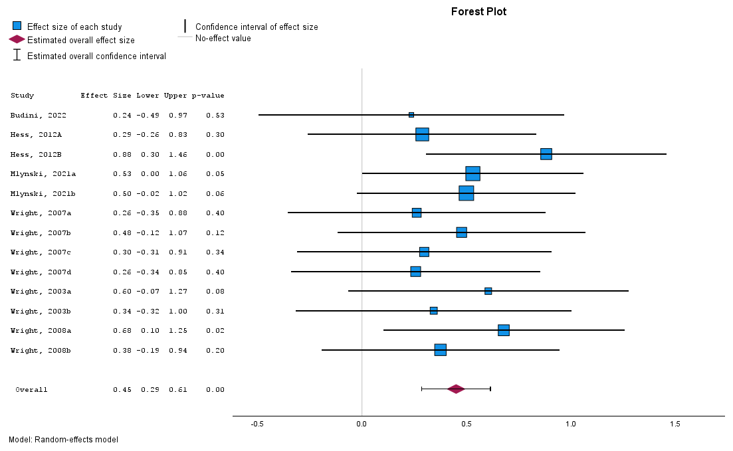

Supplementary Figure 2. Overall analysis of diastolic blood pressure. The size of the blue squares is proportional to the weight of the study. The red diamond represents the overall effect. Error bars are 95% confidence intervals

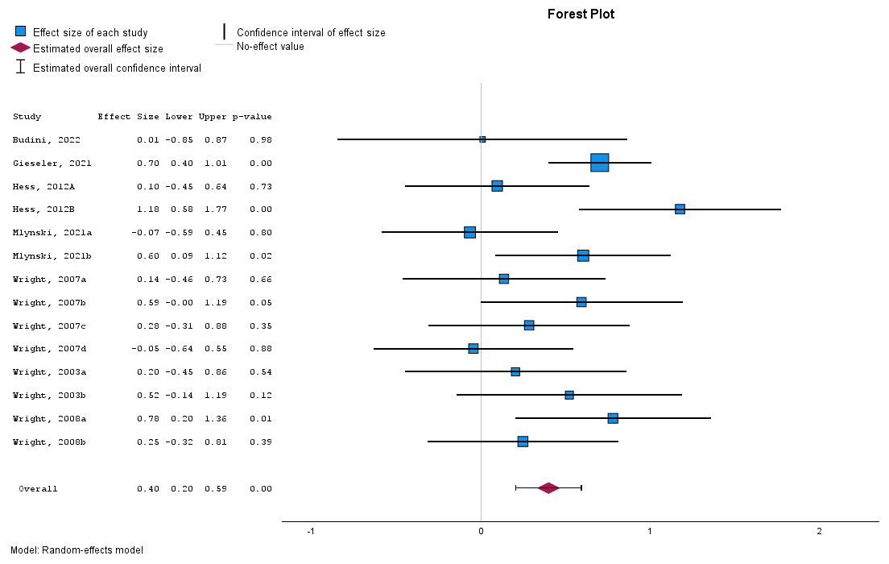

Supplementary Figure 3. Overall analysis of systolic blood pressure. The size of the blue squares is proportional to the weight of the study. The red diamond represents the overall effect. Error bars are 95% confidence intervals

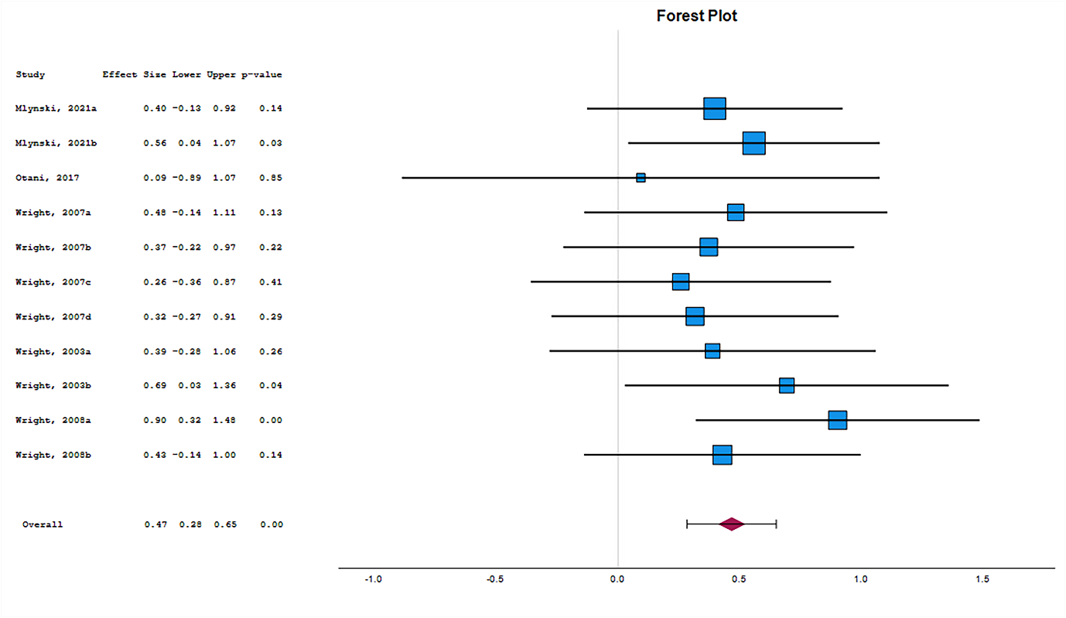
Supplementary Figure 4. Overall analysis of mean arterial pressure. The size of the blue squares is proportional to the weight of the study. The red diamond represents the overall effect. Error bars are 95% confidence intervals

