The Israeli Face Database (IFD): A Multi-Ethnic Database of Faces with Supporting Social Norming Data
Supplementary Materials
Table S1
The proportion of Correct Expression Recognition, Mean Ratings, and Standard Deviations for Each Facial Expression of the images taken from the Chicago Face Database in Study 1.
Expression | Valence |  |  | Intensity |  |  | Clarity |  |  | Honesty |  |  | Proportion of Correct Recognition |  | ≥ 0.667 recognized correctly | Number of Raters
Expression | M | SD |  | M | SD |  | M | SD |  | M | SD |  | M | SD | ≥ 0.667 recognized correctly | Number of Raters
Anger | 18.30 | 14.55 |  | 65.09 | 20.11 |  | 62.91 | 22.13 |  | 50.92 | 26.35 |  | 0.73 | 0.32 | 0.60 | 318
Happiness, closed mouth | 71.11 | 17.55 |  | 56.54 | 20.82 |  | 60.27 | 22.80 |  | 57.17 | 23.59 |  | 0.78 | 0.32 | 0.80 | 318
Happiness, open mouth | 86.90 | 13.21 |  | 79.53 | 16.88 |  | 81.05 | 18.20 |  | 71.49 | 22.28 |  | 0.97 | 0.13 | 1.00 | 318
Neutral without mask | 40.31 | 14.23 |  | 59.97 | 21.42 |  | 56.39 | 22.68 |  | 63.19 | 20.29 |  | 0.63 | 0.37 | 0.40 | 318
Note. Scores represent the means and standard deviations of the mean scores of each face.
We considered both “happiness” and “enjoyment” as correct recognitions of happiness (either with open or closed mouth).
≥ 0.667 recognized correctly = the proportion of face identities whose expressions were correctly recognized by at least 66.7% of participants.

Table S2.
Comparison Between Ratings of Expression of Faces from Chicago Face Database and Israeli Face Database in Study 1.

Rating criteria and expressions | t | df | 95% CI  low | 95% CI high | p
Valence
Anger | 0.95 | 317 | -0.69 | 1.97 | .428
Happiness (closed mouth) | -2.62 | 317 | -4.18 | -0.59 | .026
Happiness (open mouth) | 1.86 | 317 | -0.07 | 2.49 | .105
Neutral | -2.24 | 317 | -3.47 | -0.23 | .058
Clarity
Anger | 1.45 | 317 | -0.63 | 4.16 | .197
Happiness (closed mouth) | -1.83 | 317 | -4.14 | 0.15 | .105
Happiness (open mouth) | 0.30 | 317 | -1.30 | 1.78 | .803
Neutral | -2.08 | 317 | -4.98 | -0.14 | .069
Honesty
Anger | -0.21 | 317 | -2.71 | 2.18 | .831
Happiness (closed mouth) | 0.70 | 317 | -1.44 | 3.06 | .536
Happiness (open mouth) | -1.67 | 317 | -3.78 | 0.31 | .137
Neutral | -2.72 | 317 | -4.59 | -0.74 | .023
Intensity
Anger | 2.81 | 317 | 0.83 | 4.72 | .023
Happiness (closed mouth) | -2.78 | 317 | -4.46 | -0.76 | .023
Happiness (open mouth) | 0.80 | 317 | -0.90 | 2.14 | .499
Neutral | -2.18 | 317 | -4.62 | -0.23 | .060
Note. p values are corrected for false-rate discovery (FDR).
df = degrees of freedom.

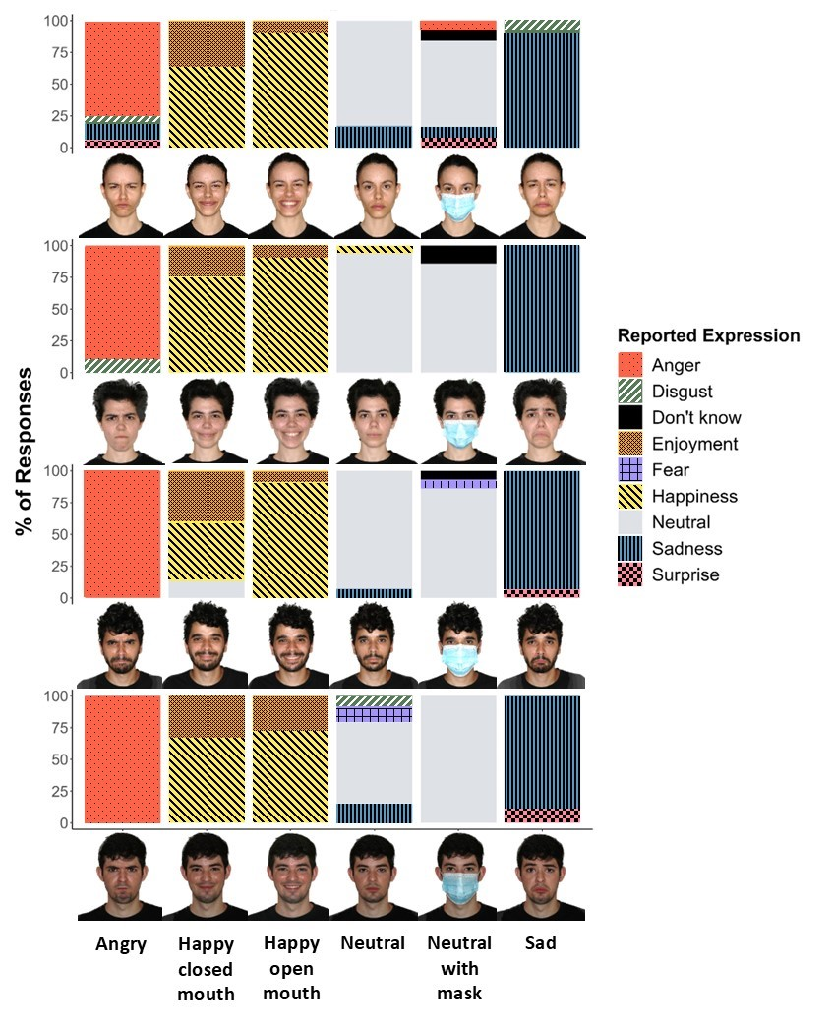
Fig S1. Examples of IFD face images and distribution of expression recognition responses to six expressions, adapted for impaired vision.

Additional demographic information regarding rating participants in Study 2
Israeli sample
Religiosity level. Among the participants included in the analysis, 57.49% self-identified as non-religious, 21.03% as conservative, 9.06% as moderately religious, 6.29% as religious, 1.12% as ultra-Orthodox, and 5.01% specified other identifications.
Education level. Among the participants included in the analysis, 27.10% had completed high school, 37.28% had completed a bachelor's degree (B.A. or B.Sc.), 18.64% had completed a master's degree (M.A., M.B.A., or M.Sc.), 1.95% had completed a Ph.D. or M.D., 12.50% had earned another professional diploma, and 0.75% specified other education levels.
U.S. sample
Religion. Among the participants included in the analysis, 42.95% self-identified as non-religious, 25.60% as Protestant Christian, 20.77 as Catholic or Orthodox Christian, 2.25% as Muslim, 1.50% as Jewish, 1.08% as Buddhist, Confucian, or Shinto, and 5.85% specified other identifications.
Education level. Among the participants included in the analysis, 1.00% had completed Junior high or middle school, 31.69% had completed high school, 39.87% had completed a bachelor's degree (B.A. or B.Sc.), 14.01% had completed a master's degree (M.A., M.B.A., M.Sc.), 3.50% had completed a Ph.D., M.D. or J.D., 0.33% had earned another professional diploma, and 9.59% specified other education levels.

Table S3
Results of the Comparisons of Social Traits Between the U.S. and Israeli Samples in Study 2.
Rating Criterion | Israel |  |  | US
Rating Criterion | M | SD |  | M | SD |  | t | df | p
Perceived age | 31.51 | 3.04 |  | 31.57 | 3.08 |  | -0.13 | 153.98 | .917
Typicality | 42.99 | 9.47 |  | 32.23 | 11.23 |  | 6.47 | 149.73 | < .001
Aggressiveness | -18.86 | 20.85 |  | -13.11 | 19.17 |  | -1.79 | 152.93 | .153
Attractiveness | -3.03 | 19.83 |  | 5.86 | 19.50 |  | -2.82 | 153.96 | .018
Care | 11.97 | 15.63 |  | 9.05 | 15.19 |  | 1.18 | 153.87 | .331
Dominance | 7.77 | 15.33 |  | 9.10 | 20.37 |  | -0.46 | 143.04 | .775
Emotional stability | 17.33 | 14.64 |  | 10.60 | 15.44 |  | 2.79 | 153.57 | 0.018
Friendliness | 13.97 | 14.93 |  | 2.96 | 18.43 |  | 4.10 | 147.62 | < .001
Meanness | -17.33 | 17.92 |  | -4.46 | 17.41 |  | -4.55 | 153.87 | < .001
Responsibility | 24.16 | 14.50 |  | 25.68 | 14.68 |  | -0.65 | 153.98 | .660
Self-confidence | 18.60 | 14.33 |  | 18.35 | 15.66 |  | 0.10 | 152.80 | .917
Intelligence | 21.06 | 13.95 |  | 23.91 | 9.99 |  | -1.47 | 139.51 | .237
Trustworthiness | 16.72 | 17.10 |  | 12.43 | 13.68 |  | 1.73 | 146.93 | .154
Weirdness | -12.09 | 19.01 |  | -17.22 | 16.90 |  | 1.78 | 151.91 | .153
Femininity (female faces) | 32.39 | 15.69 |  | 41.05 | 14.03 |  | –3.00 | 102.72 | .015
Femininity (male face) | –63.45 | 8.99 |  | –64.07 | 7.42 |  | 0.27 | 46.33 | .889
Masculinity (female faces) | –22.19 | 15.78 |  | –26.04 | 15.60 |  | 1.26 | 103.99 | .314
Masculinity (male faces) | 64.56 | 6.52 |  | 67.82 | 5.79 |  | –1.87 | 47.33 | .153
Note. p values are corrected for false-rate discovery (FDR).
df = degrees of freedom.

Table S4.
Test results of the comparisons of rated social traits to the scale’s middle point.
Rated trait | US |  |  |  | Israel
Rated trait | t | df | P |  | t | df | p
Perceived age | 90.59 | 77 | < .001 |  | 91.54 | 77 | < .001
Typicality | 25.34 | 77 | < .001 |  | 40.09 | 77 | < .001
Aggressiveness | -6.04 | 77 | < .001 |  | -7.99 | 77 | < .001
Attractiveness | 2.66 | 77 | .011 |  | -1.35 | 77 | .182
Care | 5.26 | 77 | < .001 |  | 6.76 | 77 | < .001
Dominance | 3.95 | 77 | < .001 |  | 4.48 | 77 | < .001
Emotional stability | 6.06 | 77 | < .001 |  | 10.45 | 77 | < .001
Friendliness | 1.42 | 77 | .166 |  | 8.27 | 77 | < .001
Meanness | -2.26 | 77 | .029 |  | -8.54 | 77 | < .001
Responsibility | 15.45 | 77 | < .001 |  | 14.71 | 77 | < .001
Self-confidence | 10.35 | 77 | < .001 |  | 11.47 | 77 | < .001
Intelligence | 21.14 | 77 | < .001 |  | 13.33 | 77 | < .001
Trustworthiness | 8.02 | 77 | < .001 |  | 8.64 | 77 | < .001
Weirdness | -9.00 | 77 | < .001 |  | -5.61 | 77 | < .001
Note. Scales’ range was -100 to 100, except for perceived age, which was 18-99.
All p values are corrected for FDR.

Table S5.
Results of Spearman’s correlation tests between the mean social ratings of face identities given by U.S. and Israeli raters.
Rated trait | r | P
Perceived age | .95 | < .001
Typicality | .50 | < .001
Aggressiveness | .77 | < .001
Attractiveness | .79 | < .001
Care | .70 | < .001
Dominance | .49 | < .001
Emotional stability | .74 | < .001
Friendliness | .71 | < .001
Meanness | .69 | < .001
Responsibility | .52 | < .001
Self-confidence | .79 | < .001
Intelligence | .61 | < .001
Trustworthiness | .74 | < .001
Weirdness | .66 | < .001
Males' masculinity | .91 | < .001
Males' femininity | .86 | < .001
Females' masculinity | .94 | < .001
Females' femininity | .94 | < .001

Table S6
Results of Levene’s tests comparing heterogeneity of ratings given by U.S. compared to Israeli participants in Study 2.
Rated trait | F(1,154) | p
Perceived age | 0.07 | .788
Typicality | 3.27 | .073
Aggressiveness | 0.19 | .664
Attractiveness | 0.07 | .792
Care | 0.11 | .743
Dominance | 4.83 | .029
Emotional stability | 0.09 | .767
Friendliness | 3.25 | .073
Meanness | 0.16 | .689
Responsibility | 1.76 | .186
Self-confidence | 1.91 | .169
Intelligence | 7.87 | .006
Trustworthiness | 0.54 | .463
Weirdness | 2.16 | .144
Males' masculinity | 0.39 | .533
Males' femininity | 0.53 | .469
Females' masculinity | 0.14 | .708
Females' femininity | 1.22 | .272

a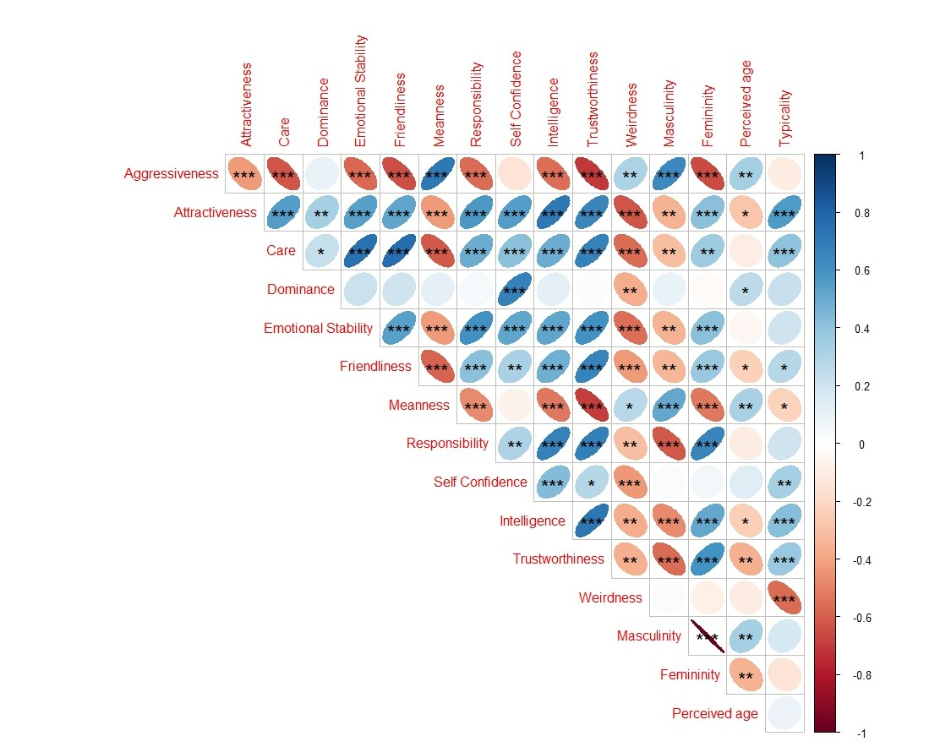
b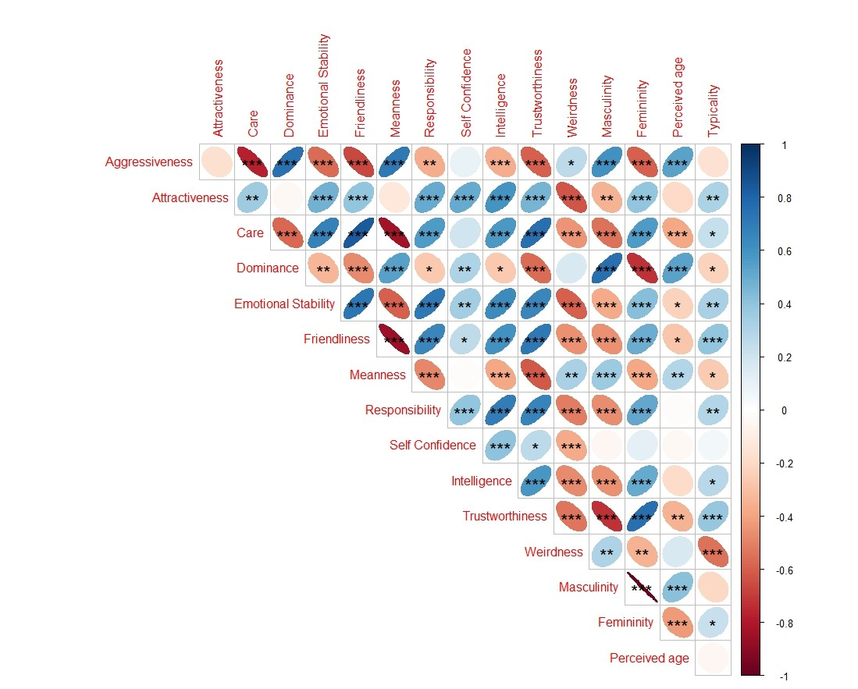
Fig. S2
Cross-correlation matrix of average face ratings across multiple traits as rated by (a) the Israeli sample and (b) the U.S. sample. The matrix shows the Spearmen correlation coefficients between each pair of traits. All correlations were computed using the mean ratings for each face across all participants. * = p < .05, ** = p < .01, *** = p < .001.

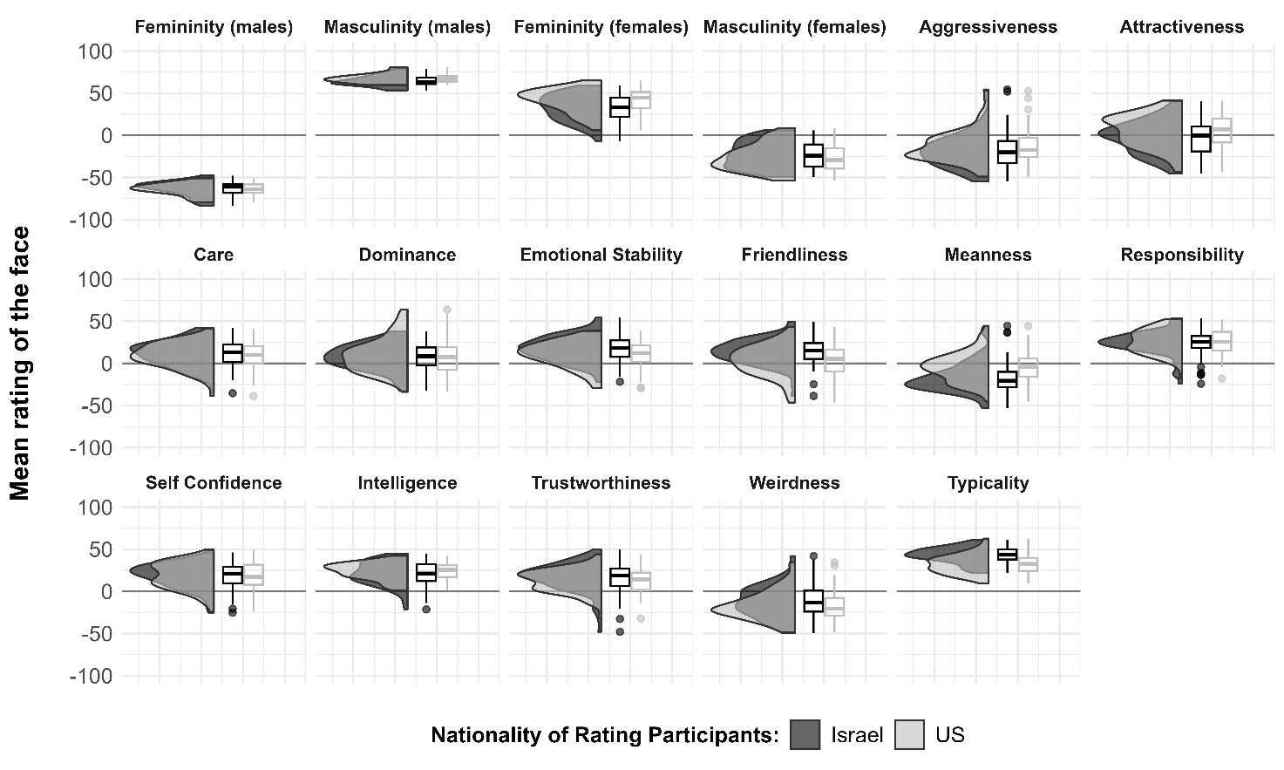
Fig. S3
Distributions of social ratings, as rated by U.S. and Israeli participants in Study 2, adapted for impaired vision. * = p < .05; *** = p < .001.

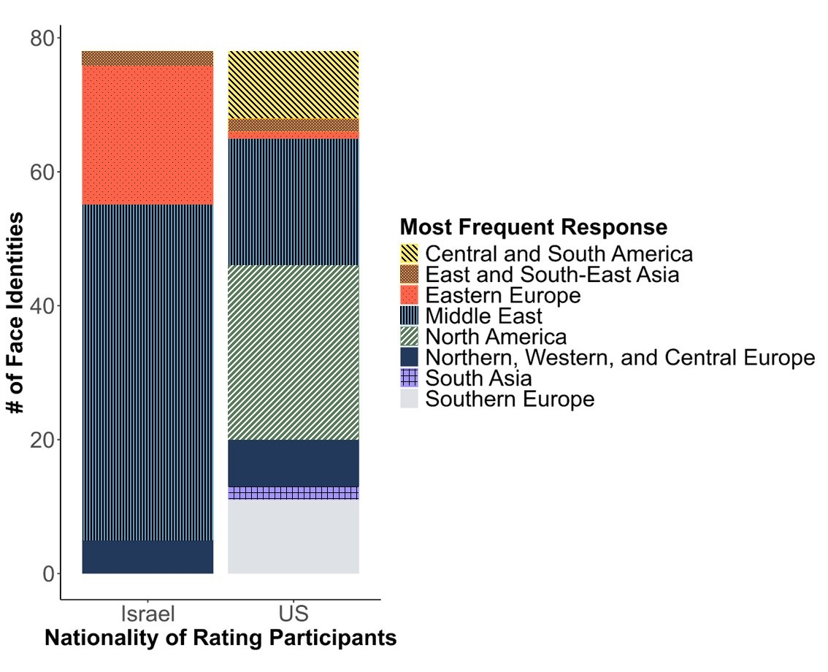
Fig. S4
Distribution of the most frequent ethnicity categorizations of faces, as categorized by U.S. and Israeli participants, adapted for impaired vision.

