SUPPLEMENTARY INFORMATION
Table 1.
Demographic information.
 | VR Condition |  | TV Condition
 | Count | Percentage | Count | Percentage
Gender
Agender | 0 | 0% | 3 | 4.3%
Man | 14 | 20.0% | 13 | 18.6%
Woman | 16 | 22.9% | 18 | 25.7%
Non-binary | 1 | 1.4% | 0 | 0%
Prefer not to answer | 4 | 5.7% | 1 | 1.4%
Race/Ethnicity
White | 28 | 40% | 25 | 35.7%
Black | 4 | 5.7% | 5 | 7.1%
Asian | 3 | 4.3% | 9 | 12.3%
Middle Eastern | 1 | 1.4% | 0 | 0%
Mixed race | 0 | 0% | 1 | 1.4%
Latinx | 1 | 1.4% | 1 | 1.4%

Note. Percentages are based on the number of participants selecting the responses and may total more than 100%.

Table 2.
Survey measures.
Scale Name | Citation | Example Item | # of Items | Response Type | M | SD | Α
Pretest Measures
Need for Affect | Appel et al. (2012) | “I feel that I need to experience strong emotions regularly.” | 10 | 1 = strongly disagree to 7 = strongly agree | 4.97 | .93 | .85
Need for Cognition | Lins de Holanda Coelho et al. (2020) | “I would prefer complex to simple problems.” | 6 | 1 = strongly disagree to 7 = strongly agree | 4.64 | .95 | .75
Big Five (short version) | Soto & John (2017) | “I am someone who… worries a lot.” | 30 | 1 = strongly disagree to 5 = strongly agree
Immersive Tendencies Questionnaire | Witmer & Singer (1998) | “Do you easily become deeply involved in movies or tv dramas?” | 18 | 1 = never, 4 = occasionally, and 7 = often | 4.75 | .75 | .76
Posttest Measures
Perceived Controller Naturalness | McGloin et al. (2011) | “The virtual environment was manipulated in a lifelike manner.” | 12 | 1 = strongly disagree to 7 = strongly agree | 4.81 | .77 | .80
Spatial Presence Experience Scale | Hartmann et al. (2016) | “I felt like I was actually there in the environment of the presentation.” | 10 | 1 = I do not agree at all to 5 = I fully agree | 3.60 | .73 | .88
Simulator Sickness Questionnaire | Kennedy et al. (1993) | fatigue, headache, eyestrain | 16 | 1 = none, 2 = mild, and 3 = severe | 1.24 | .20 | .75

Note. The three posttest measures – Perceived Controller Naturalness, Spatial Presence Experience Scale, and the Simulator Sickness Questionnaire – were the only scales analyzed for the current study. The remaining scales will be analyzed and reported in a separate paper.

Table 3.
Repeated measures ANOVAs for each movie clip as within-subject factor on emotional tone ratings from stimulus check.
 |  | SS | df | MS | F | p
Scary | The Conjuring 2 | 179637.26 | 2 | 89818.63 | 270.49 | < .001
 | The Ring | 70623.62 | 2 | 35311.81 | 114.28 | < .001
 | Guest | 79260.07 | 2 | 39630.03 | 89.56 | < .001
Funny | Hot Rod | 129256.90 | 2 | 64628.45 | 273.12 | < .001
 | The Other Guys | 165922.01 | 2 | 82961.00 | 370.36 | < .001
 | I Think You Should Leave | 129996.18 | 2 | 64998.09 | 287.04 | < .001
Sad | My Girl | 137483.77 | 2 | 68741.88 | 292.24 | < .001
 | Marley & Me | 303166.31 | 2 | 151583.15 | 835.81 | < .001
 | The Green Mile | 205778.98 | 2 | 102889.49 | 446.87 | < .001

Table 4.
Post hoc comparisons of emotion ratings on each movie clip.
 |  | Mean Diff. | SE | t | P_{holm}
The Conjuring 2 | Sad x Funny | -3.27 | 3.08 | -1.06 | 0.29
 | Sad x Scary | -63.61 | 3.08 | -20.65 | < .001
 | Funny x Scary | -60.34 | 3.08 | -19.59 | < .001
The Ring | Sad x Funny | -4.57 | 2.97 | -1.53 | .12
 | Sad x Scary | -40.98 | 2.97 | -13.79 | < .001
 | Funny x Scary | -36.41 | 2.97 | -12.25 | < .001
Guest | Sad x Funny | -3.97 | 3.66 | -1.084 | .28
 | Sad x Scary | -44.28 | 3.66 | -12.09 | < .001
 | Funny x Scary | -40.31 | 3.66 | -11.01 | < .001
Hot Rod | Sad x Funny | -54.67 | 2.69 | -20.26 | < .001
 | Sad x Scary | -.12 | 2.69 | -.04 | .96
 | Funny x Scary | 54.55 | 2.69 | 20.21 | < .001
The Other Guys | Sad x Funny | -60.17 | 2.54 | -23.61 | < .001
 | Sad x Scary | -.23 | 2.54 | -.09 | .92
 | Funny x Scary | 59.94 | 2.54 | 23.52 | < .001
I Think You Should Leave | Sad x Funny | -53.97 | 2.60 | -20.75 | < .001
 | Sad x Scary | -.04 | 2.60 | -.01 | .98
 | Funny x Scary | 53.92 | 2.60 | 20.74 | < .001
My Girl | Sad x Funny | 54.33 | 2.61 | 20.80 | < .001
 | Sad x Scary | 55.00 | 2.61 | 21.06 | < .001
 | Funny x Scary | .66 | 2.61 | .25 | .79
Marley & Me | Sad x Funny | 81.22 | 2.27 | 35.68 | < .001
 | Sad x Scary | 79.95 | 2.27 | 35.12 | < .001
 | Funny x Scary | -1.27 | 2.27 | -.55 | .57
The Green Mile | Sad x Funny | 71.37 | 2.58 | 27.63 | < .001
 | Sad x Scary | 61.23 | 2.58 | 23.70 | < .001
 | Funny x Scary | -10.14 | 2.58 | -3.92 | < .001

Figure 1.
Frequency of responses for Perceived Controller Naturalness items.
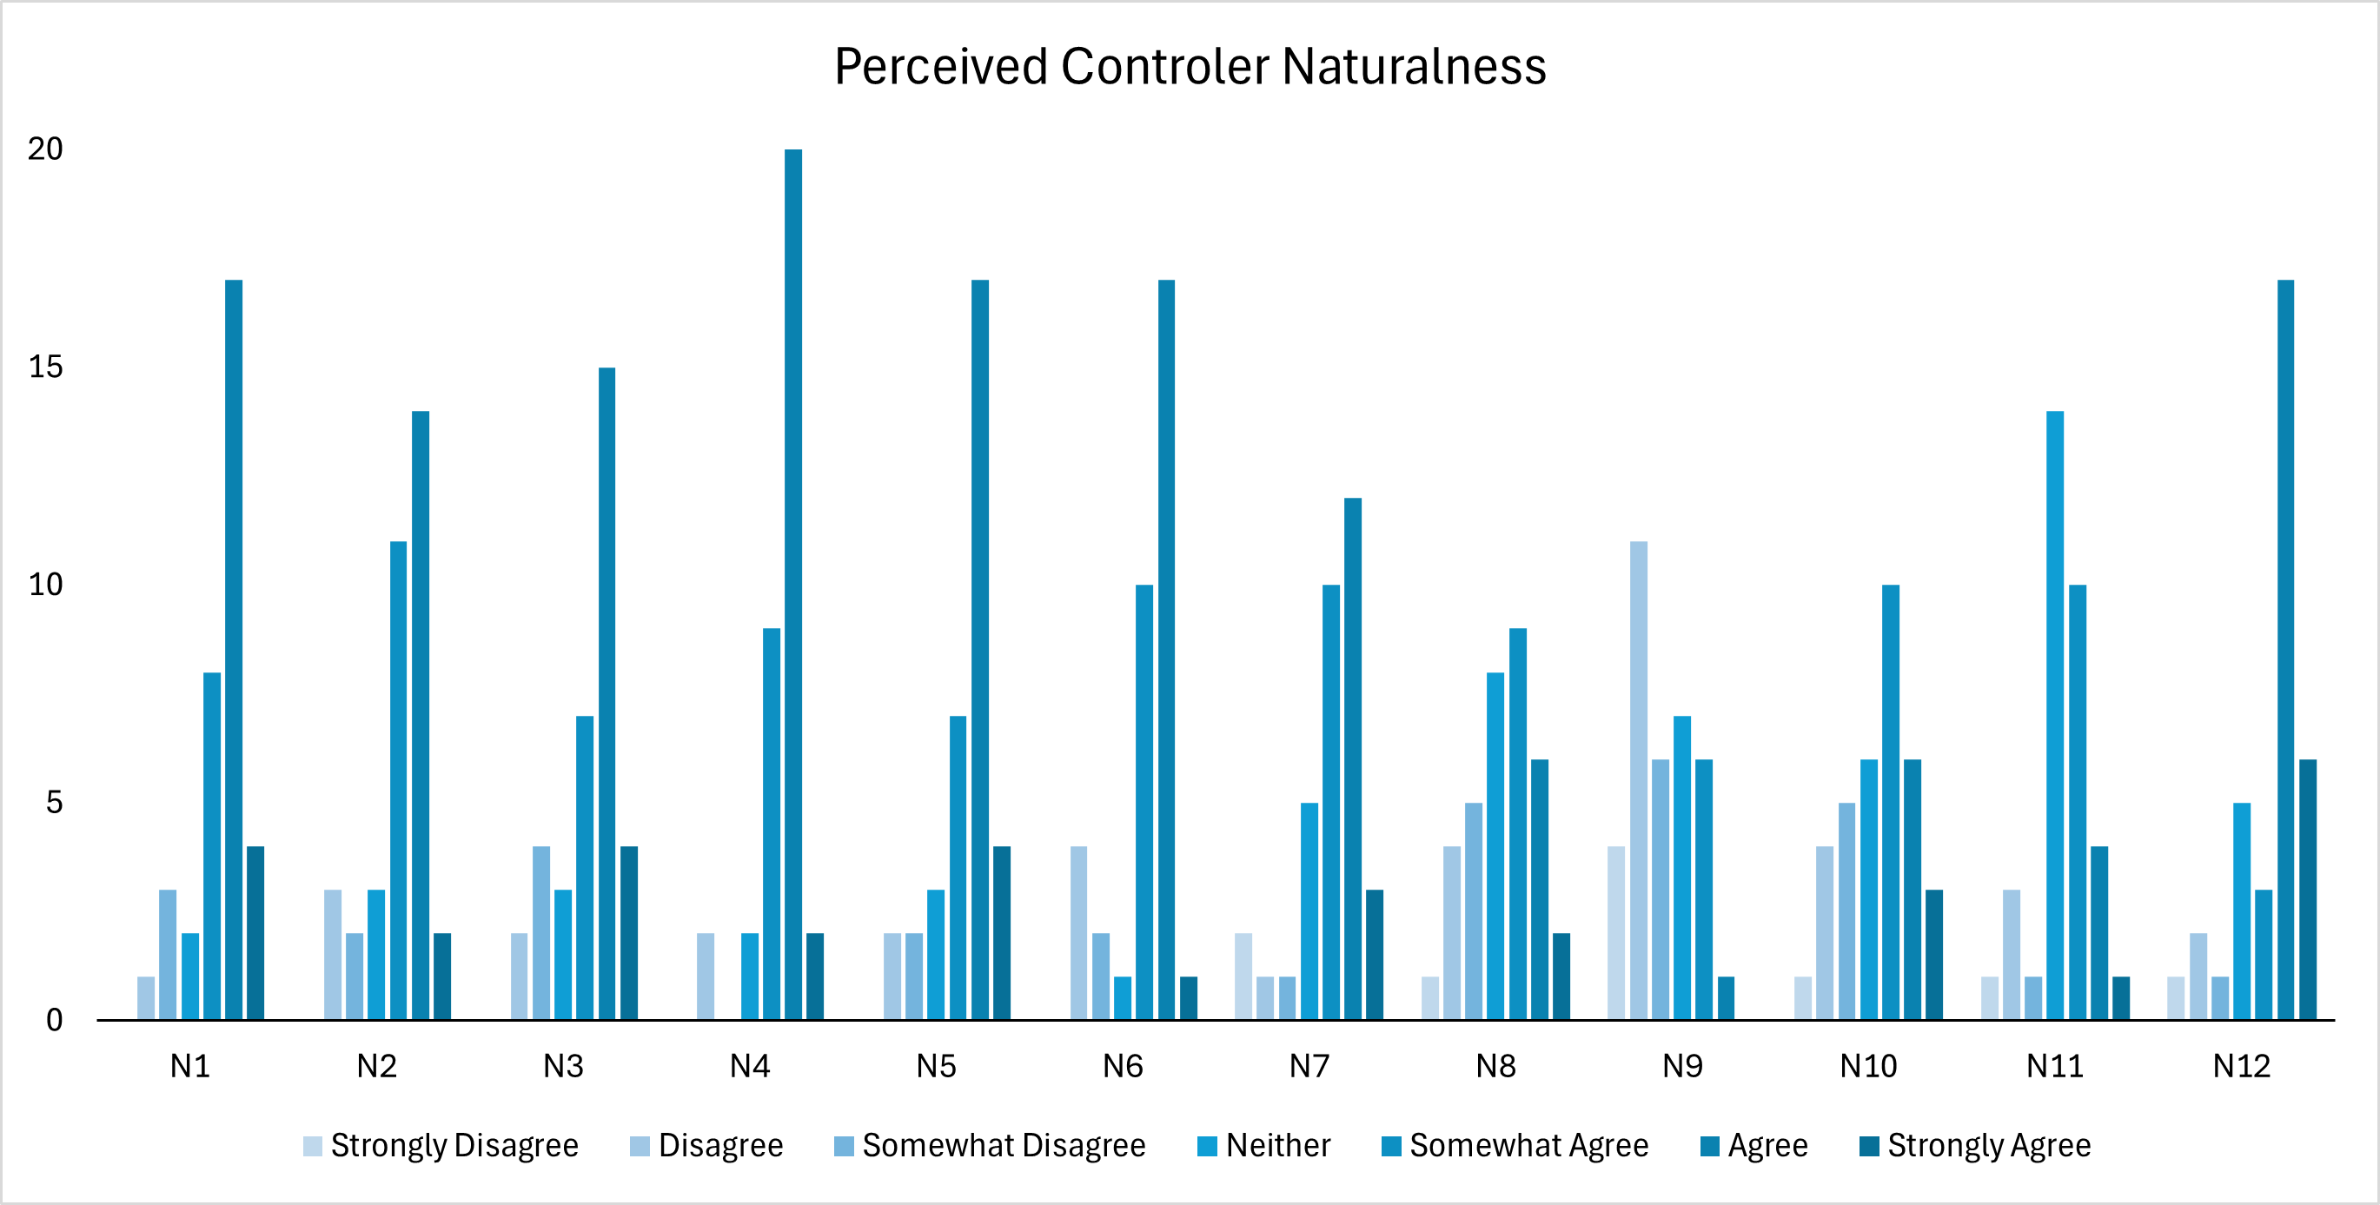

Table 5.
Perceived Controller Naturalness items.
Item | Description
N1 | The virtual environment controls seemed natural.
N2 | The actions used to interact with the virtual environment were similar to the actions that would be used to do the same things in the real world.
N3 | The virtual environment interface was not realistic (reversed item).
N4 | The virtual environment was manipulated in a lifelike manner.
N5 | The actions I performed with the controller were closely connected to the actions happening in the virtual environment.
N6 | The actions used to control the virtual environment seemed natural.
N7 | The way in which I controlled my virtual body felt realistic.
N8 | The controller itself made the virtual environment seem more realistic.
N9 | It was much more difficult to control my virtual body than I expected it to be.
N10 | I felt like the controller was an extension of my body.
N11 | When I was sorting pictures, the controls made it seem realistic.
N12 | The controller allowed me to do everything I needed to, to be successful in the virtual environment.

Figure 2.
Frequency of responses for Spatial Presence Experience items.
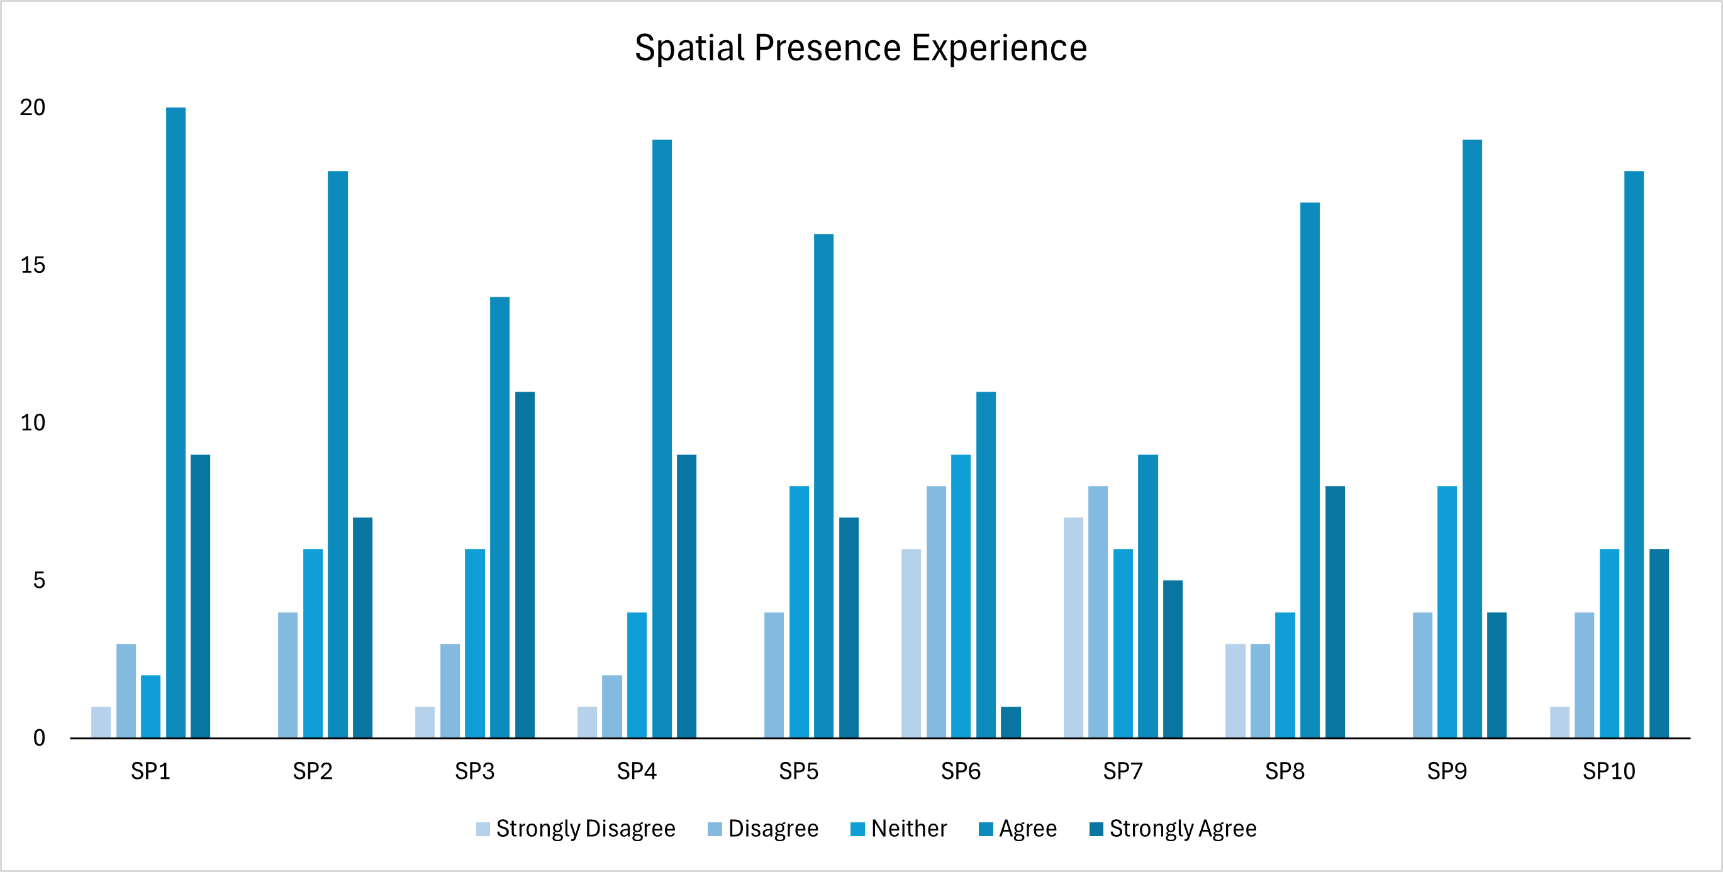

Table 6.
Spatial Presence Experience items.
Item | Description
SP1 | I felt like I was actually there in the environment of the presentation.
SP2 | It seemed as though I actually took part in the action of the presentation.
SP3 | It was as though my true location had shifted into the environment in the presentation.
SP4 | I felt as though I was physically present in the environment of the presentation.
SP5 | I experienced the environment in the presentation as though I had stepped into a different place.
SP6 | I was convinced that things were actually happening around me.
SP7 | I had the feeling that I was in the middle of the action rather than merely observing.
SP8 | I felt like the objects in the presentation surrounded me.
SP9 | I experienced both the confined and open spaces in the presentation as though I was really there.
SP10 | I was convinced that the objects in the presentation were located on the various sides of my body.

Figure 3.
Frequency of responses for Virtual Sickness Symptoms items.
