a
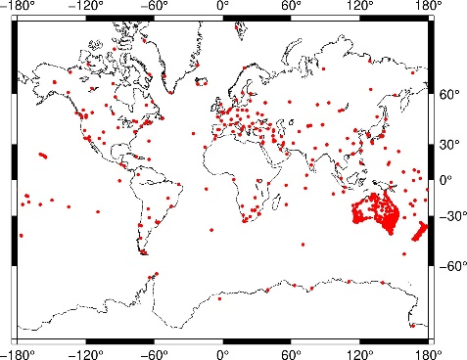
d
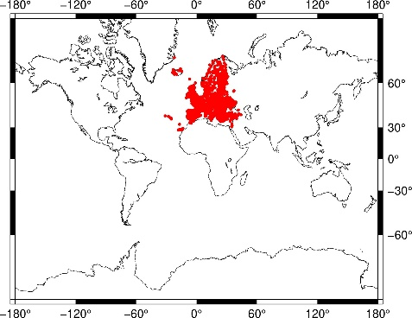
g
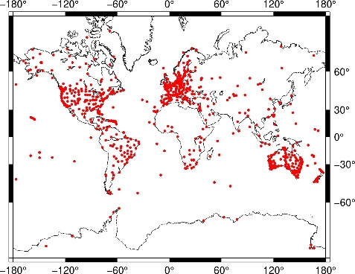
j
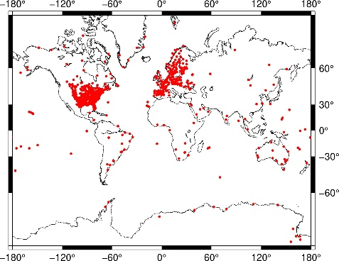
m
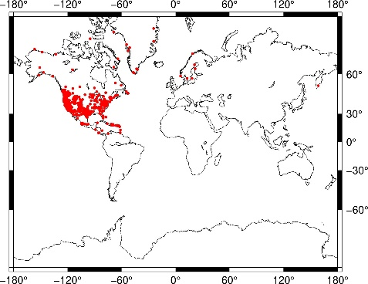

b
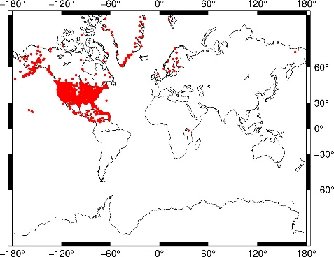
e
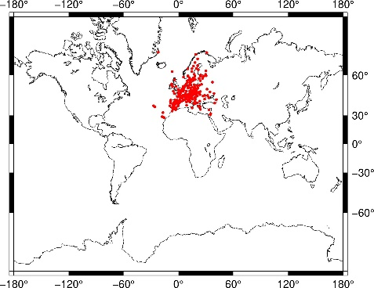
h
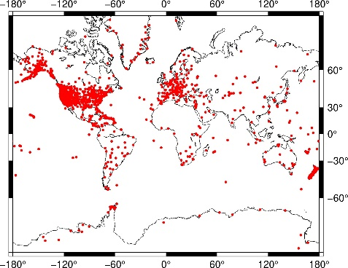
k
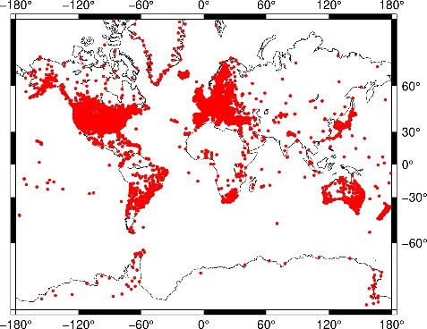
n
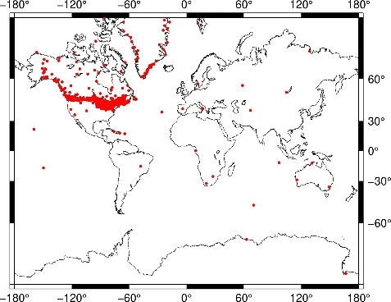
c
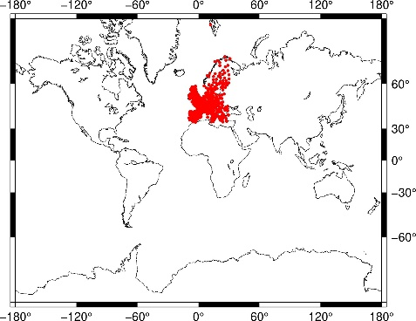
f
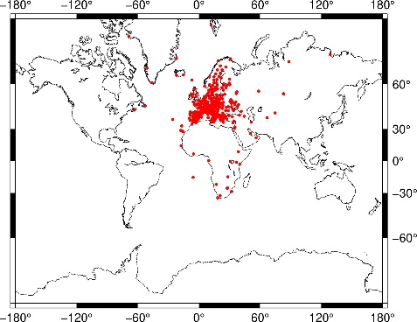
i
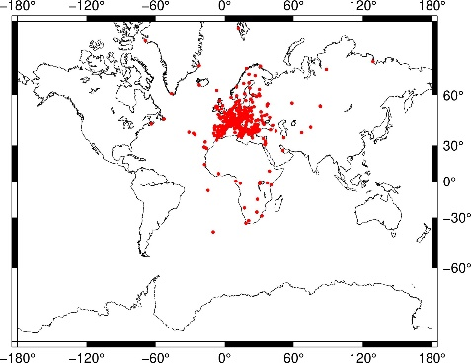
l
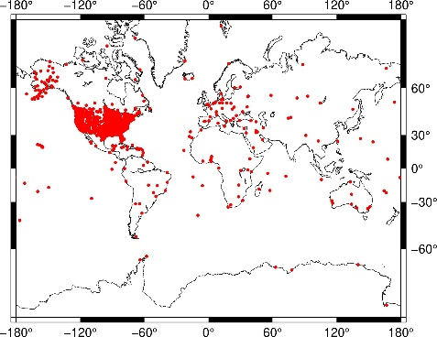
o
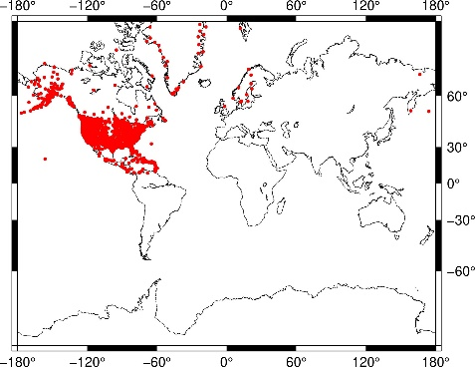

p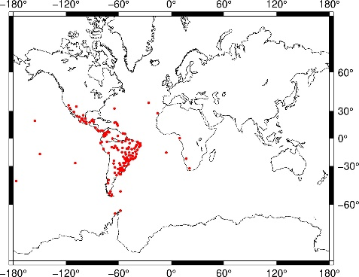
s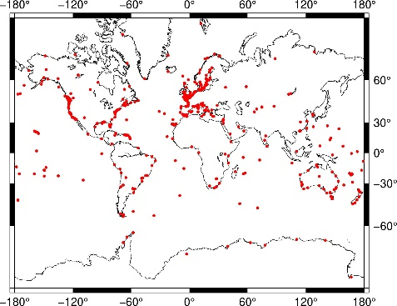
q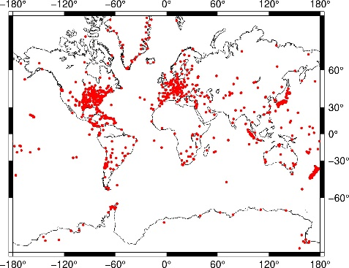
t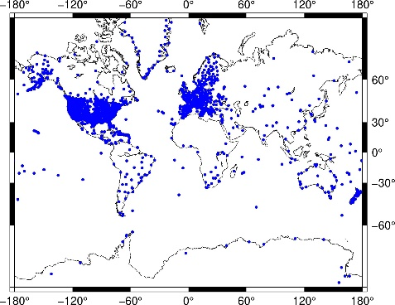
r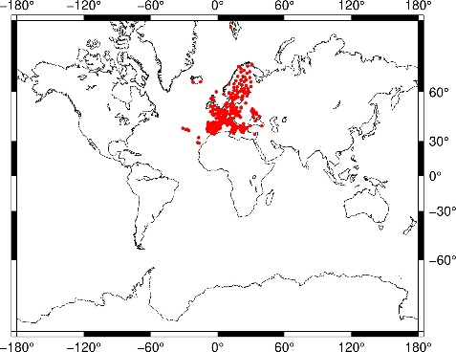

Fig. 1. Geographical distribution of the input velocity fields : APREF (a), CWU (b), EOST (c), EPND (d), EUREF (e), INGV (f), ITRF2020 (g), JPL (h), LTK (i), NCL (j), NGL (k), NGS (l), NMT(m), NRCAN (n), PBO (o), SIRGAS (p), SOPAC (q), UGA (r) and ULR (s). The distribution of the sites having more than four velocity estimates is shown in (t).

Table1. Number of common sites between the input velocity fields

 | APREF | CWU | EOST | EPND | EUREF | INGV | ITRF | JPL | LTK | NCL | NGL | NGS | NMT | NRCAN | PBO | SIRGAS | SOPAC | UGA | ULR
APREF | 720 | 53 | 29 | 38 | 39 | 81 | 290 | 291 | 79 | 114 | 618 | 125 | 16 | 56 | 49 | 21 | 275 | 25 | 169
CWU | 53 | 2102 | 13 | 14 | 13 | 19 | 168 | 1434 | 17 | 353 | 1967 | 732 | 553 | 216 | 1963 | 8 | 236 | 12 | 91
EOST | 29 | 13 | 986 | 735 | 178 | 438 | 165 | 125 | 362 | 118 | 924 | 29 | 6 | 4 | 11 | 0 | 125 | 383 | 105
EPND | 38 | 14 | 735 | 2528 | 194 | 397 | 185 | 131 | 373 | 159 | 1509 | 32 | 6 | 4 | 12 | 2 | 131 | 392 | 111
EUREF | 39 | 13 | 178 | 194 | 227 | 224 | 120 | 119 | 202 | 127 | 225 | 35 | 6 | 4 | 11 | 2 | 119 | 132 | 50
INGV | 81 | 19 | 438 | 397 | 224 | 594 | 182 | 204 | 477 | 161 | 552 | 66 | 9 | 14 | 18 | 6 | 205 | 398 | 88
ITRF | 290 | 168 | 165 | 185 | 120 | 182 | 881 | 430 | 179 | 206 | 776 | 260 | 60 | 93 | 175 | 61 | 349 | 100 | 332
JPL | 291 | 1434 | 125 | 131 | 119 | 204 | 430 | 2434 | 187 | 287 | 2161 | 647 | 375 | 177 | 1555 | 41 | 812 | 82 | 256
LTK | 79 | 17 | 362 | 373 | 202 | 477 | 179 | 187 | 581 | 152 | 485 | 69 | 8 | 13 | 16 | 5 | 190 | 323 | 79
NCL | 114 | 353 | 118 | 159 | 127 | 161 | 206 | 287 | 152 | 689 | 609 | 351 | 122 | 112 | 357 | 20 | 262 | 90 | 114
NGL | 618 | 1967 | 924 | 1509 | 225 | 552 | 776 | 2161 | 485 | 602 | 11546 | 1594 | 591 | 520 | 2101 | 111 | 779 | 500 | 453
NGS | 125 | 732 | 29 | 32 | 35 | 66 | 260 | 647 | 69 | 351 | 1594 | 1748 | 223 | 331 | 751 | 20 | 303 | 20 | 127
NMT | 16 | 553 | 6 | 6 | 6 | 9 | 60 | 375 | 8 | 122 | 591 | 223 | 633 | 70 | 631 | 1 | 95 | 6 | 40
NRCAN | 56 | 216 | 4 | 4 | 4 | 14 | 93 | 177 | 13 | 112 | 520 | 331 | 70 | 593 | 216 | 6 | 131 | 2 | 47
PBO | 49 | 1963 | 11 | 12 | 11 | 18 | 175 | 1555 | 16 | 357 | 2101 | 751 | 631 | 216 | 2233 | 5 | 223 | 10 | 93
SIRGAS | 21 | 8 | 0 | 2 | 2 | 6 | 61 | 41 | 5 | 20 | 111 | 20 | 1 | 6 | 5 | 152 | 38 | 1 | 34
SOPAC | 275 | 236 | 125 | 131 | 119 | 205 | 349 | 812 | 190 | 262 | 779 | 303 | 95 | 131 | 223 | 38 | 978 | 82 | 211
UGA | 25 | 12 | 383 | 392 | 132 | 398 | 100 | 82 | 323 | 90 | 500 | 20 | 6 | 2 | 10 | 1 | 82 | 547 | 53
ULR | 169 | 91 | 105 | 111 | 50 | 88 | 332 | 256 | 79 | 114 | 453 | 127 | 40 | 47 | 93 | 34 | 211 | 53 | 503

Table 2. List of stations with renamed IDs for each velocity field. See the file supplemental_table2.txt

Table 3. Transformation parameters in mm/yr between each input velocity field and the ITRF2020 velocity field. A null uncertainty means the uncertainty value is smaller than the rounded value.
 | TX | TY | TZ | S | RX | RY | RZ
APREF | 0.02 +/- 0.00 | -0.08 +/- 0.00 | 0.13 +/- 0.00 | -0.06 +/- 0.00 | 0.06 +/- 0.00 | -0.08 +/- 0.00 | 0.15 +/- 0.00
CWU | 0.70 +/- 0.00 | 0.35 +/- 0.00 | 0.19 +/- 0.00 | -0.06 +/- 0.00 | 0.33 +/- 0.03 | -0.55 +/- 0.03 | -0.32 +/- 0.03
EOST | 0.29 +/- 0.10 | 0.34 +/- 0.10 | 0.17 +/- 0.10 | 0.08 +/- 0.06 | 0.40 +/- 0.06 | -0.33 +/- 0.06 | -0.14 +/- 0.06
EPND | -0.03 +/- 0.00 | 0.20 +/- 0.00 | 0.42 +/- 0.00 | -0.24 +/- 0.00 | 0.23 +/- 0.03 | 0.14 +/- 0.03 | -0.11 +/- 0.03
EUREF | 0.07 +/- 0.10 | 0.13 +/- 0.10 | 0.10 +/- 0.10 | -0.03 +/- 0.06 | 0.29 +/- 0.06 | -0.12 +/- 0.09 | 0.08 +/- 0.06
INGV | 0.12 +/- 0.00 | -0.05 +/- 0.00 | 0.24 +/- 0.00 | -0.27 +/- 0.00 | 0.07 +/- 0.03 | -0.07 +/- 0.06 | 0.14 +/- 0.03
ITRF | 0.00 | 0.00 | 0.00 | 0.00 | 0.00 | 0.00 | 0.00
JPL | 0.05 +/- 0.00 | -0.01 +/- 0.00 | 0.22 +/- 0.00 | -0.12 +/- 0.00 | 0.06 +/- 0.00 | -0.09 +/- 0.00 | 0.06 +/- 0.00
LTK | -0.30 +/- 0.00 | -0.68 +/- 0.10 | 0.24 +/- 0.00 | 0.52 +/- 0.06 | -0.17 +/- 0.06 | 0.34 +/- 0.06 | 0.70 +/- 0.03
NCL | 0.15 +/- 0.00 | -0.06 +/- 0.00 | 0.19 +/- 0.00 | -0.01 +/- 0.00 | 0.00 +/- 0.00 | -0.12 +/- 0.00 | 0.07 +/- 0.00
NGL | 0.02 +/- 0.00 | -0.07 +/- 0.00 | 0.23 +/- 0.00 | -0.08 +/- 0.00 | 0.00 +/- 0.00 | -0.05 +/- 0.00 | 0.07 +/- 0.00
NGS | 0.03 +/- 0.00 | -0.10 +/- 0.00 | 0.15 +/- 0.00 | -0.06 +/- 0.00 | 0.02 +/- 0.00 | -0.09 +/- 0.00 | 0.07 +/- 0.00
NMT | 0.71 +/- 0.00 | -0.37 +/- 0.00 | -0.81 +/- 0.00 | -0.03 +/- 0.00 | -0.90 +/- 0.06 | -0.35 +/- 0.03 | -0.53 +/- 0.03
NRCAN | -0.08 +/- 0.00 | 0.09 +/- 0.00 | 0.08 +/- 0.00 | 0.25 +/- 0.00 | 0.31 +/- 0.03 | 0.20 +/- 0.03 | 0.11 +/- 0.03
PBO | 0.87 +/- 0.00 | -0.39 +/- 0.00 | -0.83 +/- 0.00 | -0.01 +/- 0.00 | -0.93 +/- 0.03 | -0.41 +/- 0.03 | -0.68 +/- 0.03
SIRGAS | -0.15 +/- 0.10 | 0.14 +/- 0.00 | -0.16 +/- 0.00 | -0.57 +/- 0.06 | -0.34 +/- 0.06 | -0.27 +/- 0.03 | 0.12 +/- 0.06
SOPAC | 0.01 +/- 0.00 | -0.07 +/- 0.00 | 0.18 +/- 0.00 | 0.17 +/- 0.00 | 0.05 +/- 0.00 | -0.08 +/- 0.00 | 0.06 +/- 0.00
UGA | 0.05 +/- 0.10 | 0.25 +/- 0.10 | -0.07 +/- 0.10 | 0.04 +/- 0.06 | 0.38 +/- 0.06 | -0.24 +/- 0.09 | -0.10 +/- 0.06
ULR | 0.16 +/- 0.00 | -0.13 +/- 0.00 | 0.29 +/- 0.00 | -0.06 +/- 0.00 | 0.10 +/- 0.00 | -0.06 +/- 0.00 | 0.06 +/- 0.00

Table 4. Combined global velocity field in mm/yr. See the file supplemental_table4.txt

Table 5. Horizontal and vertical velocity repeatability (WRMS) in mm/yr for each site having more than four velocity estimates among the input velocity fields. The number of velocity estimates considered are indicated in the fourth column. Sites with poor repeatability are marked with *. See the file supplemental_table5.txt

Table 6. Velocity residuals in mm/yr for each site and input velocity field compared to the combined velocity field. See supplemental_table6.txt

Table 7. List of velocity estimates having a large absolute velocity residual (in mm/yr) that were removed from the combination. See the file supplemental_table7.txt

