ANNEXES

Annex 1. Typology by area in Bogotá
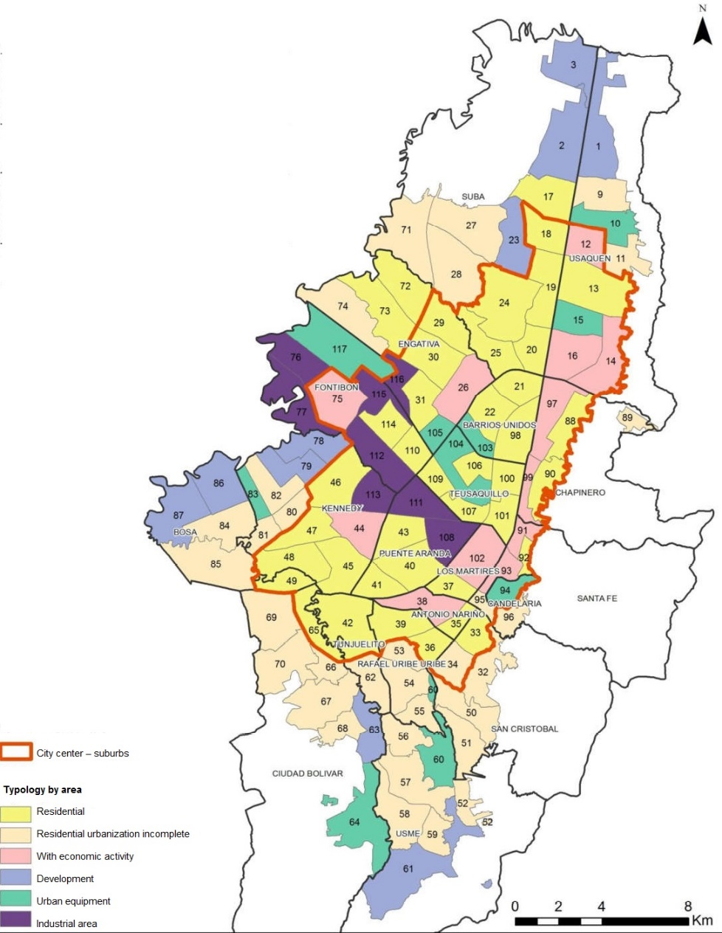

Source: García y Gascón (2016).

Annex 2. Fitting of the least weighted squares linear model that estimates the current per capita income
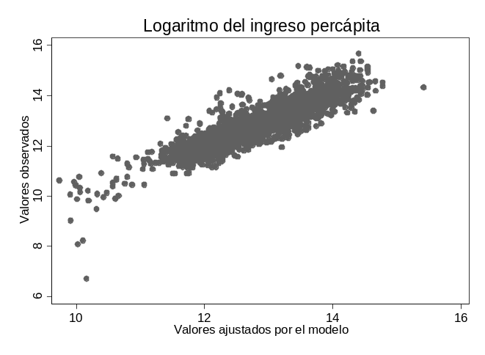
Source: Elaboration by the authors based on ECV-B2007 (DANE, 2007).
Annex 3. Estimation of the least weighted squares linear model for the current per capita income
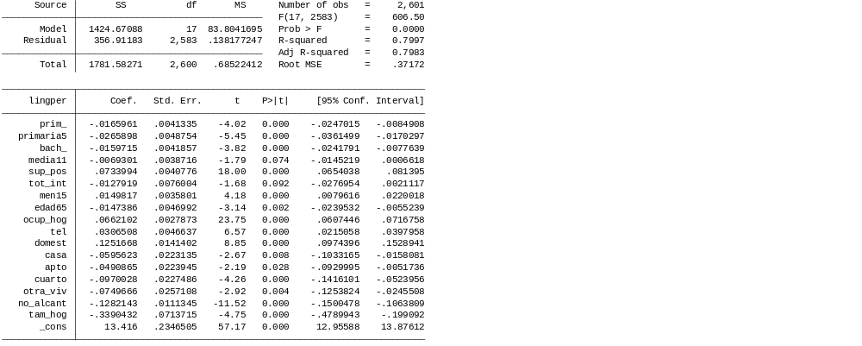
Source: Elaboration by the authors based on ECV-B2007 (DANE, 2007).

Annex 4. Correlation spatial index for a group at block scale in Bogotá, 2005
Variable | IGM
Household head with kindergarten | 0,0123
Household head with elementary school | 0,3379
Household head with high school | 0,3332
Household head with higher education | 0,4386
Household head without education | 0,1540

Source: Elaboration by the authors based on 2005 Population Census (DANE, 2005).

