International Atlas of Axial Spondyloarthritis (IMAS) 2020: European Results

Contributors
The European IMAS working group consisted of members of Health & Territory Research group (HTR) of the University of Seville, Spain, collaborating with Novartis Pharma AG, the Axial Spondyloarthritis International Federation (ASIF) and a multi-stakeholder steering committee of axial spondyloarthritis experts.
Health & Territory Research (HTR)
- Prof. PhD Marco Garrido Cumbrera
- Prof. PhD David Gálvez Ruiz
- PhD Olta Braçe
- MSc Sergio Sanz Gómez
- MSc José Correa Fernández
Novartis Pharma AG
- MSc Laura Christen
- Mrs Patricia Pertel
- Mrs Monia Steenackers
Steering committee
- Prof. PhD Marco Garrido Cumbrera. HTR group at the University of Seville, Spain
- Dr Dennis Poddubnyy. Rheumatologist at Charité-Universitätsmedizin Berlin, Berlin and German Rheumatism Research Centre, Berlin, Germany
- Dr Victoria Navarro Compán. Rheumatologist at University Hospital La Paz (IdiPaz), Madrid, Spain
- Dr Christine Bundy, School of Healthcare Sciences, Cardiff University, Wales, UK
- Mr Raj Mahapatra, Chairman at Axial Spondyloarthritis International Federation (ASIF), London, UK
- Mrs Souzi Makri, President of the Cyprus League Against Rheumatism, Nicosia, Cyprus
- PhD Carlos J. Delgado Domínguez, Health & Territory Research (HTR) Group at the University of Seville, Spain
- Mr Pedro Plazuelo Ramos. Spanish Federation of Spondyloarthritis Associations (CEADE), Madrid, Spain

6 Physical Health
Supplemental Fig. 6.1 Proportion of participants with active/inactive disease (BASDAI ≥4 /<4) by country (N=2,584)
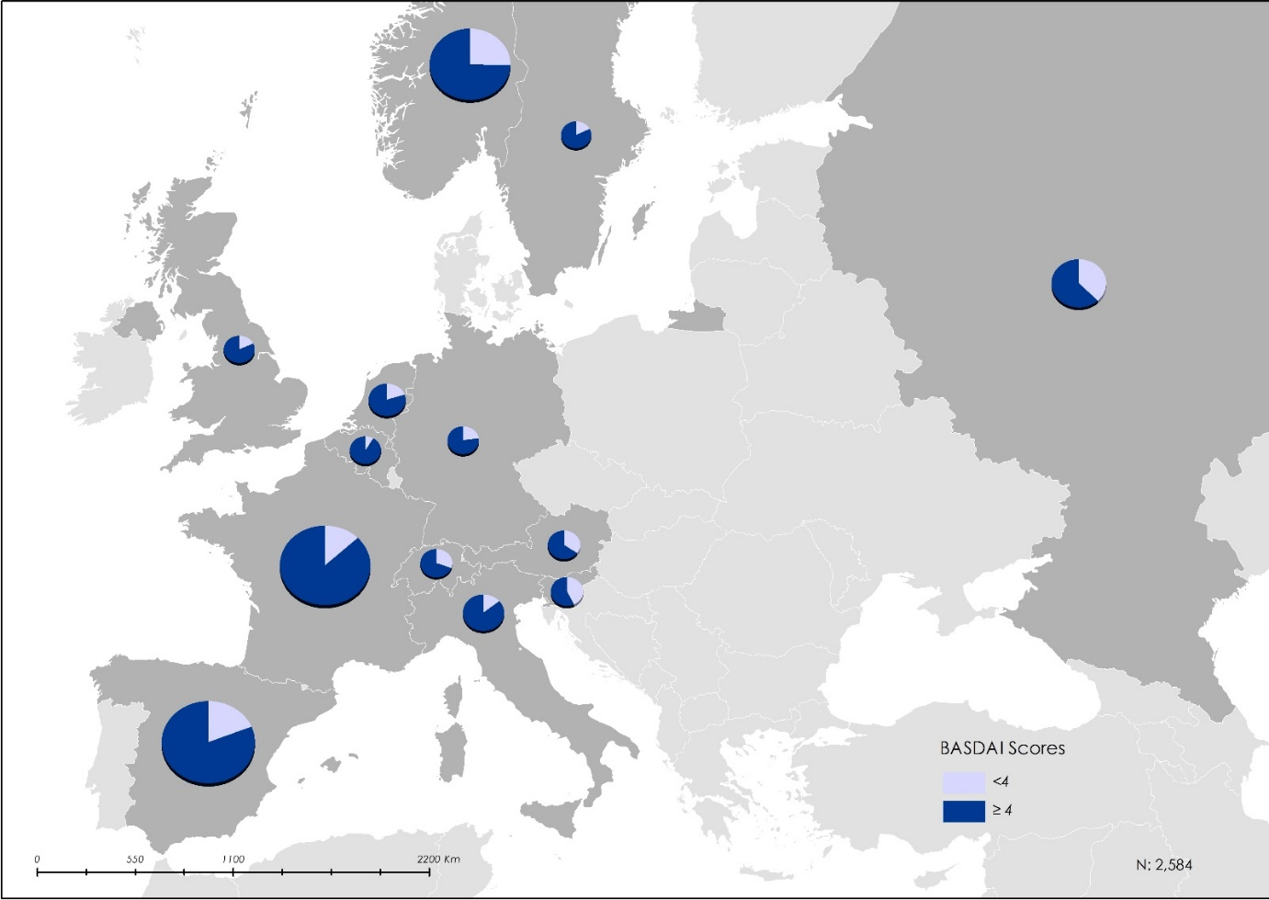
BASDAI Bath Ankylosing Spondylitis Disease Activity Index.
Supplemental Fig. 6.2 Level of disease activity of participants (BASDAI <4 or ≥4) of participants by sociodemographic categories
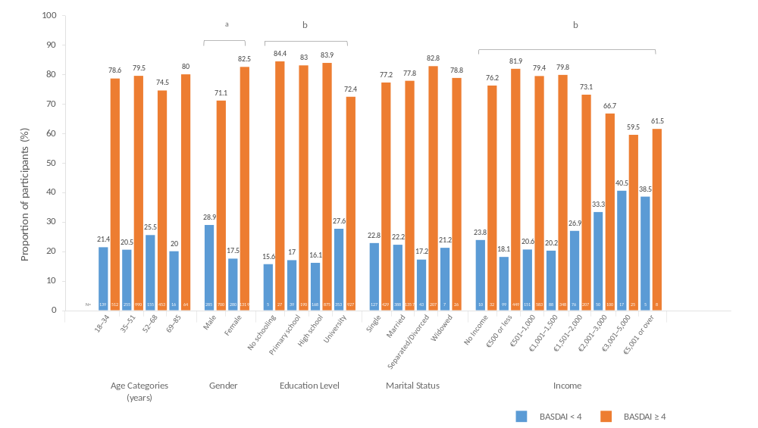
BASDAI Bath Ankylosing Spondylitis Disease Activity Index.
ªχ² test p-value < 0.001; ^{b}χ² test p-value < 0.001.

Supplemental Fig. 6.3 Participants with or without any degree of spinal stiffness by sociodemographic categories
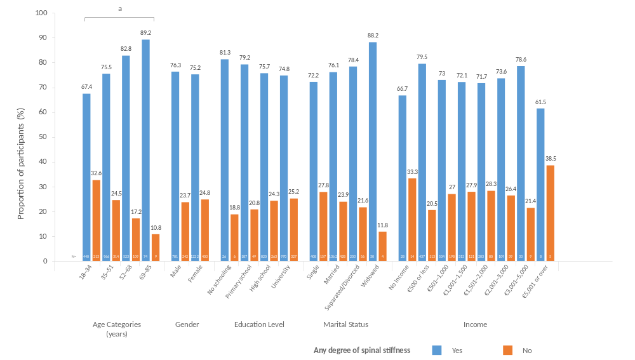
ªχ² test p-value < 0.001.

Supplemental Table 6.1 Mean number of comorbidities of survey participants (N = 2,733–2,771)
Physical comorbidities | n | % | N
None | 1,050 | 37.9 | 2,733
One | 561 | 20.2 | 2,733
Two or more | 1,122 | 40.5 | 2,733
Mental health-related comorbidities | n | % | N
None | 1,427 | 52.2 | 2,771
One | 532 | 19.5 | 2,771
Two or more | 812 | 29.7 | 2,771

Supplemental Table 6.2 Mean Functional Limitation Index of survey participants by gender (N = 2,771)
Gender | N | Mean | SD
Overall | 2,771 | 20.4 | 16.3
Genderª
Male | 1,071 | 19.1 | 16.7
Female | 1,700 | 21.2 | 16.0
SD Standard deviation.
ªMann-Whitney test p-value was < 0.001 indicating an association between Functional Limitation Index and gender.

Supplemental Table 6.3 Diagnostic delay and BASDAI score of survey participants
BASDAI cut-off | N | Mean | SD
<4 | 551 | 6.9 | 8.2
≥4 | 1,961 | 7.6 | 8.6
Total | 2,512 | 7.4 | 8.5
BASDAI Bath Ankylosing Spondylitis Disease Activity Index, SD standard deviation.

Supplemental Table 6.4 Mean BASDAI score by stiffness level score
 | Cervical stiffness |  |  | Dorsal stiffness |  |  | Lumbar stiffness
 | N | Mean | SD | N | Mean | SD | N | Mean | SD
No stiffness | 536 | 4.3 | 2.1 | 485 | 4.2 | 2.2 | 281 | 4.0 | 2.2
Mild | 869 | 5.4 | 1.8 | 792 | 5.3 | 1.8 | 569 | 4.8 | 1.9
Moderate | 710 | 5.9 | 1.7 | 857 | 5.9 | 1.7 | 892 | 5.5 | 1.8
Severe | 447 | 6.4 | 1.9 | 418 | 6.4 | 1.9 | 830 | 6.4 | 1.7
Total | 2,562 | 5.5 | 2.0 | 2,552 | 5.5 | 2.0 | 2,572 | 5.5 | 2.0
BASDAI Bath Ankylosing Spondylitis Disease Activity Index, SD standard deviation.
Kruskal-Wallis p-value for all following mean analysis was < 0.001 indicating an association between stiffness indexes and BASDAI.

Supplemental Table 6.5 Correlation between spinal stiffness and BASDAI score
 |  | BASDAI
Global Stiffness Index | Pearson’s correlation | 0.437ª
Global Stiffness Index | Significant (bilateral) | < 0.001
Global Stiffness Index | N | 2,542
Maximum degree of stiffness | Pearson’s correlation | 0.409ª
Maximum degree of stiffness | Significant (bilateral) | < 0.001
Maximum degree of stiffness | N | 2,577
Cervical stiffness | Pearson’s correlation | 0.340ª
Cervical stiffness | Significant (bilateral) | < 0.001
Cervical stiffness | N | 2,562
Dorsal stiffness | Pearson’s correlation | 0.358ª
Dorsal stiffness | Significant (bilateral) | < 0.001
Dorsal stiffness | N | 2,552
Lumbar stiffness | Pearson’s correlation | 0.393ª
Lumbar stiffness | Significant (bilateral) | < 0.001
Lumbar stiffness | N | 2,572
BASDAI Bath Ankylosing Spondylitis Disease Activity Index.
ªRelationship significant at the 0.01 level (bilateral).
Supplemental Table 6.6 Mean number of body areas with inflammation by BASDAI cut-off point of survey participants
BASDAI cut-off | N | Mean | SD
<4 | 564 | 5.8 | 4.4
≥4 | 2,018 | 8.5 | 5.3
Total | 2,582 | 7.9 | 5.2
BASDAI Bath Ankylosing Spondylitis Disease Activity Index, SD standard deviation.Mann-Whitney test p-value was < 0.001 indicating an association between the number of areas with inflammation and scoring above the cut-off point of BASDAI.

Supplemental Table 6.7 Mean Functional Limitation Index of survey participants by BASDAI cut-off point
BASDAI | N | Mean | SD
<4 | 564 | 12.1 | 13.7
≥4 | 2,019 | 20.8 | 15.5
Total | 2,583 | 18.9 | 15.6
BASDAI Bath Ankylosing Spondylitis Disease Activity Index, SD standard deviation.Mann-Whitney test p-value was < 0.001 indicating an association between Functional Limitation Index and scoring above the cut-off point on BASDAI.

Supplemental Table 6.8 Mean number of inflamed body areas of participants by maximum degree of spinal stiffness
Maximum degree of spinal stiffness | N | Mean | SD
No stiffness | 186 | 5.2 | 4.6
Mild | 471 | 5.9 | 4.7
Moderate | 933 | 7.7 | 5.0
Severe | 1,113 | 9.6 | 5.1
SD standard deviation.
Kruskal-Wallis test p-value was < 0.001 indicating an association between the number of body areas with inflammation and the maximum degree of spinal stiffness.

Supplemental Table 6.9 Mean Functional Limitation Index of survey participants by maximum degree of spinal stiffness
Maximum degree of stiffness | N | Mean | SD
No stiffness | 187 | 17.1 | 18.2
Mild | 471 | 14.1 | 14.8
Moderate | 934 | 18.9 | 15.8
Severe | 1,115 | 23.7 | 15.4
Total | 2,707 | 19.9 | 16.0
SD standard deviation.
ªKruskal-Wallis test p-value was < 0.001 indicating an association between Functional Limitation Index and the maximum degree of stiffness in spine.
Supplemental Table 6.10 Mean numbers of comorbidities of survey participants by area and degree of spinal stiffness
 | Stiffness in  cervical region |  |  | Stiffness in  dorsal region |  |  | Stiffness in  lumbar region
 | N | Mean | SD | N | Mean | SD | N | Mean | SD
No restriction | 540 | 1.2 | 1.8 | 505 | 1.0 | 1.5 | 291 | 0.8 | 1.3
Mild | 857 | 1.7 | 2.1 | 776 | 1.6 | 2.05 | 561 | 1.3 | 2.0
Moderate | 720 | 2.0 | 2.2 | 863 | 2.1 | 2.2 | 896 | 1.8 | 2.0
Severe | 455 | 2.6 | 2.6 | 415 | 2.55 | 2.7 | 837 | 2.5 | 2.5
Total | 2,572 | 1.8 | 2.2 | 2,559 | 1.8 | 2.2 | 2,585 | 1.8 | 2.2
SD standard deviation.
Kruskal-Wallis test p-value for all spinal regions was < 0.001 indicating an association between number of comorbidities and degree of spinal stiffness.

Supplemental Table 6.11 Mean numbers of physical comorbidities of survey participants by BASDAI and General Health Questionnaire (GHQ)-12 cut-off points
BASDAI cut-off |  | N |  |  | Mean |  |  |  | SD
<4 |  | 543 |  |  | 1.14 |  |  |  | 1.55
≥4 |  | 1,928 |  |  | 2.07 |  |  |  | 2.32
Total |  | 2,471 |  |  | 1.87 |  |  |  | 2.21
GHQ-12 cut-off |  | N |  |  | Mean |  |  |  | SD
<3 |  | 970 |  |  | 1.57 |  |  |  | 1.98
≥3 |  | 1,557 |  |  | 2.02 |  |  |  | 2.31
Total |  | 2,527 |  |  | 1.85 |  |  |  | 2.20
Total | 2,562 | 5.5 | 2.0 | 2,552 |  | 5.5 | 2.0 | 2,572 |  | 5.5 | 2.0
BASDAI Bath Ankylosing Spondylitis Disease Activity Index, SD standard deviation.
Mann-Whitney test p-values were < 0.001 indicating an association between number of physical comorbidities and disease activity and general health.

