Supplementary Materials
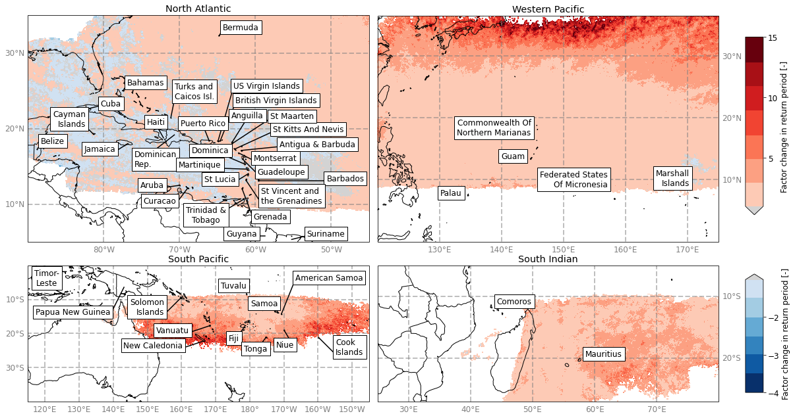
Supplementary Figure 1 Factor change in return period for 10-minute 10-meter wind speed equivalent to a Category 3 (43.4 m/s) tropical cyclone. The factor change is calculated between the median of the STORM future climate datasets (the multi-model median) and the STORM baseline dataset. A positive factor (red tones) indicate a decrease in return period, and hence an increase in probability under climate change, a negative factor (blue tones) indicate an increase in return period/decrease in probability.

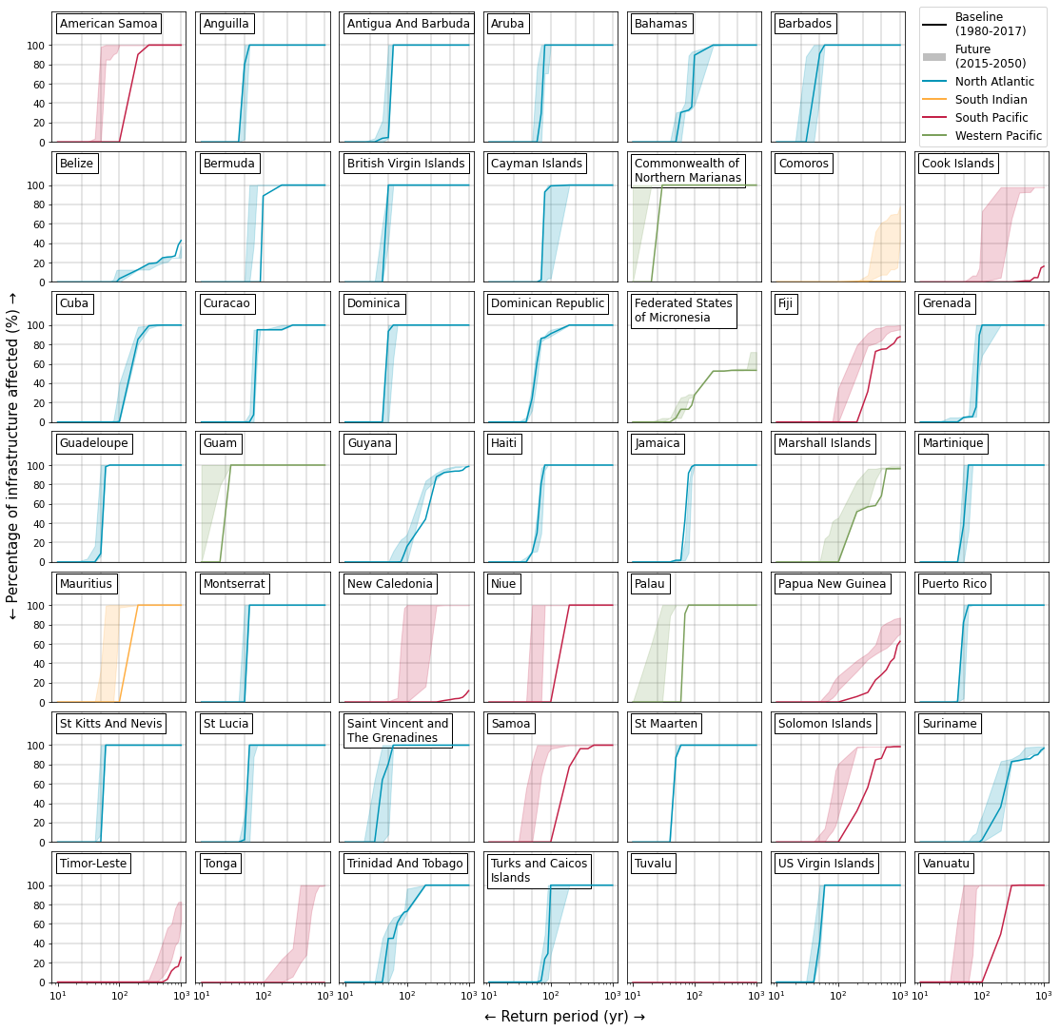
Supplementary Figure 2 Empirically derived return periods of the percentage of infrastructure affected by Category-3 (43.4 m/s) wind speeds or higher in each of the 48 SIDS. The solid line represents the STORM baseline climate conditions (corresponding to the average climate conditions over 1980-2017). The shaded areas represent the range of return periods of the four STORM future climate datasets (average climate conditions over 2015-2050). Colors indicate the respective basin: North Atlantic - blue, South Indian - yellow, South Pacific - red, and Western Pacific - green.

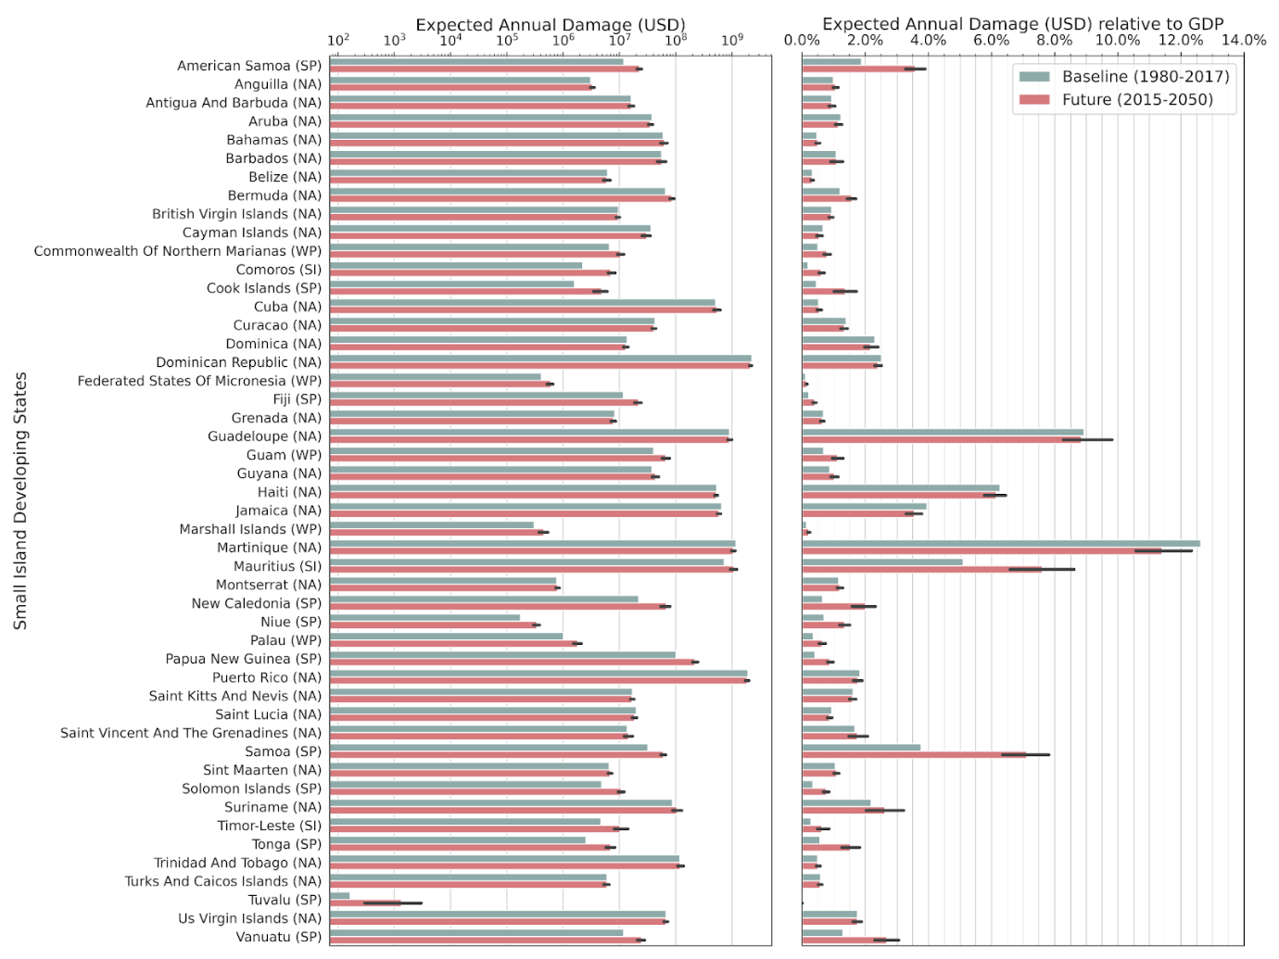
Supplementary Figure 3 Expected Annual Damage (EAD, in USD) for the baseline and future climate conditions using the RMSF-calibration method. The error bar for the future situation represents the spread of EAD across the four separate STORM future-climate datasets (see Methods).

Supplementary Table 1 Number of assets per category included in the analysis in this study. All assets were extracted from OSM on July 19, 2021. All assets that do not fall in the category ‘buildings’ are included in the infrastructure exposure results.
Small Island Developing State | Buildings | Roads | Electricity | Telecommunication | Airports | Solid Waste | Waste Water | Water Supply | Education | Healthcare
Aruba | 60,664 | 784 | 10 | 4 | 1 | 2 | 0 | 2 | 63 | 78
Anguilla | 10,037 | 93 | 1 | 3 | 1 | 1 | 0 | 0 | 7 | 3
American Samoa | 19,930 | 97 | 6 | 1 | 3 | 1 | 0 | 1 | 3 | 1
Antigua And Barbuda | 43,845 | 263 | 0 | 21 | 3 | 1 | 0 | 7 | 39 | 36
Bahamas | 100,544 | 871 | 75 | 118 | 31 | 5 | 2 | 13 | 143 | 84
Belize | 136,547 | 1,174 | 0 | 57 | 28 | 10 | 0 | 6 | 204 | 205
Bermuda | 20,980 | 243 | 18 | 4 | 1 | 0 | 0 | 0 | 37 | 26
Barbados | 115,654 | 1,052 | 12 | 3 | 1 | 1 | 1 | 15 | 96 | 84
Cook Islands | 11,096 | 119 | 9 | 4 | 9 | 3 | 1 | 2 | 19 | 13
Comoros | 81,119 | 309 | 1 | 3 | 3 | 0 | 0 | 0 | 84 | 61
Cuba | 318,878 | 18,769 | 1,527 | 203 | 75 | 71 | 8 | 241 | 2,229 | 2,652
Curaçao | 17,189 | 800 | 4 | 18 | 2 | 2 | 0 | 0 | 87 | 141
Cayman Islands | 8,898 | 274 | 1 | 4 | 2 | 1 | 0 | 2 | 16 | 37
Dominica | 38,765 | 290 | 0 | 5 | 3 | 1 | 0 | 3 | 33 | 22
Dominican Republic | 94,082 | 6,306 | 0 | 94 | 18 | 9 | 1 | 16 | 898 | 1,541
Fiji | 170,310 | 1,512 | 24 | 8 | 19 | 2 | 0 | 7 | 87 | 56
F. S. Of Micronesia | 17,600 | 65 | 10 | 17 | 8 | 1 | 0 | 7 | 6 | 8
Guadeloupe | 331,669 | 2,646 | 0 | 23 | 5 | 5 | 6 | 53 | 221 | 190
Grenada | 48,037 | 324 | 3 | 4 | 3 | 1 | 0 | 0 | 39 | 34
Guam | 18,713 | 146 | 26 | 84 | 3 | 2 | 2 | 1 | 37 | 19
Guyana | 201,246 | 1,019 | 8 | 48 | 11 | 1 | 0 | 0 | 142 | 147
Haiti | 106,0347 | 2,546 | 0 | 287 | 11 | 51 | 1 | 110 | 629 | 2,142
Jamaica | 996,257 | 2,404 | 72 | 123 | 6 | 4 | 1 | 15 | 316 | 296
Saint Kitts And Nevis | 10,121 | 372 | 1 | 2 | 3 | 7 | 1 | 2 | 62 | 37
Saint Lucia | 38,565 | 275 | 8 | 2 | 2 | 2 | 1 | 2 | 129 | 80
Marshall Islands | 9,123 | 24 | 0 | 30 | 10 | 1 | 0 | 0 | 10 | 4
Cmlth Of Northern Marianas | 15,553 | 131 | 3 | 49 | 4 | 1 | 0 | 3 | 13 | 5
Montserrat | 4,855 | 29 | 0 | 0 | 1 | 1 | 0 | 0 | 10 | 6
Martinique | 290,181 | 2,482 | 0 | 79 | 1 | 4 | 0 | 58 | 127 | 173
Mauritius | 18,685 | 1,623 | 344 | 23 | 2 | 0 | 1 | 10 | 136 | 269
New Caledonia | 68,080 | 2,554 | 0 | 34 | 5 | 16 | 1 | 80 | 203 | 180
Niue | 1,866 | 17 | 1 | 17 | 1 | 1 | 0 | 0 | 2 | 1
Palau | 3,211 | 28 | 2 | 6 | 1 | 3 | 0 | 0 | 2 | 3
Papua New Guinea | 246,614 | 3,738 | 0 | 103 | 465 | 11 | 0 | 7 | 1,815 | 228
Puerto Rico | 1,500,527 | 11,539 | 0 | 95 | 20 | 10 | 5 | 21 | 635 | 830
Samoa | 46,264 | 276 | 8 | 16 | 4 | 0 | 0 | 1 | 87 | 15
Solomon Islands | 34,556 | 193 | 1 | 3 | 14 | 0 | 0 | 2 | 27 | 10
Suriname | 290,091 | 692 | 27 | 25 | 33 | 7 | 0 | 10 | 73 | 128
Sint Maarten | 15,543 | 323 | 4 | 3 | 1 | 4 | 1 | 0 | 32 | 22
Turks And Caicos Islands | 14,622 | 242 | 0 | 3 | 8 | 1 | 0 | 6 | 14 | 15
Timor-Leste | 55,437 | 1,179 | 33 | 16 | 7 | 0 | 0 | 11 | 71 | 154
Tonga | 41,488 | 139 | 79 | 35 | 6 | 2 | 2 | 3 | 118 | 20
Trinidad And Tobago | 98,675 | 3,194 | 60 | 45 | 2 | 2 | 0 | 12 | 292 | 533
Tuvalu | 4,070 | 5 | 0 | 0 | 1 | 1 | 0 | 0 | 2 | 1
Saint Vincent And The Grenadines | 40,629 | 172 | 0 | 54 | 6 | 1 | 0 | 0 | 68 | 59
British Virgin Islands | 10,242 | 105 | 9 | 9 | 3 | 1 | 0 | 1 | 7 | 7
Us Virgin Islands | 48,844 | 513 | 40 | 3 | 2 | 3 | 0 | 2 | 17 | 10
Vanuatu | 108,883 | 234 | 5 | 9 | 13 | 1 | 0 | 3 | 91 | 144

Supplementary Table 2 Expected Annual Damages (EAD, in million USD) for the 48 SIDS for the baseline and future climate conditions and both calibration methods as presented in Eberenz et al. (2021)

Small Island Developing State | EAD baseline climate, TDR | EAD range future climate, TDR | EAD baseline climate, RMSF | EAD range future climate, RMSF
American Samoa | 4.14 | 7.72 - 10.01 | 11.91 | 20.1 - 24.8
Anguilla | 2.02 | 1.93 - 2.4 | 3.1 | 2.92 - 3.64
Antigua And Barbuda | 10.39 | 9.25 - 12.37 | 16.1 | 14.2 - 18.82
Aruba | 24.48 | 20.32 - 26.78 | 37.78 | 31.24 - 40.64
Bahamas | 39.53 | 34.37 - 47.88 | 59.9 | 52.26 - 71.42
Barbados | 37.08 | 30.21 - 48.6 | 56.17 | 45.62 - 58.46
Belize | 3.96 | 3.16 - 4.63 | 6.12 | 5.63 - 7.11
Bermuda | 41.76 | 47.83 - 62.24 | 65.73 | 74.08 - 95.27
British Virgin Islands | 6.29 | 5.56 - 6.83 | 9.58 | 9.85 - 10.34
Cayman Islands | 24.14 | 14.54 - 24.69 | 36.4 | 22.35 - 37.27
Commonwealth Of Northern Marianas | 0.34 | 0.46 - 0.7 | 6.62 | 8.73 - 12.73
Comoros | 1.24 | 3.66 - 5.54 | 2.22 | 6.15 - 8.99
Cook Islands | 0.46 | 1.05 - 2.09 | 1.58 | 6.07 - 6.09
Cuba | 337.1 | 300.81 - 439.98 | 513.48 | 456.69 - 662.58
Curacao | 27.6 | 24.22 - 30.25 | 42.81 | 37.19 - 46.21
Dominica | 8.99 | 7.55 - 9.86 | 13.74 | 11.56 - 14.97
Dominican Republic | 1,473.49 | 1,345.1 – 1,514.2 | 2,240.01 | 2,016.54 – 2,277.54
Federated States Of Micronesia | 0.02 | 0.02 - 0.04 | 0.41 | 0.48 - 0.66
Fiji | 3.99 | 6.4 - 10.0 | 11.77 | 16.92 - 25.12
Grenada | 5.34 | 4.43 - 5.89 | 8.27 | 6.81 - 8.99
Guadeloupe | 583.86 | 543.25 - 680.24 | 900.55 | 827.72 – 1,039.08
Guam | 2.07 | 2.86 - 4.56 | 40.39 | 54.52 - 83.27
Guyana | 24.05 | 23.88 - 33.51 | 37.52 | 37.33 - 51.61
Haiti | 349.85 | 312.22 - 370.57 | 532.75 | 473.4 - 556.22
Jamaica | 429.45 | 345.29 - 413.21 | 650.94 | 520.79 - 632.01
Marshall Islands | 0.02 | 0.02 - 0.03 | 0.31 | 0.32 - 0.42
Martinique | 763.84 | 615.86 - 779.58 | 1170.38 | 948.37 – 1,183.46
Mauritius | 445.97 | 557.02 - 839.15 | 723.21 | 875.21 – 1,260.68
Montserrat | 0.5 | 0.47 - 0.58 | 0.77 | 0.72 - 0.89
New Caledonia | 6.29 | 14.76 - 27.8 | 21.97 | 69.16 - 79.88
Niue | 0.06 | 0.11 - 0.15 | 0.17 | 0.3 - 0.41
Palau | 0.05 | 0.07 - 0.11 | 1.01 | 1.47 - 2.05
Papua New Guinea | 32.87 | 70.93 - 98.19 | 101.24 | 194.2 - 258.8
Puerto Rico | 1250.67 | 1,097.09 – 1,330.85 | 1911.42 | 1,684.36 – 2,010.26
Saint Kitts And Nevis | 11.02 | 10.03 - 12.18 | 16.97 | 15.29 - 18.58
Saint Lucia | 12.96 | 10.65 - 13.87 | 19.83 | 16.42 - 21.04
Saint Vincent And The Grenadines | 9.02 | 7.6 - 12.52 | 13.79 | 11.53 - 18.58
Samoa | 10.66 | 19.76 - 27.04 | 32.06 | 53.52 - 63.59
Sint Maarten | 4.28 | 3.97 - 4.95 | 6.58 | 6.73 - 7.0
Solomon Islands | 1.59 | 3.29 - 5.01 | 4.82 | 8.9 - 12.5
Suriname | 56.18 | 45.94 - 88.77 | 86.97 | 72.4 - 105.51
Timor-Leste | 1.36 | 2.25 - 4.98 | 4.68 | 7.8 - 16.1
Tonga | 0.71 | 1.59 - 2.75 | 2.55 | 6.75 - 8.82
Trinidad And Tobago | 77.05 | 68.93 - 96.84 | 118.29 | 105.52 - 146.34
Turks And Caicos Islands | 3.98 | 3.26 - 4.51 | 6.04 | 4.94 - 6.81
Tuvalu* | <<0.01 | <<0.01 | <<0.01 | <<0.01
Us Virgin Islands | 44.01 | 40.13 - 48.41 | 67.23 | 62.11 - 73.09
Vanuatu | 3.83 | 6.73 - 11.45 | 11.82 | 18.62 - 29.2

*Tuvalu’s expected annual damages lie below 200 USD.

