Supplementary material – Tables
Supplementary material Table 1: Differences between age classes (significant differences are marked with an asterisk)
Average similarity tests | M3 vs. M4 |  | M3 vs. M5 |  | M4 vs. M5
Average similarity tests | Value | p-value | Value | p-value | Value | p-value
All-male groups
All-male group size | -1.20 | 0.135 | -0.93 | 0.483 | 0.27 | 0.972
Mixed-sex groups
Males per female | -0.11 | 0.980 | 1.99* | 0.000* | 2.10* | 0.000*
# Females | -0.64 | 0.110 | -1.27* | 0.003* | -0.63 | 0.238
# Females in consortships | 0.17 | 0.967 | -0.60 | 0.572 | -0.60 | 0.053
Bayesian proportion tests | M3 vs. M4 |  | M3 vs. M5 |  | M4 vs. M5
Bayesian proportion tests | Estimated value | 95% CI | Estimated value | 95% CI | Estimated value | 95% CI
All-male groups
Socializing | 0.22* | 0.091, 0.340* | 0.17* | 0.060, 0.280* | 0.05 | -0.054, 0.140
Male-male aggression | 0.00 | -0.027, 0.041 | 0.01 | -0.033, 0.047 | 0.01 | -0.023, 0.048
Mixed-sex groups
Targets paired with male | -0.22* | -0.400, -0.015* | 0.20* | 0.028, 0.390* | 0.42* | 0.300, 0.530*
In nursery | -0.21* | -0.280, -0.140* | -0.38* | -0.500, -0.250* | -0.01 | -0.110, 0.086
Female-directed aggression | -0.01 | -0.065, 0.050 | 0.04 | -0.020, 0.093 | 0.05 | -0.004, 0.097
Bull chase | 0.02 | -0.032, 0.073 | 0.04 | -0.018, 0.091 | 0.02 | -0.027, 0.062

Supplementary material Table 2: Differences between mixed-sex groups and all-male groups per male age class (significant differences are marked with an asterisk)
Average similarity tests | M3 |  | M4 |  | M5
Average similarity tests | Value | p-value | Value | p-value | Value | p-value
# Males | 2.51* | 0.002* | 2.60* | 0.000* | -1.69 | 0.160
Bayesian proportion tests | Estimated value | 95% CI | Estimated value | 95% CI | Estimated value | 95% CI
Male-male aggression | 0.02 | -0.028, 0.059 | 0.05* | 0.009, 0.091* | 0.02 | -0.020, 0.066
Socializing | 0.13* | 0.006, 0.260* | 0.26* | 0.170, 0.350* | 0.06 | -0.054, 0.170

Supplementary material Fig. 1
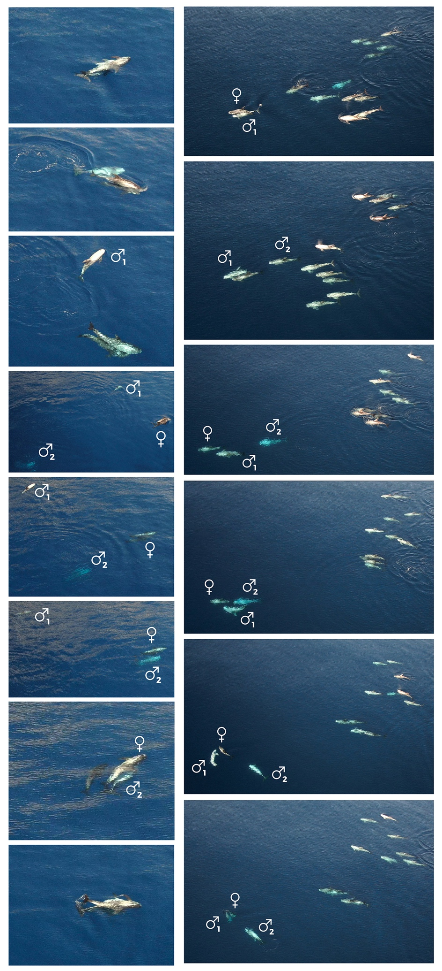
Two examples of multiple mating, and successive mating by the same male, captured by a drone in 2022
Left:
A: Actual mating male1 and female
B: male 1 leaves the female
C: more distance between male 1 and the female and her calf,
D+E: Male 2 approaching
F: Male 2 “arriving” in mating position at female
G: Male 2 under female, clicking movement visible, calf near the mating event
H: Actual mating male 2
Right:
A: Mating with male 1 taking place in frontal position of the pod
B: Male 2 approaching the female
C: Male 2 approaching, male 1 closest to the female
D: Male 1 in mating position under female
E: Female turns, male 1 follows the female in mating position, male 2 in the back
F: Second mating event with male 1 takes place under water, male 2 follows

Supplementary material - videos

Consortships:
https://vimeo.com/306545533

Synchrony:
https://vimeo.com/306545171

Multiple mating:
https://vimeo.com/382755472

Video abstract drone study and sociality:
https://vimeo.com/384551409

