ESM 16.1: Isolina Virginia. Core descriptions.

Core 1262
The first core (Fig. 1) started at -22 cm with respect to the surface (238.46 m a.s.l.). We kept this distance for subsequent cores, so core 2 started at 122 cm of depth. 1262_1 came out well and we could observe the presence of wood. We lost the upper part of 1262_2 between -122 and -158 cm because of water infiltrations. It was really difficult to obtain because one had to go through pieces of well-preserved wood. 1262_3 came out well. After -234 it was lake marl or silt. Just above this layer one could observe a fine layer of thin twigs.
Fig. 1. Core 1262.
The 5 organic phases (Table 1) detected must belong to the Early Neolithic period and probably accumulated in a very short period of time (Fig. 2). Loamy layers were frequent.
No. | Depth (m) | Sediment | Minor component | Sample no. | Note
1262/1 | 0.00 |  |  |  | Starting height: 236.26 m a.s.l.
 | -0.07 | Sand | Loam
 | -0.12 | Loam | Sand
 | -0.20 | Organic | Sand
 | -0.23 | Loam | Sand
 | -0.32 | Loam | Organic | 202
 | -0.37 | Loam |  | 202
 | -0.42 | Loam | Organic
 | -0.47 | Loam | Sand
 | -0.54 | Loam | Gravel
 | -0.60 | Burnt Loam
 | -0.63 | Loam | Organic
 | -0.68 | Organic |  | 207
 | -0.77 | Loam | Gravel | 208 | ETH-96185: 6043 ± 29 BP
 | -0.84 | Wood |  | 208 | ETH-96185: 6043 ± 29 BP
 | -0.86 | Loam | Sand | 208 | ETH-96185: 6043 ± 29 BP
 | -0.89 | Organic | Sand
1262/2 | -1.00 | Loam | Sand |  | About 1.60 large oak
 | -1.58 | Loss of sediment
 | -1.81 | Loam | Organic | 211
 | -1.84 | Organic | Loam | 212
1262/3 | -2.00 | Wood |  | 212
 | -2.10 | Sand | Organic | 213 | ETH-96183: 6051 ± 29 BP
 | -2.16 | Wood
1262/3 | -2.18 | Organic
 | -2.23 | Wood
 | -2.33 | Organic |  | 216
 | -2.34 | Organic |  | 217 | Initial construction level
 | -3.00 | Silt
Table 1. Description of the layers observed in the cores taken in 1262.
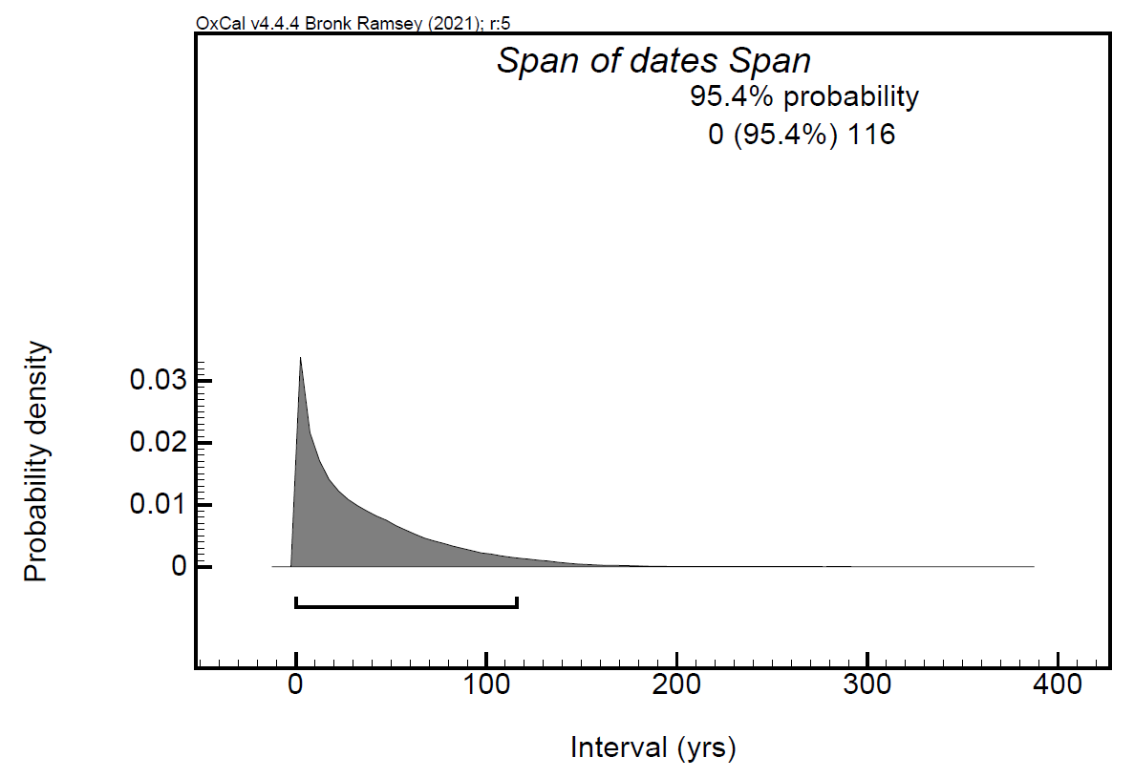
Fig. 2. Span calculated by OxCal for the two events dated in Core 1262.
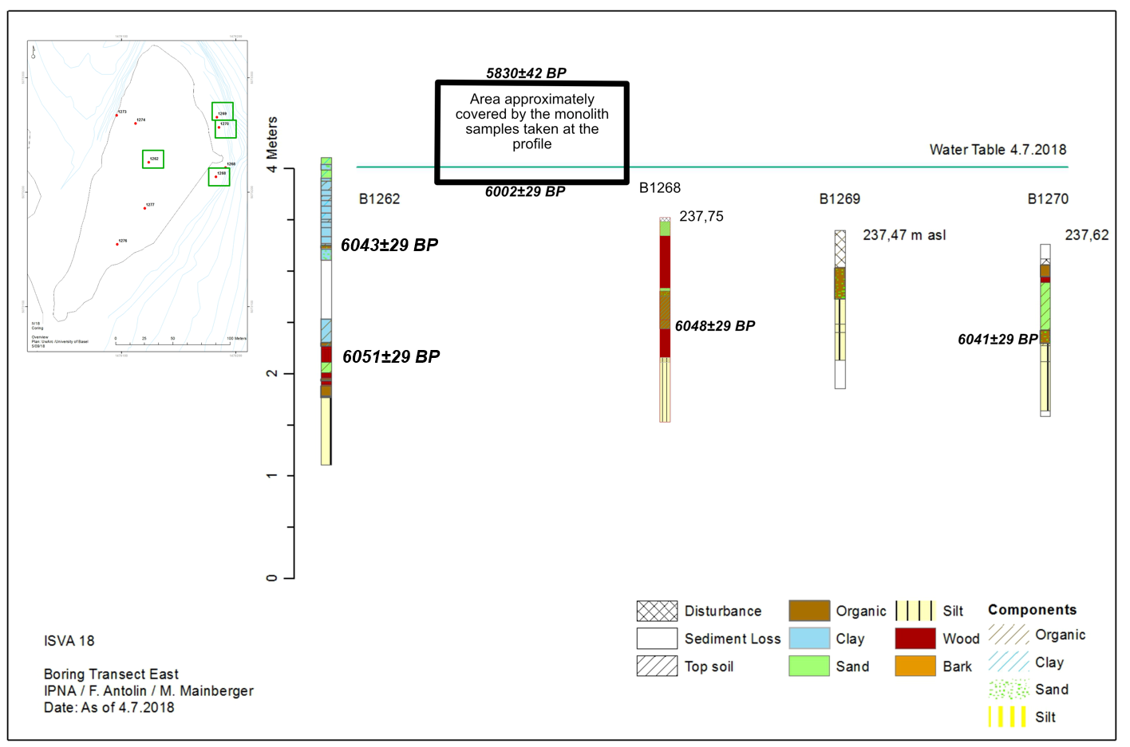
Fig. 3. Cores 1262, 1268. 1269 and 1270 from transect East, types of sediments and indication of water table in July 2018 (Antolín et al. in press).

Core 1268
This core was taken in the shallow water to the east of the island. This was a difficult area to sample due to the presence of vertical wooden posts, almost impossible to avoid by coring. The organic layers are often mixed with sand (Fig. 4, Table 2). The last organic layer on the silt could have been deposited in water (M. Mainberger, pers. com.), which is confirmed by the high amount of water plants in the first sample of the sequence (ESM 3). A radiocarbon date confirms its Early Neolithic ascription (Fig. 5).
Fig. 4. Stratigraphy of core 1268 as observed from the thinner core.

No. | Depth (m) | Sediment | Minor component | Sample no. | Note
1268/1 | 0.00 |  |  |  | 237.75 m a.s.l.
 | -0.04 | Loss of sediment
 | -0.18 | Sand | Organic
 | -0.69 | Wood
 | -0.72 | Sand | Organic
 | -0.77 | Organic | Sand | 242
1268/2 | -1.00 | Organic | Loam | 243 | ETH-96188: 6068 ± 29 BP
 | -1.09 | Organic | Loam | 244
 | -1.37 | Wood |  | 245
 | -1.42 | Organic | Silt | 246 | Sedimentation in water?
 | -2.00 | Silt |  |  | Layered Organically
Table 2. Description of the layers observed in the cores taken in 1268.
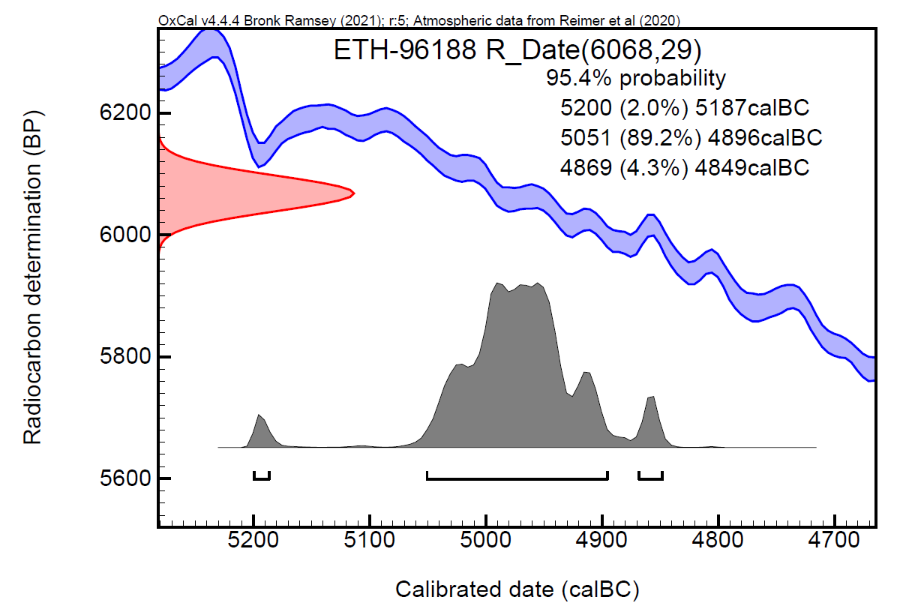
Fig. 5. Core 1268, calibrated radiocarbon date.

Core 1269
This core was taken in the shallow water to the north-east of the island. Silt was soon observed at the end of the first core (Fig. 6, Table 3). In the second core we reached the basin loam. Given the dates obtained for other organic layers in this area of the island we assume that it dates to the Early Neolithic period (c. 5000–4800 cal BC).
Fig. 6. Core 1269.

No. | Depth (m) | Sediment | Minor component | Sample no. | Note
1269/1 | 0.00 |  |  |  | 237.55 m a.s.l., 72 cm water depth
 | -0.14 | Loss of sediment
 | -0.20 | Disturbance
 | -0.32 | Organic |  | 261
 | -0.37 | Wood
 | -0.84 | Sand | Organic | 263
 | -0.97 | Organic | Sand | 264
1269/2 | -0.99 | Silt | Organic |  | Transition
 | -1.14 | Silt
 | -1.62 | Silt
 | -1.68 | Basin Loam
Table 3. Description of the layers observed in the cores taken in 1269.

Core 1270 (Transect E)
This core was also taken along the eastern shore of the island, a bit further North than core 1269. It was difficult to drill here due to the presence of stones and wood. Silt (or lake marl) was achieved in the first core (Fig. 7, Table 4). We took a second one to be sure, but we reached the basin loam at c. -155 cm. Several samples from the organic archaeological layer (-37 to -67 cm) were taken because the core was repeated and a thicker core was also taken twice. A radiocarbon date confirms the Early Neolithic dating of the archaeological layer (Fig. 8).

No. | Depth (m) | Sediment | Minor component | Sample no. | Note
1270/1 | 0.00 |  |  |  | 237.93 m a.s.l., 61 cm of water depth
 | -0.37 | Disturbance | Organic
 | -0.67 | Organic | Sand | 267, 268 | ETH-96189: 6041 ± 29 BP
 | -0.92 | Silt
1270/2 | -1.00 | Silt
 | -1.27 | Silt
 | -1.55 | Basin loam
Table 4. Description of the layers observed in the cores taken in 1270.

Fig. 7. Core 1270.
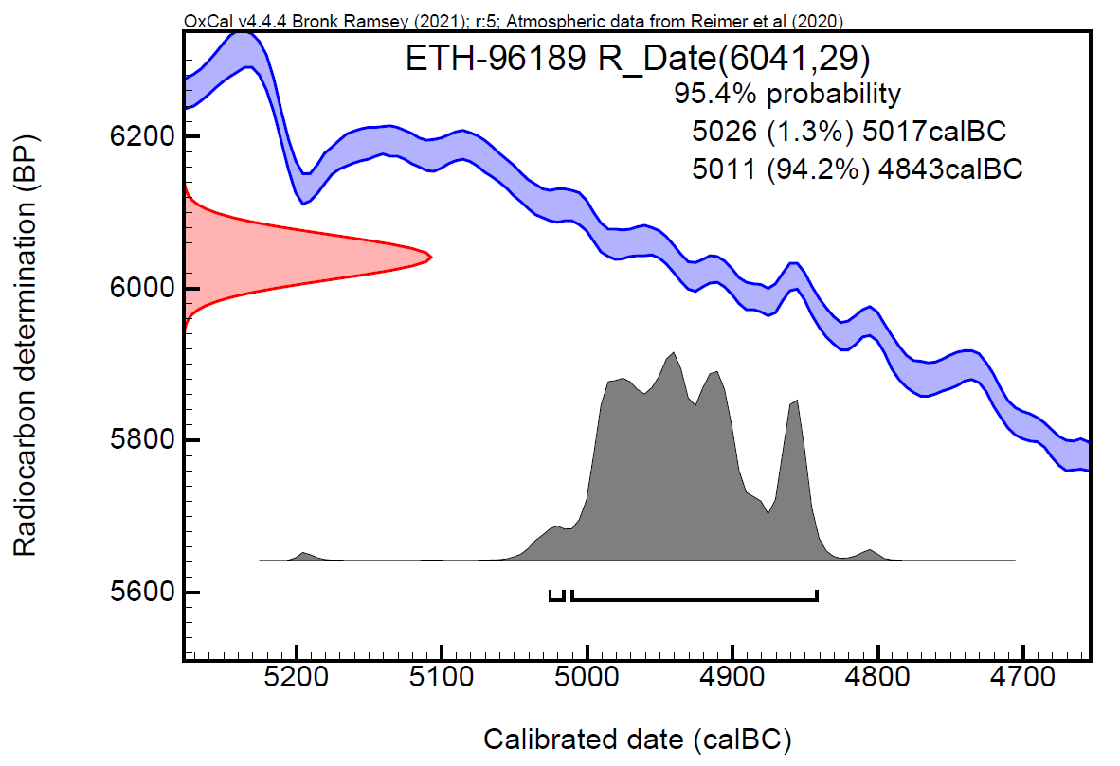
Fig. 8. Core 1270. Calibrated radiocarbon date.

Core 1274 (Transect W)
This core was taken in the hole left on the ground by a fallen tree. It helped to avoid the first c. 80 cm of rubble and stones. The first two metres were very organic and then the silt appeared (Fig. 9–10, Table 5). Four dates were obtained from four different layers separated by sandy layers. Therefore, we generated a Sequential Bayesian model (Fig. 11) and the results were statistically significant. The radiocarbon dates performed indicate a rapid formation of the lower deposits between 4850–4600 cal BC: The span of each layer is likely to be of a maximum of 55 years. The uppermost date, at the top of the organic sequence is dated to the Middle Neolithic (Neolitico Recente): c. 4200–4000 cal BC. No obvious hiatuses were observed in between (Table 5), but we cannot confirm a continuous occupation with the available radiocarbon dates.
Fig. 9. Core 1274.

No. | Depth (m) | Sediment | Minor component | Sample no. | Note
1274/1 | 0.00 | Top soil |  |  | 238.85 m a.s.l.
 | -0.39 | Sand | Organic
 | -0.49 | Sand | Loam
 | -0.52 | Bark
 | -0.53 | Sand | Loam
 | -0.55 | Sand | Organic |  | Water table
 | -0.56 | Loam
 | -0.61 | Organic |  | 221
 | -0.64 | Sand | Organic
 | -0.67 | Organic | Sand | 222 | ETH-101540: 5321 ± 26 BP
 | -0.79 | Organic |  | 223
 | -0.83 | Organic | Sand | 224
 | -0.92 | Organic |  | 224
1274/2 | -1.00 | Organic | Sand
 | -1.10 | Organic
 | -1.42 | Organic | Sand | 225
 | -1.51 | Organic |  | 226
 | -1.56 | Organic | Sand | 227 | ETH-96186: 5879 ± 29 BP
 | -1.61 | Sand | Organic | 228
 | -1.69 | Organic | Sand | 228 | ETH-101539: 5889 ± 25 BP
 | -1.78 | Sand | Organic |  | Sediment Loss at -182
 | -1.85 | Organic | Sand | 230 | ETH-96187: 5915 ± 29 BP
 | -1.96 | Sand | Silt
1274/3 | -2.00 | Silt |  |  | With brownish-layered sections
 | -3.00
Table 5. Description of the layers observed in the cores taken in 1274.
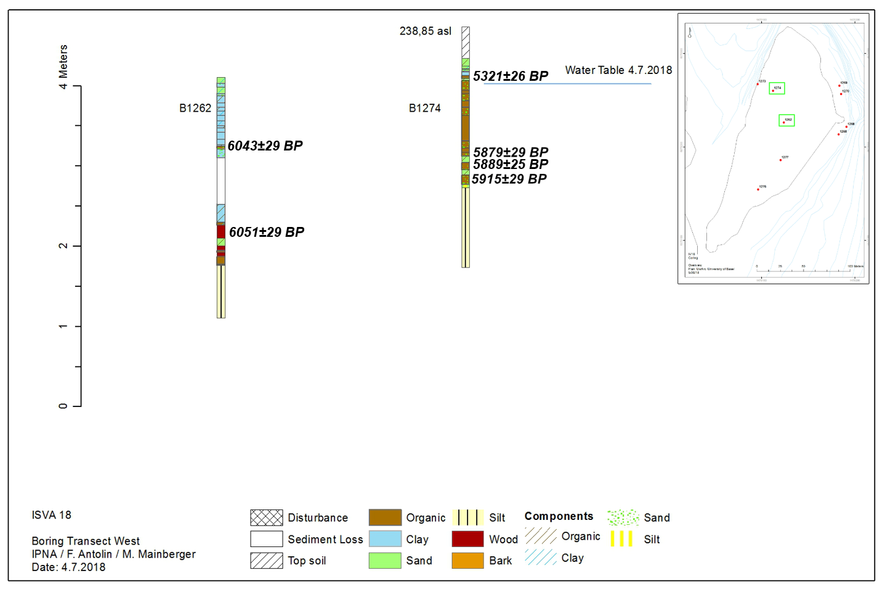
Fig. 10. Cores from transect West, types of sediments and indication of water table in July 2018 (Antolín et al. in press).
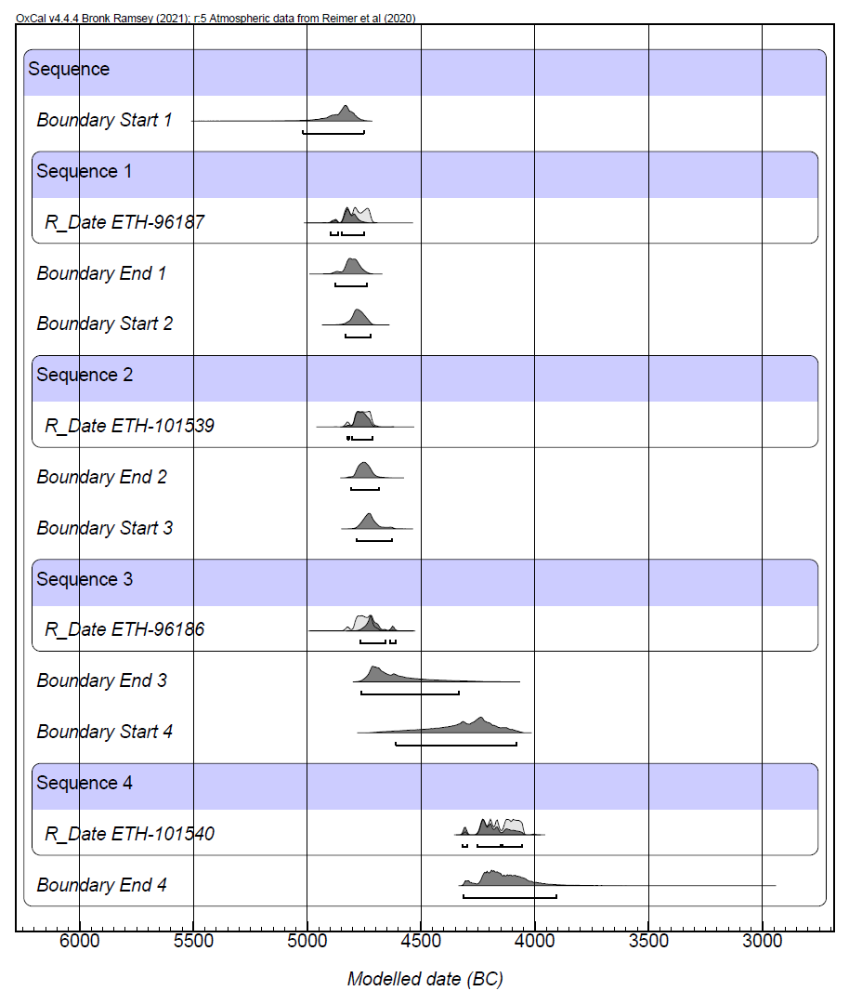
Fig. 11. Bayesian modelling of the radiocarbon dates obtained for core 1274.

Core 1273 (Transect W)
This core was taken in the water, between the island and the main lakeshore. One core was enough to reach the silt and we took a second one just to be sure (Fig. 12, Table 6). Two possibly reduced archaeological horizons with more organic remains within the silt were observed. They might correspond with two settlement phases on the island.

No. | Depth (m) | Sediment | Minor component | Sample no. | Note
1273/1 | 0.00 |  |  |  | 237.78 m a.s.l.
 | -0.18 | Loss of sediment | NN
 | -0.23 | Disturbance | Organic
 | -0.74 | Silt
 | -0.77 | Silt | Organic | 253
 | -0.88 | Silt
 | -0.90 | Silt
1273/2 | -1.00 | Silt
 | -1.28 | Silt
 | -1.31 | Silt | Organic | 257
 | -2.00 | Silt
Table 6. Description of the layers observed in the cores taken in 1273.
Fig. 12. Core 1273.

Core 1276 (Transect S)
This core was taken in another hole in the topsoil produced by a fallen tree. There are organic layers and sandy layers that indicate proximity to the palaeoshoreline (Fig. 13–14, Table 6). The second core reached the lake marl. Two dates were obtained from two different layers with clear stratigraphical separation between them, one date from the late 5th millennium cal BC and one from the beginnings of the 4th millennium cal BC (Fig. 15). Consequently, we can conclude that no Early Neolithic deposits have been preserved in this area. A short hiatus between both dated episodes is possible, although dates performed in a second core at the same spot suggest a sequence of closely dated occupations (Antolín et al. in press).
Fig. 13. Stratigraphy of core 1276 as observed from the thinner core.
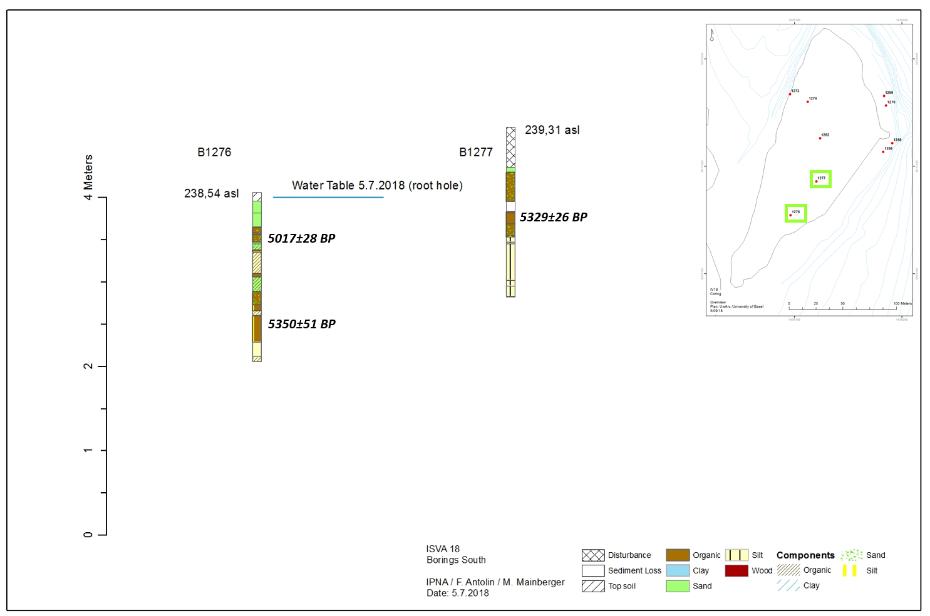
Fig. 14. Cores 1276 and 1277 from transect South, types of sediments and indication of water table in July 2018 (Antolín et al. in press).
No. | Depth (m) | Sediment | Minor component | Sample no. | Note
1276/1 | 0.00 |  |  |  | 238.71 m a.s.l., 12 cm below WT
 | -0.10 | Top soil
 | -0.24 | Sand |  |  | yellow
 | -0.41 | Sand |  |  | grey
 | -0.48 | Organic | Sand | 280
1276/1 | -0.50 | Organic |  | 281
 | -0.59 | Organic | Sand | 282 | ETH-96190: 5017 ± 28 BP
 | -0.61 | Sand
 | -0.68 | Sand | Organic
 | -0.71 | Organic |  | 285
 | -0.96 | Organic | Silt | 286
1276/2 | -1.00 | Organic |  | 287
 | -1.18 | Sand | Organic | 288
 | -1.33 | Organic | Sand | 289
 | -1.40 | Organic | Silt | 290
 | -1.46 | Silt | Organic
 | -1.77 | Organic | Silt | 292 | ETH-96191: 5350 ± 51 BP
 | -1.94 | Silt
 | -2.00 | Silt | Organic
Table 6. Description of the layers observed in the cores taken in 1276.
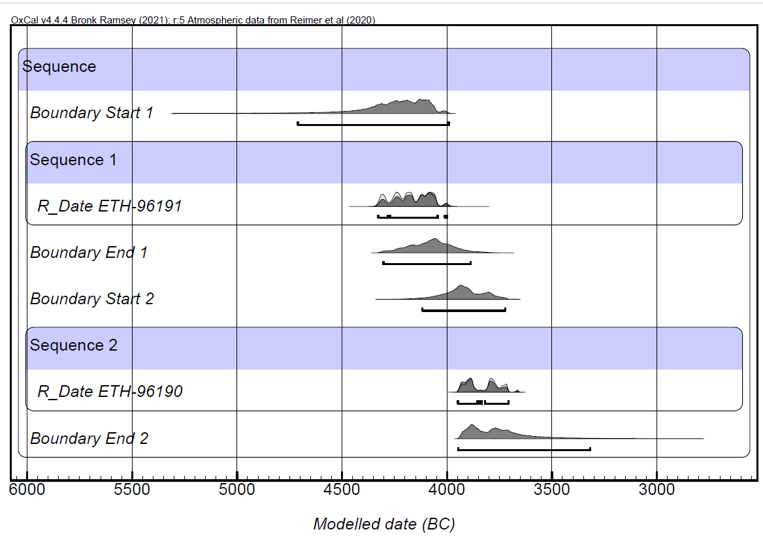
Fig. 15. Bayesian modelling of the radiocarbon dates obtained for core 1276.

Core 1277 (Transect S)
The final core was done in an undisturbed area between core 1276 and the excavation area. Fortunately, intact layers were found after c. 1.5 m of disturbed sediment. We could even document the transition to the lake marl. We attempted to obtain thicker cores of the three meters but it was only possible for the last one, between -141 and -241 cm, since the rest could not be retained in the core. It is an important one, since the last cultural layer over the lake marl was captured (Fig. 16–17, Table 7).
Fig. 16. Core 1277.

No. | Depth (m) | Sediment | Minor component | Sample no. | Note
1277/1 | 0.00 | Disturbance |  |  | 239.31 m a.s.l.
1277/2 | -1.00 | Disturbance
 | -1.47 | Disturbance
 | -1.53 | Sand
 | -1.88 | Organics | Sand | 297, 298
1277/3 | -2.00 | Sediment Loss
 | -2.14 | Disturbance
 | -2.28 | Organics | Sand | 300
 | -2.30 | Organics | Silt | 301 | ETH-96193: 5384 ± 41 BP
 | -2.36 | Silt
 | -2.38 | Silt | Organics
 | -2.81 | Silt
 | -2.88 | Silt | Organics
 | -3.00 | Silt
Table 7. Description of the layers observed in the cores taken in 1277.
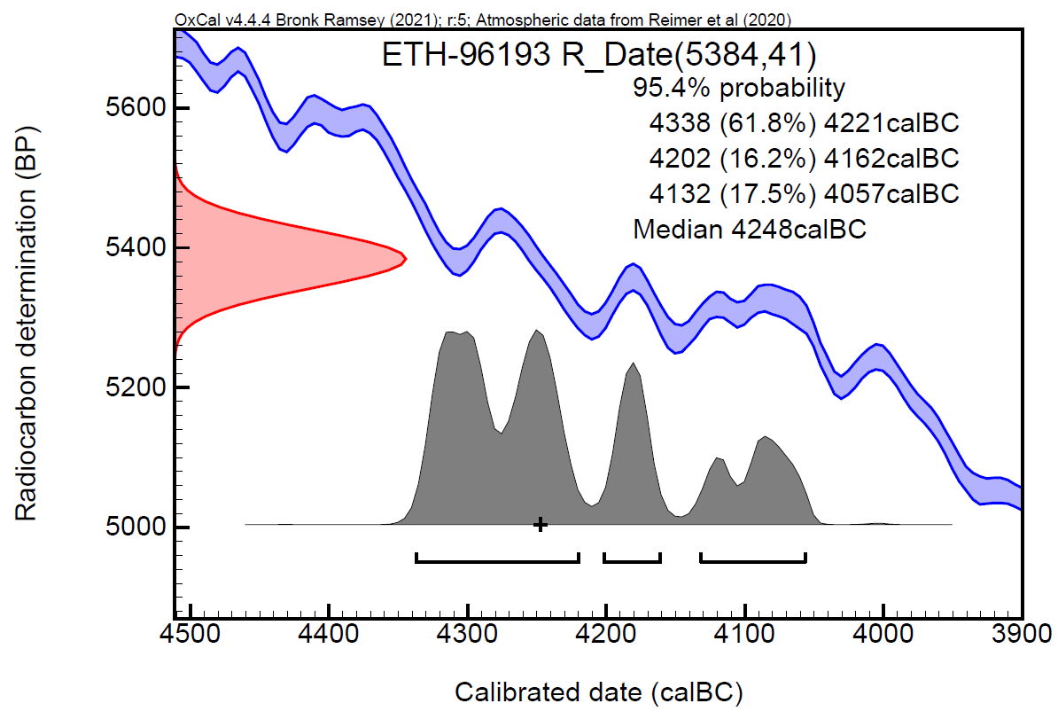
Fig. 17. Core 1277. Calibrated radiocarbon date.

